ISTE-230 Introduction to Database & Data Modeling

## Practice Exercise 1

**Name: __Ryan Cheevers-Brown__**

**Part 1**

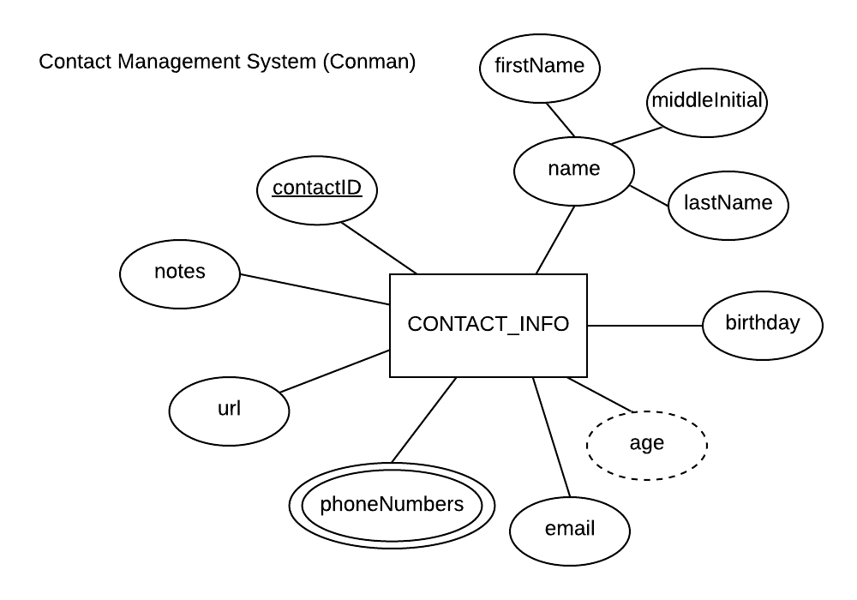

In the table below, classify each attribute specified based on the E-R diagram above, which uses the Chen notation covered in Week 1. In each column please place the answer that best describes the each attribute.

|  |  |  |  |  |
| --- | --- | --- | --- | --- |
| **Attribute** | **Composite**  **or**  **Simple** | **Single-valued**  **or**  **Multi-valued** | **Stored**  **or**  **Derived** | **Identifier?**  **(Yes or no)** |
| name | Composite | Single-value | Stored | No |
| age | Simple | Single-value | Derived | No |
| lastName | Simple | Single-value | Stored | No |
| contactID | Cimple | Single-value | Stored | Yes |
| phoneNumbers | Simple | Multi-valued | Stored | No |

**Part 2**

Using relational structure notation, please transpose the E-R diagram below into a relational schema.

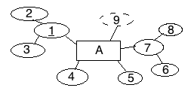

**Your Answer (relational schema):**

A(2, 3, 4, 5, 6, 8)

**Part 3**

The relations below are not transposed from the ER diagram in Part 2 and there is no connection between them. For each relation below, state whether or not the relation is in 1NF. If the relation is not in 1NF, please list the characteristic(s) being violated.

A(1, 2, 3, 4, 5, 6, 6, 7)

**Your Answer:**

Not in 1NF, the item of type (6) is duplicated.

B(1, 2, 3, 4)

**Your Answer:**

Yes, in 1NF.

C(1, 2, 3, 4, 5, 6, 7, 8)

**Your Answer:**

Yes, in 1NF.