ISTE-230 Introduction to Database & Data Modeling Homework # 2 – Interpret, Transpose, and Implement a Single Entity E-R

Diagram in MySQL

**DUE: September 11, 2022 by 11:30pm**

**Name: Ryan Cheevers-Brown**



**All assignments will be graded with regard to the coding standards that were discussed in class, which can be found in the Standards Content area.**

**Submit this document to the Homework #2 assignment folder, edited to include your answers AND the script file created for Part 3.**

**Part 1 - 20 points**

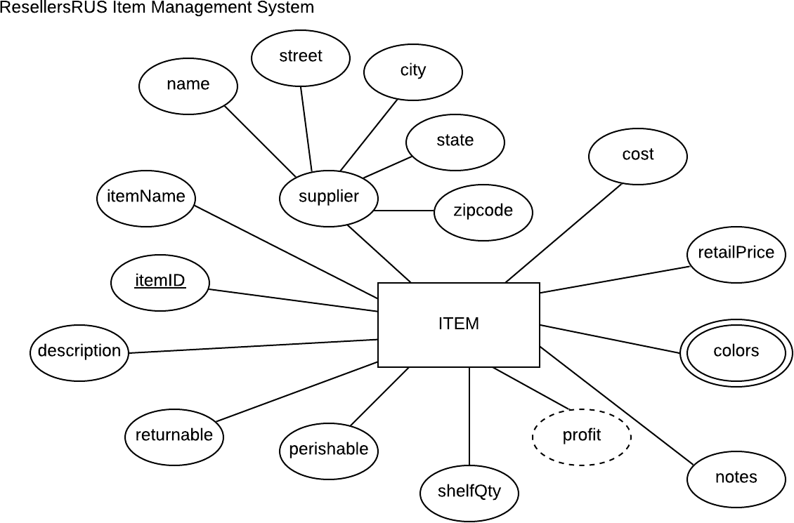

For the table below, please classify each attribute specified based on the E-R diagram above. Please place the best answer for each column that best describes the attribute.

|  |  |  |  |  |
| --- | --- | --- | --- | --- |
| **Attribute** | **Composite or**  **Simple** | **Single-valued or**  **Multi-valued** | **Stored**  **or Derived** | **Identifier ? (Yes or no)** |
| profit | Simple | Single-valued | Derived | No |
| street | Simple | Single-valued | Stored | No |
| itemID | Simple | Single-valued | Stored | Yes |
| supplier | Composite | Single-valued | Stored | No |
| colors | Simple | Multi-valued | Stored | No |

Using relational structure notation, transpose the E-R diagram below into a relational schema. You do not need to normalize the relation.

*NOTE:* The transposed ITEM relation includes a 'colors' attribute, therefore it would not pass the 1NF (the criteria for a relation). Although the ITEM relation is not in 1NF, there is an approach that we will learn next week.



**Your Answer (relational schema):**

ITEM(itemID, perishable, shelfQty, notes, {colors}, retailPrice, cost, supplier{name, street, city, state, zipcode}, itemName, description, returnable)

“1NF”, see above.

Create a script called ‘*yourlastname_*HW2’ that includes the statements that will create a database called ‘HW2’ that includes a table for ITEM, based the relation above in Part 2 and the specifications in the table below. Use ONLY the data types discussed so far (CHAR, VARCHAR, INT, and DATE).

|  |  |
| --- | --- |
| **Attribute(s)** | **Data type description** |
| itemID; itemName; name; street; city; colors | Variable-length string up to 25 characters |
| state | Fixed-length string of 2 characters |
| zipcode | A string that could accommodate either of the formats below: ‘#####-####’ or ‘#####’ |
| cost; retailPrice | Variable-length string up to 10 characters |
| notes; description | Variable-length string up to 255 characters |
| returnable; perishable | Will store one character |
| shelfQty | A whole number between 0 and 50000 |

**What to submit to the HW2 Assignment Folder:**

* **Your script file named as specified above**
* **A clean tee file named** ‘*yourlastname_*HW2’ **that shows the execution of your script followed by the appropriate commands to show the database has been created and a listing of the attributes defined.**