ISTE-230 Introduction to Database & Data Modeling

## Practice Exercise # 6 – Normalization through BCNF

**Name: Ryan Cheevers-Brown**

**All assignments will be graded with regard to the standards that were discussed in class, which can be found in the Standards Content area.**

**Problem #1**

Given the original relation (PUPPY) and functional dependencies, normalize the original and all resulting relations to BCNF. Be sure to use proper relational notation: RELATION(pkattr, attribute, *fkattr*). Include reference statements for foreign keys.

PUPPY(puppyID, puppyName, kennelNumber, kennelLocation)

Functional Dependencies:

puppyID 🡺 puppyName, kennelNumber, kennelLocation

kennelNumber 🡺 kennelLocation

**YOUR ANSWER (Final set of relations normalized to BCNF):**

Puppy(puppyID, puppyName, *kennelNumber*, ~~kennelLocation~~)

Puppy(kennelNumber) MEI Kennel(kennelNumber)

Kennel(kennelNumber, kennelLocation)

**Problem #2**

Given the original relation (VEHICLE) and functional dependencies, normalize the original and all resulting relations to BCNF. Be sure to use proper relational notation: RELATION(pkattr, attribute, *fkattr*). Include reference statements for foreign keys.

VEHICLE

|  |  |  |  |  |  |
| --- | --- | --- | --- | --- | --- |
| vin | make | model | year | ownerID | owner |
| 111abc | Toyota | Corrolla | 1988 | 111223333 | Joe Smith |
| 223ahv | Ford | Windstar | 1998 | 222334444 | Bill Gates |
| 332amz | GM | GMC | 1995 | 333445555 | Tom Green |
| 876grd | Subarau | Outback | 2000 | 987654321 | Bob Jones |

VEHICLE(vin, make, model, year, ownerID, owner)

Functional Dependencies:

vin 🡺 make, model, year, ownerID, owner

ownerID 🡺 owner

**YOUR ANSWER (Final set of relations normalized to BCNF):**

Vehicle(vin, make, model, year, *ownerID*, ~~owner~~)

Vehicle(ownerID) MEI Owner(ownerID)

Owner(ownerID, owner)

**Problem #3**

A violation of 1NF is repeating groups – more than one attribute from same physical and logical domain (ex. author1, author2, etc.)

* Some examples we have worked with hid or omitted this as a “fix” for multi-valued attributes.

In PE#2 there should have been the following:

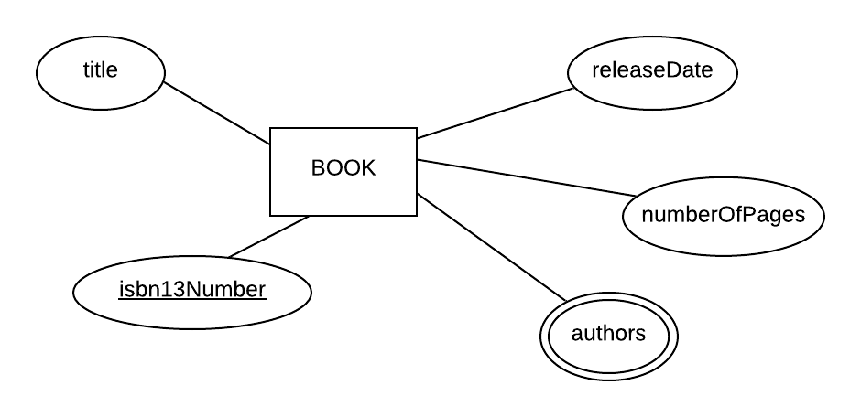

**UoD:** PE2 Book Tracking System

**Resulting Relation:** BOOK(title, isbn13Number, author1, author2, author3, author4, author5, numberOfPages, releaseDate)

**Functional Dependencies:**

isbn13Number 🡺 title, author1, author2, author3, author4, author5, numberOfPages, releaseDate

Finish the solution that what was started below in an effort to solve the repeating group problem. Include the modified BOOK relation that would result from the addition of the BOOK_AUTHOR relation. Use proper relational notation and include reference statements for any foreign keys.

**Unfinished Solution:**

BOOK(isbn13Number, title, releaseDate, numberOfPages)

BOOK_AUTHOR(isbn13Number, author)

**YOUR COMPLETED SOLUTION:**

Book(isbn13Number, title, releaseDate, numberOfPages)

BookAuthor(*isbn13Number*, author)

BookAuthor(isbn13Number) MEI Book(isbn13Number)

**Problem #4**

For the relation below, determine the *highest* normal form the relation is in, the reason, and if necessary normalize through BCNF.

Relation: Q2( a, b, c, d )

Functional Dependencies:

a, b 🡪 c, d

c, d 🡪 a, b

**YOUR ANSWER:**

Highest possible NF is BCNF. Meets criteria of a relation, no transitive or partial dependencies, every determinant is a candidate key.

**Problem #5**

Given the original relation (A) and functional dependencies, normalize the original and all resulting relations to BCNF. Be sure to use proper relational notation: RELATION(pkattr, attribute, *fkattr*). Include reference statements for foreign keys.

A(1, 2, 3, 4, 5, 6, 7, 8, 9)

Functional Dependencies:

1, 2, 3 🡪 4, 5, 6, 7, 8, 9 (based on PK choice for a)

1🡪 4

4 🡪 1

2🡪 6, 7, 8, 9

6,7 🡪 8,9

**YOUR ANSWER (Final set of relations normalized to BCNF):**

This is in maximum first normal form.

A(*1, 2*, 3, 5)

A(1) MEI B(1)

A(2) MEI C(2)

B(1, 4)

C(2, *6, 7*)

C(6, 7) MEI D(6, 7)

D(6, 7, 8, 9)