ISTE-230 Introduction to Database & Data Modeling

## Homework # 5 – HAS-A and IS-A Relationships

DUE: Tonight

**Name: Ryan Cheevers-Brown**

**Submit this document, edited to include your answers, to the HW#5 Assignment folder by the stated deadline.**

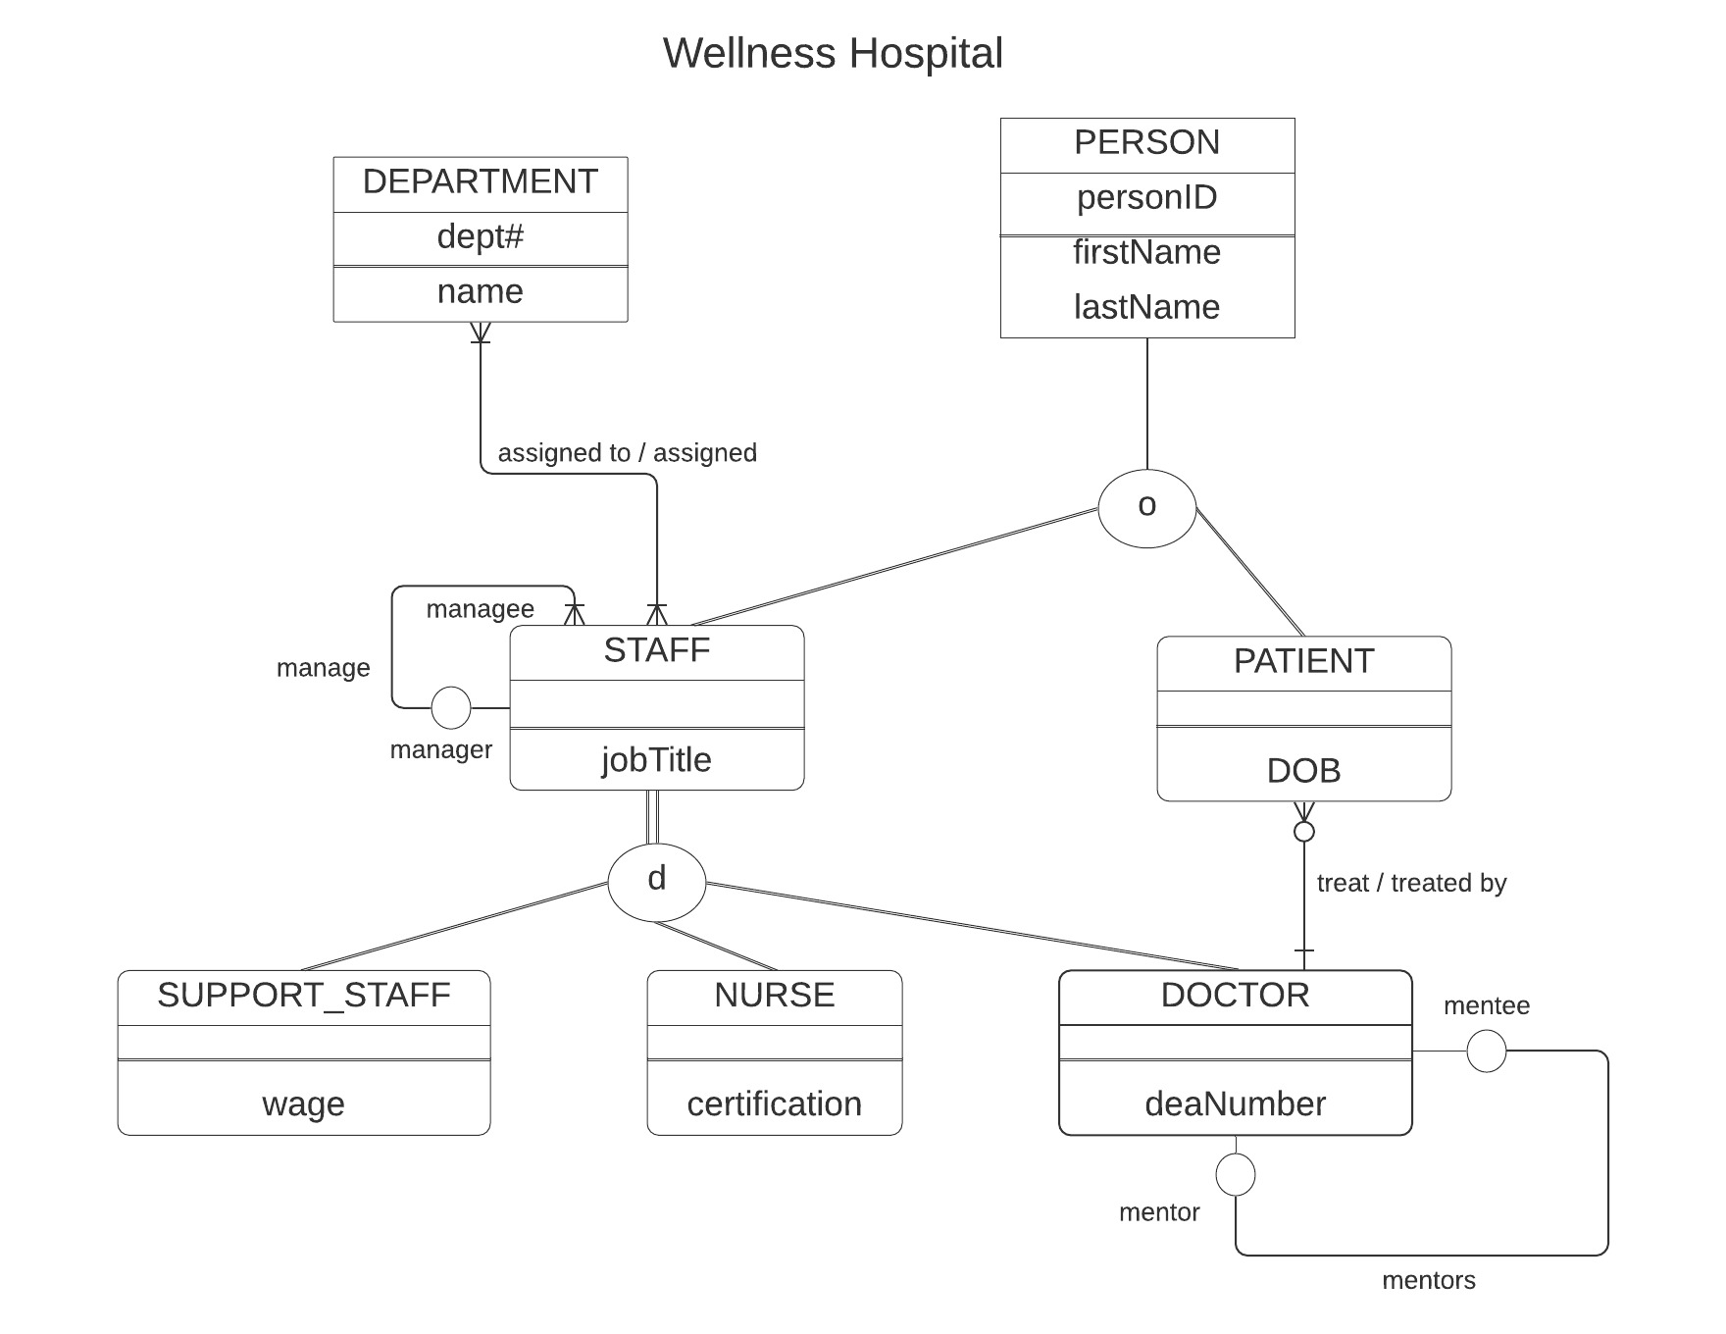

Using the E-R diagram for Wellness Hospital, that appears on the previous page, please provide your answer to the following questions.

1. (5 points) List the relationship verb phrase for each 'HAS-A' relationship that appears in the diagram.

**YOUR ANSWER:**

DEPARTMENT has a NAME

DEPARTMENT has a DEPT#

PERSON has a PERSONID

PERSON has a firstName

PERSON has a lastName

STAFF has a jobTitle

SUPPORT_STAFF has a WAGE  
NURSE has a CERTIFICATION  
DOCTOR has a deaNumber

PATIENT has a DOB

1. (5 points) List the relationship verb phrase for each binary relationship that appears in the diagram.

**YOUR ANSWER:**

STAFF is assigned to a DEPARTMENT  
DEPARTMENT is assigned STAFF

PATIENT is treated by DOCTOR

DOCTOR treats PATIENT

1. (5 points) List the relationship verb phrase for each recursive relationship that appears in the diagram.

**YOUR ANSWER:**

MENTOR mentors a MENTEE

MENTEE is mentored by MENTOR

MANAGER manages STAFF  
STAFF is managed by a MANAGER

1. (5 points) List the name of each supertype entity that appears in the diagram.

**YOUR ANSWER:**

STAFF

PERSON

1. (6 points) List the name of each subtype entity that appears in the diagram.

**YOUR ANSWER:**

PATIENT  
STAFF  
DOCTOR  
NURSE

SUPPORT_STAFF

1. (5 points) Provide an example of an entity instance of PERSON.

**YOUR ANSWER:**

PERSON  
firstName: Mary

lastName: Kay

personID: 2

1. (5 points) List the relationship verb phrase for every 1:1 relationship that appears in the diagram.

**YOUR ANSWER:**

MENTOR mentors a MENTEE

MENTEE is mentored by MENTOR

1. (5 points) List the relationship verb phrase for every 1:N (N:1) relationship that appears in the diagram.

**YOUR ANSWER:**

PATIENT is treated by DOCTOR

DOCTOR treats PATIENT

MANAGER manages STAFF  
STAFF is managed by a MANAGER

1. (5 points) List the relationship verb phrase for every M:N relationship that appears in the diagram.

**YOUR ANSWER:**

STAFF is assigned to a DEPARTMENT  
DEPARTMENT is assigned STAFF

1. (5 points) List the name of each strong entity that appears in the diagram.

**YOUR ANSWER:**

DEPARTMENT

PERSON

1. (6 points) List the name of each weak entity that appears in the diagram.

**YOUR ANSWER:**

PATIENT

STAFF  
SUPPORT_STAFF  
DOCTOR

NURSE

1. (4 points) Must a STAFF:managee be managed by a manager? Explain how you determined your answer from the E-R diagram provided.

**YOUR ANSWER:**Yes – minimum cardinality is 1 denoted by the vertical line.

1. (4 points) Can there be an instance of DOCTOR that is not an instance of STAFF? Explain your answer.

**YOUR ANSWER:**

No – DOCTOR is dependent on STAFF and is a weak entity.

1. (4 points) Can a DOCTOR treat more than one PATIENT? Explain how you determined your answer from the E-R diagram provided.

**YOUR ANSWER:**

Yes – the doctor’s maximum cardinality is N, shown by the split/tree-ish line into PATIENT.

1. (4 points) Must every instance of PERSON belong to a subtype? Fully explain how you determined your answer from the E-R diagram provided.

**YOUR ANSWER:**

No – the line is single (partial specialization).

1. (4 points) Could an instance of PERSON be both a STAFF and a PATIENT? Fully explain how you determined your answer from the E-R diagram provided.

**YOUR ANSWER:**

Yes – the “o” shows that the relationship obeys the overlap rule.

1. (4 points) Must every instance of STAFF belong to a subtype? Fully explain how you determined your answer from the E-R diagram provided.

**YOUR ANSWER:**

Yes – the line is a double which indicates total specialization.

1. (4 points) Could an instance of STAFF be both a SUPPORT_STAFF and a DOCTOR? Fully explain how you determined your answer from the E-R diagram provided.

**YOUR ANSWER:**

No – the “d” means that the relationship obeys the disjoint rule.

1. (5 points) If a discriminator were to be added to PERSON, fully explain what that would entail and why?

**YOUR ANSWER:**

This is already discriminated. Overlap rule.

1. (5 points) If a discriminator were to be added to STAFF, fully explain what that would entail and why?

**YOUR ANSWER:**

Staff is already discriminated. Disjoint rule.

1. (5 points) Fully state the business rules for the **assigned to/assigned** relationship without using technical terms.

**YOUR ANSWER:**

Every employee must belong to a department. Departments can have multiple employees. Employees may belong to multiple departments. Every department must have at least one employee.