ISTE-230 Introduction to Database and Data Modeling

## Practice Exercise # 7 – ‘Has-A’ Relationships

**Name: _____________________________________________**

**All assignments will be graded with regard to the standards that were discussed in class, which can be found in the Standards Content area.**

**Problem #1**

Given the following business rules, please complete the E-R diagram below:

* A CONTACT does not have to be associated with a PHONE.
* A CONTACT can be associated with many PHONEs.
* A PHONE must be associated with a CONTACT.
* A PHONE can associated with many CONTACTs.
* A COMPANY does not have to employ any CONTACTs.
* A CONTACT does not have to be employed by a COMPANY.
* A COMPANY can employ many CONTACTs.
* A CONTACT is employed at most one COMPANY.
* A COMPANY:subsidiary does not have to be owned by a COMPANY:parent.
* A COMPANY:parent does not have to own a COMPANY:subsidiary.
* A COMPANY:subsidiary can be owned by no more than one COMPANY:parent.
* A COMPANY:parent can own many COMPANYs:subsidiaries.

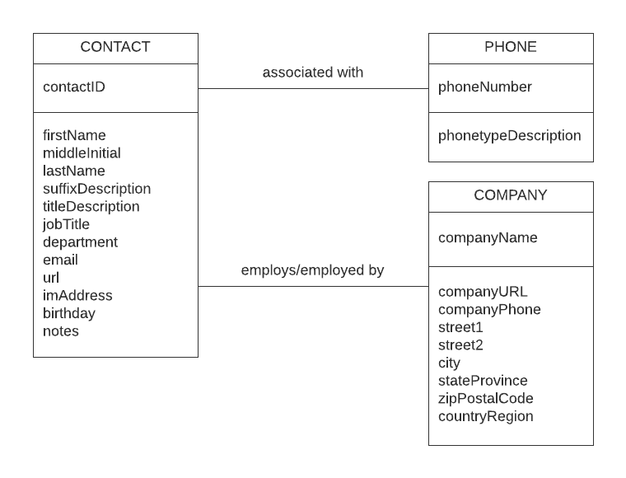

**YOUR ANSWER (Diagram above completed):**

**Problem #2**

Given the following E-R diagram, please answer each question.



1. What is the identifier of COUNTRY?

**YOUR ANSWER:**

1. Provide an example of an entity instance of LANGUAGE?

**YOUR ANSWER:**

1. What is the cardinality ratio for the ‘has/within’ relationship between COUNTRY and CITY?

**YOUR ANSWER:**

1. What is the type of relationship between COUNTRY and LANGUAGE (1:1, 1:N, or M:N)?

**YOUR ANSWER:**

1. Does a COUNTRY have to have a CITY? How can you tell that from the diagram?

**YOUR ANSWER:**

1. Does a CITY have to have a COUNTRY? How can you tell that from the diagram?

**YOUR ANSWER:**

1. Can a COUNTRY have more than one CITY? How can you tell that from the diagram?

**YOUR ANSWER:**

1. Can a CITY have more than one COUNTRY? How can you tell that from the diagram?

**YOUR ANSWER:**

1. Please list the relationship verb phrases for all recursive relationships appearing in the diagram.

**YOUR ANSWER:**

1. Please list the relationship verb phrases for all relationships in the diagram that have a degree of 2.

**YOUR ANSWER:**