ISTE-230 Introduction to Database & Data Modeling

## Homework # 6 – Transposing

DUE:

**Name: Ryan Cheevers-Brown**

**Submit this document edited to include your answers, for the two parts, to the HW#6 Dropbox by the stated deadline.**

(It may be helpful to right-click on the  icon and select Hide Spelling Errors and Hide Grammatical Errors.)

**Part #1 – 50 points**

1. (45 points) Transpose the E-R diagram above into relations, implementing all relationships. Denote primary keys and foreign keys appropriately. Use proper relation notation. You need to provide reference statements.

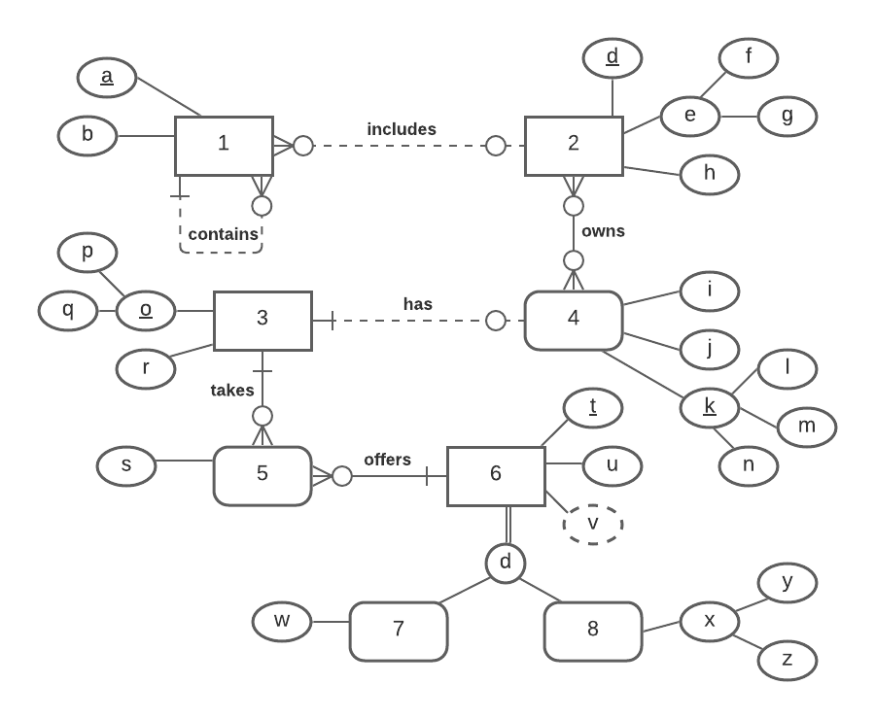

**YOUR TRANSPOSED RELATIONS:**

1(a, b, *1r*, *d*)

1(1r) MEI 1(a)

1(d) MEI 2(d)

2(d, f, g, h)

3(p, q, r)

4(l, m, n, i, j)

2_4(*d, l, m, n*)

2_4(d) MEI 2(d)

2_4(l, m, n) MEI 4(l, m, n)

5(*o*, *t*, s)

5(o) MEI 3(o)

5(t) MEI 6(t)

6(t, u, 7or8)

7(*t*, w)

7(t) MEI 6(t)

8(*t*, y, z)

8(t) MEI 6(t)

2. (2 points) Using the E-R diagram above, please explain why entity 7 is weak and what the specific term for that type of entity is.

**REASON: Entity 7 is weak because it is a specialization of entity 6.**

**TERM: disjoint rule, specialization**

3. (2 points) Using the E-R diagram above, please explain why entity 5 is weak and what the specific term for that type of entity is.

**REASON: Entity 5 is weak because it depends on identifiers from 3 and 6.**

**TERM: does not have its own identifier.**

4. ( 1 point) Using the E-R diagram above, please explain what relationship makes entity 4 weak and what about that relationship causes it to be weak.

**EXPLANATION: The relationship with entity 2, where 2 owns an instance of 4, makes 4 weak.**

**Part 2 – RIT Savings and Loan (50 points)**

1. (50 points) Transpose the E-R diagram above into relations, implementing all relationships. Denote primary keys and foreign keys appropriately. Use proper relation notation. You need to provide reference statements.

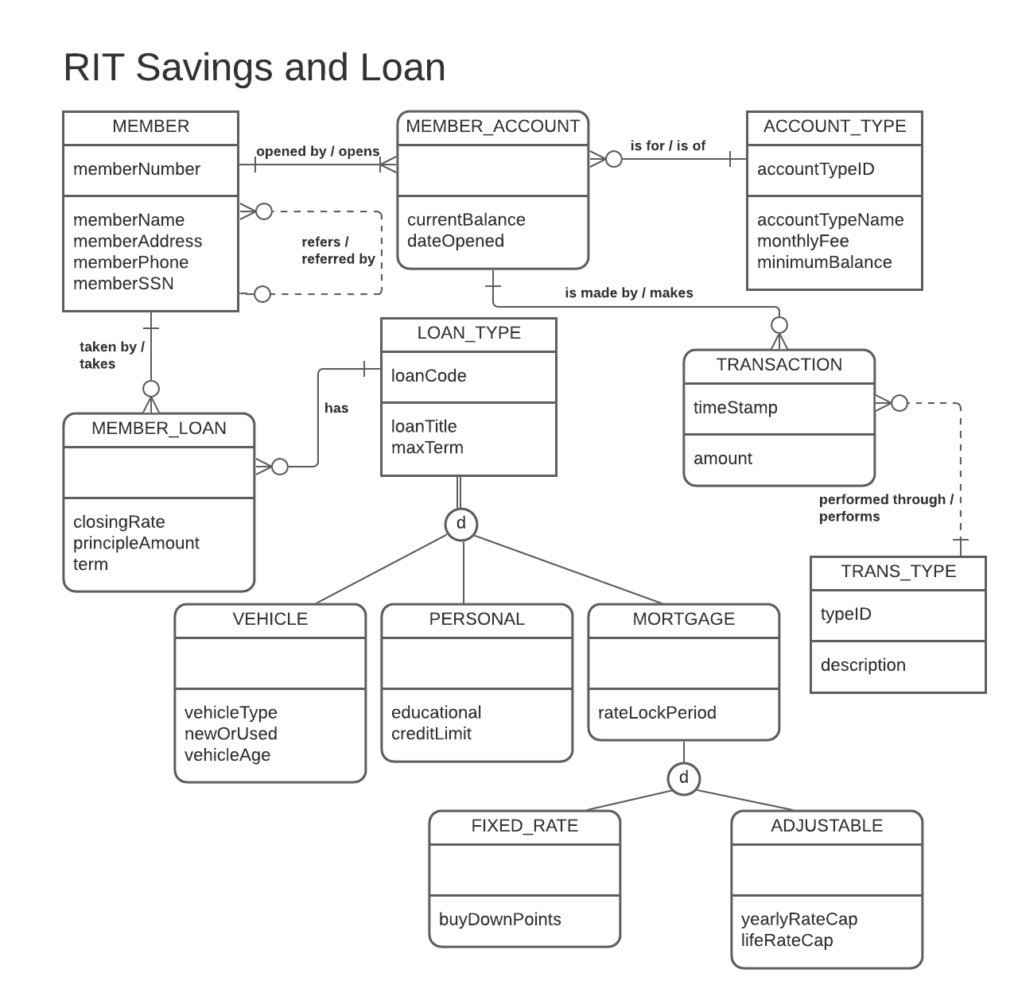

**YOUR TRANSPOSED RELATIONS:**

MEMBER(memberNumber, memberName, memberAddress, memberPhone, memberSSN, *referredBy*)

MEMBER(referredBy) MEI MEMBER(memberNumber)

MEMBER_ACCOUNT(*memberNumber*, *accountTypeID*, currentBalance, dateOpened)

MEMBER_ACCOUNT(memberNumber) MEI MEMBER(memberNumber)

MEMBER_ACCOUNT(accountTypeID) MEI ACCOUNT_TYPE(accountTypeID)

ACCOUNT_TYPE(accountTypeID, accountTypeName, monthlyFee, minimumBalance)

TRANSACTION(timeStamp, *accountTypeID, memberNumber*, amount, *transType*)

TRANSACTION(accountTypeID, memberNumber) MEI MEMBER_ACCOUNT(accountTypeID, memberNumber)

TRANSACTION(transType) MEI TRANS_TYPE(typeID)

TRANS_TYPE(typeID, description)

MEMBER_LOAN(*memberNumber*, *loanCode*, closingRate, principleAmount, term)

MEMBER_LOAN(memberNumber) MEI MEMBER(memberID)

MEMBER_LOAN(loanCode) MEI LOAN_TYPE(loanCode)

LOAN_TYPE(loanCode, loanTitle, maxTerm, loanType)

VEHICLE(*loanCode*, vehicleType, newOrUsed, vehicleAge)

VEHICLE(loanCode) MEI LOAN_TYPE(loanCode)

PERSONAL(*loanCode*, educational, creditLimit)

PERSONAL(loanCode) MEI LOAN_TYPE(loanCode)

MORTGAGE(*loanCode*, rateLockPeriod, fixedOrAdjustable)

MORTGAGE(loanCode) MEI LOAN_TYPE(loanCode)

FIXED_RATE(*loanCode*, buyDownPoints)

FIXED_RATE(loanCode) MEI MORTGAGE(loanCode)

ADJUSTABLE(*loanCode*, yearlyRateCap, lifeRateCap)

ADJUSTABLE(loanCode) MEI MORTGAGE(loanCode)