ISTE-230 Introduction to Database & Data Modeling

## Practice Exercise # 10 – Transposing II

**Name: Ryan Cheevers-Brown**

**All assignments will be graded with regard to the standards that were discussed in class, which can be found in the Standards Content area.**

Be sure to use proper relational notation: RELATION(pkattr, attribute, *fkattr*). Include reference statements for foreign keys.

(It may be helpful to right-click on the  icon and select Hide Spelling Errors and Hide Grammatical Errors.)

**Problem #1**

Using the RITPO diagram that appears below, answer the following questions. **Please account for the note that is at the bottom of the diagram.**

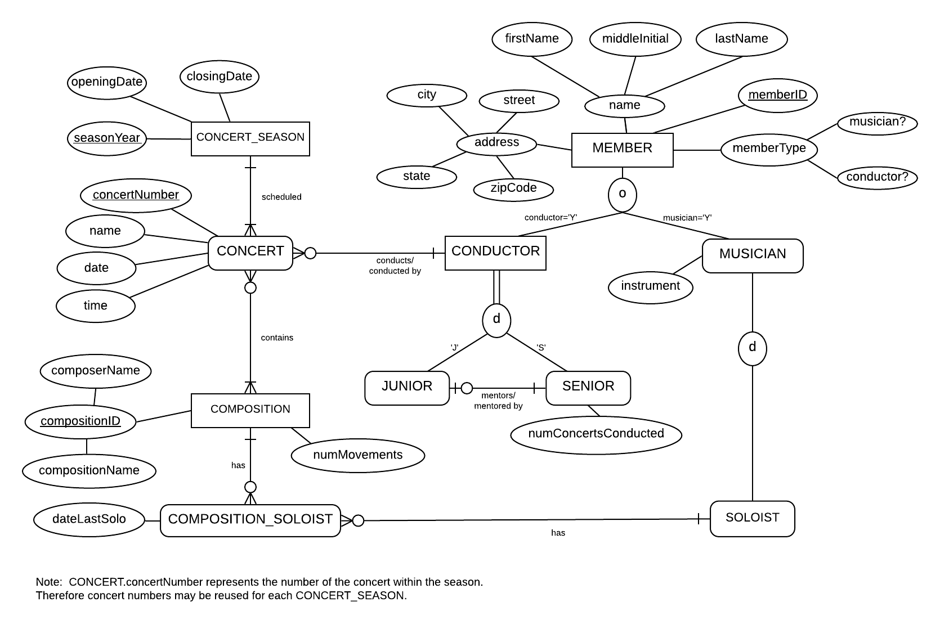

Explain why SOLOIST is weak and what the specific term for that type of entity is.

**REASON: SOLOIST does not have a unique identifier.**

**TERM: Depends on MUSICIAN and COMPOSITION_SOLOIST.**

Explain why CONCERT is weak and what the specific term for that type of entity is.

**REASON: Does not have a unique identifier.**

**TERM: Depends on CONCERT_SEASON.**

**Problem #2**

Transpose the E-R diagram below into relations, implementing all relationships. Denote primary keys and foreign keys appropriately. Use proper relation notation. Make sure your relation names are in all caps. **Please account for the note that is at the bottom of the diagram.**



**YOUR TRANSPOSED RELATIONS:**

MEMBER(memberID, firstName, middleInitial, lastName, street, city, state, zipCode, musician, conductor)

MUSICIAN(*memberID*, instrument, soloist)

MUSICIAN(memberID) MEI MEMBER(memberID)

CONDUCTOR(*memberID*, juniorOrSenior)

CONDUCTOR(memberID) MEI MEMBER(memberID)

JUNIOR(*memberID*, mentor)

JUNIOR(memberID) MEI CONDUCTOR(memberID)

SENIOR(*memberID,* mentee, numConcertsConducted)

SENIOR(memberID) MEI CONDUCTOR(memberID)

JUNIOR(mentor) MEI SENIOR(memberID)

CONCERT(concertNumber, *year*, name, date, time, *conductor*)

CONCERT(conductor) MEI CONDUCTOR(memberID)

CONCERT(year) MEI CONCERT_SEASON(year)

COMPOSITION(*compositionID*, numMovements, *soloist, concertNumber*)

COMPOSITION(soloist) MEI MUSICIAN(soloist)

COMPOSITION(concertNumber) MEI CONCERT(concertNumber)

COMPOSITION_ID(compositionName, composerName)

COMPOSITION_SOLOIST(*memberID,* dateLastSolo, *compositionID*)

COMPOSITION_SOLOIST(memberID) MEI MUSICIAN(memberID)

COMPOSITION_SOLOIST(compositionID) MEI COMPOSITION(compositionID)

CONCERT_SEASON(seasonYear, closingDate, openingDate)

**Problem #3**

Given the E-R diagram, transposed relations (from PE9 – does not distinguish between identifying and non-identifying relationships) and the functional dependencies shown below, normalize all relations, and any resulting relations through BCNF, using proper relational notation. Note: The lines in the E-R diagram do not distinguish identifying and non-identifying relationships.

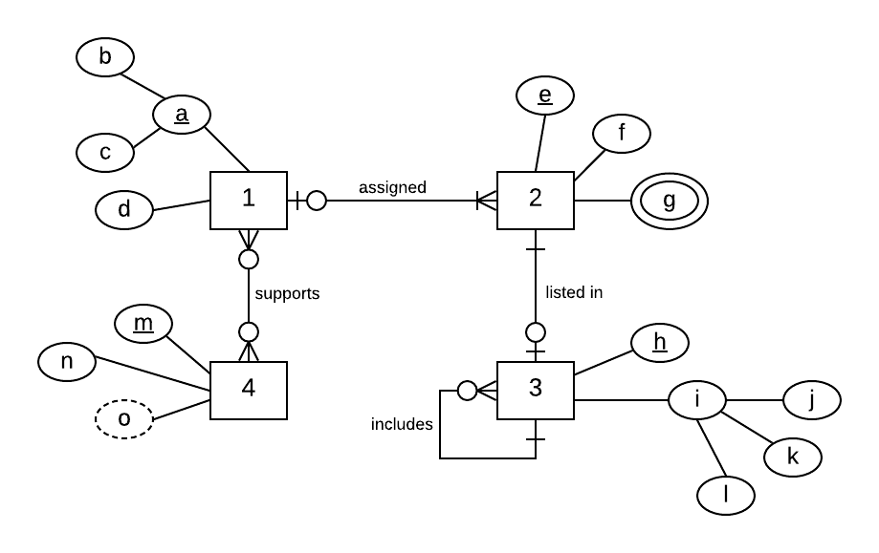

**Functional Dependencies:**

b, c -> d

c->d

d->c

e->f, (b, c)

h-> j, k, l, e, h1

k-> l

m->n

**The Transposed Relations:**

1(b, c, d)

2(e, f, *b, c*)

2(b, c) MEI 1(b, c)

3(h, j, k, l, *e, h1*)

3(e) MEI 2(e)

3(h1) MEI 3(h)

4(m, n)

1_4(*b, c, m*)

1_4(b, c) MEI 1(b, c)

1_4(m) MEI 4(m)

**YOUR FINAL SET OF NORMALIZED RELATIONS:**

1(*a*, d)

1(a) MEI A(a)

A(a, b, c)

2(e, f, *1a*)

2(1a) MEI 1(a)

3(h, j, k, l, *e, h1*)

3(h1) MEI 3(h)

3(e) MEI 2(e)

4(m, n)

1_4(*a, m*)

1_4(a) MEI 1(a)

1_4(m) MEI 4(m)

**Problem #4**

Transpose the E-R diagram below into relations, implementing all relationships. Denote primary keys and foreign keys appropriately. Use proper relation notation. Make sure your relation names are in all caps.

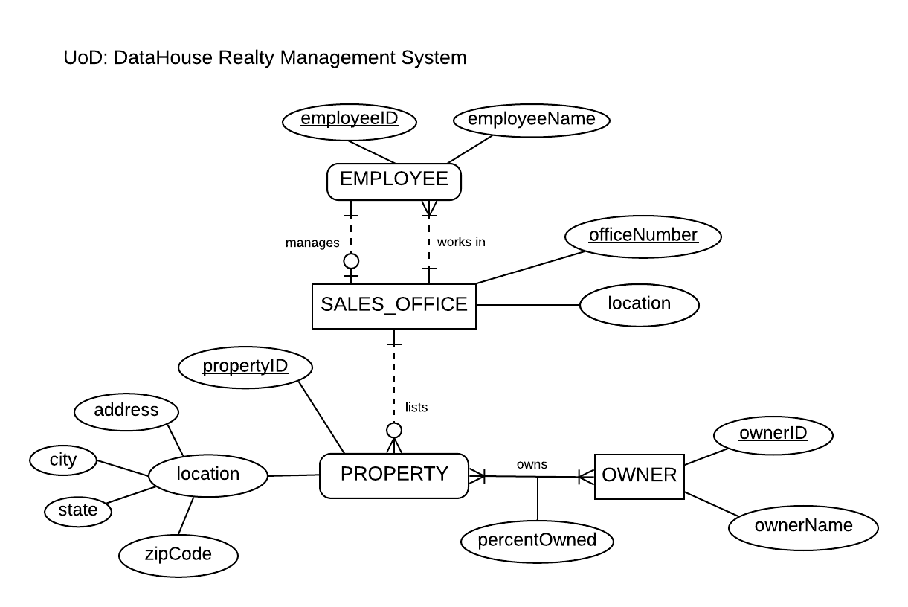

**YOUR TRANSPOSED RELATIONS:**

EMPLOYEE(employeeID, employeeName, *worksIn*)

EMPLOYEE(worksIn) MEI SALES_OFFICE(officeNumber)

SALES_OFFICE(officeNumber, location, *manager*)

SALES_OFFICE(manager) MEI EMPLOYEE(employeeID)

PROPERTY(propertyID, address, city, state, zipCode, *listingOffice*)

PROPERTY(listingOffice) MEI SALES_OFFICE(officeNumber)

OWNER(ownerID, ownerName)

PERCENT_OWNED(percentOwned, *property, owner*)

PERCENT_OWNED(property) MEI PROPERTY(propertyID)

PERCENT_OWNED(owner) MEI OWNER (ownerID)

**Problem #5**

Using the DataHouse Realty diagram from Problem #4, please explain what relationship makes PROPERTY weak and what about that relationship causes PROPERTY to be weak.

**YOUR REASON:**

PROPERTY requires an owner – does not have a unique identifier. Different owners can have properties with the same propertyID.