ISTE-230 Introduction to Database & Data Modeling

## Practice Exercise # 9 – Transposing

**Name: _____________________________________________**

**All assignments will be graded with regard to the standards that were discussed in class, which can be found in the Standards Content area.**

Be sure to use proper relational notation: RELATION(pkattr, attribute, *fkattr*). Include reference statements for foreign keys.

**Problem #1**

Transpose the E-R diagram below into relations, implementing all relationships. Denote primary keys and foreign keys appropriately. Use proper relation notation. Make sure your relation names are in all caps.



**YOUR TRANSPOSED RELATIONS:**

**Problem #2**

Transpose the E-R diagram below into relations, implementing all relationships. Denote primary keys and foreign keys appropriately. Use proper relation notation. You do not need to fix any possible normalization issues.

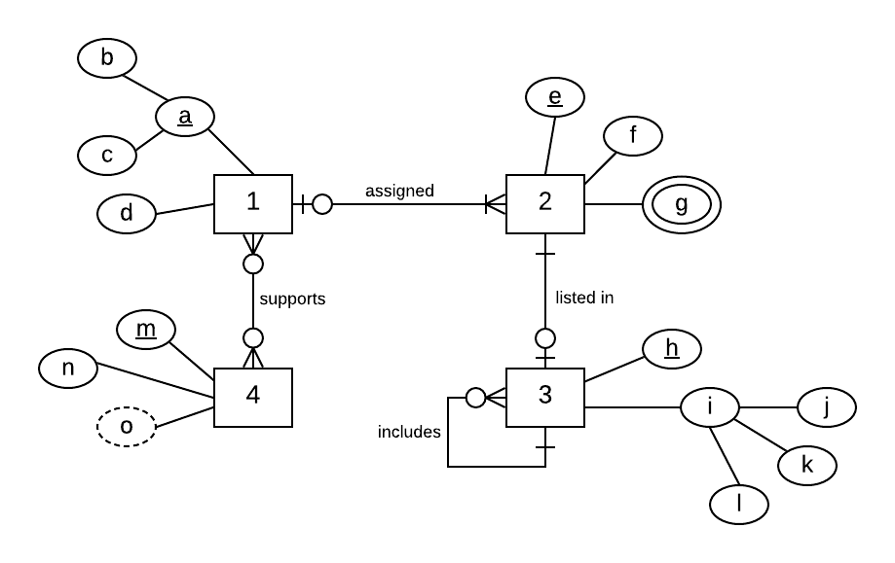

**YOUR TRANSPOSED RELATIONS:**

**Problem #3**

Transpose the E-R diagram below into relations, implementing all relationships. Denote primary keys and foreign keys appropriately. Use proper relation notation. Make sure your relation names are in all caps.



**YOUR TRANSPOSED RELATIONS:**