Chapter Nine Hands-On-Assignments Part I
Assignment 9-2: Updating Stock Information When a Product Request Is Filled
Brewbean's has a BB_PRODUCT_REQUEST table where requests to refill stock levels are inserted automatically via a trigger. After the stock level falls below the reorder level, this trigger fires and enters a request in the table. This procedure works great; however, when store clerks record that the product· request has been filled by updating the table's DTRECD and COST columns, they want the stock level in the product table to be updated. Create a trigger named BB_REQFILL_TRG to handle this task, using the following steps as a guideline:
- In SQL Developer, run the following INSERT statement to create a product request you can use in this assignment:
INSERT INTO bb_product_request (idRequest, idProduct, dtRequest, qty) VALUES (3, 5, SYSDATE, 45);
COMMIT;

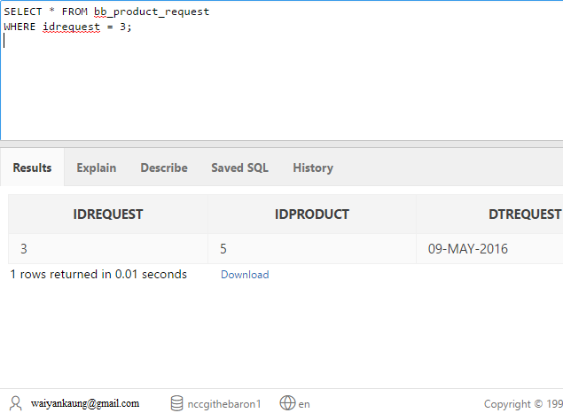

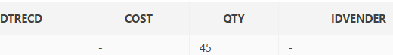

- Create the trigger (BB_REQFILL_TRG) so that it fires when a received date is entered in the BB_PRODUCT_REQUEST table. This trigger needs to modify the STOCK column in the BB_PRODUCT table to reflect the increased inventory.
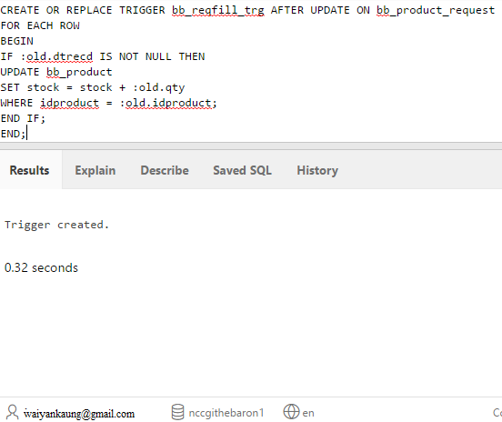

- Now test the trigger. First, query the stock and reorder data for product 5, as shown below.

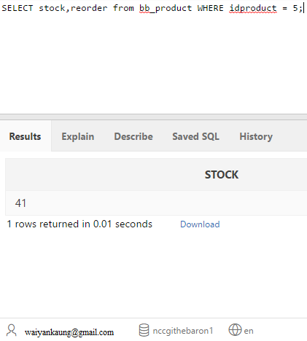

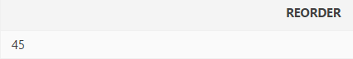

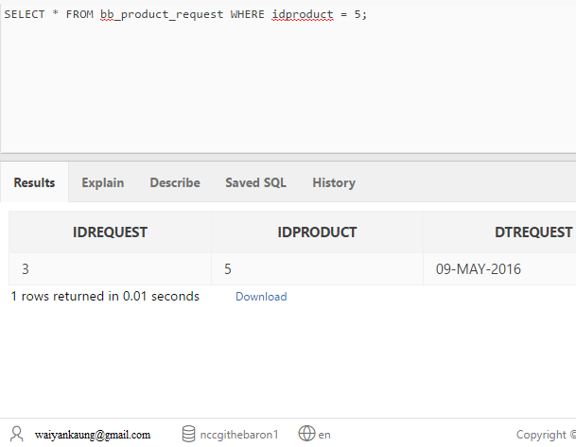

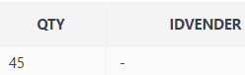

- Now update the product request to record it as fulfilled by using the UPDATE statement shown below'.

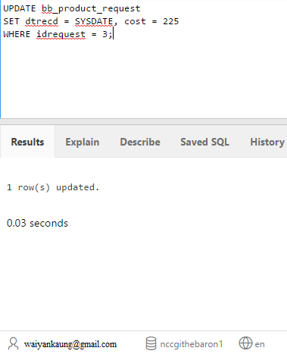

- Issue queries to verify that the trigger fired and the stock level of product 5 has been modified correctly. Then issue a ROLLBACK statement to undo the modifications.

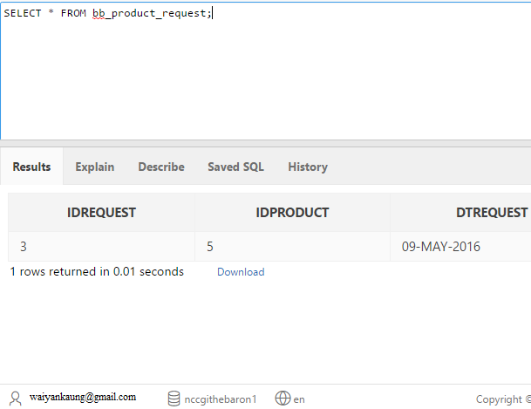

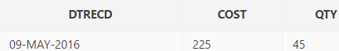

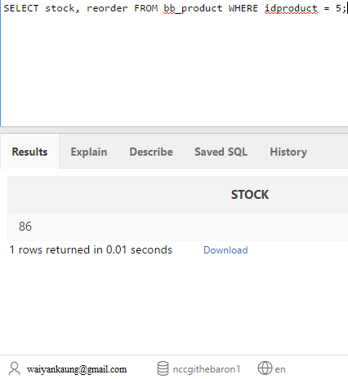
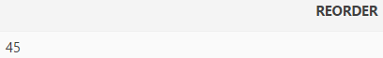

ROLLBACK
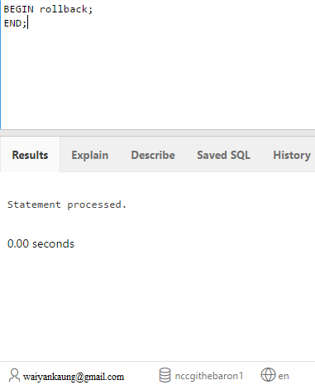

- Disable the trigger.

