**SUMMARY LEVEL 9**

**WORDS**

|  |  |  |  |  |  |  |  |  |  |  |  |  |  |  |  |  |  |  |  |  |  |  |  |  |  |  |  |  |  |  |  |  |  |  |  |  |  |  |  |  |  |  |  |  |  |  |  |  |  |  |  |  |  |  |  |  |  |  |  |  |  |  |  |  |  |  |  |  |  |  |  |  |  |  |  |  |  |  |  |  |  |  |  |  |  |  |  |  |  |  |  |  |  |  |  |  |  |  |  |  |  |  |  |  |  |  |  |  |  |  |  |  |  |  |  |  |  |  |  |  |  |  |  |  |  |  |  |  |  |  |  |  |  |  |  |  |  |  |  |  |  |  |  |  |  |
| --- | --- | --- | --- | --- | --- | --- | --- | --- | --- | --- | --- | --- | --- | --- | --- | --- | --- | --- | --- | --- | --- | --- | --- | --- | --- | --- | --- | --- | --- | --- | --- | --- | --- | --- | --- | --- | --- | --- | --- | --- | --- | --- | --- | --- | --- | --- | --- | --- | --- | --- | --- | --- | --- | --- | --- | --- | --- | --- | --- | --- | --- | --- | --- | --- | --- | --- | --- | --- | --- | --- | --- | --- | --- | --- | --- | --- | --- | --- | --- | --- | --- | --- | --- | --- | --- | --- | --- | --- | --- | --- | --- | --- | --- | --- | --- | --- | --- | --- | --- | --- | --- | --- | --- | --- | --- | --- | --- | --- | --- | --- | --- | --- | --- | --- | --- | --- | --- | --- | --- | --- | --- | --- | --- | --- | --- | --- | --- | --- | --- | --- | --- | --- | --- | --- | --- | --- | --- | --- | --- | --- | --- | --- | --- | --- | --- |
| |  |  | | --- | --- | | psychic /ˈsaɪkɪk/ | экстрасенс | | preferably | желательно; предпочт-но | | insecure /ˌɪnsɪˈkjʊə/ | неуверенный в себе | | involve | вовлекать, быть связанным с | | tension | напряженность, натянутые отношения, противоречия | | abdomen /ˈæbdəmən/ | (мед.) живот | | blame (it) on | обвинять к-то, сваливать вину на к-то, ч-то | | forgetfulness | забывчивость | | confirm | подтверждать | | common /ˈkɒmən/ | распространенный | | deduce (from) | делать вывод (из ч-то), догадаться | | come up with smth | предложить, придумать | | What’s eating you? | Какая муха тебя укусила?  Что тебя гложет? | | get sth off your chest | облегчить душу, признаться | | have the guts to do smth | решиться, иметь мужество сделать что-то | | give it a shot | попробовать | | I wouldn’t be caught dead (with him / Ving smth) | Я лучше умру, чем…; испыт-ть отвращение, омерзение, ни за что на свете | | Skip it! | Неважно! Забудь! | | http://thumbs.dreamstime.com/z/bite-bullet-25667921.jpgbite the bullet | решиться сделать что-то неприятное, сделать что-то собрав волю в кулак | | put it off | откладывать что-то | | hit it off | понравиться друг другу, ладить с кем-то | | That'll be the day! | После дождичка в четверг, этому никогда не бывать | | take the initiative /ɪˈnɪʃətɪv/ | брать на себя инициативу | | Now you're talking! | Вот это другой разговор! | | be bound to | рано или поздно, наверняка | | pass up | отказаться, пропустить | | keep things bottled up | скрывать, сдерживать чувства | | chat | болтать | | gossip | сплетничать | | make small talk | болтать о том-о сем, вести «светскую беседу» | | greet someone | приветствовать к-то | | give someone a compliment | делать комплимент | | boast /bəʊst/ | хвастать | | mumble | бормотать, бурчать | | speak up | говорить громко, говорить внятно и отчетливо | | talk down to smn | говорить с кем-то свысока |   http://ia.media-imdb.com/images/M/MV5BMTMwNDM0NDI5OV5BMl5BanBnXkFtZTcwOTc5MTQyMw@@._V1._SX640_SY980_.jpg | |  |  | | --- | --- | | stumble over your words | спотыкаться на словах, говорить с запинками | | treat people | обращаться с людьми | | judgemental /dʒʌdʒˈmentl/ | категоричный, нетерпимый | | unconscious /ʌnˈkɒnʃəs/ | бессознательный, подсознательный | | ridiculous /rɪˈdɪkjələs/ | смехотворный, нелепый | | reflect | отражать | | evolve /iˈvɒlv/ | развиваться, формироваться | | self | личность, сущность | | prominent | крупный, выдающийся | | imply | значить, подразумевать | | http://2.bp.blogspot.com/_KalLWw8IzOI/TBfC2o-i5bI/AAAAAAAAAfo/_MwA4fPqOmU/s1600/Brad+Pitt.jpgspace | пространство | | legible / illegible /ˈledʒəbl/ | разборчивый/неразборч. (о почерке) | | descend /dɪˈsend/ | опускаться | | angle | угол (наклона) | | keep things separate /ˈseprət/ | не смешивать что-то | | disorganized | неорганизованный | | indecisive /ˌɪndɪˈsaɪsɪv/ | нерешительный | | determined | решительный, целеустрем. | | assertive | напористый, самоуверенный | | ambitious /æmˈbɪʃəs/ | честолюбивый, целеустрем | | lack self-confidence | не иметь уверенности в себе | | stable | твердый, непоколебимый | | http://www.wallpaperswala.com/wp-content/gallery/natalie-portman/pretty-natalie-portman.jpgwell-balanced | уравновешенный, спокойный | | http://upload.wikimedia.org/wikipedia/commons/thumb/1/15/Firma_de_Natalie_Portman.svg/120px-Firma_de_Natalie_Portman.svg.pngself-confident | уверенный в себе | | arrogant | высокомерный, надменный | | have low self-esteem /ɪˈstiːm/ | иметь заниженную самооценку | | secretive /ˈsiːkrətɪv/ | скрытный, замкнутый | | big-headed | самодовольный | | disheartened /dɪsˈhɑːtnd/ | унылый | | make a good impression | произвести хорошее впечатление | | form opinions about smb. | сформировать мнение о ком-то | | proper etiquette /ˈetɪkət/ | хорошие манеры | | judge smb. based on his appearance | судить о ком-то по внешности | | professional-looking attire /əˈtaɪə/ | профессионально выглядящая одежда | | make a lasting impression on smn | произвестинеизгладимое впечатление на к-то | | a neat and tidy appearance | чистый и аккуратный внешний вид |   http://www.ioffer.com/img/item/174/449/071/RUK0iKbz84IyWe7.jpghttp://www.theplace2.ru/archive/will_smith/img/002_men_will_smith_m.jpg |

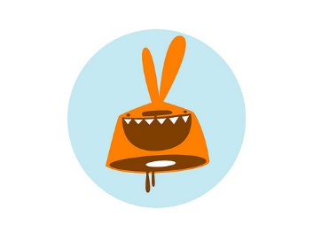**PRONUNCIATION**

**psychic** /ˈsaɪkɪk/; **insecure** /ˌɪnsɪˈkjʊə/; **abdomen** /ˈæbdəmən/; **common** /ˈkɒmən/; **boast** /bəʊst/; **unconscious** /ʌnˈkɒnʃəs/; **ridiculous** /rɪˈdɪkjələs/; **evolve** /iˈvɒlv/; **initiative** /ɪˈnɪʃətɪv/; **legible** /ˈledʒəbl/; **descend** /dɪˈsend/; **separate** /ˈseprət/; **indecisive** /ˌɪndɪˈsaɪsɪv/; **ambitious** /æmˈbɪʃəs/; **self-esteem** /ɪˈstiːm/; **secretive** /ˈsiːkrətɪv/; **disheartened** /dɪsˈhɑːtnd/; **etiquette** /ˈetɪkət/; **attire** /əˈtaɪə/

|  |  |
| --- | --- |
| **VERBS**  can express either | |
| **Action** | **State** |
| something happens (действие).  # decide, go, jump, listen, run, speak, work. | something remains the same (состояние).  # like, believe, understand, see, hear, taste* |
| **\* Note**: With verbs of perception (с глаголами восприятия) (feel, hear, see, smell, taste) you often use **can/could**:  *# I could hear the waves on the beach. Can you smell burning?* | |
| You use action verbs in the **simple** **or continuous** **form**, depending on the situation:  *# I often go to the cinema. # Where are you going?*  *# Stan read fifteen books last month.*  *# Yesterday I was reading a book.* | You use the **simple** **form** (not the continuous) with most state verbs**:  *# This medication contains caffeine.*  *NOT This medication is containing caffeine;*  *# Do you need anything? NOT Are you needing anything?* |
| **\*\*Note:** It's possible that you'll hear native speakers using other state verbs in the continuous form. However, if you want to be sure you don't make mistakes, it's probably best to follow these rules. | |
| **NB1:** You can use the **simple or continuous** **form** with some state verbs when there is no difference in meaning. These verbs are ***feel***, ***ache*** and ***hurt***.  *# I'm feeling a bit depressed. OR I feel a bit depressed. # My head's aching. OR My head aches.*  *# My tummy's hurting. OR My tummy hurts.* | |
| **NB2:** Some verbs can have both a state and an action meaning. You use the **simple** **form** (not the continuous) when they have stative meaning:  *# I think (= believe) Martin is a handsome guy. I am thinking about Martin.* (см. таблицу “Action and State Verbs”) | |

|  |  |
| --- | --- |
| State | Action |
| I have (= own) a small house. **(иметь, владеть)** | I'm having lunch/a bath/a great time. **(часть устойчивого выражения)** |
| I think (= believe) you're right. **(иметь мнение)** | What are you thinking about now? **(размышлять)** |
| I feel (= have an opinion) it's the right thing to do. **(иметь мнение)** | I'm feeling a bit depressed. **(чувствовать себя)** |
| He looks (= seems) happy. **(выглядеть)** | What's the cat looking at? **(смотреть на что-то)** |
| He appears (= seems) to be happy. **(кажется)** | He's appearing on several chat shows today. **(выступать)** |
| http://www.brainpickings.org/wp-content/uploads/2010/11/halsman_jump1.jpgI see (= understand) the problem. **(понимать)** | Are you seeing the doctor this morning? **(встречаться)** |
| I weigh about 52 kilos. **(весить)** | I'm just weighing the ingredients. **(взвешивать что-то)** |
| The room measures 10 metres by 5 metres.  **(иметь размер)** | Pete's measuring himself. He's growing fast. **(измерять)** |
| This meat smells bad. **(пахнуть, иметь запах)** | I'm smelling the milk to see if it's gone off. **(нюхать)** |
| It tastes like water but it's lemonade. **(иметь вкус)** | She's tasting the soup in case it needs more salt. **(пробовать)** |
| I don't care what you say **(не волнует)** | She's caring for the sick in Calcutta at the moment. **(заботиться о ком-то)** |

**COMMONLY CONFUSED IRREGULAR VERBS**

|  |  |  |  |  |
| --- | --- | --- | --- | --- |
| **Infinitive** | **V2** | | **V3** | **Translation** |
| bite | bit | | bitten | кусать |
| beat | beat | | beaten | бить |
|  | | | | |
| fall | fell | | fallen | падать |
| feel | felt | | felt | чувствовать |
| fill | filled | | filled | наполнять |
|  | | | | |
| flow | flowed | | flowed | течь, литься |
| fly | flew | | flown | летать |
|  | | | | |
| lay | laid | | laid | класть, положить |
| lie | lay | | lain | лежать, ложиться |
| lie | lied | | lied | лгать |
|  | | | | |
| raise | raised | | raised | поднимать |
| rise | rose | risen | | подниматься |
|  | | | | |
| bet | bet/betted | | bet/betted | спорить, делать ставку |
| burn | burnt/burned | | burnt/burned | жечь, гореть |
| fit | fit/fitted | | fit/fitted | быть впору, подходить |
| learn | learnt/learned | | learnt/learned | учить |
| quit | quit/quitted | | quit/quitted | оставлять/ увольняться |
| shine | shone/shined | | shone/shined | светить, сиять |
| speed | sped/speeded | | sped/speeded | спешить, ускорять(ся) |
| wet | wet/wetted | | wet/wetted | мочить |

**TAG QUESTIONS**

We use tag questions to check smth you already think is true.

|  |  |  |  |  |  |
| --- | --- | --- | --- | --- | --- |
| |  |  | | --- | --- | | **Positive statement**  **+**  Snow is white, | **Negative Tag**  -  isn’t it? | | |  |  | | --- | --- | | **Negative statement**  **-**  You don’t smoke, | **Positive Tag**  **+**  do you? | |

**TAG TRAINER**

|  |  |
| --- | --- |
| 1. Ты еще не посплетничала с ней, да? | You haven’t gossiped with her yet, have you? |
| 2. У твоего брата тяжелый характер, верно? | Your brother has a bad temper, doesn’t he? |
| 3. Джон обычно не берет инициативу на себя, не так ли? | John doesn’t usually take the initiative, does he? |
| 4. Уже слишком поздно откладывать это на потом, правда? | It's too late to put it off now, isn’t it? |
| 5. Здесь присутствуют крупные ученые, не правда ли? | There are prominent scientists here, aren't there? |
| 6. Он произвел на тебя неизгладимое впечатление, да? | He made a lasting impression on you, didn’t he? |
| 7. Ты же не был закомплексованным? | You weren’t insecure, were you? |
| 8. Дети еще не вернулись из школы когда я звонил, да? | The kids hadn’t returned from school when I called, had they? |
| 9. Мне следует говорить погромче, правда? | I should speak up, shouldn’t I? |
| 10. Дети должны иметь чистый и аккуратный внешний вид, не так ли? | The children must have a neat and tidy appearance, mustn't they? |
| 11. Он никогда не делает тебе комплименты, да? | He never gives you compliments, does he? |
| 12. Я напористый человек, правда? | I am an assertive person, aren't I? |
| http://vector-magz.com/wp-content/uploads/2013/07/baseball-bat-clipart1.png13. Я же не высокомерный, правда? | I am not arrogant, am I? |
| 14. Давай убедим его пойти в кино, а? | Let's convince him to go to the cinema, shall we? |
| 15. Давай не будем хвастать, ладно? | Let's not boast, shall we? |
| 16. Все ценят его, правда? | Everybody appreciates him, don't they? |
| 17. Никого нет здесь, да? | Nobody is here, are they? |
| 18. Все ведь прекрасно, да? | Everything is great, isn’t it? |
| 19. Попробуй сделать это, а? | Give it a shot, will you? |
| 20. Да не думай ты так много, ладно? | http://4vector.com/i/free-vector-football-ball-clip-art_111438_Football_Ball_clip_art_hight.pngDon't think so hard, will you? |
| 21. Мы мало что можем сделать, да? | There's little we can do, is there? |

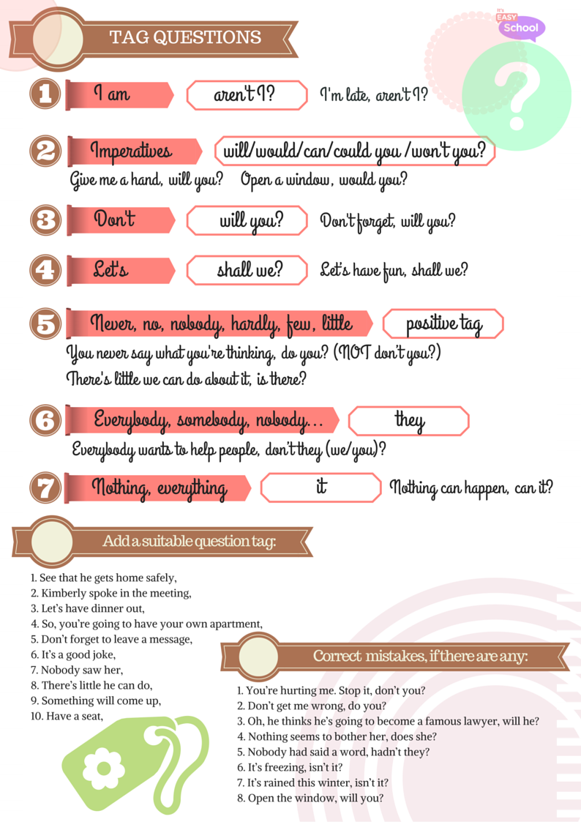

**ADJECTIVES AND ADVERBS: COMPARATIVE AND SUPERLATIVE DEGREES**

|  |  |
| --- | --- |
| **-er , the -est** | **more …, the most …** |
| **1 syllable**  *# short – short****er*** *– the short****est***  **NB:** If the adjective ends in **consonant-vowel-consonant**, we double the last consonant:  *# sad – sad****d****er –* ***the*** *sad****d****est; # big – big****g****er –* ***the*** *big****g****est* | **2 syllables or more**  # interesting – more interesting – the most interesting  **adverbs**  *# quickly –* ***more*** *quickly –* ***the most*** *quickly*  *# happily –* ***more*** *happily –* ***the most*** *happily* |
| **with 2-syllable adjectives ending in:**  **- le** (simple) **- ow** (narrow) **- er** (clever) **- y** (heavy)  **you can use –er or more** # *This road is* ***narrower/more narrow****.*  **1 syllable / 2 syllables + y: “y” changes into “i”**  *#**happy – happ****i****er – the happ****i****est* | **NB:**  **The following adverbs are used with -er, the -est!**  **early, fast, near, soon,** **hard, late**  http://www.clker.com/cliparts/5/4/a/9/k/I/owl-hi.png  *# early – earli****er*** *–* ***the*** *earli****est***  *# fast – fast****er*** *–* ***the*** *fast****est***  *# late – lat****er*** *–* ***the*** *lat****est*** |

**COMPARATIVE AND SUPERLATIVE DEGREES: EXCEPTIONS SIMILES**

**as + … + as**

*# She is* ***as*** *energetic* ***as*** *her mother*

*# He runs* ***as*** *fast* ***as*** *his friend*

|  |
| --- |
| **Good** – better – the best **Bad** – worse – the worst  **Many/much** – more – the most **Little** – less – the least  **Far**1 – further/farther – the furthest/the farthest  **Old**2 (*when we talk about relatives*) – elder – the eldest  **Old**3 *(when we talk about the age)* - older – the oldest |

****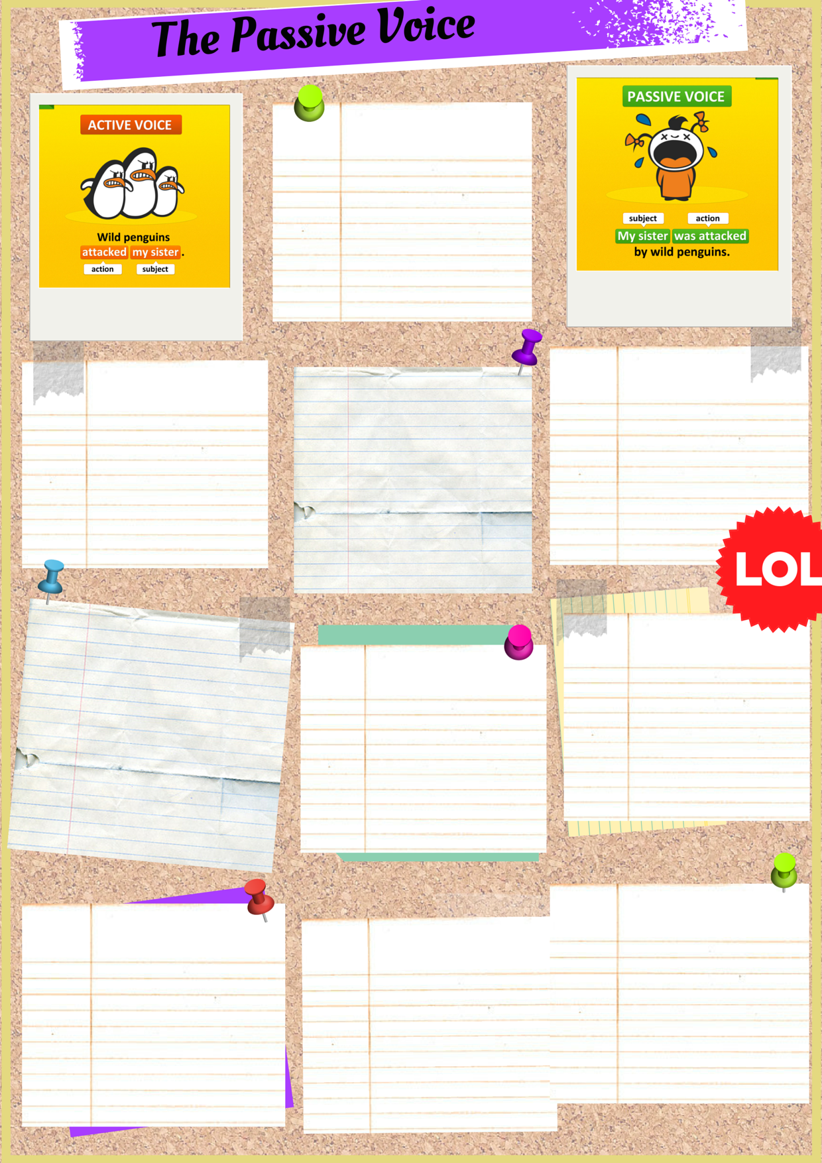

**USED TO**

**used to be + V3**

You used to be asked all the time.

**GOING TO**

**am / is / are + going to be + V3**

You’re going to be asked soon.

**FUTURE PERFECT**

**will + have been + V3**

You will have been asked by tomorrow.

**PAST PERFECT**

**had + been + V3**

I knew you had been asked.

**PRESENT PERFECT**

**have / has + been + V3**

You have just been asked.

**PAST CONTINUOUS**

**was / were + being + V3**

You were being asked from 5 to 6.

**PRESENT CONTINUOUS**

**am/is/are + be + V3**

You are being asked now.

**FUTURE SIMPLE**

**will + be + V3**

You will be asked tomorrow.

**PAST SIMPLE**

**was / were + V3**

You were asked yesterday.

**PRESENT SIMPLE**

**am / is / are + V3**

You are asked every day.