**SUMMARY LEVEL 7**

|  |  |  |  |  |  |  |  |  |  |  |  |  |  |  |  |  |  |  |  |  |  |  |  |  |  |  |  |  |  |  |  |  |  |  |  |  |  |  |  |  |  |  |  |  |  |  |  |  |  |  |  |  |  |  |  |  |  |  |  |  |  |  |  |  |  |  |  |  |  |  |  |  |  |  |  |  |  |  |  |  |  |  |  |  |  |  |  |  |  |  |  |  |  |  |  |  |  |  |  |  |  |  |  |  |  |  |  |  |  |  |  |  |  |  |  |  |  |  |  |  |  |  |  |  |  |  |  |  |  |  |  |  |  |  |  |  |  |  |  |  |  |  |  |  |  |  |  |  |  |  |  |  |  |  |  |  |  |  |  |  |  |  |  |  |  |  |  |  |  |  |  |  |  |  |  |  |  |  |  |  |  |  |  |  |  |  |  |  |  |  |  |  |  |  |  |
| --- | --- | --- | --- | --- | --- | --- | --- | --- | --- | --- | --- | --- | --- | --- | --- | --- | --- | --- | --- | --- | --- | --- | --- | --- | --- | --- | --- | --- | --- | --- | --- | --- | --- | --- | --- | --- | --- | --- | --- | --- | --- | --- | --- | --- | --- | --- | --- | --- | --- | --- | --- | --- | --- | --- | --- | --- | --- | --- | --- | --- | --- | --- | --- | --- | --- | --- | --- | --- | --- | --- | --- | --- | --- | --- | --- | --- | --- | --- | --- | --- | --- | --- | --- | --- | --- | --- | --- | --- | --- | --- | --- | --- | --- | --- | --- | --- | --- | --- | --- | --- | --- | --- | --- | --- | --- | --- | --- | --- | --- | --- | --- | --- | --- | --- | --- | --- | --- | --- | --- | --- | --- | --- | --- | --- | --- | --- | --- | --- | --- | --- | --- | --- | --- | --- | --- | --- | --- | --- | --- | --- | --- | --- | --- | --- | --- | --- | --- | --- | --- | --- | --- | --- | --- | --- | --- | --- | --- | --- | --- | --- | --- | --- | --- | --- | --- | --- | --- | --- | --- | --- | --- | --- | --- | --- | --- | --- | --- | --- | --- | --- | --- | --- | --- | --- | --- | --- | --- | --- | --- | --- | --- | --- | --- | --- | --- |
| |  |  | | --- | --- | | **nagging works** | нытье работает | | **maid** | служанка, горничная | | **to be anxious** /'æŋkʃəs/ **(about smth)** | озабоченный, беспокоящийся | | **annoying** /ə'nɔɪŋ/ | раздражающий; надоедливый | | **annoy** | раздражать, надоедать | | **fiancé** /fiˈɒnseɪ/ | жених | | **fiancée** /fiˈɒnseɪ/ | невеста | | **ask smb out** | приглашать к-то на свидание | | **available** /əˈveɪləbl/ | доступный; имеющийся в распоряжении | | **view** /vju:/ | вид; пейзаж | | **permission** /pəˈmɪʃn/ | позволение, разрешение | | **http://ec.l.thumbs.canstockphoto.com/canstock12546601.jpgpass away** | = die | | **ink stain** | пятно от чернил | | **tear out** /tɛə/ | вырывать что-либо (страницу) | | **blurry** /'blɜːri/ | неясный, туманный; расплывчатый | | **fair** | справедливый | | **blame smb for smth** | обвинять кого-то в чем-то | | **miss smb** | скучать по к-либо | | **bra** | бюстгальтер | | **rip** | разрез, разрыв, рвать(ся) | | **quit (a job)** /kwit/ | оставлять, уходить, прекращать | | **loud** /laud/ | громкий | | **seriously wounded** /ˈwuːndɪd/ | серьезно ранен | | **pay a visit** | навестить | | **Little Red Riding Hood** | Красная Шапочка | | **murder** | http://hlape.net/wp-content/uploads/2014/04/palechka.pngубивать, убийство | | **recall** /rɪˈkɔːl/ | вспоминать | | **fur** | мех, меховой | | **elderly** | пожилой | | **under suspicion** /səˈspɪʃn/ | под подозрением | | **cruel crime** | жестокое преступление | | **guilty** /'gɪlti/ | виновный | | **innocent** /'ɪnəsənt/ | невиновный | | **vacant room** /ˈveɪkənt/ | свободная комната | | **less** | менее | | **hard** | сильно | | **change (my, his) mind** | передумать | | **peacefully** | спокойно, мирно | | **suddenly** | внезапно, вдруг | | **loud noise** | громкий звук (шум) | | **What’s the matter?** | В чем дело? | | **in addition** | к тому же | | **look for** | искать | | **moan** /məʊn/ | стонать | | **at last** | наконец | | **weaker and weaker** | слабее и слабее | | **in horror** | в ужасе | | **immediately** /ɪˈmiːdiətli/ | сразу же, тотчас же | | |  |  | | --- | --- | | **grateful** | благодарный | | **broken to pieces** | разбитый на кусочки | | **drawer** /drɔ:/ | выдвижная полка, ящик в шкафу | | **internationally famous** | всемирно известный | | **be close to someone** | быть близким с кем-то | | **be good at languages** | хорошо знать языки | | **join smb/smth** | присоединиться к к-то/ч-то | | **have a bad heart** | иметь проблемы с сердцем | | **at least he knew** | по крайней мере он знал | | **create** | создавать | | **advertisement, ad** | /əd'vɜːtɪsmənt/ реклама | | **advertise** /'ædvətaɪz/ | рекламировать | | **commercial** /kə'mɜːʃəl/ | рекламный видео-ролик | | **in ten years** | через 10 лет | | **pay bills** | оплачивать счета | | **well-paid job** | хорошо оплачиваемая работа | | **accountant** | бухгалтер | | **improve** | улучшать | | **standard of living** | уровень жизни | | **white lie** | невинная ложь | | **every man for himself** | каждый сам за себя | | **wealth** /welθ/ | богатство | | **hand luggage** /ˈlʌɡɪdʒ/ | ручная кладь | | **it's over there** | это (находится) вон там | | **label** | бирка | | **Here you are!** | Вот! Держите! | | **carry** | нести | | **charge** | взимать плату | | **sliced loaf** /ləʊf/ | нарезанная буханка хлеба | | **we only have … left** | у нас остался только … | | **greasy** | жирный | | **letters of the alphabet** | буквы алфавита /ˈælfəbet/ | | **write in** | вписывать | | **fill** | заполнять | | **stick** | http://www.illustrationsof.com/royalty-free-letter-a-clipart-illustration-1167656tn.jpgприклеивать; наклеивать | | **bits of paper** | кусочки бумаги | | **all over my house** | по всему дому | | **door handle** | дверная ручка | | **What’s the matter with her?** | Что с ней случилось? | | **take out** | вытаскивать | | **record** /ri'kɔːd/ | записывать | | **look up** | смотреть в словаре | | **desperate** /ˈdespərət/ | отчаянно желающий ч-л | | **seek** | искать | | **high-flier** | «птица высокого полета» | | **high-powered (job)** | высокооплачиваемая, влиятельная (работа) | | **documentary** | документальный фильм | | **get on well with smb** | ладить с кем-либо | | **degree** | степень (научная и т.д.) | |

|  |  |  |  |  |  |  |  |  |  |  |  |  |  |  |  |  |  |  |  |  |  |  |  |  |  |  |  |  |  |  |  |  |  |  |  |  |  |  |  |  |  |  |  |  |  |  |  |  |  |  |  |  |  |  |  |  |  |  |  |  |  |  |  |  |  |  |  |  |  |  |  |  |  |  |  |  |  |  |  |  |  |  |  |
| --- | --- | --- | --- | --- | --- | --- | --- | --- | --- | --- | --- | --- | --- | --- | --- | --- | --- | --- | --- | --- | --- | --- | --- | --- | --- | --- | --- | --- | --- | --- | --- | --- | --- | --- | --- | --- | --- | --- | --- | --- | --- | --- | --- | --- | --- | --- | --- | --- | --- | --- | --- | --- | --- | --- | --- | --- | --- | --- | --- | --- | --- | --- | --- | --- | --- | --- | --- | --- | --- | --- | --- | --- | --- | --- | --- | --- | --- | --- | --- | --- | --- | --- | --- |
| |  |  | | --- | --- | | **be fed up with smth** | быть сытым по горло ч-то | | **considerate** /kənˈsɪdərət/ | внимательный к чувствам других людей | | **of average build** /ˈævərɪdʒ/ | среднего телосложения | | **once in a while** | иногда, время от времени | | **see-how-it-goes relationship** | отношения «посмотрим, что получится» | | **similar qualities** /ˈkwɒlətiz/ | похожие качества | | **be stuck doing the same thing** | застрять, делая одно и то же | | **6 days out of 7** | шесть дней из семи | | **kinda = kind of** | что-то типа | | **grouchy** /ˈɡraʊtʃi/ | ворчливый | | **moody** | угрюмый, c переменчивым настроением | | **LOL (Laughing Out Loud)** | я умираю от смеха | | **of athletic build** | атлетического телосложения | | **explore** /ɪk'splɔː/ | изучать, исследовать | | **sense of humor** /'hjuːmə/ | чувство юмора | | **might lead to romance** | может привести к романтическим отношениям | | **outgoing** | коммуникабельный, общительный | | **the rest is up to you** | остальное - ваше дело | | |  |  | | --- | --- | | **cute** | хорошенький, милый | | **creative** /krɪ'eɪtɪv/ | креативный | | **appreciate** /ə'priːʃɪeɪt/ | ценить | | **sensual** /ˈsenʃuəl/ | чувственный | | **to be in a good mood** | быть в хорошем настроении | | **get in touch with me** | связаться со мной | | **look 4ward 2 hearing = look forward to Ving** | ждать чего-то с нетерпением | | **award** /ə'wɔːd/ | награда | | **adventurous** /əd'venʧərəs/ | любящий приключения | | **snoopy** | чрезмерно любопытный | | **http://4.bp.blogspot.com/_-jcyNS-nKyE/S6rTGyp4N8I/AAAAAAAAACM/Z8ynrzduamQ/S226/snoopy6.pngpull** | тянуть | | **cope with** | совладать, справляться с | | **admit** | признавать | | **look back** | оглядываться | | **fair** /fɛə/ | 1) светлый 2) справедливый | | **caring** | внимательный, заботливый | | **sincere** /sɪnˈsɪə/ | искренний | | **supportive** | поддерживающий | | **honesty** | честность | | **although** /ɔːlˈðəʊ/ | хотя | | **hang out** | зависать, проводить время | | **desires** | желания | | **blond** | блондин | |

**PRONUNCIATION**

**anxious /**'æŋkʃəs**/, annoying /**ə'nɔɪŋ**/**, **fiancé /**fiˈɒnseɪ**/, available /**əˈveɪləbl**/, view /**vju:**/, permission /**pəˈmɪʃn**/, tear out /**tɛə**/, blurry /**'blɜːri**/, quit /**kwit**/, loud /**laʊd**/, wounded /**ˈwuːndɪd**/, recall /**rɪˈkɔːl**/, suspicion /**səˈspɪʃn**/, guilty /**'gɪlti**/, innocent /**'ɪnəsənt**/, vacant /**ˈveɪkənt**/, moan /**məʊn**/, immediately /**ɪˈmiːdiətli**/, drawer /**drɔ:**/, advertisement /**əd'vɜːtɪsmənt**/, advertise /**'ædvətaɪz**/, commercial /**kə'mɜːʃəl**/, wealth /**welθ**/, luggage /**ˈlʌɡɪdʒ**/, sliced loaf /**ləʊf**/, alphabet /**ˈælfəbet**/, record /**ri'kɔːd**/, desperate /**ˈdespərət**/, considerate /**kənˈsɪdərət**/, average /**ˈævərɪdʒ**/, qualities /**ˈkwɒlətiz**/, grouchy /**ˈɡraʊtʃi**/, explore /**ɪk'splɔː**/, creative /**krɪ'eɪtɪv**/, appreciate /**ə'priːʃɪeɪt**/, sensual /**ˈsenʃuəl**/, award /**ə'wɔːd**/, adventurous /**əd'venʧərəs**/, fair /**fɛə**/, sincere /**sɪnˈsɪə**/, although /**ɔːlˈðəʊ**/**

**PN: POLITE OFFERS AND REQUESTS**

**In a fast food restaurant:** We'd like two cheeseburgers and one Big Mac with fries, please. – *Would you like anything to drink with that?*

**At the bakery:** I'd like a large brown sliced loaf, please. – *I’m afraid we only have white left.*

**At the airport:** Can I take this bag as hand luggage? – *Yes, that's fine. I'll give you a label for it.*

**At the railway station:** Excuse me. Can you tell me where platform six is? – *It's over there. Come with me. I'll show you.*

**In a department store:** Have you got any shampoo for greasy hair? – *I'll check, but I think we only have it for dry.*

**At the supermarket:** Could I have another plastic bag? I've got so much to carry – *Here you are. We don't charge for them.*

**I'VE BEEN WAITING FOR AN HOUR**

|  |  |
| --- | --- |
| I've been waiting for an hour  And she's not here yet  Maybe she's stood me up  It's been raining all the time  and my hair is wet  Now I feel fed up  I've been seeing her for over two weeks now  I thought she was mine, all mine  We've been going out dancing almost every night | I thought everything was fine  I've been waiting for two hours  Standing here alone  http://www.legrandblogdelavente.com/files/2010/10/le-plan-daction-commercial-Analyser-la-situation-.jpgI've been trying to call her on the phone  I've been cursing, I've been screaming  Cause for two weeks I've been dreaming  Now the only thing to do is go back home  I've been seeing her... |

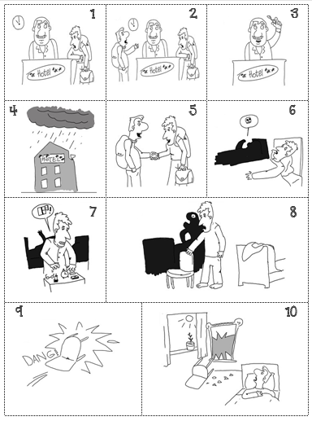**POWER OF IMAGINATION: RETELLING**

Mr. Brown got to a hotel late in the evening after a long journey. He asked the receptionist if there were any vacant rooms in the hotel. At that moment another traveller came to the hotel and asked the receptionist for a room, too. The only vacant room was a double room. At first the travellers didn’t want to spend the night in that room together but then it began to rain hard and they changed their minds. Mr. Brown was sleeping peacefully when he suddenly heard a loud noise. He asked another traveller what the matter was. In a weak voice the second traveller said that he had asthma and felt very bad. He asked Mr. Brown to open the window as soon as possible. Mr. Brown jumped out of bed and began looking for his matches, but he couldn't find them in the dark, and the sick man went on moaning. Mr. Brown didn’t find the matches, so he tried to find the window. It took him some time, and at last he found it! But he couldn’t open it. The voice of the traveller became weaker and weaker, Mr. Brown in horror took a chair and broke the window with it. The sick man immediately stopped moaning and said that he was very grateful and that he felt better. Then the two of them slept peacefully until morning. When they woke up next morning, they saw that the only window in the room was still closed, but the large mirror was broken to pieces.

**MY PROFILE**

|  |  |
| --- | --- |
|  | General information: |
| *He/she describes himself/herself like this:* |
| *He/she says of his ideal woman/man:* |

**QUESTIONS:**

1) Date and place of your birth, some family background (parents, family), education, some important events in your life, important people in your life, your achievements and failures, your present life

2) Your present life: What do you like about your life today most of all? What do you dislike about your life today? What are some of your favorite things to do now? Who or what is your favorite entertainer now? What takes most of your time now? What did you use to like when you were a child?

3) Are you an ambitious person? Why? Is money very important to you? What is important to you?

**HOW YOU CAN IMPROVE YOUR ENGLISH**

|  |  |
| --- | --- |
| **w y a i t world** | **Wherever you are in the world** you can always **get access** /'ækses/ **to the Internet** or find **a text that you are interested in** not only because **it will provide you with** words and structures **you are likely to need** but also with **motivation to study actively**. When you read a text, **you should look out for words and phrases** that you can use in **your own English** later. It’s a good idea **to carry a small** notebook so that you can write down any **examples that might be useful**. The first time you read a text it's usually **best not to stop** when you see some unknown word. You have to understand the general meaning of the text. When you **have finished** reading, you should **go over the bits you are not sure about**. If the problem is an unknown word, **look it up** in a dictionary. However, you must promise yourself that you will open and use this notebook at least once a week because **the real key to learning English is to practise, practise, practise!** |
| **get a t t I** |
| **a text t y a i i** |
| **not only because it w p y with** |
| **you a l to need, but also** |
| **m to a study** |
| **When you read a text, you s l o for w and p that you can use in y o E later** |
| **It’s a good idea to с a s notebook so that …** |
| **you can write down any e that m b u** |
| **The first time you read a text it’s usually b n t s** |
| **When you h f, you should go o t b you are not s a** |
| **If the problem is an u w, l it u in a dictionary** |
| **the r k to l E is to p,p,p!** |

**DEFINITIONS**

|  |  |
| --- | --- |
| 1) If you are **desperate** for smth | you want it very, very much, and will do anything to get it |
| 2) If you are **seeking** something | you are looking for it |
| 3) A **high-flier** is | someone who is ambitious |
| 4) A **high-powered** job is | one that is important and well paid |
| 5) A **documentary** is | a TV programme that gives factual information about smth |
| 6) If you **get on well with** someone | you have a good relationship |
| 7) A **degree** is | the qualification you get from university |
| 8) If you are **fed up** with something | you are unhappy or bored with it |
| 9) A **considerate** person is | someone who is kind, and pays attention to other people's feelings |

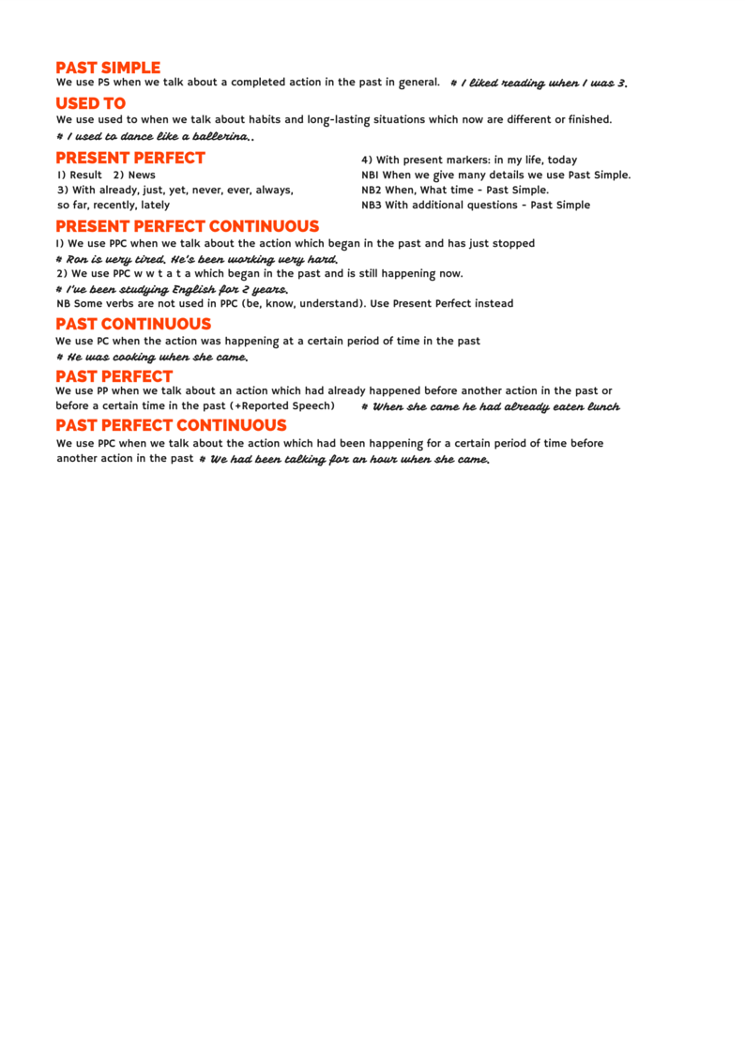**VERY STUPID STORY**

|  |  |
| --- | --- |
| http://content.mycutegraphics.com/graphics/clothing/green-sock.pngВы слышали новость? Я купил новые розовые носки! Я всегда имел дело только с хорошими носками. Эти розовые носки подошли мне очень хорошо, несмотря на то, что (despite the fact that) мой босс запретил мне носить их на работе. Но они стоили целое состояние! А вчера я потерял их! Я чувствовал себя таким усталым! Кто спрятал мои носки? Когда-то они были моими любимыми носками. Я знал, что это вы! Я оставил их на столе специально. Я переплатил 5 долларов за свои розовые носки, хотя они стоили 4 доллара, и я их еще не перепродал. Я никогда никому их не одалживал. Я поклялся носить их каждый день. Я думаю, вы просто неправильно услышали меня, когда кинули в меня ананасом. Я предвидел это! Итак, вы украли мои носки! Вы просто взяли их из моих рук, после того, как проползли под столом. Я вас еще не простил! Я даже не побил вас, хотя вы укусили меня два раза и ударились головой. Кто позволил вам поступать так? Я выбрал эти носки, и они принадлежат мне! | http://content.mycutegraphics.com/graphics/clothing/sock-yellow.pngHave you heard the news? I’ve bought new pink socks! I have always dealt only with good socks. These pink socks fit me very well, despite the fact that my boss forbade me to wear them at work. But they cost me a fortune! And I lost them yesterday! I felt so tired! Who hid my socks? They used to be my favorite socks. I knew it was you! I left them on the table on purpose. I overpaid 5 dollars for my pink socks though they cost 4 dollars and I haven’t resold them yet. I’ve never lent them to anyone. I swore to wear them every day. I think you just misheard me when you threw a pineapple at me. I foresaw it! So, you’ve stolen my socks! You just took them out of my hands after you crept under the table. I haven’t forgiven you yet! I didn’t even beat you although you bit me twice and hit your head. Who let you act that way? I chose these socks and they belong to me! |

