컴퓨터구조 과제 / 20175105_곽영주

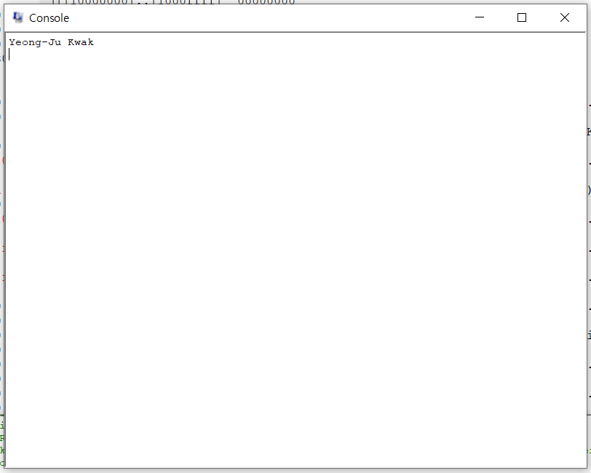

.text

.globl main

main:

la $a0, myStr

li $v0, 4

syscall

li $v0, 10

syscall

.data

myStr: .asciiz "Yeong-Ju Kwak\n"