|  |  |  |  |  |
| --- | --- | --- | --- | --- |
| 2021_1_WEB_14_과제 | 학번 : | 20175105 | 이름 : | 곽영주 |

* 개념 활용

1. jQuery 속성 추가를 사용하여 이미지너비를 증가시켜 웹 브라우저로 출력하는 스크립트를 작성하시오.

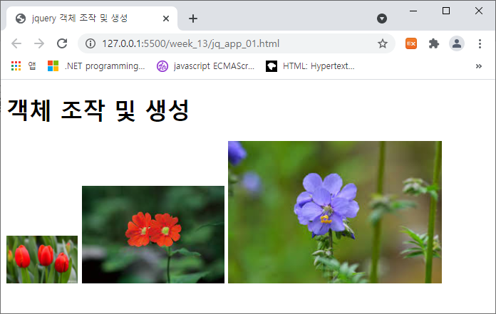

<body>

  <h1>객체 조작 및 생성</h1>

 <img src="flow4.jpg" alt="">

 <img src="flow6.jpg" alt="">

 <img src="flow7.jpg" alt="">

</body>

|  |
| --- |
| [소스]   <!DOCTYPE html>  <html lang="en">  <head>      <meta charset="UTF-8">      <meta http-equiv="X-UA-Compatible" content="IE=edge">      <meta name="viewport" content="width=device-width, initial-scale=1.0">      <title>Document</title>      <script src="https://code.jquery.com/jquery-3.6.0.js"></script>      <script>          $(document).ready(function(){              $("body img:nth-child(2)").attr("width", "50");              $("body img:nth-child(3)").attr("width", "100");              $("body img:nth-child(4)").attr("width", "150");          });      </script>  </head>  <body>      <h1>객체 조작 및 생성</h1>      <img src="image/flow4.jpg" alt="">      <img src="image/flow6.jpg" alt="">      <img src="image/flow7.jpg" alt="">  </body>  </html> |
| [실행결과] |

1. jQuery를 사용하여 1초 간격으로 랜덤한 크기의 글자를 제시된 결과처럼 출력하는 스크립트를 작성하시오. 단, 글자크기는 10px~40px

   <body>

   <div id="panel">난수로 생성된 숫자 추가</div>

</body>

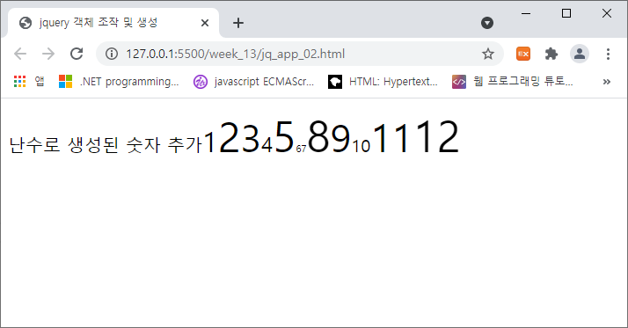

|  |
| --- |
| [소스]  <!DOCTYPE html>  <html lang="en">  <head>      <meta charset="UTF-8">      <meta http-equiv="X-UA-Compatible" content="IE=edge">      <meta name="viewport" content="width=device-width, initial-scale=1.0">      <title>Document</title>      <script src="https://code.jquery.com/jquery-3.6.0.js"></script>      <script>          let count = 1;          let size;          $(document).ready(function(){              setInterval(function() {                  size = Math.floor(Math.random() * 31) + 10;                  $("#panel").append(`<span id='${count}'>${count}</span>`);                  $(`#${count}`).css('font-size', `${size}px`);                    count++;              }, 1000);          });      </script>  </head>  <body>      <div id="panel">난수로 생성된 숫자 추가</div>  </body>  </html> |
| [실행결과] |

1. jQuery 이벤트를 사용하여 제시된 결과처럼 실행되는 펼침 메뉴를 구현하시오. 단, 메인메뉴는 3가지이고 서브메뉴의 개수와 내용은 본인이 임의로 결정할것.

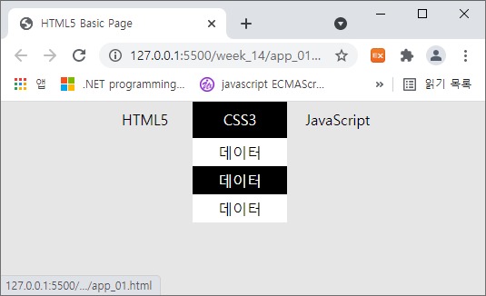

|  |
| --- |
| [소스]  <!DOCTYPE html>  <html lang="en">  <head>      <meta charset="UTF-8">      <meta http-equiv="X-UA-Compatible" content="IE=edge">      <meta name="viewport" content="width=device-width, initial-scale=1.0">      <title>Document</title>      <style>          *{ margin: 0; padding: 0; }          li{ list-style-type: none; }          .menubar{              width: 300px;              height: 30px;              margin: 0 auto;          }          .menu{              float: left;              width: 100px;              height: 30px;              text-align: center;              line-height: 30px;          }          .menu ul{              background-color: lightblue;          }          .menu ul li:hover{              background-color: lightgray;          }      </style>      <script src="https://code.jquery.com/jquery-3.6.0.js"></script>      <script>          $(document).ready(function(){              $(".menu ul").slideUp(0);              $(document).on("click", ".menu", function(){                  let id = $(this).attr("id");                  $(".menu").css("background-color", "#fff");                  $(this).css("background-color", "lightgray");                  $(".menu").children("ul").slideUp(1000);                  $(this).children("ul").slideDown("slow");              });          });      </script>  </head>  <body>      <ul class="menubar">          <li class="menu" id="m0">              HTML5              <ul>                  <li>tag</li>                  <li>attr</li>              </ul>          </li>          <li class="menu" id="m1">              CSS3              <ul>                  <li>color</li>                  <li>style</li>              </ul>          </li>          <li class="menu" id="m2">              JavaScript              <ul>                  <li>jquery</li>                  <li>script</li>              </ul>          </li>      </ul>  </body>  </html> |
| [실행결과] |

1. ‘14주 수업자료’ 슬라이드 번호 3번

|  |
| --- |
| [소스]  <!DOCTYPE html>  <html lang="en">  <head>      <title>jquery 이벤트 - 이벤트 연결 메소드</title>      <script src="https://code.jquery.com/jquery-3.6.0.js"></script>      <script>          $(document).ready(function () {              $('h1').hover(function () {                  $(this).css({                      background: 'red',                      color: 'white'                  });                  }, function () {                      $(this).css({                          background: '',                          color: ''                      });              });          });      </script>  </head>  <body>      <h1>Header-0</h1>      <h1>Header-1</h1>      <h1>Header-2</h1>  </body>  </html> |
| [실행결과] |

1. ‘14주 수업자료’ 슬라이드 번호 23번

|  |
| --- |
| [소스]  <!DOCTYPE html>  <html lang="en">  <head>      <title>시각 효과</title>      <script src="https://code.jquery.com/jquery-3.6.0.js"></script>      <script>          $(document).ready(function () {              $("#btn1").on("click", function () {                  $("h1").slideUp(1000);              });              $("#btn2").on("click", function () {                  $("h1").slideDown("slow");              });              $("#btn3").on("click", function () {                  $("h1").slideToggle("fast");              });          });      </script>      <style type="text/css">          h1 {              width: 200px; height: 200px; background-color: #FF0;          }      </style>  </head>  <body>      <button id="btn1">slideUp</button>      <button id="btn2">slideDown</button>      <button id="btn3">slideToggle</button>      <h1>내용</h1>  </body>  </html> |
| [실행결과] |