Social Network Recommendation Based-on User Context

# Abstract

# Introduction

With the development of social networks, the extreme explosion of information makes it increasingly difficult for users to obtain what they want. Therefore, social networks recommendation system becomes an important mechanism for active service. To meet users’ individual requirements, the system should extract content from a lot of information in line with user needs and interests.

Traditional recommendation technologies [1] mainly contain content-based and collaborative filtering recommendation and the hybrid recommendation technology. In social networks, collaborative filtering methods are unable to fully characterize the complex relationship in social networks. For social networks recommendation, the researchers introduced trust-base and influence-base methods to leverage social networks the relationship between users, so that the social networks recommended more precise.

Both the traditional and the existing social networks recommendation methods recommend with two-dimensional matrix such as the observed user ratings matrix, the user feature matrix, the item features matrix to predict the user ratings matrix describing the users’ preference for items. These 2-dimensional recommendation mechanisms ignore the influence of user context on user behavior. Only user and project dimensions are considered but the context dimension.

In our real life, people communicate with who they like and talk about what they are interested in according to the prevailing situation. That is, in a dynamic environment, user-user influence and user preference of topic will change with the social situation. For example, when a person has trouble, he would choose older experienced people exchanges, and the topic may change from his usual favorite sports to a life philosophy class. And when he is working, he will turn to his work colleagues, sharing the contents of work-related. However, same in work time, if it is Friday, the day before the weekend, he and his colleagues’ talking content may be more to do with the weekend activities.

In the social networks similar with real life, the main factors affecting user behavior have three aspects as shown in Figure 1. Figure 1 shows entire social network information when user surfing on the social networks. According to the social context, item sender and its contents, by filtering social networks information, user will choose the items they like the current social context. For example in Sina Weibo, when an user receive an item posted by one of his friends, he usually will quickly scan who send it and its content, and decide whether he is interested in the item and to re-tweet it according to the current social context. If at work, he may cares more about some professional items from expect authors he follows and if at home, he may prefer his close friends items and items about his personal hobbies. So when establish the social networking user behavior model, it is necessary to take into account: (1) the user's personal preferences, (2) the impact between users and (3) the user social context.

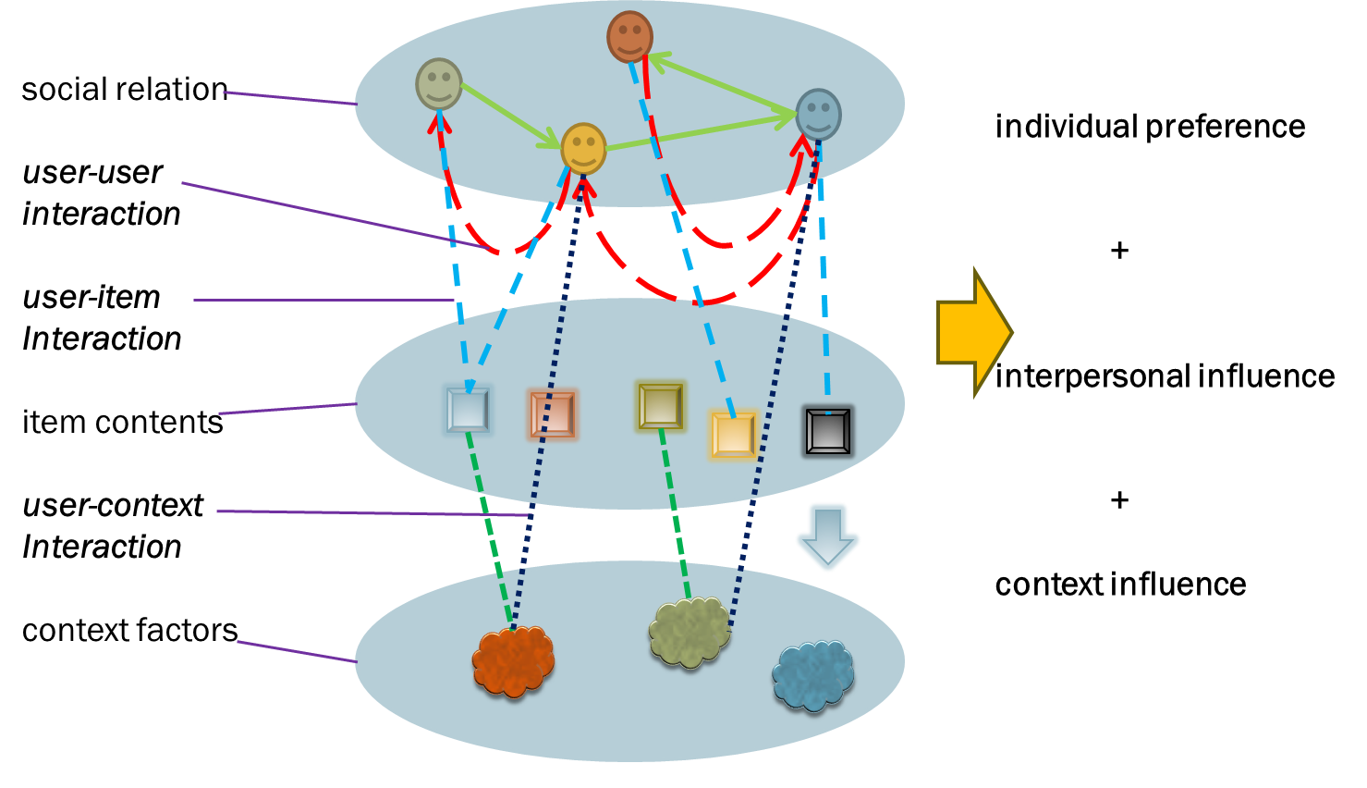

In order to improve the accuracy of social networks recommendation, we propose a context-based three-dimensional model, in which the third dimension of user context is introduced into the existing user-item two-dimensional model.

We conducted experiments on the existing social networks Sina Weibo to do the recommended model validation. Firstly we crawled Sina micro blogging data, and then analyzed the data to identify the social context data, the sender information and the item content. For situational awareness of today's social networking for is limited, the situational data mainly include location data aware by mobile device, time data, and the mood data both from Sina Weibo mood service and facial expression analysis of user. Our experimental data is divided into training and testing sets, using the most commonly recommended metrics MAE and RMSE as the evaluation criteria. We show that the real word social context contribute to the precise of social networking recommendation.

This paper is organized as follows. Section 2 provides an overview of some recommendation approaches and related work. Section 3 describes how specific user, item and social context to are abstract and modeled and our context-based social networking recommendation model is formulated. Section 4 describes our experimental design and experimental results, followed by the conclusion and future work in Section 6.

# Related work

In this section we review several major recommendation approaches, including traditional recommendation system which are mainly based on collaborative filtering technology and some social recommendation system.

Traditional recommendation approaches [1] mainly contain content-based method and the commonly-used approach collaborative filtering and the hybrid approaches. Collaborative filtering is the most widely used and mature recommended method. Collaborative filtering can be divided into neighborhood-based (based on user or item) and model-based collaborative filtering. User-based collaborative filtering approach [?] primarily based on the assumption that similar users have similar tastes of a certain item. Use the history item rating to find neighbors similar with the current user and then predict the ratings with the user-neighbors’ ratings. Similarly, item-based collaborative filtering predicts the rating based on the ratings of item-neighbors which are rated by active user. The neighborhood-based collaborative filtering mainly use Pearson Correlation Coefficient [13] and the Vector Space Similarity [?] algorithm to compute the similarity of user and item. Model-based collaborative filtering methods use existing user rating matrix to train a recommended model predict user preferences instead of directly calculate the ratings as neighborhood-based. The mainly used algorithms include Personality Diagnosis [17], Bayesian Network Model [8] and Clustering Model [].

In social networks, collaborative filtering approaches are unable to fully characterize the complex graph-based relationship in social networks and make full use of social knowledge. Recently, for social networks recommendation, researchers introduced a trust-based [2] [9] [11] [22] and influence-based [4] [10] [16] [18] approaches to take advantage of the relationship of users in the social network to get more accurate prediction. Trust-base recommendation is based on the assumption of homogeneity principle that the user has similar tastes with his trusted people, which is not entirely realistic. This approach is only applicable to trust mechanism network rather than the real social networks. While Huang [10] introduced users mutually influencing factors, but ignored the users’ own factors. Jiang [4] proposed a new social network user behavior model, that user behavior is affected by the user's preferences and influence from other users which characterize the user behavior a more comprehensively in social networks. But ignored that in different real life contexts, the influence between users and user preferences are changing. In efficiency of social networking recommender approaches, methods of the matrix decomposition [6] [7] and matrix regularization [5] have been proposed to calculate the mass of the social network data.

But both traditional and existing social networks recommendation approaches recommend by processing the observed user ratings 2-dimensional matrix R, resulting in predicted user ratings matrix to describe the user for an item preference. These 2-dimensional recommendation mechanisms ignore the context information of user behavior. In the same way, only two dimensions user and item are considered without considering the dimension of context. In this paper we apply the contexts’ impact on user’s preference and influence between users to the recommendation model in social networks.

# Social Recommendation Model Based-on Context

## Context Definition

Definition of context in different areas will be different. We use the definition of Schmidt [20]: A context describes a situation and the environment a device or user is in. A context is identified by a unique name. For each context a set of features is relevant.

In social networks, Context describes the user state and the situation when users browse the social network, including external and internal factors. The context when user browse the social network with the external environment is limited including the time and place and the internal factor of user can be described as mood. For example, a user might browse social networking information at home, in work places or in public places, in different period of the day, with different mood such as happy, worried or no feeling.

## Context-based 3 Dimensional Model

Dimensions are used to represent the range of recommendation space. In addition to user dimension U and item dimension I, there is context dimension C. Recommendation dimensional space S is the Cartesian product of user, item and context dimensions:

In traditional recommendation systems, rating on the item indicates how much user like the item. Different recommendation approach predicts by calculating the 2-dimensional rating matrix of user and item dimensions.

In 3-dimensional recommendation model with social context dimension, we predict with recommended space S. Figure 2 the 3-dimensional rating matrix may exhibit user rating of an item in a certain context. But in social networks, R is the adoption matrix, that is, value 1 of indicates user i adopted item j and value 0 indicates no adoption. So.

The recommendation space S can be intuitively represented by the following 3-dimensional of Figure 3, each small square represents a user adopts of an item in a context. In this paper we refer it as adoption matrix R.

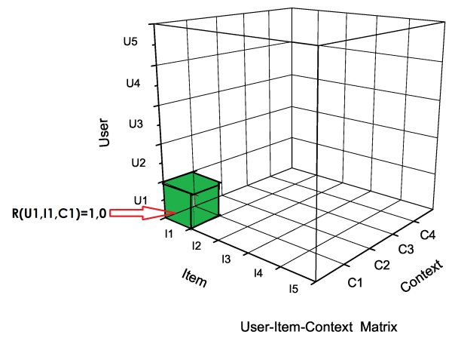

Figure 2: User-Item-Context Matrix

## Social Recommendation Algorithm

Context-based social network recommendation is to predict the user-item-context adoption matrix R, then recommend items by the values in R.

According to the analysis of user behavior in social networks in Figure 1, we propose a 3-dimensional social network recommendation model based on the social context as shown in Figure 3. The model takes two main factors into account: 1 the user-user influences in different contexts and 2 the personal preference in different contexts. The original User-Item adoption matrix R is conducted for the User-Item Influence Matrix and User-Item Preference matrix. While now we expanse the 2-dimensional adoption matrix R to 3-dimensional from the User-Item to User-Item-Context. So R is decomposed into User-Item-Context Influence matrix I and User-Item-Context Preference matrix P.

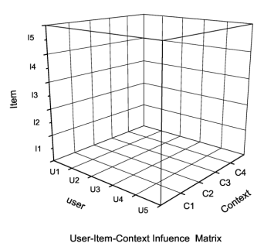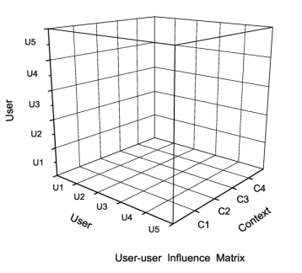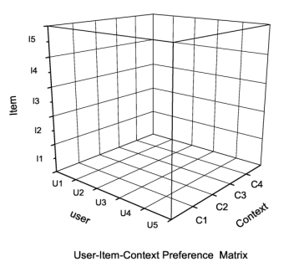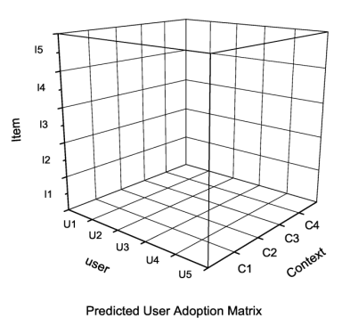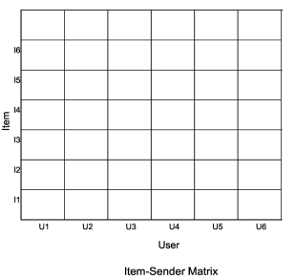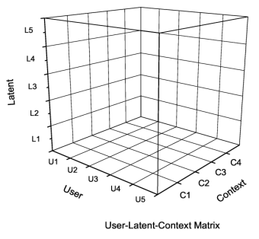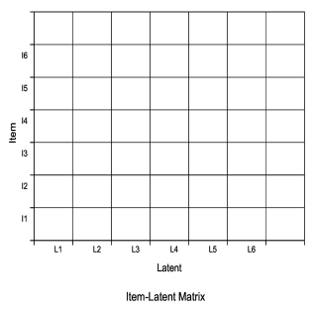

We use LDA [] to calculate the item’s topic distribution to the item latent feature matrix. Based on the users’ historical adoption data, we then get the User-Item-Context preference matrix (1). On the other hand, according to the adopted items’ senders and the adoption context, User-User-Context Influence matrix is calculated, and then combined with the actual senders of the items to obtain User-Item-Context Influence matrix (2). Finally the User-Item-Context adoption matrix is generated by matrixes (1) (2).

In our model, we assume that the user whether to adopt a project depends on 4 factors: the content of item, the sender, users’ preference, and contextual information.

First, we suppose there are m users, n items and k kinds of context. Item-Sender matrix M represents senders of items, =1 means that the user j send the item i. User-User-Context Influence matrix N is the user inter-impact matrix, expresses the influence user i to j in context k. User-Latent-Context matrix G represents users latent preferences in different contexts. Item-latent matrix S represents the topic distribution of items. So that can well approximate the adoption matrix R without over fitting, where is the Hadamard Product.

We use context vector represents context x, where , , ..., denote context x in the value of k kinds of contexts.

We apply LDA on content of each item and extract the topic distributions of items. Vector represents the topic distribution of item a, so that all of the items’ topic distribution vectors constitute the Item-latent matrix S.

Vector represents the influence of user u to user v in each kind of contexts. is defined as follows:

where is the set of items sent from user v to user u. is the set of items user u adopts. is the context vector when user u adopted item . All of these vectors constitute the 3-dimensional matrix N.

Users’ topic distribution in different contexts is a 2-dimensional matrix as follows:

where is the set of items user adopts. is the context vector when user u adopted item . is the topic distribution of item . All these vectors constitute 3-dimensional matrix G.

From matrixes M and N, we conduct the 3-dimensional User-Item-Context Influence matrix I. is a 2-dimensional matrix of I represents the adoption value user u to item a in different contexts, which attribute to the influence of senders to user u in different contexts. is defined as follow:

where is a set of users who send item a to user u, is a set of items adopted by user u, is a set of items user v sent to user u, is the context vector when user u adopted item .

Similarly, from matrixes S and G, we conduct the 3-dimensional User-Item-Context Preference matrix P. is a 2-dimensional matrix of P represents the adoption value user u to item a in different contexts, which attribute to user’s preferences of items in different contexts. is defined as follow:

where is a set of all items sent to user u except a, is the number of elements in the set.

# Experiments

In this section, we use real social network data conducted experiments to compare with other recommendation methods.

## Datasets

We use existing social networks Sina Weibo to get experimental data and do the recommendation model validation. Sina Weibo is a Chinese famous social networking like Twitter, people can follow people he is interest in and then receive the micro-blogs posted by them and the user can keep, forward or comment the micro-blogs he likes. Micro-blogs can be posted or forwarded with the facial expression and location information. Sina also provide a service to for user to record their mood. First we crawled data of micro-blogs and user from Sina Weibo and then extract the contextual information, the sender and the item content of each micro-blog. For situational awareness of today's social networking for is limited, the situational data mainly include location data aware by mobile device, time data, and the mood data both from Sina Weibo mood service and facial expression analysis of user. The experiment data statistics as follows:

|  |  |
| --- | --- |
| Statistic | Value |
| User Number |  |
| Tweet Item Number |  |
| Forward Behavior Number |  |

Table 1: Statistics of Sina Micro-blogs

*Experiment Target*: Our experiments require the recommender to predict the adoption of items the active user is reading according to the current context. *Experimental settings*: Different with browsing static information in other networks, the user browses latest updated information so that user may not be able to see all the information sent to him. We are unable to know when the user is online and unable to get real-time contextual information if the user does nothing but browsing the micro-blogs. Only according to the user's behavior, we can determine the user's online time and contextual information. So we act according to the user's effective behaviors (such as post, forward or keep micro-blogs come) to determine the user is online and for each active behavior, we define an effective period of time as online session (before and after the act for some time), which means that in this period of time users online. We use online session to represent the time when user is online. Then we extract three kinds of contextual information (time, place or mood) from the micro-blogs. What’s more, not each user behavior necessarily contain all the contextual information, so we regard the behavior which contains two or more contextual data as a valid behavior and the item as a valid context item as shown in Figure 4. Then the contextual data last for the time session of the valid context item and the adoption behaviors in this time session are defined as valid behaviors. The experimental data is divided into training and testing sets. We use our model to calculate the influence among user on different contexts, item and user latent features from the training set. Then we extract the valid items from the testing sets as testing cases. These experiment settings are equally effective to other compared methods.

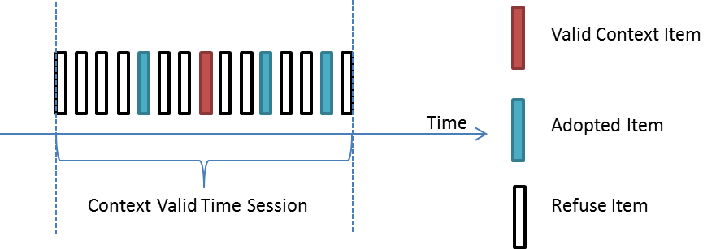

Figure 4: Timeliness of Context Data

## Metrics

We use the commonly used measurement metrics Mean Absolute Error (MAE) and the Root Mean Square Error (RMSE) as the evaluation criterion to measure the recommendation accuracy by calculating the deviation between the real and prediction adoption. The smaller value of MAE and RMSE means the higher quality.

MAE metric is defined as follows:

RMSE metric is defined as follows:

where means that the real user i adoption information of item j in the adoption context k, represents predicted user adoption, and T represents the number of the test adoption.

## Comparisons

# Conclusion and Future Work

# References

[1] Emmanouil Vozalis, Konstantinos G. Margaritis, Analysis of Recommender Systems’ Algorithms, 2003

[2] P. Bedi, H. Kaur, and S. Marwaha. Trust based recommender system for semantic web. In Proc. of

IJCAI’07, 2007

[3] Bardul M. Sarwar, Sparsity, Scalability, and Distribution in Recommender Systems, Ph.D. thesis, University of Minnesota, 2001

[4] Meng Jiang,Peng Cui, Rui Liu，Social Contextual Recommendation,2012

[5] Hao Ma,Denglong Zhou, Recommender Systems with Social Regularization,2011

[6] Y. Koren. Factorization meets the neighborhood: a multifaceted collaborative filtering model. In Proceeding of the 14th ACM SIGKDD International Conference on Knowledge Discovery and Data Mining (KDD), pages 426–434, 2008.

[7] Y. Koren. Collaborative filtering with temporal dynamics. In Proceeding of the 15th ACM SIGKDD International Conference on Knowledge Discovery and Data Mining (KDD), 2009.

[8] John S. Breese, David Heckerman, and Carl Kadie, Empirical analysis of predictive algorithms for collaborative filtering, 1998

[9] Samaneh Moghaddam, Mohsen Jamali, Martin Ester. FeedbackTrust: Using Feedback Effects in Trust-based Recommendation Systems, 2011

[10] J. Huang, X. Cheng, J. Guo, H. Shen, and K. Yang. Social recommendation with interpersonal influence.In Proceedings of the 19th European Conference on Artificial Intelligence (ECAI), pages 601–606, 2010

[11] M. Jamali and M. Ester. Trustwalker: a random walk model for combining trust-based and item-based recommendation.In Proceedings of the 15th ACM SIGKDD International Conference on Knowledge Discovery and Data Mining (KDD), 2009

[12] HAO MA, IRWIN KING, MICHAEL R. LYU. Thomas Kriechbaum, Learning to Recommend with Explicit and Implicit Social Relations, 2011

[13] Paul Resnick, Neophytos Iacovou, Mitesh Sushak, Peter Bergstrom, and John Riedl, Grouplens: An open architecture for collaborative filtering of netnews , 1994

[14] Shuang Hong Yang, Bo Long, Alex Smola, Like like alike — Joint Friendship and Interest Propagation in Social Networks, 2011

[15] Yelong Shen,Ruoming Jin, Learning Personal+Social Latent Factor Model for Social Recommendation,2012

[16] J. Leskovec, A. Singh, and J. Kleinberg. Patterns of influence in a recommendation network. Lecture Notes in Computer Science, 2006

[17] David M. Pennock, Eric Horvitz, Steve Lawrence, and C. LeeGiles, Collaborative filtering by personality diagnosis: A hybric memory- and model-based approach, 2000

[18] L. Liu, J. Tang, J. Han, M. Jiang, and S. Yang. Mining topic-level influence in heterogeneous networks. In Proceedings of CIKM, 2010

[19] Ke Sun,Yunbo Cao,Xinying Song , Learning to Recommend Questions Based on User Ratings, 2009

[20] Schmit A, Beigl M, Gellersen H W. There is more to context than location, 2008

[22] P. Massa and P. Avesani. Trust-aware recommender systems. In Proceedings of the2007 ACM Conference on Recommender Systems (RecSys), 2007