**文件上传下载操作**

**文件上传遇到的问题**

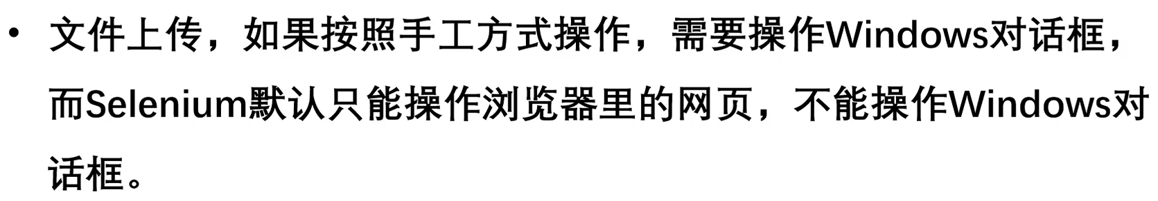

**Selenium标准文件上传**

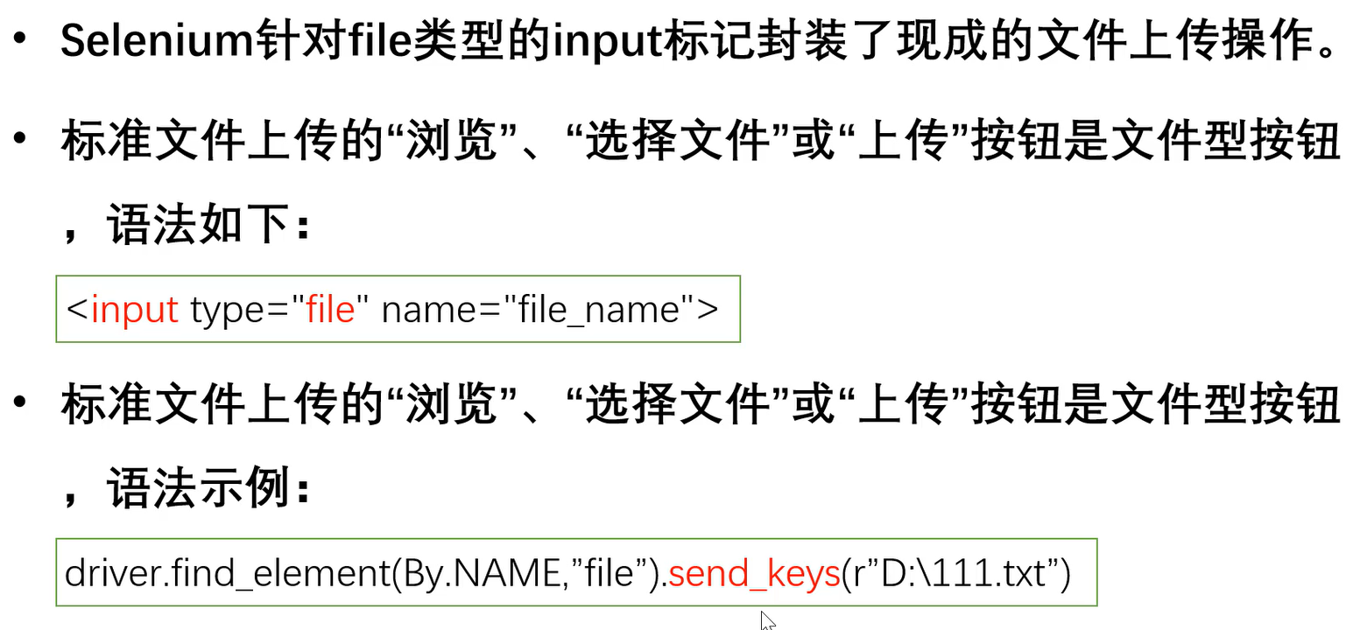

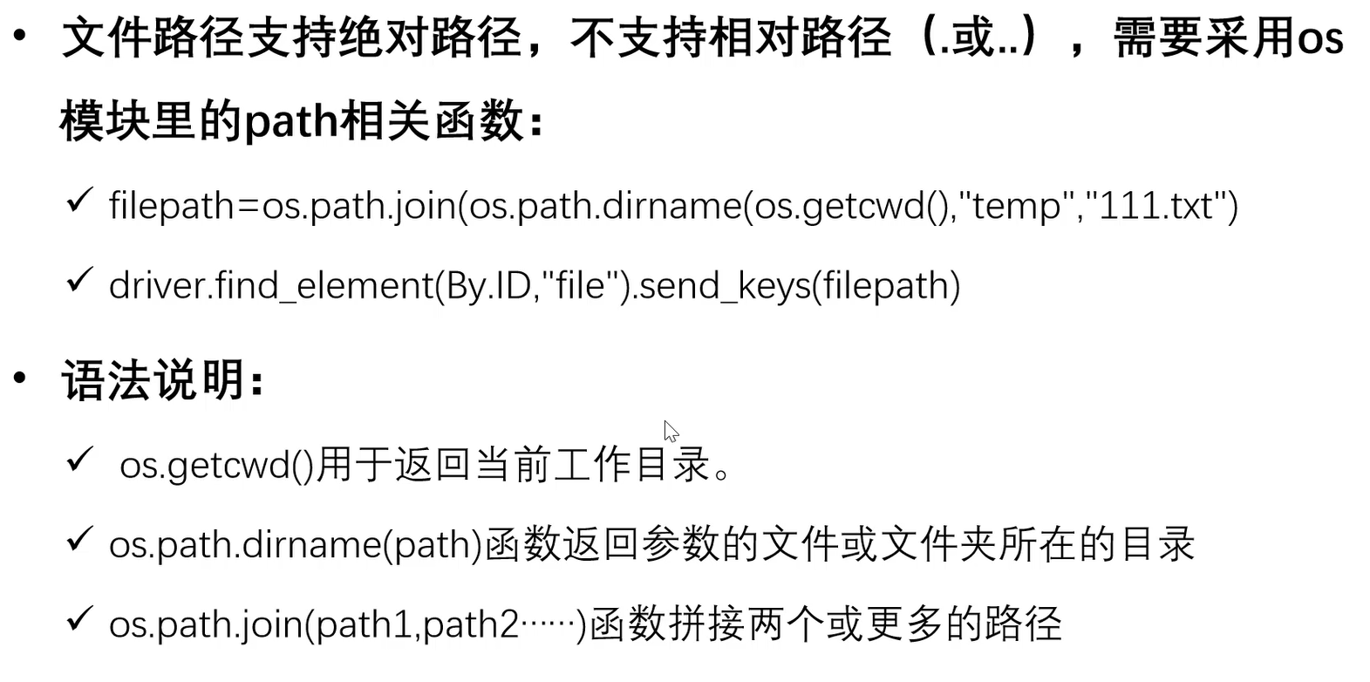

**火狐浏览器下载配置**

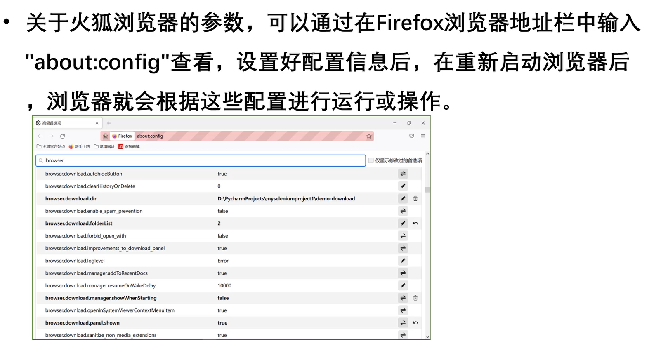

**火狐浏览器下载相关配置参数**

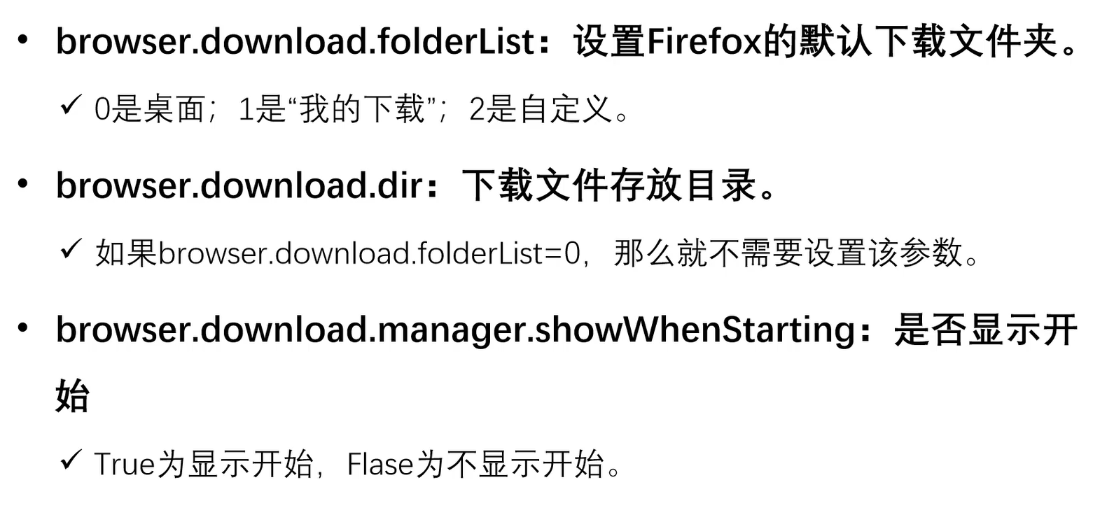

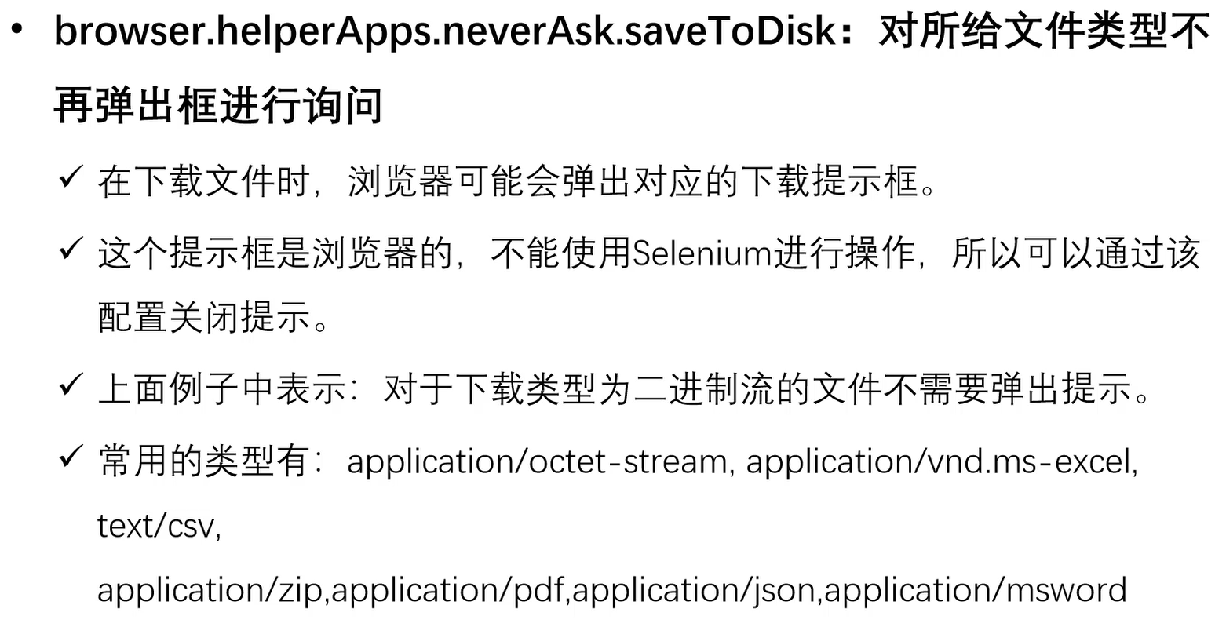

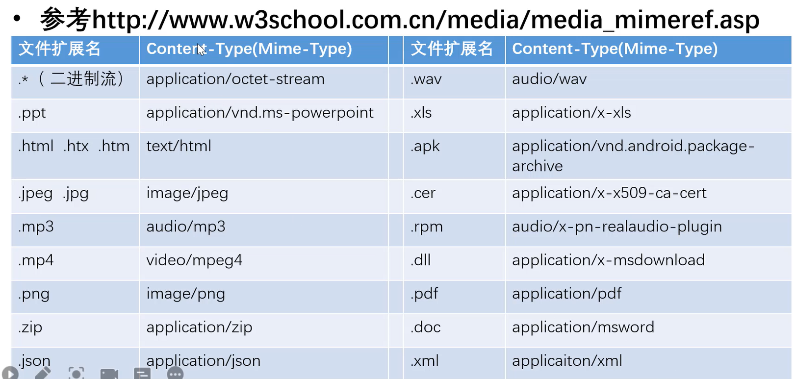

**Firefox启动配置**

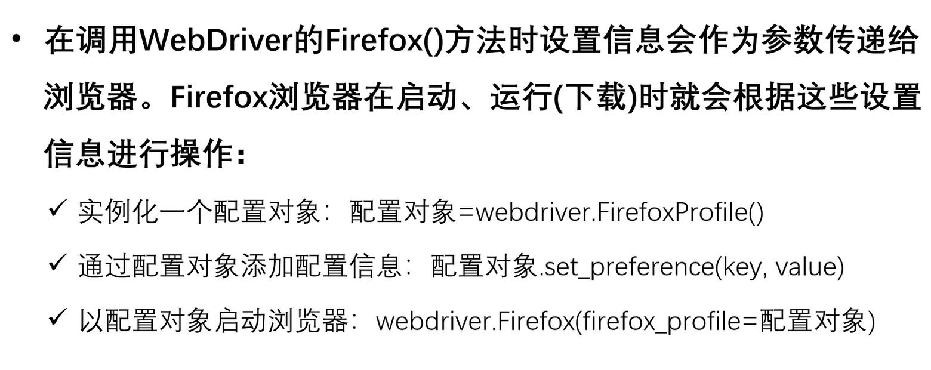

**练习**

打开https://www.firefox.com.cn/

setobj=webdriver.FirefoxProfile()

setobj.set_preference(“browser.download.folderList”,2)

setobj.set_preference(“browser.download.dir”,”c:\\temp\\”)

setobj.set_preference(“browser.download.manager.showWhenStarting”,False)

setobj.set_preference(“browser.helperApps.neverAsk.saveToDisk”,”application/octet-stream”)

driver=webdriver.Firefox(firefox_profile=profile)

注意：同学们做实验时会遇到报错的情况，是因为FirefoxProfile()已经弃用，请把上面的代码更改如下：

from selenium.webdriver.common.options import BaseOptions

setobj=webdriver.FirefoxOptions()

setobj.set_preference(“browser.download.folderList”,2)

setobj.set_preference(“browser.download.dir”,”c:\\temp\\”)

setobj.set_preference(“browser.download.manager.showWhenStarting”,False)

setobj.set_preference(“browser.helperApps.neverAsk.saveToDisk”,”application/octet-stream”)

driver=webdriver.Firefox(Options=setobj)

参考来源：https://blog.csdn.net/huaalily/article/details/122492912

下面是完整代码

from selenium import webdriver  
from time import sleep  
from selenium.webdriver.common.by import By  
from selenium.webdriver.common.options import BaseOptions  
setobj=webdriver.FirefoxOptions()  
setobj.set_preference("browser.download.folderList",2)  
setobj.set_preference("browser.download.dir","d:\\temp\\")  
setobj.set_preference("browser.download.manager.showWhenStarting",False)  
setobj.set_preference("browser.helperApps.neverAsk.saveToDisk","application/octet-stream")  
driver=webdriver.Firefox(options=setobj)  
  
driver.get("https://www.firefox.com.cn/")  
sleep(3)  
driver.find_element(By.XPATH,'//div[@id="download-button-thanks"]/a').click()  
sleep(10)  
driver.quit()