**MEEN 673**

**Final Exam**

**Jicheng Lu**

**525004048**

**Problem 4:**

Table 4.1 center deflection versus load.

|  |  |  |  |  |  |  |
| --- | --- | --- | --- | --- | --- | --- |
| **Load, q** | **N=0, EBT** | **N=1, EBT** | **N=5, EBT** | **N=0, TBT** | **N=1, TBT** | **N=5, TBT** |
| 5 | 0.08310 | 0.09459 | 0.12365 | 0.08316 | 0.09475 | 0.12379 |
| 10 | 0.10957 | 0.12548 | 0.16325 | 0.10992 | 0.12584 | 0.16392 |
| 15 | 0.12759 | 0.14674 | 0.19053 | 0.12787 | 0.14705 | 0.19122 |
| 20 | 0.14171 | 0.16353 | 0.21213 | 0.14198 | 0.16384 | 0.21287 |
| 25 | 0.15344 | 0.17763 | 0.23029 | 0.15378 | 0.17795 | 0.23109 |
| 30 | 0.16372 | 0.18981 | 0.24570 | 0.16403 | 0.19025 | 0.24698 |
| 35 | 0.17286 | 0.20062 | 0.25986 | 0.17315 | 0.20122 | 0.26116 |
| 40 | 0.18104 | 0.21058 | 0.27271 | 0.18140 | 0.21116 | 0.27404 |
| 45 | 0.18864 | 0.21972 | 0.28452 | 0.18871 | 0.22030 | 0.28586 |
| 50 | 0.19568 | 0.22820 | 0.29546 | 0.19574 | 0.22847 | 0.29645 |
| 55 | 0.20225 | 0.23612 | 0.30569 | 0.20230 | 0.23640 | 0.30672 |
| 60 | 0.20842 | 0.24356 | 0.31531 | 0.20847 | 0.24386 | 0.31639 |
| 65 | 0.21424 | 0.25060 | 0.32440 | 0.21429 | 0.25091 | 0.32553 |
| 70 | 0.21977 | 0.25727 | 0.33303 | 0.21981 | 0.25760 | 0.33420 |
| 75 | 0.22503 | 0.26363 | 0.34126 | 0.22507 | 0.26397 | 0.34247 |
| 80 | 0.23006 | 0.26972 | 0.34912 | 0.23010 | 0.27006 | 0.35037 |
| 85 | 0.23488 | 0.27555 | 0.35666 | 0.23491 | 0.27590 | 0.35795 |
| 90 | 0.23951 | 0.28115 | 0.36391 | 0.23954 | 0.28151 | 0.36523 |
| 95 | 0.24397 | 0.28655 | 0.37090 | 0.24399 | 0.28692 | 0.37224 |
| 100 | 0.24827 | 0.29176 | 0.37764 | 0.24828 | 0.29214 | 0.37902 |

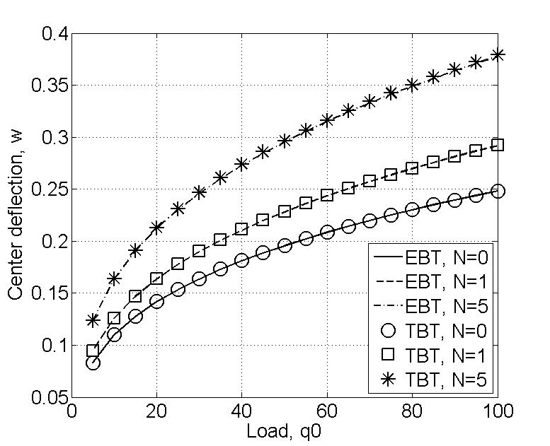

Figure4.1 center deflection versus load.

**Problem 5:**

Table 5.1 Horizontal velocity vx(0.5, y) versus y

|  |  |  |  |
| --- | --- | --- | --- |
| **y** | **U (Re=0)** | **U (Re=5000)** | **U (Re=10000)** |
| 0.00000 | 0 | 0.00000 | 0.00000 |
| 0.03125 | -0.01961 | -0.11342 | -0.08989 |
| 0.06250 | -0.036587 | -0.16710 | -0.12346 |
| 0.09375 | -0.051763 | -0.19148 | -0.13295 |
| 0.12500 | -0.065674 | -0.19086 | -0.12617 |
| 0.18750 | -0.091198 | -0.16045 | -0.10237 |
| 0.25000 | -0.11514 | -0.12011 | -0.08039 |
| 0.31250 | -0.13828 | -0.10523 | -0.06781 |
| 0.37500 | -0.16002 | -0.06793 | -0.04189 |
| 0.43750 | -0.17854 | -0.04248 | -0.02609 |
| 0.50000 | -0.18992 | -0.01197 | -0.00524 |
| 0.56250 | -0.18839 | 0.01816 | 0.01439 |
| 0.62500 | -0.1649 | 0.04843 | 0.03422 |
| 0.68750 | -0.1085 | 0.08473 | 0.05894 |
| 0.75000 | -0.0057853 | 0.11519 | 0.07998 |
| 0.81250 | 0.15435 | 0.15854 | 0.10541 |
| 0.87500 | 0.3792 | 0.19200 | 0.13379 |
| 0.90625 | 0.51533 | 0.19896 | 0.12905 |
| 0.93750 | 0.66614 | 0.18633 | 0.13085 |
| 0.96875 | 0.82884 | 0.25124 | 0.13665 |
| 1.00000 | 1. 00000 | 1.00000 | 1.00000 |

Table 5.2 Pressure P(x, 0.15625) versus x

|  |  |  |
| --- | --- | --- |
| **x** | **P (Re=5000)** | **P (Re=10000)** |
| 0.015625 | 44.6380 | 34.2010 |
| 0.046875 | 49.5530 | 48.2380 |
| 0.078125 | 44.1740 | 33.6690 |
| 0.109380 | 48.9330 | 47.6750 |
| 0.156250 | 43.7240 | 36.1030 |
| 0.218750 | 41.4340 | 38.7510 |
| 0.281250 | 27.5270 | 20.1770 |
| 0.343750 | 16.4050 | 14.1050 |
| 0.437500 | 1.2502 | -3.6203 |
| 0.562500 | 1.4209 | -1.4493 |
| 0.656250 | 10.1760 | 2.6343 |
| 0.718750 | 24.5130 | 20.9200 |
| 0.781250 | 31.4970 | 24.9360 |
| 0.843750 | 38.7890 | 39.5750 |
| 0.890620 | 35.5010 | 29.9010 |
| 0.921880 | 41.9170 | 44.8940 |
| 0.953120 | 34.6050 | 29.4000 |
| 0.984380 | 42.3150 | 45.2000 |

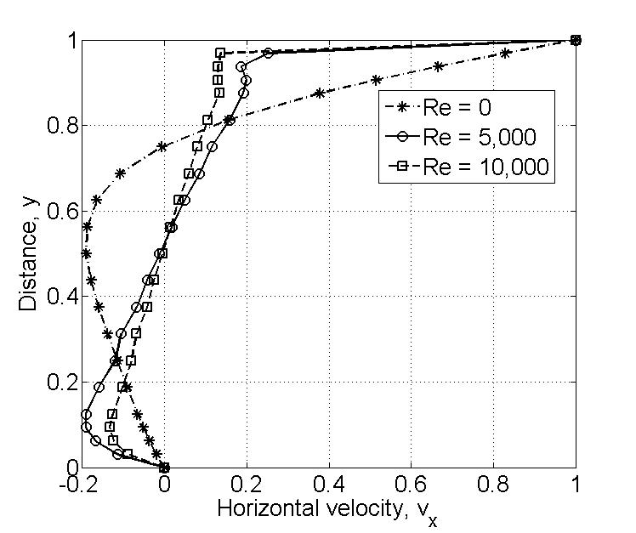

Figure 5.1 vx(0.5, y) versus y

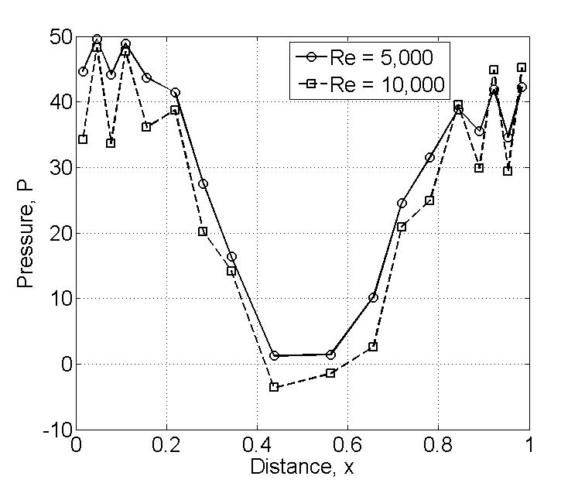

Figure 5.2 P(x, 0.15625) versus x

**Problem 6:**

Table 6.1 Displacement of node 22.

|  |  |  |
| --- | --- | --- |
| **Load step** | **-y** | **-v** |
| 1 | -0.1817 | 0.3183 |
| 2 | 0.0671 | 0.5671 |
| 3 | 0.2584 | 0.7584 |
| 4 | 0.4135 | 0.9135 |
| 5 | 0.5447 | 1.0447 |
| 6 | 0.6600 | 1.1600 |
| 7 | 0.7631 | 1.2631 |
| 8 | 0.8571 | 1.3571 |
| 9 | 0.9439 | 1.4439 |
| 10 | 1.0248 | 1.5248 |
| 11 | 1.1010 | 1.6010 |
| 12 | 1.1731 | 1.6731 |
| 13 | 1.2418 | 1.7418 |
| 14 | 1.3075 | 1.8075 |
| 15 | 1.3706 | 1.8706 |
| 16 | 1.4314 | 1.9314 |
| 17 | 1.4901 | 1.9901 |
| 18 | 1.5471 | 2.0471 |
| 19 | 1.6025 | 2.1025 |
| 20 | 1.6563 | 2.1563 |
| 21 | 1.7089 | 2.2089 |
| 22 | 1.7602 | 2.2602 |
| 23 | 1.8104 | 2.3104 |
| 24 | 1.8596 | 2.3596 |
| 25 | 1.9078 | 2.4078 |
| 26 | 1.9552 | 2.4552 |
| 27 | 2.0018 | 2.5018 |
| 28 | 2.0476 | 2.5476 |
| 29 | 2.0927 | 2.5927 |
| 30 | 2.1372 | 2.6372 |
| 31 | 2.1811 | 2.6811 |

Table 6.2 Stress at Gauss point closest to (0,b).

|  |  |  |  |  |  |  |
| --- | --- | --- | --- | --- | --- | --- |
| **load** | **x** | **y** | **sigma xx** | **x** | **y** | **Sxx** |
| 1 | 0.4256 | 0.7847 | 0.5126 | 0.4227 | 0.7887 | 0.5235 |
| 2 | 0.4284 | 0.7809 | 0.9840 | 0.4227 | 0.7887 | 1.0258 |
| 3 | 0.4309 | 0.7775 | 1.3902 | 0.4227 | 0.7887 | 1.4778 |
| 4 | 0.4331 | 0.7743 | 1.7452 | 0.4227 | 0.7887 | 1.8901 |
| 5 | 0.4352 | 0.7712 | 2.0616 | 0.4227 | 0.7887 | 2.2731 |
| 6 | 0.4371 | 0.7682 | 2.3495 | 0.4227 | 0.7887 | 2.6368 |
| 7 | 0.4389 | 0.7653 | 2.6134 | 0.4227 | 0.7887 | 2.9842 |
| 8 | 0.4406 | 0.7624 | 2.8578 | 0.4227 | 0.7887 | 3.3196 |
| 9 | 0.4422 | 0.7596 | 3.0859 | 0.4227 | 0.7887 | 3.6457 |
| 10 | 0.4438 | 0.7569 | 3.2998 | 0.4227 | 0.7887 | 3.9644 |
| 11 | 0.4453 | 0.7541 | 3.5014 | 0.4227 | 0.7887 | 4.2773 |
| 12 | 0.4468 | 0.7514 | 3.6920 | 0.4227 | 0.7887 | 4.5856 |
| 13 | 0.4482 | 0.7487 | 3.8726 | 0.4227 | 0.7887 | 4.8902 |
| 14 | 0.4496 | 0.7461 | 4.0444 | 0.4227 | 0.7887 | 5.1919 |
| 15 | 0.4510 | 0.7435 | 4.2080 | 0.4227 | 0.7887 | 5.4913 |
| 16 | 0.4523 | 0.7409 | 4.3641 | 0.4227 | 0.7887 | 5.7891 |
| 17 | 0.4536 | 0.7383 | 4.5132 | 0.4227 | 0.7887 | 6.0856 |
| 18 | 0.4549 | 0.7357 | 4.6560 | 0.4227 | 0.7887 | 6.3814 |
| 19 | 0.4562 | 0.7331 | 4.7927 | 0.4227 | 0.7887 | 6.6766 |
| 20 | 0.4575 | 0.7305 | 4.9238 | 0.4227 | 0.7887 | 6.9718 |
| 21 | 0.4587 | 0.7280 | 5.0496 | 0.4227 | 0.7887 | 7.2670 |
| 22 | 0.4599 | 0.7254 | 5.1704 | 0.4227 | 0.7887 | 7.5625 |
| 23 | 0.4611 | 0.7229 | 5.2866 | 0.4227 | 0.7887 | 7.8587 |
| 24 | 0.4623 | 0.7204 | 5.3983 | 0.4227 | 0.7887 | 8.1555 |
| 25 | 0.4635 | 0.7179 | 5.5058 | 0.4227 | 0.7887 | 8.4534 |
| 26 | 0.4647 | 0.7154 | 5.6092 | 0.4227 | 0.7887 | 8.7523 |
| 27 | 0.4658 | 0.7128 | 5.7088 | 0.4227 | 0.7887 | 9.0524 |
| 28 | 0.4670 | 0.7103 | 5.8048 | 0.4227 | 0.7887 | 9.3540 |
| 29 | 0.4681 | 0.7079 | 5.8973 | 0.4227 | 0.7887 | 9.6570 |
| 30 | 0.4693 | 0.7054 | 5.9864 | 0.4227 | 0.7887 | 9.9616 |
| 31 | 0.4704 | 0.7029 | 6.0724 | 0.4227 | 0.7887 | 10.2680 |
| 32 | 0.4715 | 0.7004 | 6.1552 | 0.4227 | 0.7887 | 10.5760 |

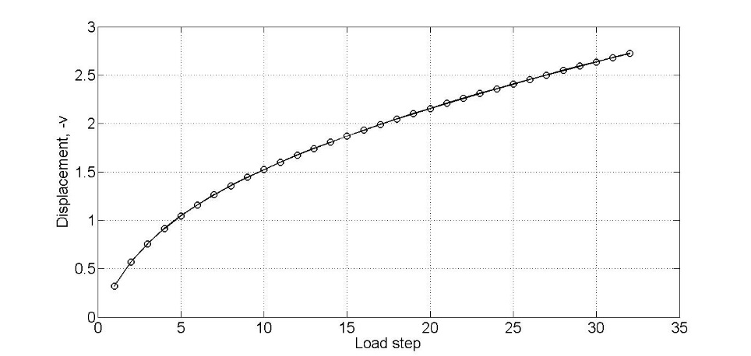

Figure 6.1 Displacement, –v, versus load (UL formulation)

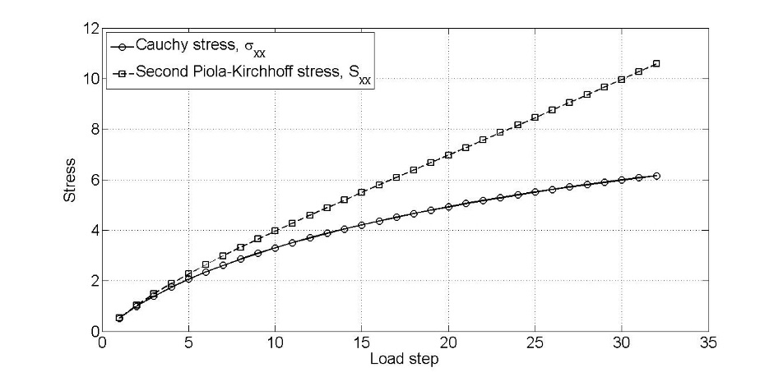

Figure 6.2 Stress versus load (UL formulation)