**MEEN 673**

**Assignment 2**

**Jicheng Lu**

**525004048**

**EX 5.2.1**

Table 1.1 Finite element results for the transverse deflections, w(L/2), of a beam with both ends hinged and subjected to uniformly distributed load (half-beam model)

|  |  |  |  |  |  |
| --- | --- | --- | --- | --- | --- |
| Load  q0 | DI  (2×2 Gauss rule) | | NI  (2×2 Gauss rule) | | DI-NI  (2×1) |
| 4 elements | 8 elements | 4 elements | 8 elements | 4&8 elements |
| 1.0 | 0.51082 | 0.51815 | 0.51043 | 0.51774 | 0.52083 |
| 2.0 | 0.97381 | 1.0213 | 0.97321 | 1.0204 | 1.0417 |
| 3.0 | 1.3766 | 1.4987 | 1.3757 | 1.4974 | 1.5625 |
| 4.0 | 1.7261 | 1.9452 | 1.7257 | 1.9438 | 2.0833 |
| 5.0 | 2.0347 | 2.3604 | 2.0334 | 2.3589 | 2.6042 |
| 6.0 | 2.3109 | 2.7469 | 2.3098 | 2.7446 | 3.1250 |
| 7.0 | 2.5631 | 3.1056 | 2.5606 | 3.1037 | 3.6458 |
| 8.0 | 2.7916 | 3.4406 | 2.7909 | 3.4392 | 4.1667 |
| 9.0 | 3.0071 | 3.7569 | 3.0043 | 3.7538 | 4.6875 |
| 10.0 | 3.2063 | 4.0513 | 3.2034 | 4.0501 | 5.2083 |

**EX 5.2.2**

Table 2.1 The center transverse deflections, w(L/2), versus load q0 for a beam with both ends pinned and subjected to uniformly distributed load (half-beam model)

|  |  |  |  |  |  |  |
| --- | --- | --- | --- | --- | --- | --- |
| Load  q0 | 2×2 Gauss rule | | | | 2×1 Gauss rule | |
| 4 elements | | 8 elements | | 8 elements | |
| DI | NI | DI | NI | DI | NI |
| 1 | 0.36695 | 0.36671 | 0.36793 | 0.36792 | 0.36842 | 0.36853 |
| 2 | 0.54211 | 0.54218 | 0.54486 | 0.54443E | 0.54541 | 0.54567 |
| 3 | - | 0.65995 | - | 0.66282 | - | 0.66451 |
| 4 | - | 0.75095 | - | 0.75425 | - | 0.75637 |
| 5 | - | 0.82626 | - | 0.82986 | - | 0.83240 |
| 6 | - | 0.89112 | - | 0.89496 | - | 0.89791 |
| 7 | - | 0.94847 | - | 0.95249 | - | 0.95585 |
| 8 | - | 1.0001 | - | 1.0043 | - | 1.0080 |
| 9 | - | 1.0473 | - | 1.0516 | - | 1.0557 |
| 10 | - | 1.0908 | - | 1.0952 | - | 1.0997 |

Note: “-” means divergence for the current setting.

Table 2.2 The center transverse deflections, w(L/2), versus load q0 for a beam with both ends clamped and subjected to uniformly distributed load (half-beam model)

|  |  |  |  |  |  |
| --- | --- | --- | --- | --- | --- |
| Load  q0 | Direct iteration | | Newton iteration | | |
| 4 elements | 8 elements | 4 elements | 8 elements | 8 elements |
| 2×1 | 2×1 | 2×1 | 2×1 | 2×2 |
| 1 | 0.10335 | 0.10336 | 0.10335 | 0.10336 | 0.10327 |
| 2 | 0.20225 | 0.20228 | 0.20224 | 0.20228 | 0.20204 |
| 3 | 0.29384 | 0.29393 | 0.29385 | 0.29394 | 0.29346 |
| 4 | 0.37722 | 0.37737 | 0.37726 | 0.37741 | 0.37647 |
| 5 | 0.45286 | 0.45305 | 0.45282 | 0.45301 | 0.45169 |
| 6 | 0.52132 | 0.52152 | 0.52138 | 0.52157 | 0.51985 |
| 7 | 0.58398 | 0.58414 | 0.58391 | 0.58407 | 0.58190 |
| 8 | 0.64118 | 0.64158 | 0.64129 | 0.64137 | 0.63855 |
| 9 | 0.69443 | 0.69439 | 0.69428 | 0.69425 | 0.69100 |
| 10 | 0.74331 | 0.74313 | 0.74352 | 0.74333 | 0.73965 |

**Problem 5.11**

Table 3.1 The center transverse deflections, w(L/2), versus load q0 for a beam (clamped at one end and pinned at the other end) subjected to uniformly distributed load (half-beam model)

|  |  |  |
| --- | --- | --- |
| Load  q0 | EBT (8 elements)  2×2 | |
| DI | NI |
| 0.25 | 0.051863 | 0.051863 |
| 0.50 | 0.10247 | 0.10247 |
| 0.75 | 0.15085 | 0.15084 |
| 1 | 0.19642 | 0.19642 |
| 2 | 0.34997 | 0.35000 |
| 3 | 0.46777 | 0.46768 |
| 4 | 0.56262 | 0.56244 |
| 5 | 0.64239 | 0.64213 |
| 6 | 0.71160 | 0.71130 |
| 7 | 0.77234 | 0.77271 |
| 8 | 0.82815 | 0.82815 |
| 9 | - | 0.87886 |
| 10 | - | 0.92571 |

Note: “-” means divergence for the current setting.

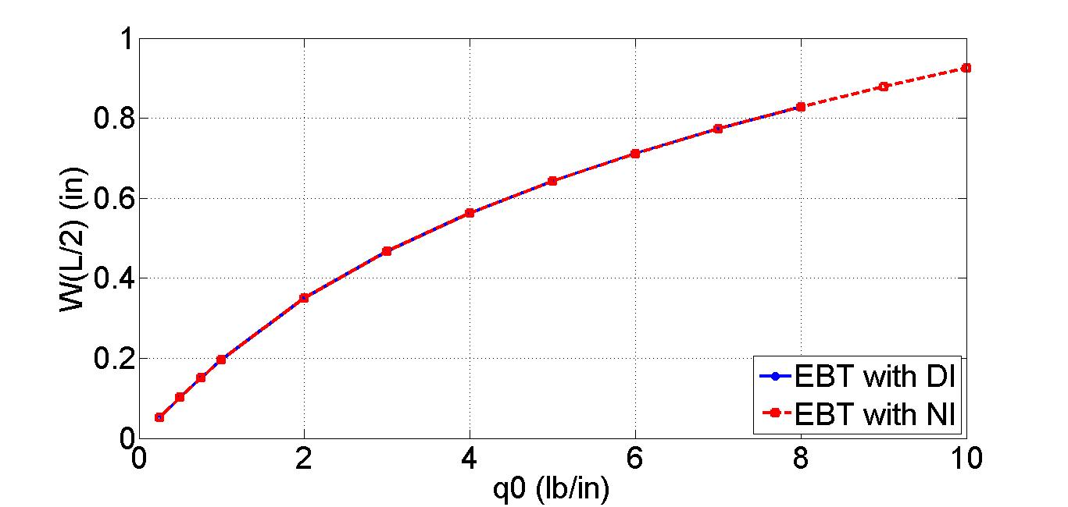

Figure 3.1 The center transverse deflections, w(L/2), versus load q0 for a beam (clamped at one end and pinned at the other end) subjected to uniformly distributed load

**Problem 5.12**

Table 4.1 The transverse deflections, w(L), versus load q0 for a beam with one end fixed and the other end vertically supported by a linear spring and subjected to uniformly distributed load

(horizontal movement of the free end is not restricted)

|  |  |  |  |
| --- | --- | --- | --- |
| Load  q0 | EBT + NI  (8 elements) | | |
| K=0 | K=25 | K=250 |
| 0.5 | 2.5000 | 0.57692 | 0.072816 |
| 1.0 | 5.0000 | 1.1538 | 0.14563 |
| 1.5 | 7.5000 | 1.7308 | 0.21845 |
| 2.0 | 10.000 | 2.3077 | 0.29126 |
| 2.5 | 12.500 | 2.8846 | 0.36408 |
| 3.0 | 15.000 | 3.4615 | 0.43689 |
| 3.5 | 17.500 | 4.0385 | 0.50971 |
| 4.0 | 20.000 | 4.6154 | 0.58252 |
| 4.5 | 22.500 | 5.1923 | 0.65534 |
| 5.0 | 25.000 | 5.7692 | 0.72816 |
| 5.5 | 27.500 | 6.3462 | 0.80097 |
| 6.0 | 30.000 | 6.9231 | 0.87379 |
| 6.5 | 32.500 | 7.5000 | 0.94660 |
| 7.0 | 35.000 | 8.0769 | 1.0194 |
| 7.5 | 37.500 | 8.6538 | 1.0922 |
| 8.0 | 40.000 | 9.2308 | 1.1650 |
| 8.5 | 42.500 | 9.8077 | 1.2379 |
| 9.0 | 45.000 | 10.385 | 1.3107 |
| 9.5 | 47.500 | 10.962 | 1.3835 |
| 10.0 | 50.000 | 11.538 | 1.4563 |

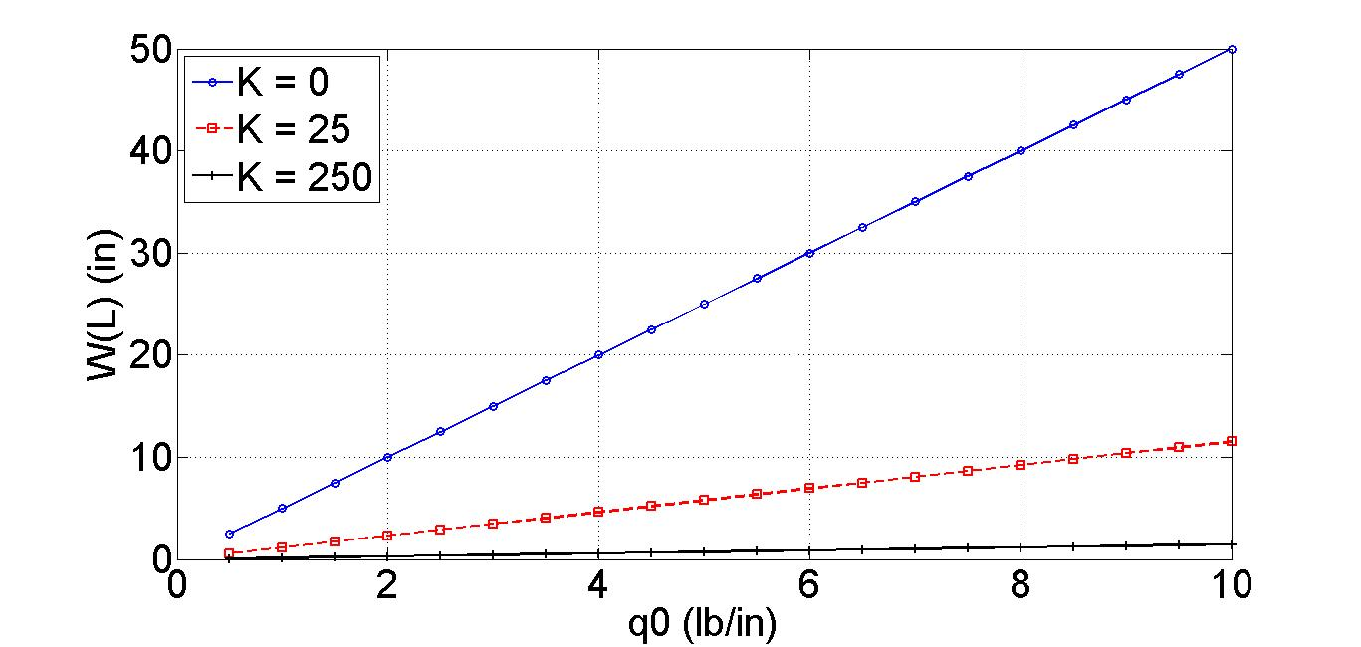

Figure 4.1 The transverse deflections, w(L), versus load q0 (K = 0, 25, 250)

(horizontal movement of the free end is not restricted)

Table 4.2 The transverse deflections, w(L), versus load q0 for a beam with one end fixed and the other end vertically supported by a linear spring and subjected to uniformly distributed load

(horizontal movement of the free end is restricted to zero)

|  |  |  |  |
| --- | --- | --- | --- |
| Load  q0 | EBT + NI  (8 elements) | | |
| K=0 | K=25 | K=250 |
| 0.5 | 0.88103 | 0.50803 | 0.072800 |
| 1.0 | 1.1888 | 0.84289 | 0.14545 |
| 1.5 | 1.4003 | 1.0804 | 0.21767 |
| 2.0 | 1.5666 | 1.2661 | 0.28912 |
| 2.5 | 1.7058 | 1.4202 | 0.35952 |
| 3.0 | 1.8267 | 1.5529 | 0.42870 |
| 3.5 | 1.9344 | 1.6704 | 0.49656 |
| 4.0 | 2.0320 | 1.7762 | 0.56305 |
| 4.5 | 2.1216 | 1.8729 | 0.62816 |
| 5.0 | 2.2048 | 1.9622 | 0.69190 |
| 5.5 | 2.2825 | 2.0454 | 0.75429 |
| 6.0 | 2.3556 | 2.1235 | 0.81535 |
| 6.5 | 2.4248 | 2.1971 | 0.87513 |
| 7.0 | 2.4906 | 2.2669 | 0.93366 |
| 7.5 | 2.5533 | 2.3334 | 0.99098 |
| 8.0 | 2.6134 | 2.3969 | 1.0471 |
| 8.5 | 2.6711 | 2.4578 | 1.1021 |
| 9.0 | 2.7266 | 2.5163 | 1.1561 |
| 9.5 | 2.7802 | 2.5726 | 1.2089 |
| 10.0 | 2.8320 | 2.6270 | 1.2608 |

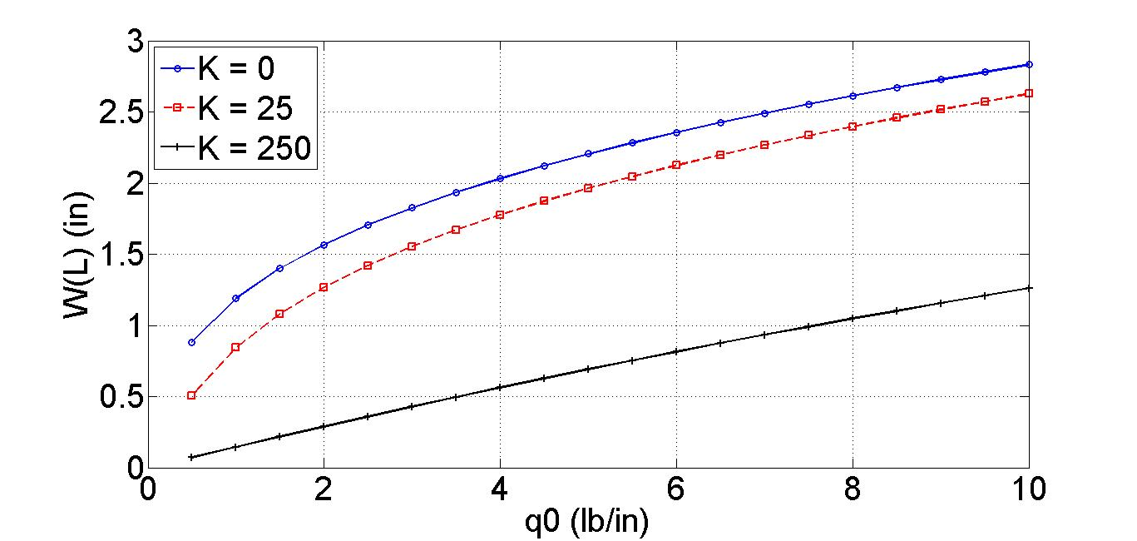

Figure 4.2 The transverse deflections, w(L), versus load q0 (K = 0, 25, 250)

(horizontal movement of the free end is restricted to zero)