**MEEN 673**

**Homework 4**

**Jicheng Lu**

**525004048**

**Problem 1: SS-3 square plate**



, 

Use 8×8L4 and 4×4Q9 elements to solve this problem.

(1) 8×8L4 mesh

Box 1.1. Input file of SS-3 square plate (8×8L4 mesh)

2 4 1 0 1 2 MODEL,NPE,MESH,NPRNT,IGRAD,NONLIN

2 1 1 1 NIPL,NIPN,NITS,NSTR

8 8 NX, NY

0.0 0.625 0.625 0.625 0.625 0.625 0.625 0.625 0.625 X0, (DX(I), I=1,NX)

0.0 0.625 0.625 0.625 0.625 0.625 0.625 0.625 0.625 Y0, (DY(I), I=1,NY)

85 NSPV and next lines ISPV, VSPV

1 1 1 2 1 4 1 5 2 2 2 5 3 2 3 5 4 2 4 5 5 2 5 5

6 2 6 5 7 2 7 5 8 2 8 5 9 1 9 2 9 3 9 5 10 1 10 4

19 1 19 4 28 1 28 4 37 1 37 4 46 1 46 4 55 1 55 4 64 1 64 4

18 1 18 2 18 3 27 1 27 2 27 3 36 1 36 2 36 3 45 1 45 2 45 3

54 1 54 2 54 3 63 1 63 2 63 3 72 1 72 2 72 3 73 1 73 2 73 3

73 4 74 1 74 2 74 3 75 1 75 2 75 3 76 1 76 2 76 3 77 1 77 2

77 3 78 1 78 2 78 3 79 1 79 2 79 3 80 1 80 2 80 3 81 1 81 2

81 3

0.0 0.0 0.0 0.0 0.0 0.0 0.0 0.0 0.0 0.0 0.0 0.0

0.0 0.0 0.0 0.0 0.0 0.0 0.0 0.0 0.0 0.0 0.0 0.0

0.0 0.0 0.0 0.0 0.0 0.0 0.0 0.0 0.0 0.0 0.0 0.0

0.0 0.0 0.0 0.0 0.0 0.0 0.0 0.0 0.0 0.0 0.0 0.0

0.0 0.0 0.0 0.0 0.0 0.0 0.0 0.0 0.0 0.0 0.0 0.0

0.0 0.0 0.0 0.0 0.0 0.0 0.0 0.0 0.0 0.0 0.0 0.0

0.0 0.0 0.0 0.0 0.0 0.0 0.0 0.0 0.0 0.0 0.0 0.0

0.0

0 NSSV

10.0 10.0 1.0 XL,YL,THIKNS

7.80E6 2.60E6 1.30E6 1.30E6 1.30E6 0.25 0.8333 E1,E2,G12,G13,G23,ANU12,AKS

1300.0 0.0 0.0 Q0,QX,QY

0 ICONV

32 20 0.001 0.0 NLS, ITMAX, EPS, GAMA

1.0 1.0 1.0 1.0 1.0 1.0 1.0 1.0 1.0 1.0

1.0 1.0 1.0 1.0 1.0 1.0 1.0 1.0 1.0 1.0

1.0 1.0 1.0 1.0 1.0 1.0 1.0 1.0 1.0 1.0

1.0 1.0 DP(I)

Table 1.1. Numerical results of SS-3 square plate (8×8L4 mesh)

|  |  |  |  |
| --- | --- | --- | --- |
| **P** | **W/h** |  |  |
| 5 | 0.16032 | 2.4625 | 0.76131 |
| 10 | 0.29023 | 4.7325 | 1.3932 |
| 15 | 0.39108 | 6.6571 | 1.901 |
| 20 | 0.47189 | 8.2996 | 2.3223 |
| 25 | 0.53912 | 9.7337 | 2.6844 |
| 30 | 0.59678 | 11.012 | 3.0042 |
| 35 | 0.64737 | 12.171 | 3.2922 |
| 40 | 0.69255 | 13.236 | 3.5557 |
| 45 | 0.73346 | 14.225 | 3.7994 |
| 50 | 0.77091 | 15.15 | 4.027 |
| 55 | 0.8055 | 16.022 | 4.2411 |
| 60 | 0.83769 | 16.849 | 4.4436 |
| 65 | 0.86782 | 17.636 | 4.6361 |
| 70 | 0.89618 | 18.389 | 4.82 |
| 75 | 0.923 | 19.111 | 4.9961 |
| 80 | 0.94845 | 19.807 | 5.1655 |
| 85 | 0.97269 | 20.478 | 5.3286 |
| 90 | 0.99585 | 21.127 | 5.4862 |
| 95 | 1.018 | 21.756 | 5.6387 |
| 100 | 1.0393 | 22.367 | 5.7867 |
| 105 | 1.0598 | 22.962 | 5.9304 |
| 110 | 1.0796 | 23.541 | 6.0701 |
| 115 | 1.0987 | 24.106 | 6.2063 |
| 120 | 1.1171 | 24.657 | 6.339 |
| 125 | 1.135 | 25.197 | 6.4687 |
| 130 | 1.1523 | 25.724 | 6.5954 |
| 135 | 1.1692 | 26.242 | 6.7193 |
| 140 | 1.1856 | 26.749 | 6.8407 |
| 145 | 1.2015 | 27.246 | 6.9596 |
| 150 | 1.2171 | 27.735 | 7.0762 |
| 155 | 1.2322 | 28.215 | 7.1907 |
| 160 | 1.247 | 28.687 | 7.3031 |

(2) 4×4Q9 mesh

Box 1.2. Input file modification of SS-3 square plate (4×4Q9 mesh)

2 9 1 0 1 2 MODEL,NPE,MESH,NPRNT,IGRAD,NONLIN

3 2 2 2 NIPL,NIPN,NITS,NSTR

4 4 NX, NY

0.0 1.25 1.25 1.25 1.25 X0, (DX(I), I=1,NX)

0.0 1.25 1.25 1.25 1.25 Y0, (DY(I), I=1,NY)

Table 1.2. Numerical results of SS-3 square plate (4×4Q9 mesh)

|  |  |  |  |
| --- | --- | --- | --- |
| **P** | **W/h** |  |  |
| 5 | 0.16024 | 2.4741 | 0.81402 |
| 10 | 0.2897 | 4.7495 | 1.4888 |
| 15 | 0.38996 | 6.6739 | 2.0305 |
| 20 | 0.47021 | 8.3135 | 2.48 |
| 25 | 0.53694 | 9.7436 | 2.8665 |
| 30 | 0.59413 | 11.018 | 3.2078 |
| 35 | 0.64431 | 12.172 | 3.5155 |
| 40 | 0.68911 | 13.232 | 3.7969 |
| 45 | 0.72968 | 14.216 | 4.0573 |
| 50 | 0.76681 | 15.137 | 4.3006 |
| 55 | 0.80111 | 16.005 | 4.5294 |
| 60 | 0.83303 | 16.827 | 4.746 |
| 65 | 0.86291 | 17.61 | 4.9519 |
| 70 | 0.89103 | 18.359 | 5.1486 |
| 75 | 0.91762 | 19.078 | 5.337 |
| 80 | 0.94286 | 19.77 | 5.5182 |
| 85 | 0.9669 | 20.437 | 5.6928 |
| 90 | 0.98987 | 21.083 | 5.8616 |
| 95 | 1.0119 | 21.709 | 6.0249 |
| 100 | 1.033 | 22.317 | 6.1833 |
| 105 | 1.0533 | 22.908 | 6.3372 |
| 110 | 1.0729 | 23.484 | 6.4869 |
| 115 | 1.0918 | 24.046 | 6.6328 |
| 120 | 1.1101 | 24.595 | 6.7751 |
| 125 | 1.1279 | 25.132 | 6.914 |
| 130 | 1.1451 | 25.657 | 7.0498 |
| 135 | 1.1618 | 26.172 | 7.1827 |
| 140 | 1.1781 | 26.677 | 7.3129 |
| 145 | 1.1939 | 27.172 | 7.4404 |
| 150 | 1.2093 | 27.658 | 7.5655 |
| 155 | 1.2244 | 28.136 | 7.6883 |
| 160 | 1.239 | 28.607 | 7.8089 |

**Problem 2: Clamped square plate**

Use 8×8L4 and 4×4Q9 elements to solve this problem.

(1) 8×8L4 mesh

Box 2.1. Input file of clamped square plate (8×8L4 mesh)

2 4 1 0 1 2 MODEL,NPE,MESH,NPRNT,IGRAD,NONLIN

2 1 1 1 NIPL,NIPN,NITS,NSTR

8 8 NX, NY

0.0 0.625 0.625 0.625 0.625 0.625 0.625 0.625 0.625 X0, (DX(I), I=1,NX)

0.0 0.625 0.625 0.625 0.625 0.625 0.625 0.625 0.625 Y0, (DY(I), I=1,NY)

117 NSPV and next lines ISPV, VSPV

1 1 1 2 1 4 1 5 2 2 2 5 3 2 3 5 4 2 4 5 5 2 5 5

6 2 6 5 7 2 7 5 8 2 8 5 9 1 9 2 9 3 9 4 9 5 10 1

10 4 19 1 19 4 28 1 28 4 37 1 37 4 46 1 46 4 55 1 55 4 64 1

64 4 18 1 18 2 18 3 18 4 18 5 27 1 27 2 27 3 27 4 27 5 36 1

36 2 36 3 36 4 36 5 45 1 45 2 45 3 45 4 45 5 54 1 54 2 54 3

54 4 54 5 63 1 63 2 63 3 63 4 63 5 72 1 72 2 72 3 72 4 72 5

73 1 73 2 73 3 73 4 73 5 74 1 74 2 74 3 74 4 74 5 75 1 75 2

75 3 75 4 75 5 76 1 76 2 76 3 76 4 76 5 77 1 77 2 77 3 77 4

77 5 78 1 78 2 78 3 78 4 78 5 79 1 79 2 79 3 79 4 79 5 80 1

80 2 80 3 80 4 80 5 81 1 81 2 81 3 81 4 81 5

0.0 0.0 0.0 0.0 0.0 0.0 0.0 0.0 0.0 0.0 0.0 0.0

0.0 0.0 0.0 0.0 0.0 0.0 0.0 0.0 0.0 0.0 0.0 0.0

0.0 0.0 0.0 0.0 0.0 0.0 0.0 0.0 0.0 0.0 0.0 0.0

0.0 0.0 0.0 0.0 0.0 0.0 0.0 0.0 0.0 0.0 0.0 0.0

0.0 0.0 0.0 0.0 0.0 0.0 0.0 0.0 0.0 0.0 0.0 0.0

0.0 0.0 0.0 0.0 0.0 0.0 0.0 0.0 0.0 0.0 0.0 0.0

0.0 0.0 0.0 0.0 0.0 0.0 0.0 0.0 0.0 0.0 0.0 0.0

0.0 0.0 0.0 0.0 0.0 0.0 0.0 0.0 0.0 0.0 0.0 0.0

0.0 0.0 0.0 0.0 0.0 0.0 0.0 0.0 0.0 0.0 0.0 0.0

0.0 0.0 0.0 0.0 0.0 0.0 0.0 0.0 0.0

0 NSSV

10.0 10.0 1.0 XL,YL,THIKNS

7.80E6 2.60E6 1.30E6 1.30E6 1.30E6 0.25 0.8333 E1,E2,G12,G13,G23,ANU12,AKS

1300.0 0.0 0.0 Q0,QX,QY

0 ICONV

32 20 0.001 0.0 NLS, ITMAX, EPS, GAMA

1.0 1.0 1.0 1.0 1.0 1.0 1.0 1.0 1.0 1.0

1.0 1.0 1.0 1.0 1.0 1.0 1.0 1.0 1.0 1.0

1.0 1.0 1.0 1.0 1.0 1.0 1.0 1.0 1.0 1.0

1.0 1.0 DP(I)

Table 2.1. Numerical results of clamped square plate (8×8L4 mesh)

|  |  |  |  |
| --- | --- | --- | --- |
| **P** | **W/h** |  |  |
| 5 | 0.051359 | 1.6429 | 0.17851 |
| 10 | 0.10223 | 3.308 | 0.35731 |
| 15 | 0.15216 | 4.9818 | 0.53484 |
| 20 | 0.20078 | 6.6522 | 0.70975 |
| 25 | 0.24782 | 8.3087 | 0.88091 |
| 30 | 0.2931 | 9.9429 | 1.0475 |
| 35 | 0.33653 | 11.549 | 1.2089 |
| 40 | 0.37809 | 13.122 | 1.3649 |
| 45 | 0.41779 | 14.66 | 1.5153 |
| 50 | 0.45571 | 16.162 | 1.6601 |
| 55 | 0.49192 | 17.627 | 1.7994 |
| 60 | 0.52651 | 19.056 | 1.9334 |
| 65 | 0.5596 | 20.449 | 2.0623 |
| 70 | 0.59127 | 21.808 | 2.1863 |
| 75 | 0.62162 | 23.134 | 2.3084 |
| 80 | 0.65074 | 24.428 | 2.4273 |
| 85 | 0.67872 | 25.692 | 2.5423 |
| 90 | 0.70563 | 26.926 | 2.6537 |
| 95 | 0.73156 | 28.134 | 2.7617 |
| 100 | 0.75656 | 29.315 | 2.8663 |
| 105 | 0.78071 | 30.471 | 2.9679 |
| 110 | 0.80405 | 31.603 | 3.0665 |
| 115 | 0.82663 | 32.713 | 3.1622 |
| 120 | 0.84852 | 33.801 | 3.2553 |
| 125 | 0.86974 | 34.869 | 3.3458 |
| 130 | 0.89034 | 35.917 | 3.4339 |
| 135 | 0.91036 | 36.947 | 3.5197 |
| 140 | 0.92983 | 37.958 | 3.6033 |
| 145 | 0.94878 | 38.952 | 3.6848 |
| 150 | 0.96724 | 39.93 | 3.7642 |
| 155 | 0.98523 | 40.892 | 3.8417 |
| 160 | 1.0028 | 41.84 | 3.9173 |

(2) 4×4Q9 mesh

Box 2.2. Input file modification of clamped square plate (4×4Q9 mesh)

2 9 1 0 1 2 MODEL,NPE,MESH,NPRNT,IGRAD,NONLIN

3 2 2 2 NIPL,NIPN,NITS,NSTR

4 4 NX, NY

0.0 1.25 1.25 1.25 1.25 X0, (DX(I), I=1,NX)

0.0 1.25 1.25 1.25 1.25 Y0, (DY(I), I=1,NY)

Table 2.2. Numerical results of clamped square plate (4×4Q9 mesh)

|  |  |  |  |
| --- | --- | --- | --- |
| **P** | **W/h** |  |  |
| 5 | 0.051456 | 1.6964 | 0.18199 |
| 10 | 0.1024 | 3.4152 | 0.36407 |
| 15 | 0.15237 | 5.1421 | 0.54461 |
| 20 | 0.20099 | 6.864 | 0.72241 |
| 25 | 0.24797 | 8.57 | 0.89692 |
| 30 | 0.29314 | 10.251 | 1.0671 |
| 35 | 0.33642 | 11.902 | 1.2323 |
| 40 | 0.37778 | 13.517 | 1.3924 |
| 45 | 0.41726 | 15.095 | 1.5472 |
| 50 | 0.45493 | 16.634 | 1.6967 |
| 55 | 0.49087 | 18.134 | 1.841 |
| 60 | 0.52519 | 19.596 | 1.9803 |
| 65 | 0.55799 | 21.02 | 2.1147 |
| 70 | 0.58937 | 22.409 | 2.2444 |
| 75 | 0.61943 | 23.763 | 2.3697 |
| 80 | 0.64826 | 25.084 | 2.4909 |
| 85 | 0.67595 | 26.373 | 2.608 |
| 90 | 0.70258 | 27.632 | 2.7213 |
| 95 | 0.72823 | 28.863 | 2.8311 |
| 100 | 0.75296 | 30.066 | 2.9375 |
| 105 | 0.77684 | 31.244 | 3.0406 |
| 110 | 0.79992 | 32.397 | 3.1406 |
| 115 | 0.82225 | 33.527 | 3.2377 |
| 120 | 0.84389 | 34.634 | 3.3321 |
| 125 | 0.86487 | 35.72 | 3.4238 |
| 130 | 0.88524 | 36.786 | 3.513 |
| 135 | 0.90503 | 37.833 | 3.5998 |
| 140 | 0.92427 | 38.861 | 3.6844 |
| 145 | 0.94301 | 39.872 | 3.7667 |
| 150 | 0.96126 | 40.866 | 3.8469 |
| 155 | 0.97904 | 41.843 | 3.9252 |
| 160 | 0.9964 | 42.806 | 4.0015 |

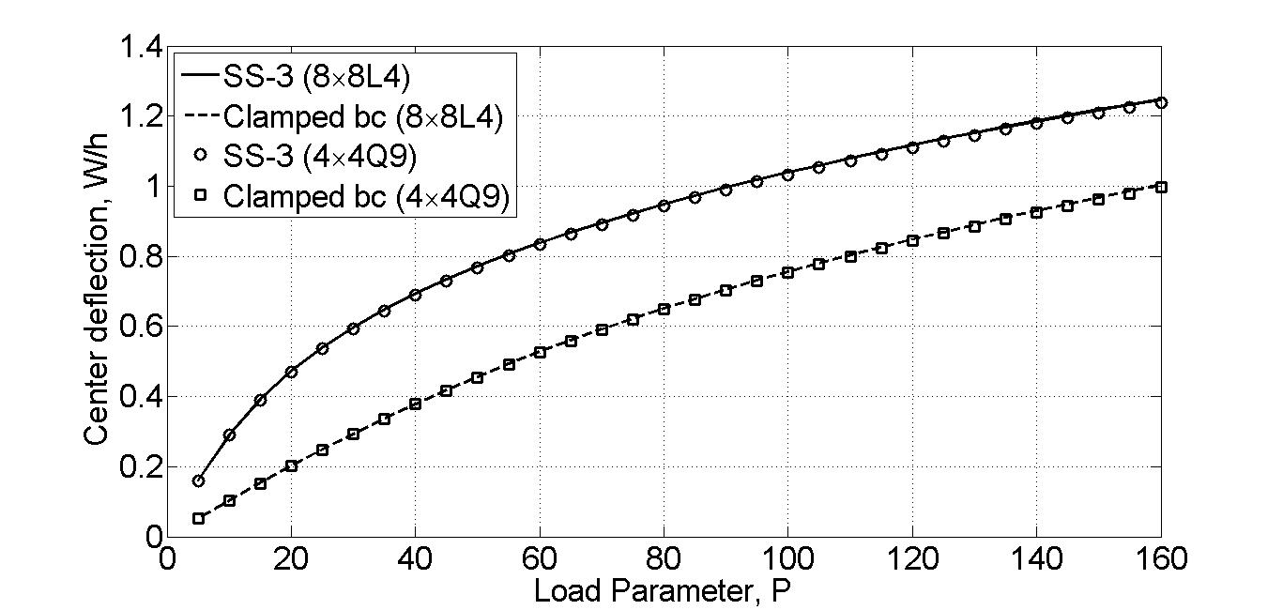

Fig 1. Load vs center deflection of the SS-3 and clamped boundary condition

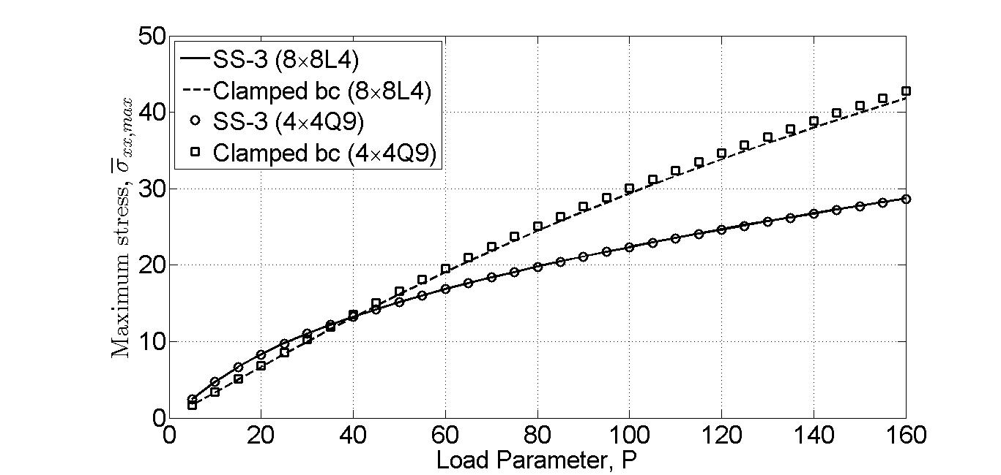

Fig 2. Load vs maximum stress () of the SS-3 and clamped boundary condition

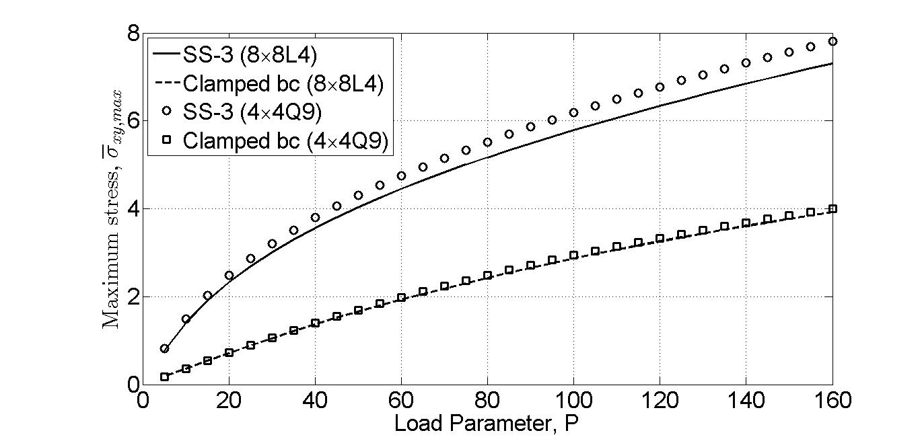

Fig 3. Load vs maximum stress () of the SS-3 and clamped boundary condition