**MEEN 673**

**Homework 5**

**Jicheng Lu**

**525004048**

**Problem 1: (Example 6.7.1)**

Governing equation:

 in ;  on 

Boundary conditions in the quarter domain:



Initial condition:



Use direction iteration method to solve the problem.

The following box gives the input file of the 8x8 linear element using Crank-Nicolson scheme.

Box 1.1 Input file of the 8x8 linear element with Crank-Nicolson scheme

4 2 1 1 0 0 1 1 NPE,NGPF,NGPR,MESH,NPRNT,IGRAD,NONLIN,ITEM

8 8 NX,NY

0.0 0.125 0.125 0.125 0.125 0.125 0.125 0.125 0.125 X0,(DX(I),I=1,NX)

0.0 0.125 0.125 0.125 0.125 0.125 0.125 0.125 0.125 Y0,(DY(I),I=1,NY)

17 NSPV and next lines ISPV, VSPV

9 1 18 1 27 1 36 1 45 1 54 1 63 1 72 1

73 1 74 1 75 1 76 1 77 1 78 1 79 1 80 1

81 1

0.0 0.0 0.0 0.0 0.0 0.0 0.0 0.0

0.0 0.0 0.0 0.0 0.0 0.0 0.0 0.0

0.0

0 NSSV

1.0 0.0 0.0 A10,A1X,A1Y

1.0 0.0 0.0 A20,A2X,A2Y

0.0 0.0 0.0 A00,A0X,A0Y

0 ICONV

1.0 0.0 0.0 F0,FX,FY

0.0 0.0 0.0 A1U,A1UX,A1UY

0.0 0.0 0.0 A2U,A2UX,A2UY

1.0 0.0 0.0 C0,CX,CY

25 25 1 NTIME,NSTP,INTVL

0.05 0.5 0.2 DT,ALFA,GAMA

1 20 0.001 0.0 NLS,ITMAX,EPS,IREX

1.0 DP(I)

For the 4x4 quadratic element, modify the parts in the input file as follows:

9 3 2 1 0 0 1 1 NPE,NGPF,NGPR,MESH,NPRNT,IGRAD,NONLIN,ITEM

4 4 NX,NY

0.0 0.25 0.25 0.25 0.25 X0,(DX(I),I=1,NX)

0.0 0.25 0.25 0.25 0.25 Y0,(DY(I),I=1,NY)

For the backward difference scheme, change the parts in the input file as follows:

25 25 1 NTIME,NSTP,INTVL

0.05 1.0 0.2 DT,ALFA,GAMA

For the forward difference scheme, change the parts in the input file as follows:

1000 1000 50 NTIME,NSTP,INTVL

0.001 0.0 0.2 DT,ALFA,GAMA

The numerical results of the center temperature with time t are presented in Table 1.1.

Table 1.1 Variation of  with time t, obtained with various time approximation schemes

|  |  |  |  |  |  |  |
| --- | --- | --- | --- | --- | --- | --- |
|  | 8x8 L4 | | | 4x4 Q9 | | |
| Time | Crank-Nicolson | Backward difference | Forward difference | Crank-Nicolson | Backward difference | Forward difference |
| 0.05 | 0.0497 | 0.0480 | 0.0500 | 0.0496 | 0.0479 | 0.0500 |
| 0.10 | 0.0975 | 0.0916 | 0.0983 | 0.0971 | 0.0913 | 0.0979 |
| 0.15 | 0.1398 | 0.1294 | 0.1400 | 0.1390 | 0.1288 | 0.1393 |
| 0.20 | 0.1740 | 0.1612 | 0.1737 | 0.1730 | 0.1604 | 0.1728 |
| 0.25 | 0.2006 | 0.1873 | 0.2004 | 0.1996 | 0.1864 | 0.1994 |
| 0.30 | 0.2215 | 0.2085 | 0.2213 | 0.2205 | 0.2075 | 0.2202 |
| 0.35 | 0.2379 | 0.2257 | 0.2376 | 0.2368 | 0.2247 | 0.2365 |
| 0.40 | 0.2506 | 0.2395 | 0.2503 | 0.2495 | 0.2385 | 0.2493 |
| 0.45 | 0.2605 | 0.2506 | 0.2603 | 0.2594 | 0.2496 | 0.2592 |
| 0.50 | 0.2682 | 0.2595 | 0.2680 | 0.2672 | 0.2585 | 0.2670 |
| 0.55 | 0.2743 | 0.2667 | 0.2741 | 0.2732 | 0.2656 | 0.2731 |
| 0.60 | 0.2790 | 0.2724 | 0.2788 | 0.2779 | 0.2714 | 0.2778 |
| 0.65 | 0.2826 | 0.2770 | 0.2825 | 0.2816 | 0.2760 | 0.2815 |
| 0.70 | 0.2855 | 0.2807 | 0.2854 | 0.2845 | 0.2797 | 0.2844 |
| 0.75 | 0.2877 | 0.2837 | 0.2876 | 0.2867 | 0.2827 | 0.2866 |
| 0.80 | 0.2895 | 0.2860 | 0.2894 | 0.2885 | 0.2850 | 0.2884 |
| 0.85 | 0.2908 | 0.2879 | 0.2908 | 0.2898 | 0.2870 | 0.2898 |
| 0.90 | 0.2919 | 0.2895 | 0.2918 | 0.2909 | 0.2885 | 0.2909 |
| 0.95 | 0.2927 | 0.2907 | 0.2926 | 0.2917 | 0.2897 | 0.2917 |
| 1.00 | 0.2933 | 0.2916 | 0.2933 | 0.2924 | 0.2907 | 0.2924 |
| 1.25 | 0.2949 | 0.2943 | 0.2949 | 0.2940 | 0.2934 | 0.2940 |

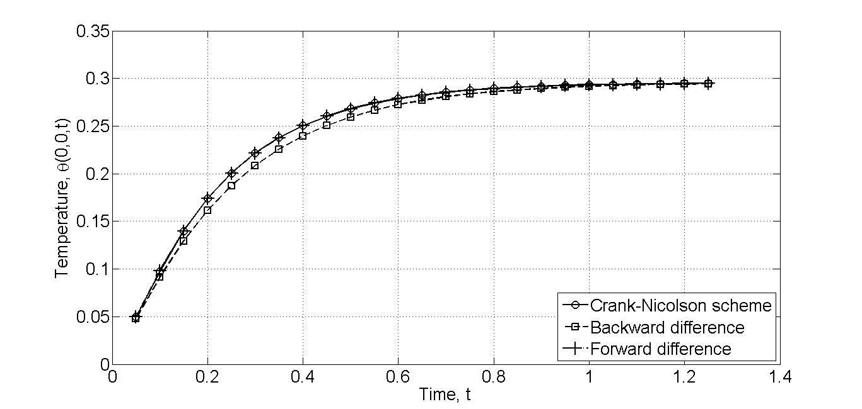

Figure 1.1. Evolution of the temperature  with time t.

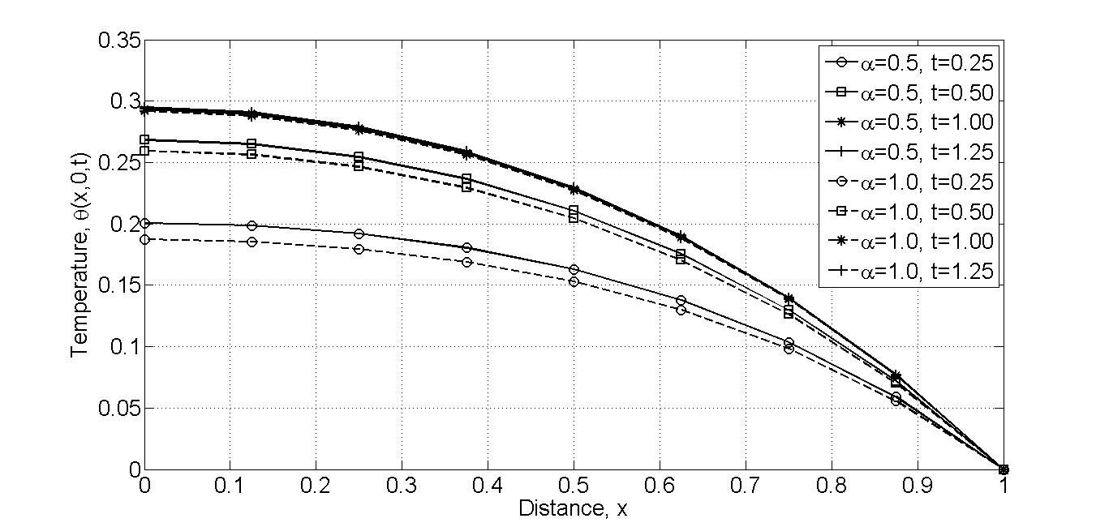

Figure 1.2. Variation of temperature field  with x for various values of time t of the heat conduction problem (the Crank-Nicolson and backward difference schemes are used; mesh 8x8 L4).

**Problem 2: (Example 6.7.3)**

Governing equation:

 in ;  on ,

where  (For linear case, , and for nonlinear case, ).

Boundary conditions:



Initial condition:



Use direction iteration method and 8x8 linear element to solve the problem.

The following box gives the input file of the 8x8 linear element using constant-average acceleration scheme (linear case).

Box 2.1 Input file of the 8x8 linear element with constant-average acceleration scheme

(linear case)

4 2 1 1 0 0 1 2 NPE,NGPF,NGPR,MESH,NPRNT,IGRAD,NONLIN,ITEM

8 8 NX,NY

0.0 0.125 0.125 0.125 0.125 0.125 0.125 0.125 0.125 X0,(DX(I),I=1,NX)

0.0 0.125 0.125 0.125 0.125 0.125 0.125 0.125 0.125 Y0,(DY(I),I=1,NY)

17 NSPV and next lines ISPV, VSPV

9 1 18 1 27 1 36 1 45 1 54 1 63 1 72 1

73 1 74 1 75 1 76 1 77 1 78 1 79 1 80 1

81 1

0.0 0.0 0.0 0.0 0.0 0.0 0.0 0.0

0.0 0.0 0.0 0.0 0.0 0.0 0.0 0.0

0.0

0 NSSV

1.0 0.0 0.0 A10,A1X,A1Y

1.0 0.0 0.0 A20,A2X,A2Y

0.0 0.0 0.0 A00,A0X,A0Y

0 ICONV

1.0 0.0 0.0 F0,FX,FY

0.0 0.0 0.0 A1U,A1UX,A1UY

0.0 0.0 0.0 A2U,A2UX,A2UY

1.0 0.0 0.0 C0,CX,CY

52 52 1 NTIME,NSTP,INTVL

0.1 0.5 0.5 DT,ALFA,GAMA

1 20 0.001 0.0 NLS,ITMAX,EPS,IREX

1.0 DP(I)

For nonlinear case, change the parts in the input file as follows:

0.0 0.2 0.2 A1U,A1UX,A1UY

0.0 0.2 0.2 A2U,A2UX,A2UY

The numerical results for the linear case are presented in Table 2.1 with CAM (), LAM1 (), LAM2 ().

Table 2.1 Center deflection versus time for a square membrane fixed on its edge and subjected to uniform load (8x8L4)

|  |  |  |  |
| --- | --- | --- | --- |
| Time | CAM | LAM1 | LAM2 |
| 0.1 | 0.0025 | 0.0017 | 0.0029 |
| 0.2 | 0.0125 | 0.0117 | 0.0154 |
| 0.3 | 0.0325 | 0.0317 | 0.0379 |
| 0.4 | 0.0625 | 0.0617 | 0.0704 |
| 0.5 | 0.1025 | 0.1017 | 0.1129 |
| 0.6 | 0.1525 | 0.1517 | 0.1657 |
| 0.7 | 0.2125 | 0.2117 | 0.2269 |
| 0.8 | 0.2825 | 0.2812 | 0.2989 |
| 0.9 | 0.3624 | 0.3626 | 0.3896 |
| 1.0 | 0.4501 | 0.4565 | 0.4876 |
| 1.1 | 0.5378 | 0.5482 | 0.5701 |
| 1.2 | 0.6110 | 0.6161 | 0.6301 |
| 1.3 | 0.6550 | 0.6546 | 0.6619 |
| 1.4 | 0.6656 | 0.6658 | 0.6608 |
| 1.5 | 0.6492 | 0.6482 | 0.6359 |
| 1.6 | 0.6133 | 0.6079 | 0.5939 |
| 1.7 | 0.5624 | 0.5578 | 0.5424 |
| 1.8 | 0.5025 | 0.5023 | 0.4858 |
| 1.9 | 0.4419 | 0.4397 | 0.4260 |
| 2.0 | 0.3833 | 0.3872 | 0.3661 |
| 2.1 | 0.3243 | 0.3122 | 0.3069 |
| 2.2 | 0.2655 | 0.2842 | 0.2511 |
| 2.3 | 0.2105 | 0.1738 | 0.1959 |
| 2.4 | 0.1601 | 0.2253 | 0.1427 |
| 2.5 | 0.1131 | -0.0085 | 0.1014 |
| 2.6 | 0.0706 | 0.2846 | 0.0693 |
| 2.7 | 0.0343 | -0.3446 | 0.0289 |
| 2.8 | 0.0038 | 0.6698 | -0.0196 |
| 2.9 | -0.0204 | -1.1897 | -0.0553 |
| 3.0 | -0.0348 | 1.9602 | -0.0625 |
| 3.1 | -0.0339 | -3.5325 | -0.0358 |
| 3.2 | -0.0102 | 5.9877 | 0.0207 |

Figure 2.1 shows the comparison of linear and nonlinear center deflections of the membrane using constant-average acceleration scheme. It can be noted that the nonlinear deflection starts to drift away from the linear solution, both in amplitude and period with time.

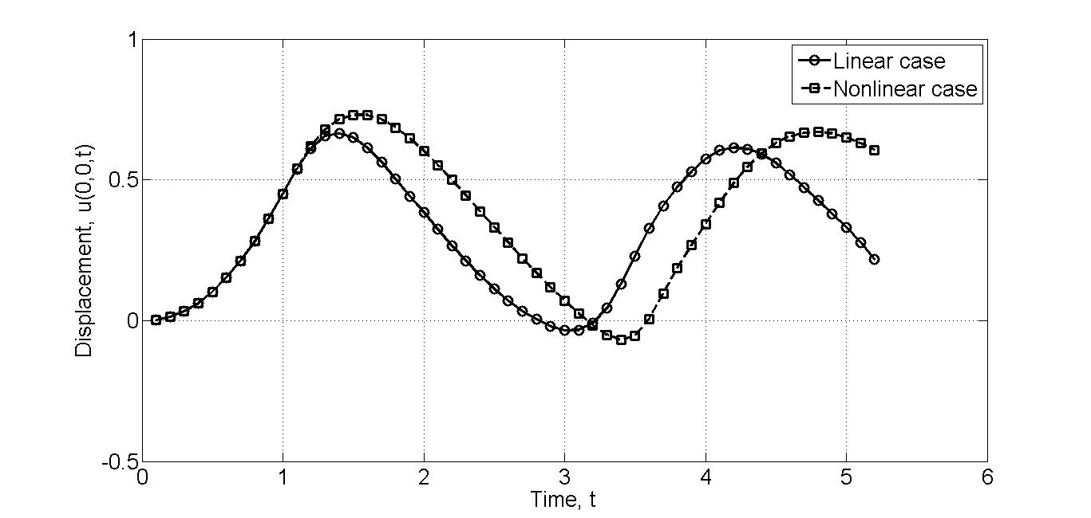

Figure 2.1. Comparison of the linear and nonlinear center deflections  of the membrane using constant-average acceleration scheme.