**MEEN 673**

**Homework 6**

**Jicheng Lu**

**525004048**

**Problem 1: (Fluid squeezed between parallel plates)**

Table 1.1 Comparison of finite solution Vx(x,0) with the analytical solution for fluid squeezed between plates; 5x3Q9 and 10x6L4 meshes are used in the penalty model.

|  |  |  |  |  |  |  |  |
| --- | --- | --- | --- | --- | --- | --- | --- |
|  | $$γ=1.0$$ | | $$γ=100$$ | | $$γ={10}^{8}$$ | |  |
| X | 4-node | 9-node | 4-node | 9-node | 4-node | 9-node | Exact |
| 1.0000 | 0.0303 | 0.0310 | 0.6563 | 0.6513 | 0.7576 | 0.7505 | 0.7500 |
| 2.0000 | 0.0677 | 0.0691 | 1.3165 | 1.3062 | 1.5135 | 1.4992 | 1.5000 |
| 3.0000 | 0.1213 | 0.1233 | 1.9911 | 1.9769 | 2.2756 | 2.2557 | 2.2500 |
| 4.0000 | 0.2040 | 0.2061 | 2.6960 | 2.6730 | 3.0541 | 3.0238 | 3.0000 |
| 4.5000 | 0.2611 | 0.2631 | 3.0718 | 3.0463 | 3.4648 | 3.4307 | 3.3750 |
| 5.0000 | 0.3297 | 0.3310 | 3.4347 | 3.3956 | 3.8517 | 3.8029 | 3.7500 |
| 5.2500 | 0.3674 | 0.3684 | 3.6120 | 3.5732 | 4.0441 | 3.9944 | 3.9375 |
| 5.5000 | 0.4060 | 0.4064 | 3.7388 | 3.6874 | 4.1712 | 4.1085 | 4.1250 |
| 5.7500 | 0.4438 | 0.4443 | 3.8316 | 3.7924 | 4.2654 | 4.2160 | 4.3125 |
| 6.0000 | 0.4793 | 0.4797 | 3.8362 | 3.7862 | 4.2549 | 4.1937 | 4.5000 |

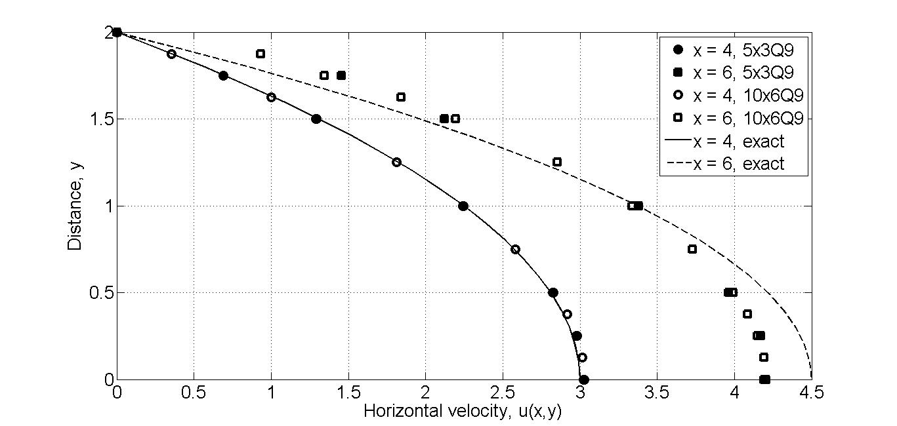

Figure 1.1 Pressure P(x,y0) versus x for fluid squeezed between parallel plates.

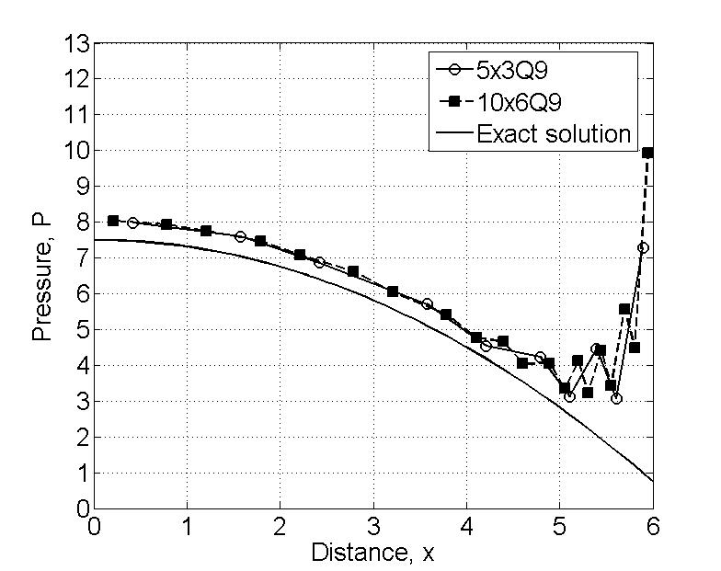

Figure 1.2 Velocity fields V(x0,y) at x0=4 and x0=6 for fluid squeezed between parallel plates (near or at the top plate).

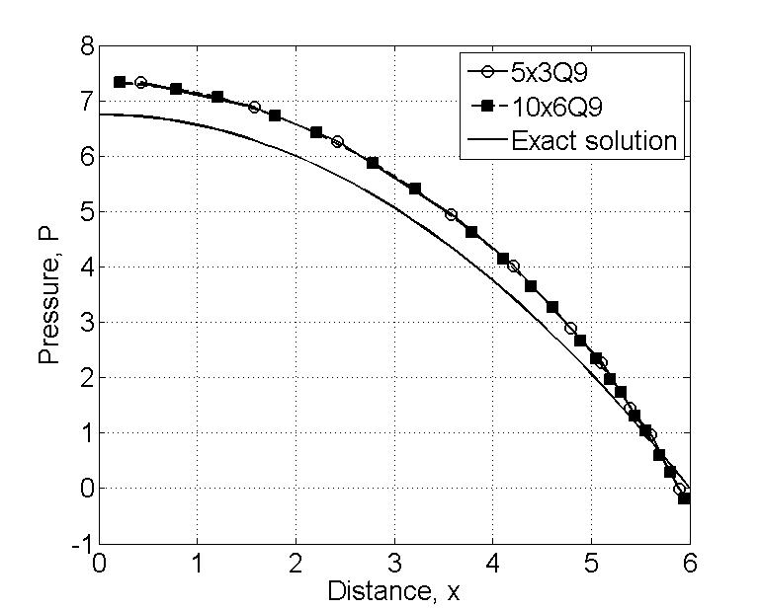

Figure 1.2 Velocity fields V(x0,y) at x0=4 and x0=6 for fluid squeezed between parallel plates (near or at the centerline of the domain).

**Problem 2: (Lid-driven cavity flow)**

Table 2.1 Velocity Vx(0.5,y) obtained with linear and quadratic elements and for various values of the Reynolds number (values in parentheses are linear solution).

|  |  |  |  |  |  |  |
| --- | --- | --- | --- | --- | --- | --- |
| y | Mesh: 8x8 L4 | | | Mesh: 4x4 Q9 | | |
| Re | 250 | 500 | 750 | 250 | 500 | 750 |
| 0.1250 | -0.0367  (-0.0579 ) | -0.0239 | -0.0128 | -0.0412  (-0.0615) | -0.0131 | 0.0146 |
| 0.2500 | -0.0688  (-0.0988) | -0.0502 | -0.0320 | -0.0851  (-0.1039) | -0.0520 | 0.0017 |
| 0.3750 | -0.0944  (-0.1317) | -0.0733 | -0.0533 | -0.1283  (-0.1394) | -0.1133 | -0.0481 |
| 0.5000 | -0.0911  (-0.1471) | -0.0696 | -0.0569 | -0.1305  (-0.1563) | -0.1284 | -0.1086 |
| 0.6250 | -0.0176  (-0.0950) | 0.0043 | 0.0020 | -0.0437  (-0.1118) | -0.0494 | -0.0901 |
| 0.7500 | 0.0470  (0.0805) | 0.0414 | 0.0323 | 0.0754  (0.0481) | 0.1042 | 0.0549 |
| 0.8750 | 0.2616  (0.4501) | 0.1712 | 0.1207 | 0.2833  (0.4186) | 0.2139 | 0.1495 |

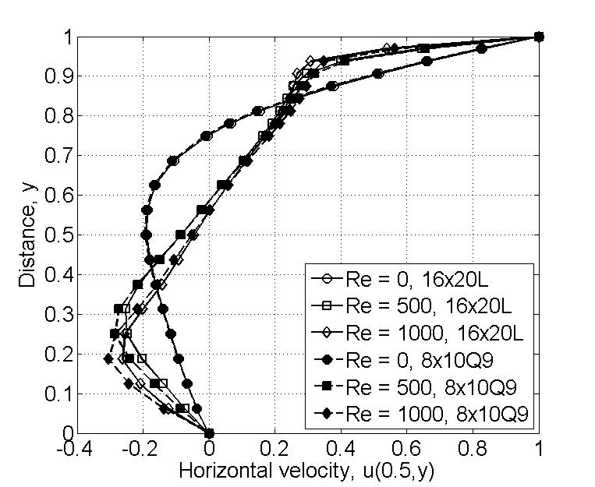

Figure 2.1 Velocity Vx(0.5,y) versus y for Reynolds numbers Re = 0,500, and 1000

(obtained with 8x10Q9 and 16x20L4 meshes)

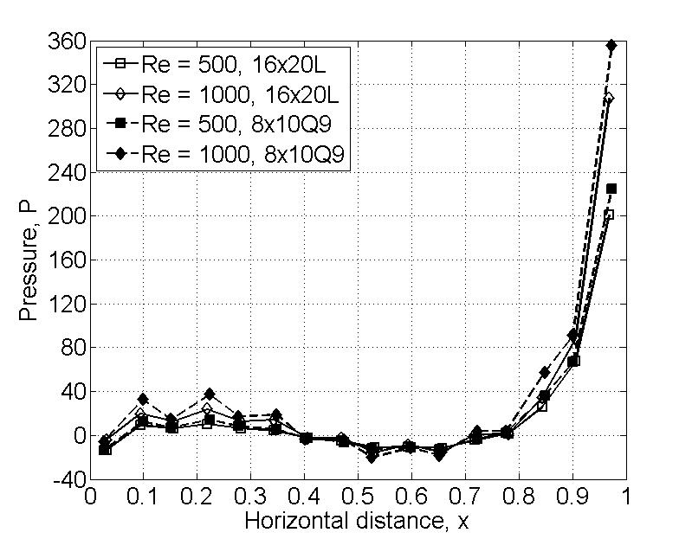

Figure 2.2 Plots of pressure P(x,y0) along the top wall of the cavity

(8x10Q9 and 16x20L4 meshes)