**MEEN 673**

**Homework 7**

**Jicheng Lu**

**525004048**

**Problem 1:**

Table 1.1 Total displacements of node 17 (at the free end) in a cantilevered plate under uniform load; obtained with the updated Lagrangian formulation (5Q8 with iteration).

|  |  |  |  |  |  |  |  |  |
| --- | --- | --- | --- | --- | --- | --- | --- | --- |
|  | 3x3 Gauss rule for K | | | | 2x2 Gauss rule for K | | | |
| f0=q0h | x | -y | -u | -v | x | -y | -u | -v |
| 50 | 9.9787 | 0.1145 | 0.0213 | 0.6145 | 9.9786 | 0.1163 | 0.0214 | 0.6163 |
| 100 | 9.9159 | 0.7181 | 0.0841 | 1.2181 | 9.9155 | 0.7225 | 0.0845 | 1.2225 |
| 150 | 9.8152 | 1.3010 | 0.1848 | 1.8010 | 9.8138 | 1.3091 | 0.1862 | 1.8091 |
| 200 | 9.6816 | 1.8554 | 0.3184 | 2.3554 | 9.6785 | 1.8688 | 0.3215 | 2.3688 |
| 250 | 9.5212 | 2.3758 | 0.4788 | 2.8758 | 9.5152 | 2.3960 | 0.4848 | 2.8960 |
| 300 | 9.3402 | 2.8593 | 0.6598 | 3.3593 | 9.3300 | 2.8874 | 0.6700 | 3.3874 |
| 350 | 9.1444 | 3.3046 | 0.8556 | 3.8046 | 9.1288 | 3.3417 | 0.8712 | 3.8417 |
| 400 | 8.9391 | 3.7125 | 1.0609 | 4.2125 | 8.9168 | 3.7587 | 1.0832 | 4.2587 |
| 450 | 8.7284 | 4.0846 | 1.2716 | 4.5846 | 8.6985 | 4.1398 | 1.3015 | 4.6398 |
| 500 | 8.5161 | 4.4229 | 1.4839 | 4.9229 | 8.4776 | 4.4871 | 1.5224 | 4.9871 |
| 550 | 8.3046 | 4.7302 | 1.6954 | 5.2302 | 8.2571 | 4.8028 | 1.7429 | 5.3028 |
| 600 | 8.0962 | 5.0093 | 1.9038 | 5.5093 | 8.0392 | 5.0897 | 1.9608 | 5.5897 |
| 650 | 7.8922 | 5.2628 | 2.1078 | 5.7628 | 7.8270 | 5.3480 | 2.1730 | 5.8480 |
| 700 | 7.6937 | 5.4932 | 2.3063 | 5.9932 | 7.6195 | 5.5843 | 2.3805 | 6.0843 |
| 750 | 7.5013 | 5.7031 | 2.4987 | 6.2031 | 7.4180 | 5.7995 | 2.5820 | 6.2995 |
| 800 | 7.3172 | 5.8922 | 2.6828 | 6.3922 | 7.2233 | 5.9956 | 2.7767 | 6.4956 |
| 850 | 7.1384 | 6.0668 | 2.8616 | 6.5668 | 7.0356 | 6.1746 | 2.9644 | 6.6746 |
| 900 | 6.9664 | 6.2268 | 3.0336 | 6.7268 | 6.8550 | 6.3382 | 3.1450 | 6.8382 |

Table 1.2 Total displacements of node 17 (at the free end) in a cantilevered plate under uniform load; obtained with the updated Lagrangian formulation (5Q8 without iteration).

|  |  |  |  |  |  |  |  |  |
| --- | --- | --- | --- | --- | --- | --- | --- | --- |
|  | 3x3 Gauss rule for K | | | | 2x2 Gauss rule for K | | | |
| f0=q0h | x | -y | -u | -v | x | -y | -u | -v |
| 50 | 10.0000 | 0.1163 | 0.0000 | 0.6163 | 10.0000 | 0.1181 | 0.0000 | 0.6181 |
| 100 | 9.9690 | 0.2686 | 0.0310 | 0.7686 | 9.9689 | 0.2707 | 0.0311 | 0.7707 |
| 150 | 9.8901 | 1.1644 | 0.1099 | 1.6644 | 9.8896 | 1.1698 | 0.1104 | 1.6698 |
| 200 | 9.8272 | 1.2658 | 0.1728 | 1.7658 | 9.8264 | 1.2719 | 0.1736 | 1.7719 |
| 250 | 9.6208 | 2.2693 | 0.3792 | 2.7693 | 9.6183 | 2.2818 | 0.3817 | 2.7818 |
| 300 | 9.5421 | 2.3359 | 0.4579 | 2.8359 | 9.5387 | 2.3493 | 0.4613 | 2.8493 |
| 350 | 9.2429 | 3.2102 | 0.7571 | 3.7102 | 9.2347 | 3.2349 | 0.7653 | 3.7349 |
| 400 | 9.1659 | 3.2796 | 0.8341 | 3.7796 | 9.1561 | 3.3051 | 0.8439 | 3.8051 |
| 450 | 8.8026 | 4.0388 | 1.1974 | 4.5388 | 8.7828 | 4.0812 | 1.2172 | 4.5812 |
| 500 | 8.7266 | 4.1054 | 1.2734 | 4.6054 | 8.7047 | 4.1480 | 1.2953 | 4.6480 |
| 550 | 8.3545 | 4.7082 | 1.6455 | 5.2082 | 8.3180 | 4.7692 | 1.6820 | 5.2692 |
| 600 | 8.2768 | 4.7839 | 1.7232 | 5.2839 | 8.2380 | 4.8448 | 1.7620 | 5.3448 |
| 650 | 7.9257 | 5.2508 | 2.0743 | 5.7508 | 7.8691 | 5.3291 | 2.1309 | 5.8291 |
| 700 | 7.8407 | 5.3368 | 2.1593 | 5.8368 | 7.7821 | 5.4146 | 2.2179 | 5.9146 |
| 750 | 7.5280 | 5.6913 | 2.4720 | 6.1913 | 7.4510 | 5.7835 | 2.5490 | 6.2835 |
| 800 | 7.4303 | 5.7880 | 2.5697 | 6.2880 | 7.3514 | 5.8796 | 2.6486 | 6.3796 |
| 850 | 7.1618 | 6.0550 | 2.8382 | 6.5550 | 7.0657 | 6.1576 | 2.9343 | 6.6576 |
| 900 | 7.0488 | 6.1600 | 2.9512 | 6.6600 | 6.9505 | 6.2621 | 3.0495 | 6.7621 |

Table 1.3 Stress (x10-5) evaluated at the left-most Gauss point nearest to the top of element 1 in a cantilevered plate under uniform load; obtained with the updated Lagrangian formulation with 5Q8 mesh (X=0.4227, Y=0.7887 when evaluate the Piola-Kirchhoff stress)

|  |  |  |  |  |  |  |  |  |
| --- | --- | --- | --- | --- | --- | --- | --- | --- |
| 3x3 Gauss rule for K | | | Cauchy stress | | | Piola-Kirchhoff stress | | |
| f0=q0h | x | y |  |  |  |  |  |  |
| 50 | 0.4253 | 0.7861 | 0.7776 | 0.1819 | 0.0539 | 0.7885 | 0.1840 | 0.0487 |
| 100 | 0.4280 | 0.7836 | 1.5457 | 0.3579 | 0.1198 | 1.5894 | 0.3661 | 0.0994 |
| 150 | 0.4308 | 0.7810 | 2.2962 | 0.5268 | 0.1975 | 2.3950 | 0.5448 | 0.1521 |
| 200 | 0.4335 | 0.7784 | 3.0226 | 0.6880 | 0.2861 | 3.1978 | 0.7191 | 0.2070 |
| 250 | 0.4362 | 0.7757 | 3.7200 | 0.8411 | 0.3845 | 3.9918 | 0.8880 | 0.2640 |
| 300 | 0.4389 | 0.7732 | 4.3854 | 0.9863 | 0.4915 | 4.7721 | 1.0509 | 0.3230 |
| 350 | 0.4415 | 0.7706 | 5.0171 | 1.1237 | 0.6057 | 5.5354 | 1.2076 | 0.3838 |
| 400 | 0.4441 | 0.7680 | 5.6151 | 1.2537 | 0.7258 | 6.2795 | 1.3579 | 0.4462 |
| 450 | 0.4466 | 0.7655 | 6.1793 | 1.3767 | 0.8507 | 7.0025 | 1.5018 | 0.5098 |
| 500 | 0.4490 | 0.7630 | 6.7118 | 1.4932 | 0.9793 | 7.7050 | 1.6396 | 0.5746 |
| 550 | 0.4514 | 0.7605 | 7.2141 | 1.6039 | 1.1108 | 8.3870 | 1.7716 | 0.6402 |
| 600 | 0.4536 | 0.7580 | 7.6879 | 1.7092 | 1.2444 | 9.0489 | 1.8980 | 0.7064 |
| 650 | 0.4558 | 0.7556 | 8.1352 | 1.8096 | 1.3795 | 9.6916 | 2.0193 | 0.7731 |
| 700 | 0.4579 | 0.7532 | 8.5579 | 1.9055 | 1.5157 | 10.3160 | 2.1356 | 0.8402 |
| 750 | 0.4600 | 0.7508 | 8.9577 | 1.9973 | 1.6525 | 10.9230 | 2.2474 | 0.9074 |
| 800 | 0.4619 | 0.7486 | 9.3271 | 2.0816 | 1.7862 | 11.5000 | 2.3511 | 0.9736 |
| 850 | 0.4638 | 0.7463 | 9.6857 | 2.1660 | 1.9230 | 12.0740 | 2.4544 | 1.0408 |
| 900 | 0.4657 | 0.7440 | 10.0260 | 2.2473 | 2.0598 | 12.6350 | 2.5542 | 1.1080 |

|  |  |  |  |  |  |  |  |  |
| --- | --- | --- | --- | --- | --- | --- | --- | --- |
| 2x2 Gauss rule for K | | | Cauchy stress | | | Piola-Kirchhoff stress | | |
| f0=q0h | x | y |  |  |  |  |  |  |
| 50 | 0.4254 | 0.7860 | 0.7929 | 0.1840 | 0.0545 | 0.8042 | 0.1862 | 0.0491 |
| 100 | 0.4282 | 0.7833 | 1.5779 | 0.3584 | 0.1220 | 1.6235 | 0.3670 | 0.1004 |
| 150 | 0.4310 | 0.7806 | 2.3476 | 0.5225 | 0.2022 | 2.4514 | 0.5416 | 0.1540 |
| 200 | 0.4339 | 0.7779 | 3.0961 | 0.6761 | 0.2943 | 3.2812 | 0.7093 | 0.2097 |
| 250 | 0.4367 | 0.7752 | 3.8185 | 0.8193 | 0.3970 | 4.1075 | 0.8699 | 0.2671 |
| 300 | 0.4396 | 0.7724 | 4.5117 | 0.9527 | 0.5092 | 4.9254 | 1.0232 | 0.3261 |
| 350 | 0.4424 | 0.7697 | 5.1731 | 1.0766 | 0.6293 | 5.7309 | 1.1693 | 0.3864 |
| 400 | 0.4452 | 0.7670 | 5.8027 | 1.1921 | 0.7562 | 6.5221 | 1.3086 | 0.4476 |
| 450 | 0.4479 | 0.7643 | 6.4003 | 1.2997 | 0.8886 | 7.2970 | 1.4414 | 0.5096 |
| 500 | 0.4505 | 0.7617 | 6.9668 | 1.4004 | 1.0254 | 8.0547 | 1.5682 | 0.5721 |
| 550 | 0.4531 | 0.7590 | 7.5032 | 1.4948 | 1.1657 | 8.7948 | 1.6894 | 0.6349 |
| 600 | 0.4556 | 0.7564 | 8.0111 | 1.5836 | 1.3088 | 9.5172 | 1.8055 | 0.6978 |
| 650 | 0.4580 | 0.7540 | 8.4794 | 1.6630 | 1.4502 | 10.2040 | 1.9118 | 0.7597 |
| 700 | 0.4603 | 0.7514 | 8.9337 | 1.7422 | 1.5961 | 10.8900 | 2.0184 | 0.8225 |
| 750 | 0.4626 | 0.7489 | 9.3650 | 1.8176 | 1.7431 | 11.5600 | 2.1212 | 0.8851 |
| 800 | 0.4649 | 0.7464 | 9.7742 | 1.8897 | 1.8907 | 12.2150 | 2.2205 | 0.9474 |
| 850 | 0.4670 | 0.7440 | 10.1630 | 1.9588 | 2.0385 | 12.8560 | 2.3166 | 1.0094 |
| 900 | 0.4692 | 0.7416 | 10.5320 | 2.0253 | 2.1864 | 13.4820 | 2.4097 | 1.0710 |

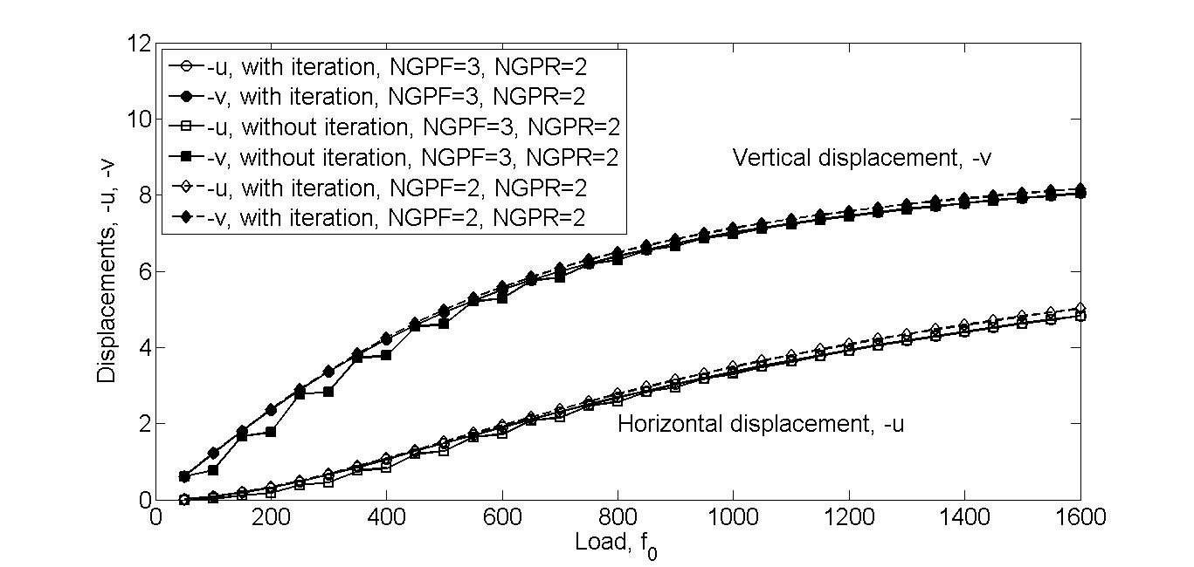

Figure 1.1 Node 17 displacements –u, and -v versus load (obtained with UL formulation).

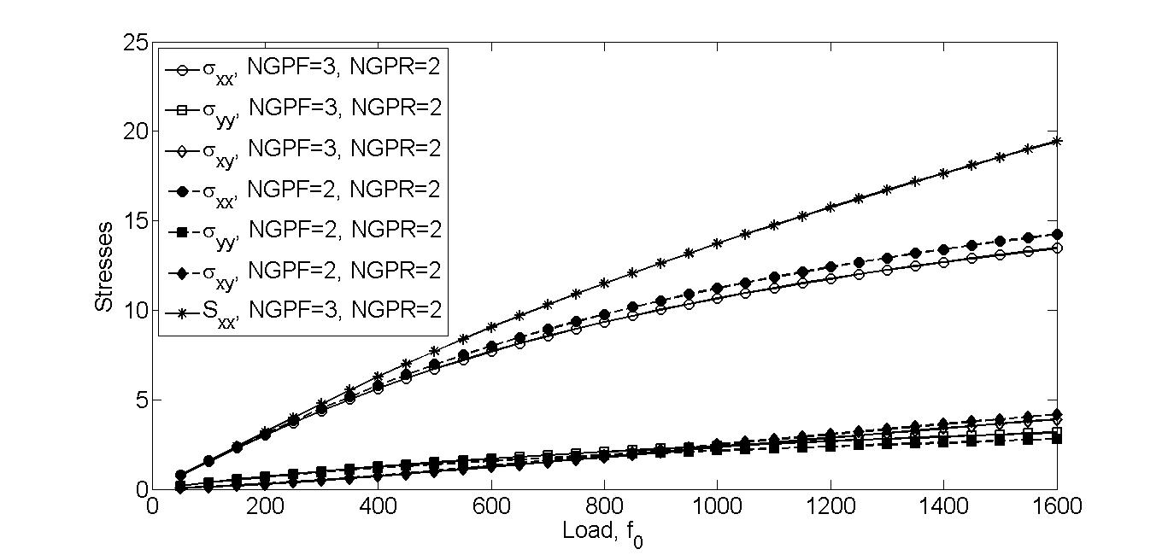

Figure 1.2 Stresses versus load (obtained with UL formulation).

Table 1.4 Total displacements of node 22 in a cantilevered plate under uniform load; obtained with the updated Lagrangian formulation and the 5Q9 mesh (3x3 Gauss rule for K and 2x2 Gauss rule for stresses)

|  |  |  |  |  |
| --- | --- | --- | --- | --- |
| f0=q0h | x | -y | -u | -v |
| 50 | 9.9782 | 0.1218 | 0.0218 | 0.6218 |
| 100 | 9.9142 | 0.7323 | 0.0858 | 1.2323 |
| 150 | 9.8115 | 1.3214 | 0.1885 | 1.8214 |
| 200 | 9.6754 | 1.8810 | 0.3246 | 2.3810 |
| 250 | 9.5123 | 2.4057 | 0.4877 | 2.9057 |
| 300 | 9.3286 | 2.8923 | 0.6714 | 3.3923 |
| 350 | 9.1301 | 3.3400 | 0.8699 | 3.8400 |
| 400 | 8.9224 | 3.7494 | 1.0776 | 4.2494 |
| 450 | 8.7095 | 4.1224 | 1.2905 | 4.6224 |
| 500 | 8.4953 | 4.4611 | 1.5047 | 4.9611 |
| 550 | 8.2823 | 4.7684 | 1.7177 | 5.2684 |
| 600 | 8.0725 | 5.0472 | 1.9275 | 5.5472 |
| 650 | 7.8675 | 5.3002 | 2.1325 | 5.8002 |
| 700 | 7.6681 | 5.5301 | 2.3319 | 6.0301 |
| 750 | 7.4750 | 5.7392 | 2.5250 | 6.2392 |
| 800 | 7.2887 | 5.9299 | 2.7113 | 6.4299 |
| 850 | 7.1114 | 6.1013 | 2.8886 | 6.6013 |
| 900 | 6.9392 | 6.2604 | 3.0608 | 6.7604 |
| 950 | 6.7738 | 6.4064 | 3.2262 | 6.9064 |
| 1000 | 6.6150 | 6.5407 | 3.3850 | 7.0407 |
| 1050 | 6.4627 | 6.6644 | 3.5373 | 7.1644 |
| 1100 | 6.3167 | 6.7787 | 3.6833 | 7.2787 |

Table 1.5 Stresses (x10-5) in a cantilevered plate under uniform load; obtained with the updated Lagrangian formulation and the 5Q9 mesh (3x3 Gauss rule for K and 2x2 Gauss rule for stresses)

|  |  |  |  |  |  |  |  |  |
| --- | --- | --- | --- | --- | --- | --- | --- | --- |
| f0=q0h | x | y |  |  | x | y |  |  |
| 50 | 0.4254 | 0.7860 | 0.7760 | 0.0549 | 0.4227 | 0.7887 | 0.7877 | 0.0485 |
| 100 | 0.4282 | 0.7834 | 1.5429 | 0.1239 | 0.4227 | 0.7887 | 1.5904 | 0.0986 |
| 150 | 0.4311 | 0.7807 | 2.2924 | 0.2065 | 0.4227 | 0.7887 | 2.3997 | 0.1504 |
| 200 | 0.4340 | 0.7780 | 3.0175 | 0.3018 | 0.4227 | 0.7887 | 3.2080 | 0.2041 |
| 250 | 0.4368 | 0.7753 | 3.7131 | 0.4084 | 0.4227 | 0.7887 | 4.0087 | 0.2597 |
| 300 | 0.4396 | 0.7726 | 4.3758 | 0.5249 | 0.4227 | 0.7887 | 4.7966 | 0.3171 |
| 350 | 0.4424 | 0.7699 | 5.0042 | 0.6497 | 0.4227 | 0.7887 | 5.5681 | 0.3764 |
| 400 | 0.4450 | 0.7673 | 5.5980 | 0.7814 | 0.4227 | 0.7887 | 6.3207 | 0.4372 |
| 450 | 0.4476 | 0.7647 | 6.1572 | 0.9185 | 0.4227 | 0.7887 | 7.0524 | 0.4994 |
| 500 | 0.4501 | 0.7621 | 6.6840 | 1.0600 | 0.4227 | 0.7887 | 7.7638 | 0.5628 |
| 550 | 0.4526 | 0.7595 | 7.1800 | 1.2047 | 0.4227 | 0.7887 | 8.4547 | 0.6272 |
| 600 | 0.4549 | 0.7570 | 7.6470 | 1.3521 | 0.4227 | 0.7887 | 9.1256 | 0.6925 |
| 650 | 0.4572 | 0.7545 | 8.0869 | 1.5012 | 0.4227 | 0.7887 | 9.7773 | 0.7586 |
| 700 | 0.4594 | 0.7520 | 8.5018 | 1.6517 | 0.4227 | 0.7887 | 10.4110 | 0.8252 |
| 750 | 0.4615 | 0.7496 | 8.8935 | 1.8030 | 0.4227 | 0.7887 | 11.0270 | 0.8923 |
| 800 | 0.4636 | 0.7472 | 9.2638 | 1.9547 | 0.4227 | 0.7887 | 11.6270 | 0.9598 |
| 850 | 0.4655 | 0.7449 | 9.6050 | 2.1020 | 0.4227 | 0.7887 | 12.1960 | 1.0260 |
| 900 | 0.4674 | 0.7426 | 9.9366 | 2.2534 | 0.4227 | 0.7887 | 12.7650 | 1.0939 |
| 950 | 0.4693 | 0.7403 | 10.2510 | 2.4048 | 0.4227 | 0.7887 | 13.3220 | 1.1620 |
| 1000 | 0.4711 | 0.7380 | 10.5510 | 2.5558 | 0.4227 | 0.7887 | 13.8660 | 1.2303 |
| 1050 | 0.4728 | 0.7357 | 10.8350 | 2.7064 | 0.4227 | 0.7887 | 14.3990 | 1.2986 |
| 1100 | 0.4746 | 0.7334 | 11.1060 | 2.8563 | 0.4227 | 0.7887 | 14.9210 | 1.3669 |