**MEEN 673**

**Test 1**

**Jicheng Lu**

**525004048**

**Problem 1:**

Table 1. Numerical results of Problem 1.

|  |  |  |  |  |  |
| --- | --- | --- | --- | --- | --- |
| x | DI | | NI | | Exact |
| 8L | 4Q | 8L | 4Q |
| 1.000 | 1.00000 | 1.0000 | 1.00000 | 1.00000 | 1.00000 |
| 1.125 | 0.88871 | 0.88891 | 0.88866 | 0.88886 | 0.88889 |
| 1.250 | 0.79976 | 0.80010 | 0.79967 | 0.80001 | 0.80000 |
| 1.375 | 0.72704 | 0.72740 | 0.72691 | 0.72727 | 0.72727 |
| 1.500 | 0.66646 | 0.66684 | 0.66630 | 0.66668 | 0.66667 |
| 1.625 | 0.61522 | 0.61558 | 0.61503 | 0.61539 | 0.61538 |
| 1.750 | 0.57132 | 0.57165 | 0.57110 | 0.57144 | 0.57143 |
| 1.875 | 0.53327 | 0.53357 | 0.53304 | 0.53334 | 0.53333 |
| 2.000 | 0.49998 | 0.50025 | 0.49973 | 0.50001 | 0.50000 |

**Problem 2:**

Table 2. Numerical results of Problem 2.

|  |  |  |  |
| --- | --- | --- | --- |
| x | DI | | Exact |
| 8L | 4Q |
| 0.000 | 1.00000 | 1.00000 | 1.00000 |
| 0.125 | 0.88844 | 0.88882 | 0.88889 |
| 0.250 | 0.79935 | 0.80002 | 0.80000 |
| 0.375 | 0.72654 | 0.72727 | 0.72727 |
| 0.500 | 0.66592 | 0.66670 | 0.66667 |
| 0.625 | 0.61466 | 0.61541 | 0.61538 |
| 0.750 | 0.57073 | 0.57147 | 0.57143 |
| 0.875 | 0.53268 | 0.53337 | 0.53333 |
| 1.000 | 0.49939 | 0.50004 | 0.50000 |

**Problem 3:**

(a) The tangent stiffness coefficients are as follows:

, , , , , 

, ,



(b)

Table 3. Center deflection, w(0), with load, q.

|  |  |
| --- | --- |
| P | Newton Iteration |
| 10 Quadratic elements |
| 5 | 11.242 |
| 10 | 17.719 |
| 15 | 22.528 |
| 20 | 26.499 |
| 25 | 29.948 |
| 30 | 33.030 |
| 35 | 35.836 |
| 40 | 38.425 |
| 45 | 40.837 |
| 50 | 43.102 |
| 55 | 45.240 |
| 60 | 47.268 |
| 65 | 49.201 |
| 70 | 51.049 |
| 75 | 52.820 |
| 80 | 54.522 |
| 85 | 56.162 |
| 90 | 57.745 |
| 95 | 59.276 |
| 100 | 60.758 |
| 105 | 62.195 |
| 110 | 63.591 |
| 115 | 64.948 |
| 120 | 66.269 |

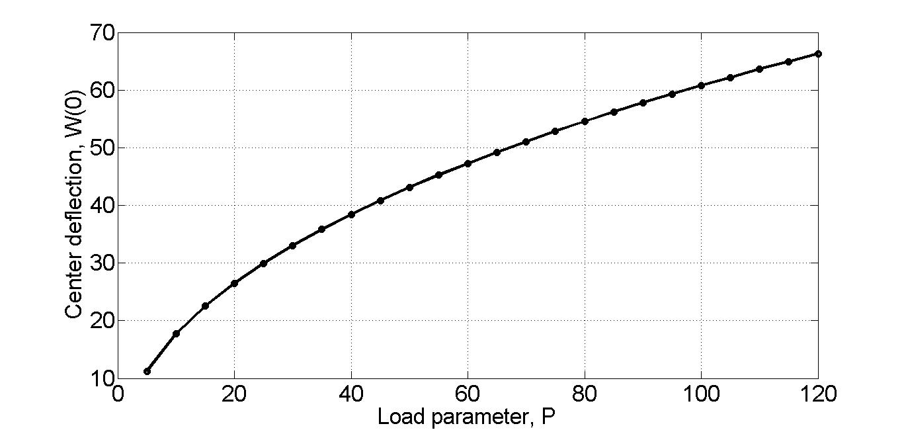

Figure 3.1 Center deflection, w(0), vs load, q.