**MEEN 673**

**Test 2**

**Jicheng Lu**

**525004048**

**Problem 1:**

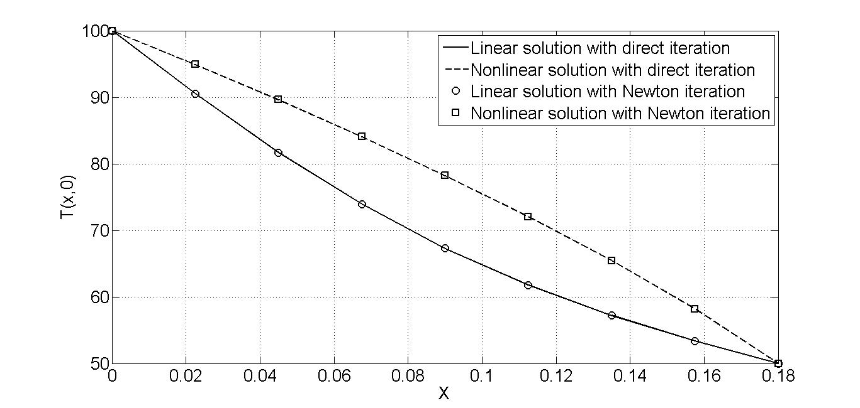

Figure 1.1 Temperature on the center line, T(x,0) versus X.

(a) Direct iteration.

Table 1.1 Numerical results with direct iteration

|  |  |  |  |
| --- | --- | --- | --- |
| **x** | **y** | **T (linear)** | **T (nonlinear)** |
| 0.00000 | 0.00000 | 100.00000 | 100.00000 |
| 0.02250 | 0.00000 | 90.54000 | 94.92800 |
| 0.04500 | 0.00000 | 81.69200 | 89.62400 |
| 0.06750 | 0.00000 | 73.92000 | 84.07800 |
| 0.09000 | 0.00000 | 67.29800 | 78.24800 |
| 0.11250 | 0.00000 | 61.76300 | 72.06700 |
| 0.13500 | 0.00000 | 57.18500 | 65.42900 |
| 0.15750 | 0.00000 | 53.38400 | 58.16900 |
| 0.18000 | 0.00000 | 50.00000 | 50.00000 |

(b) Newton’s iteration.

Table 1.2 Numerical results with Newton’s iteration

|  |  |  |  |
| --- | --- | --- | --- |
| **x** | **y** | **T (linear)** | **T (nonlinear)** |
| 0.00000 | 0.00000 | 100.00000 | 100.00000 |
| 0.02250 | 0.00000 | 90.54000 | 94.93100 |
| 0.04500 | 0.00000 | 81.69200 | 89.62900 |
| 0.06750 | 0.00000 | 73.92000 | 84.08300 |
| 0.09000 | 0.00000 | 67.29800 | 78.25200 |
| 0.11250 | 0.00000 | 61.76300 | 72.06700 |
| 0.13500 | 0.00000 | 57.18500 | 65.42600 |
| 0.15750 | 0.00000 | 53.38400 | 58.16500 |
| 0.18000 | 0.00000 | 50.00000 | 50.00000 |

**Problem 2:**

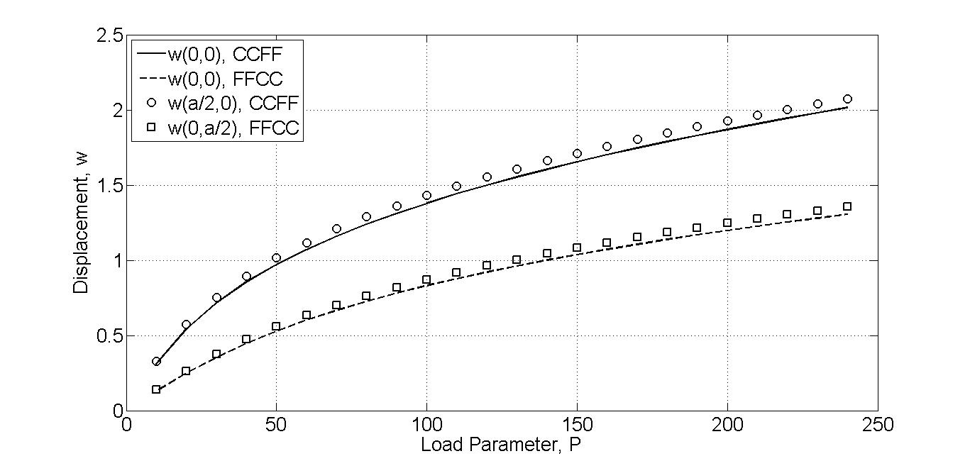

Figure 2.1 Displacements for CCFF plate and FFCC plate.

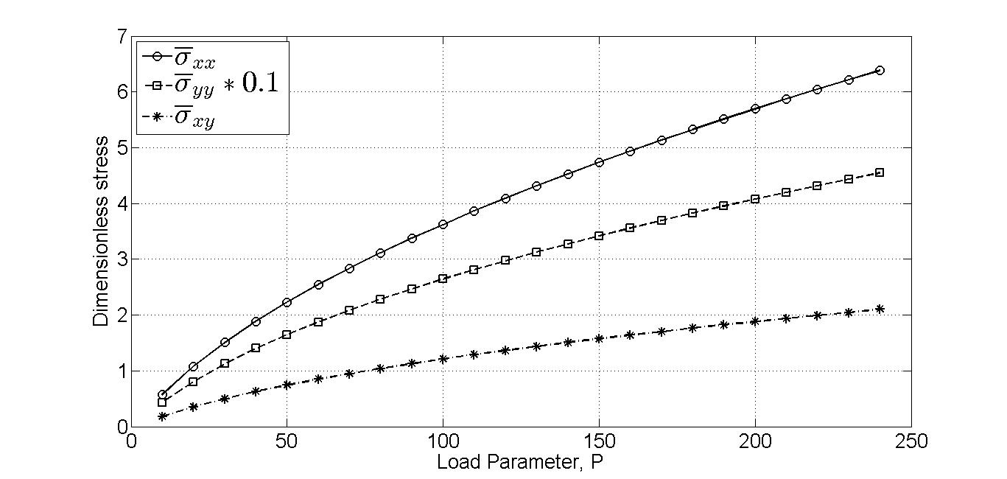

Figure 2.2 Dimensionless stresses at corner point for CCFF plate.

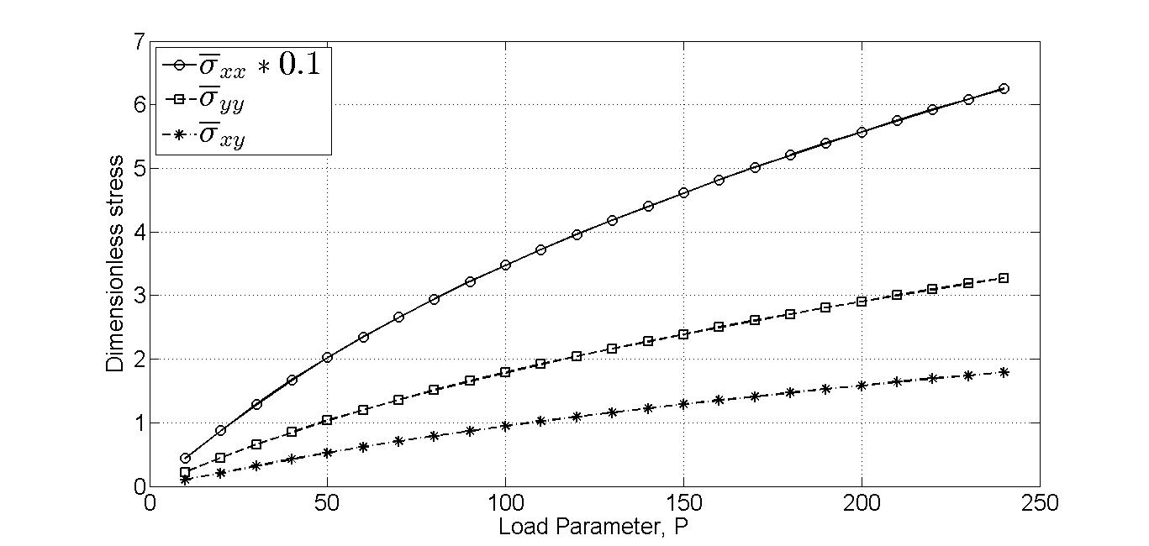

Figure 2.3 Dimensionless stresses at corner point for FFCC plate.

Table 2.1 Displacements of CCFF plate and FFCC plate.

|  |  |  |  |  |
| --- | --- | --- | --- | --- |
|  | **CCFF plate** | | **FFCC plate** | |
| **Load, P** | **W(0,0)** | **W(a/2,0)** | **W(0,0)** | **W(0,a/2)** |
| 10 | 0.3094 | 0.3274 | 0.1288 | 0.1372 |
| 20 | 0.5423 | 0.5717 | 0.2482 | 0.2640 |
| 30 | 0.7167 | 0.7529 | 0.3543 | 0.3758 |
| 40 | 0.8554 | 0.8961 | 0.4473 | 0.4732 |
| 50 | 0.9713 | 1.0152 | 0.5290 | 0.5584 |
| 60 | 1.0713 | 1.1176 | 0.6017 | 0.6338 |
| 70 | 1.1598 | 1.2079 | 0.6670 | 0.7014 |
| 80 | 1.2394 | 1.2890 | 0.7263 | 0.7625 |
| 90 | 1.3120 | 1.3628 | 0.7806 | 0.8185 |
| 100 | 1.3788 | 1.4307 | 0.8308 | 0.8700 |
| 110 | 1.4410 | 1.4938 | 0.8774 | 0.9179 |
| 120 | 1.4991 | 1.5527 | 0.9211 | 0.9627 |
| 130 | 1.5537 | 1.6081 | 0.9621 | 1.0047 |
| 140 | 1.6054 | 1.6604 | 1.0009 | 1.0444 |
| 150 | 1.6545 | 1.7100 | 1.0377 | 1.0820 |
| 160 | 1.7012 | 1.7573 | 1.0726 | 1.1177 |
| 170 | 1.7459 | 1.8024 | 1.1060 | 1.1518 |
| 180 | 1.7887 | 1.8457 | 1.1380 | 1.1844 |
| 190 | 1.8298 | 1.8872 | 1.1686 | 1.2157 |
| 200 | 1.8694 | 1.9272 | 1.1980 | 1.2457 |
| 210 | 1.9075 | 1.9657 | 1.2264 | 1.2747 |
| 220 | 1.9444 | 2.0029 | 1.2538 | 1.3026 |
| 230 | 1.9799 | 2.0388 | 1.2802 | 1.3295 |
| 240 | 2.0148 | 2.0740 | 1.3058 | 1.3556 |

Table 2.2 Dimensionless stress at corner point of CCFF plate.

|  |  |  |  |
| --- | --- | --- | --- |
| **Load, P** | $${\overline{σ}}_{xx}$$ | $${\overline{σ}}_{yy}$$ | $${\overline{σ}}_{xy}$$ |
| 10 | 0.5715 | 4.2877 | 0.1830 |
| 20 | 1.0755 | 8.0506 | 0.3537 |
| 30 | 1.5062 | 11.2310 | 0.5009 |
| 40 | 1.8853 | 14.0030 | 0.6299 |
| 50 | 2.2278 | 16.4860 | 0.7458 |
| 60 | 2.5429 | 18.7540 | 0.8517 |
| 70 | 2.8366 | 20.8540 | 0.9498 |
| 80 | 3.1130 | 22.8200 | 1.0416 |
| 90 | 3.3750 | 24.6740 | 1.1283 |
| 100 | 3.6247 | 26.4340 | 1.2105 |
| 110 | 3.8638 | 28.1120 | 1.2890 |
| 120 | 4.0937 | 29.7200 | 1.3642 |
| 130 | 4.3153 | 31.2650 | 1.4365 |
| 140 | 4.5296 | 32.7540 | 1.5062 |
| 150 | 4.7372 | 34.1930 | 1.5735 |
| 160 | 4.9387 | 35.5870 | 1.6388 |
| 170 | 5.1347 | 36.9380 | 1.7022 |
| 180 | 5.3256 | 38.2520 | 1.7638 |
| 190 | 5.5117 | 39.5310 | 1.8237 |
| 200 | 5.6935 | 40.7770 | 1.8820 |
| 210 | 5.8711 | 41.9930 | 1.9385 |
| 220 | 6.0447 | 43.1810 | 1.9926 |
| 230 | 6.2141 | 44.3430 | 2.0417 |
| 240 | 6.3824 | 45.4800 | 2.1041 |

Table 2.3 Dimensionless stress at corner point of FFCC plate.

|  |  |  |  |
| --- | --- | --- | --- |
| **Load, P** | $${\overline{σ}}_{xx}$$ | $${\overline{σ}}_{yy}$$ | $${\overline{σ}}_{xy}$$ |
| 10 | 4.3801 | 0.2232 | 0.1008 |
| 20 | 8.7314 | 0.4445 | 0.2098 |
| 30 | 12.8510 | 0.6543 | 0.3189 |
| 40 | 16.6750 | 0.8498 | 0.4240 |
| 50 | 20.2130 | 1.0315 | 0.5236 |
| 60 | 23.4990 | 1.2010 | 0.6177 |
| 70 | 26.5670 | 1.3600 | 0.7067 |
| 80 | 29.4510 | 1.5100 | 0.7911 |
| 90 | 32.1750 | 1.6524 | 0.8714 |
| 100 | 34.7610 | 1.7880 | 0.9482 |
| 110 | 37.2260 | 1.9178 | 1.0218 |
| 120 | 39.5850 | 2.0424 | 1.0925 |
| 130 | 41.8490 | 2.1623 | 1.1607 |
| 140 | 44.0290 | 2.2781 | 1.2266 |
| 150 | 46.1320 | 2.3901 | 1.2903 |
| 160 | 48.1650 | 2.4987 | 1.3522 |
| 170 | 50.1360 | 2.6042 | 1.4123 |
| 180 | 52.0490 | 2.7068 | 1.4709 |
| 190 | 53.9080 | 2.8068 | 1.5279 |
| 200 | 55.7180 | 2.9043 | 1.5836 |
| 210 | 57.4820 | 2.9995 | 1.6380 |
| 220 | 59.2040 | 3.0925 | 1.6912 |
| 230 | 60.8860 | 3.1836 | 1.7433 |
| 240 | 62.5300 | 3.2727 | 1.7944 |