Ferroelectrics search

## 1.Prepared files

As follow：

1. de.x file compiled from IM2ODE
2. python scripts ferroelectric_search.py read_poscar.py screening_POSCAR.py get_POSCAR.py export_figure.py

|  |  |
| --- | --- |
| Scripts | Function |
| ferroelectric_search.py | 1. generate_refer_phase |
|  | 2. generate_ferroelectric_phase |
|  | 1. process_data |
| read_poscar.py | Read POSCAR |
| screening_POSCAR.py | Screening of centrosymmetric phases with different structures |
| get_POSCAR.py | Verify the symmetry of the structure (boundary problem of two-dimensional layer groups) |
| export_figure.py | Visualization |

3.bash scripts for main program test.sh

4.serveral INCAR_* files INCAR_1 INCAR_2 INCAR_3 INCAR_4

|  |  |
| --- | --- |
| INCAR_* | Function |
| 1 | relax centrosymmetric phases |
| 2 | static calculation for centrosymmetric phases and ferroelectrics candidates |
| 3 | Berry phase for polarization value |
| 4 | Relax ferroelectrics candidates |

5.POTCAR for DFT

Environments：

Python: pandas, plotly, pymatgen，phonopy（not necessary）

Vaspkit, gcc（gcc-12.1.0+）

## 2.Running

Unlike running IM2ODE for structure search, ferroelectric search only uses the initial structure generation function of IM2ODE

The relevant settings of IM2ODE can be modified by modifying the test.sh main program

**Environment and parameters ( The specific meaning is stated in the essay)**

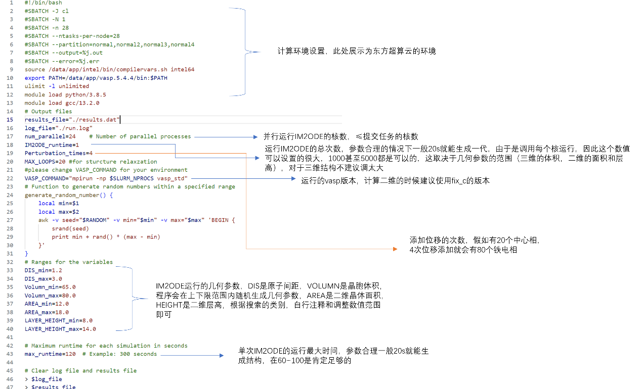

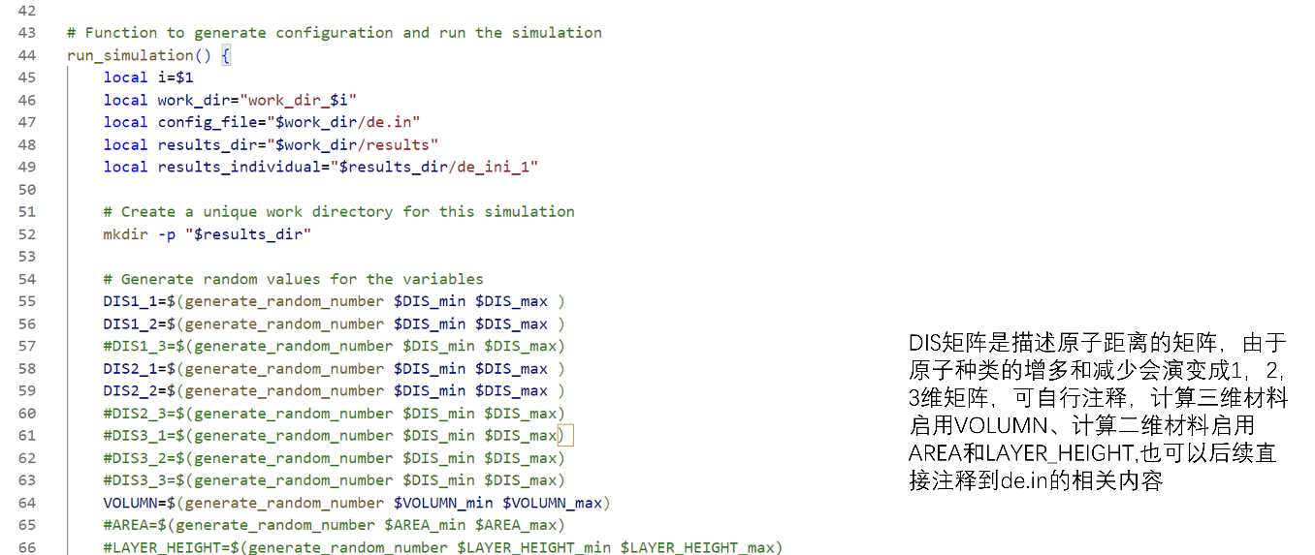

Parameters for structures(same as de.in in IM2ODE)

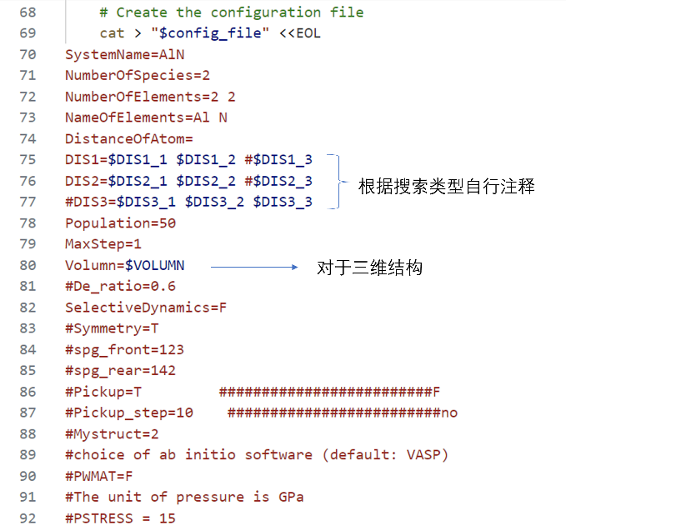

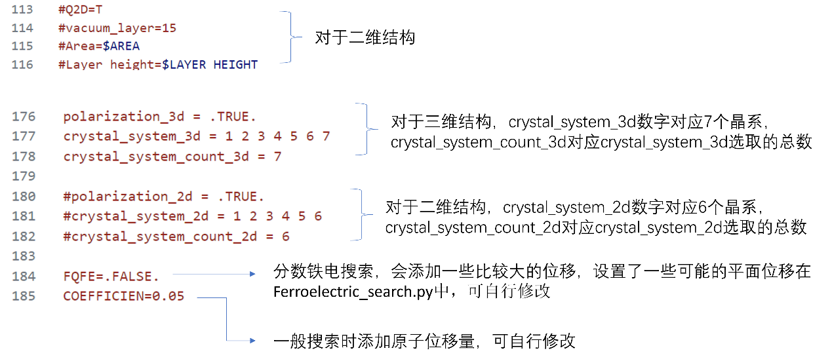

Submit test.sh and waiting for program running

**Mid files：**

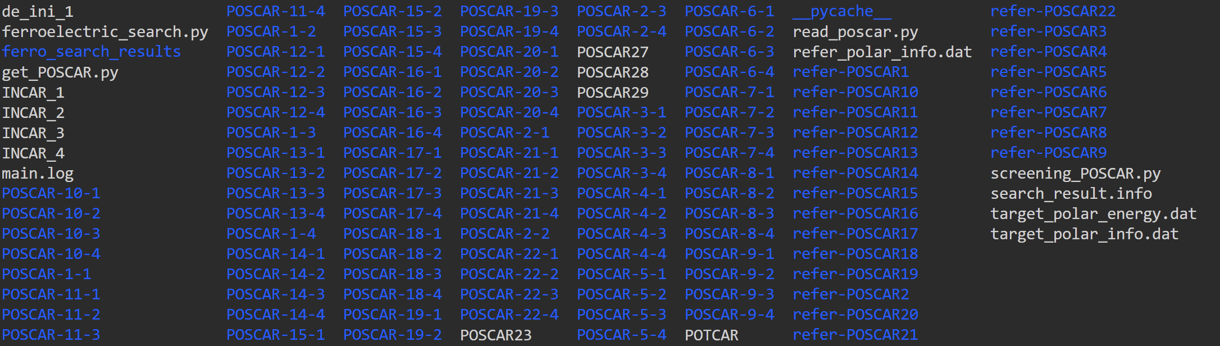

The program will create its own results folder, and all first principles calculation result files are located as shown in the figure above;

|  |  |
| --- | --- |
| 1. main.log | Record the optimization of the structure |
| 1. perturbation.log | Record the specific situation of adding displace-  -ment, where the atomic order is 0, 1, 2, 3 in this order |
| 1. refer-POSCAR* | Reference phase ( centrosymmetric phases) |
| 1. POSCAR-i-m | I corresponds to the reference phase sequence number, and m corresponds to the displacement added at which time |
| 1. Refer_polar_info.dat target_polar_info.dat | Corresponding ferroelectric calculation values |
| 1. target_polar_energy.dat | Corresponding optimized energy of ferroelectric candidates |
| 1. ferro_search_results file fold | The final calculation results |

**Calculation results**

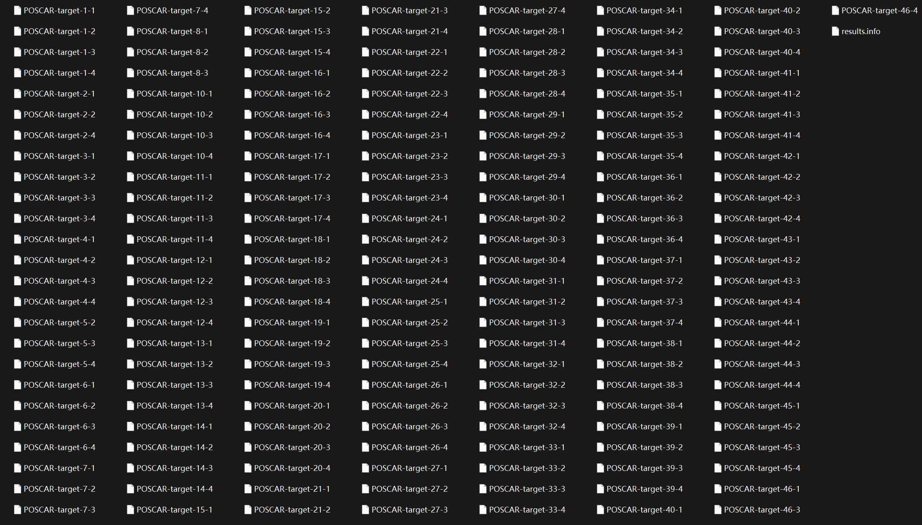

results.info:

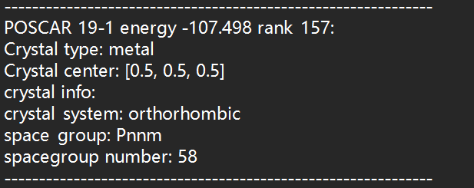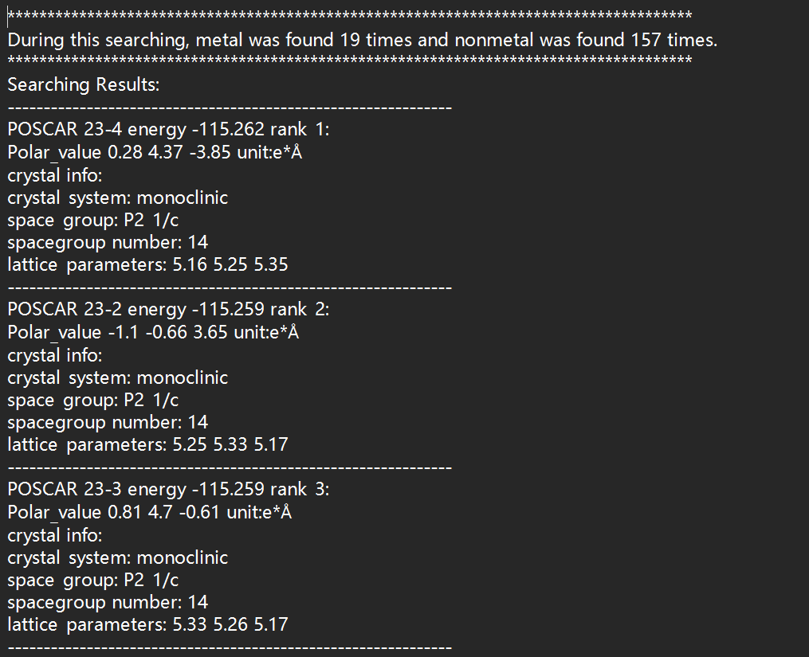

**Visualization**（scatter_plot.html/png）

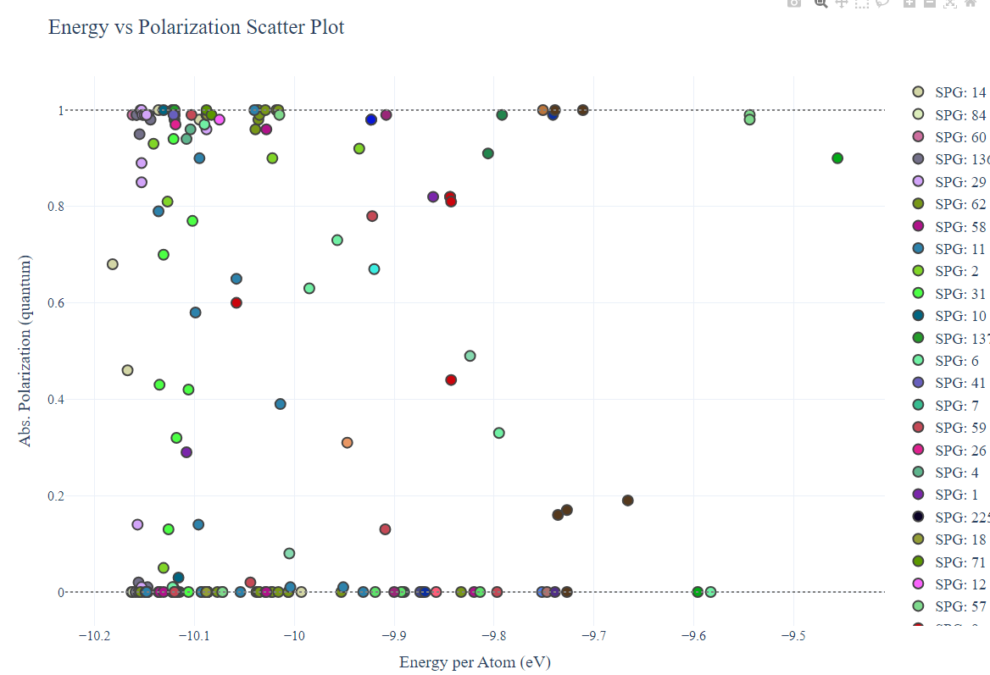

The final result records the relevant information of ferroelectric candidate phases. For phases that can be calculated using the Berry phase method for ferroelectricity, the ferroelectric values after processing the ferroelectric quantum are recorded, and the sign of this value depends on the offset of the center of mass; For the metal phase, the position of the center of mass is recorded for further viewing. As the theoretical calculation of the ferroelectric value of the metal involves the calculation of the electro acoustic coupling matrix and relies on high-precision first principles calculations, this program does not involve subsequent calculations.

#This software currently does not support integration with other IM2ODE functions

#For two-dimensional materials, fix_c version of vasp is required. For users with vasp6 or higher versions, OPTCELL needs to be added and modified

#My programming ability is limited. If you have any bugs or issues, please contact me.