

FACULTY OF COMPUTER SYSTEMS& SOFTWARE ENGINEERING

Web Application Development

BCN2203 Sem_1 17/18

MINI PROJECT

MARVEL RUN online system

PREPARED BY:

|  |  |  |
| --- | --- | --- |
| CA16119 | MUHAMMAD ASYRAF BIN RAHMAN | 1B |
| CB16148 | MUHAMMAD ASHRAF BIN KAMARUDIN | 1B |
| CB16006 | FAZRIN BINTI M.MIZI | 1B |
| CB16138 | NUR ANIS AZWA BINTI SAHARUDIN | 1B |

*PREPARED FOR |Dr.Zuriani binti Mustaffa*

Table of Contents

2 INTRODUCTION 2

3 PROBLEM STATEMENT 2

4 OBJECTVES 3

5 SCOPE 3

6 SYSTEM DESCRIPTION 4

6.1 LANDING_PAGE 4

6.2 PARTICIPANT_REGISTER 12

6.3 PARTICIPANT_VIEW 20

6.4 ADMIN_MAIN 24

6.5 ADMIN_INVOICES 27

6.6 ADMIN_ALL_PARTICPANT 34

6.7 ADMIN_PAID_PARTICIPANT 39

6.8 ADMIN_NON_PAID_PARTICIPANT 44

7 CONCLUSION 50

8 References 51

# INTRODUCTION

Annually, more than 800 marathons are organized worldwide. Some of these belong to the Association of International Marathons and Distance Races (AIMS) which has grown since its foundation in 1982 to embrace over 300 member events in 83 countries and territories. The marathons of Berlin, Boston, Chicago, London, New York City and Tokyo form the biennial World Marathon Majors series, awarding $500,000 annually to the best overall male and female performers in the series (Wikipedia, 2017).

Now even in Malaysia there is an abundant of marathon events being held. The coming of events lead to the need of a system, so, our team have initiated a website for marathon management which is named the “**Marvel Run**”. Minimum requirements of a managing system such as adding a data into a database, as well as being able to delete or update a data is covered by this system. However, the main catch is to be easier than systems that are normally used to handle such events.

# PROBLEM STATEMENT

The crucial points in making a successful is attendee satisfaction. The goal is to host a fun meeting and create a positive experience for attendees, success lies in how much they enjoy the event (2017 Marriott International, 2017). This is depending on how smoothly the organizers can manage the system. If such big events are done only by paper documents and signature forms a major havoc may occur.

Therefore, what is needed is to create a system that can manage participant data without errors and decrease the usage of time needed for recruitment significantly.

# OBJECTVES

For the time being this system should be able to accomplish the following:

* The basics of a managing system, which are add, update, and delete participant data.
* Provide a different session for admins and participants for security purposes.
* By utilizing web service components, configuration, securing and deployment in web application to create an improved system.
* Achieve minimal confusion between the managing party and participants by creating a user-friendly environment.
* Acquire minimal data entry errors by applying proper validations.
* Attract participants and adequately inform them about the event by the first page.

# SCOPE

This system will only be handling variables in these parameters:

* Participant entry is only limited to 1 per identification card number.
* After, registering only the participant will be able to access event payments.
* After, registering only the participant will be able to able to notify admins that they withdraw from the event.
* Login session is required to access privileges such as managing the participant and package payment data.
* Admins can only be registered under the admin page.
* This system can only run in machines that have C# language.
* This system is can only run in local servers for the time being.

# SYSTEM DESCRIPTION

This system will be further broken down to every page explanation.

## LANDING_PAGE

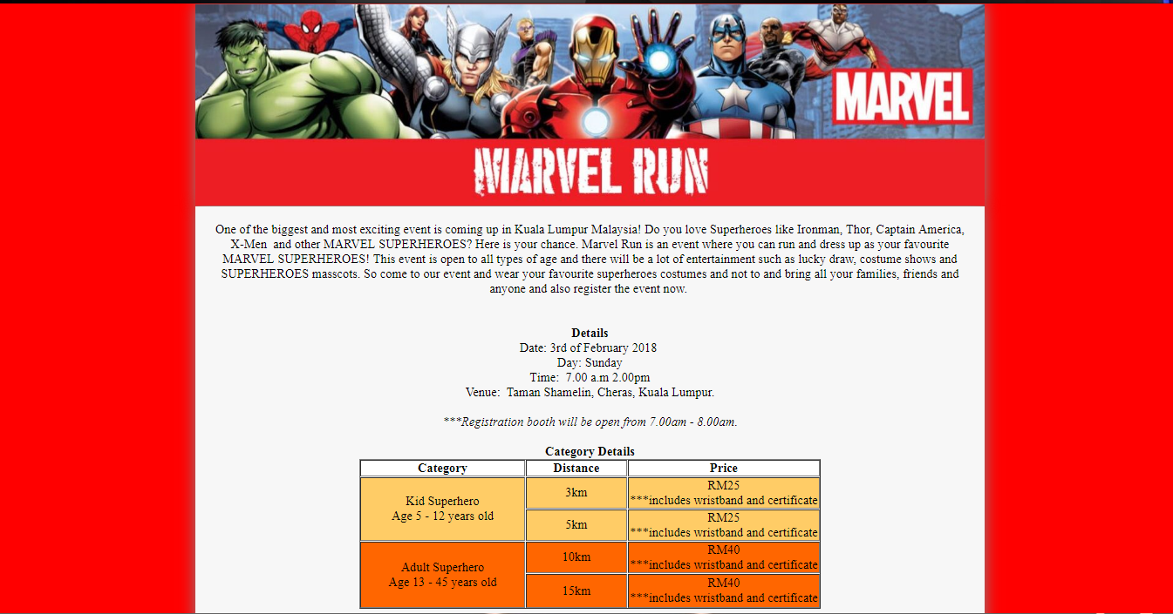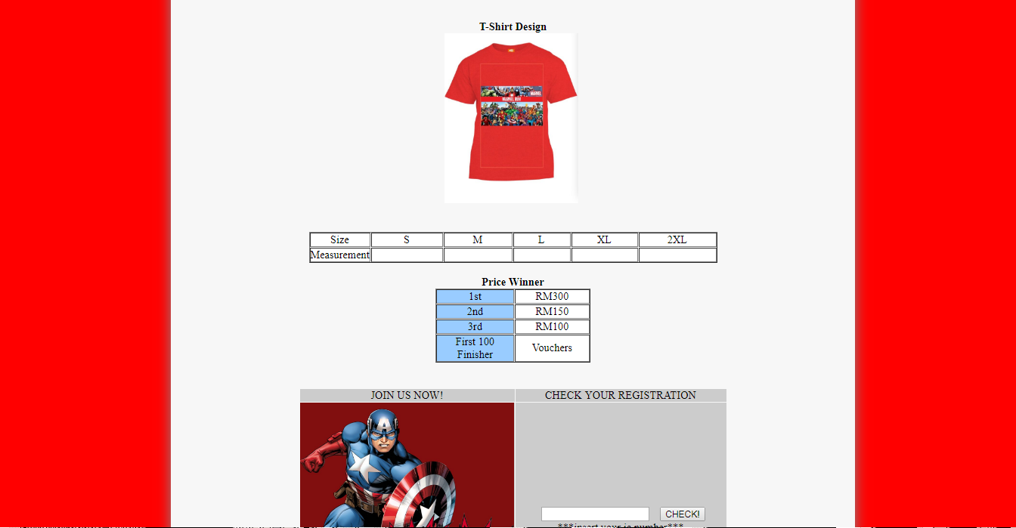

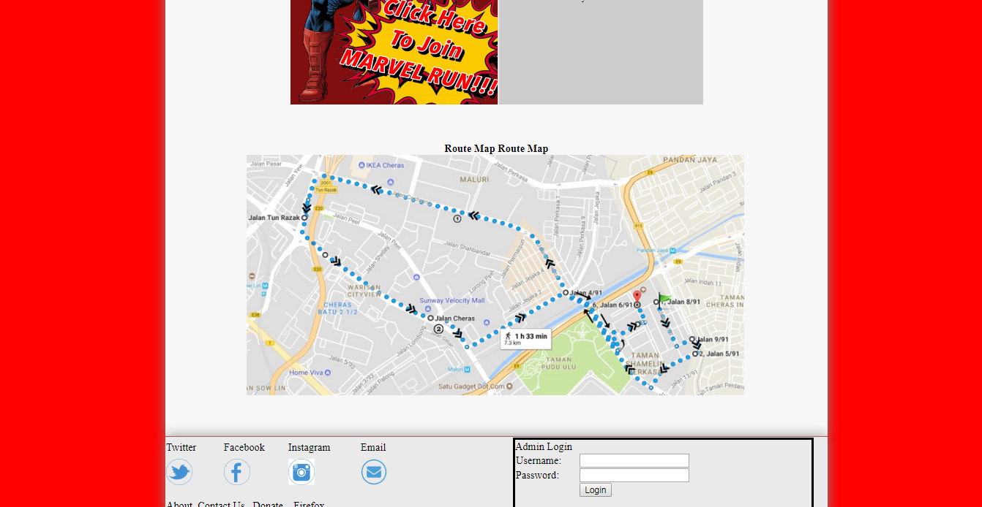

Figure 1 is a screen shot for the stated webpage.

|  |
| --- |
| Related Code/ Configuration |
| **.Aspx**  <%@ Page Language="C#" AutoEventWireup="true" CodeFile="landing_page.aspx.cs" Inherits="landing_page" %>  <!DOCTYPE html PUBLIC "-//W3C//DTD XHTML 1.0 Transitional//EN" "http://www.w3.org/TR/xhtml1/DTD/xhtml1-transitional.dtd">  <html xmlns="http://www.w3.org/1999/xhtml">  <head runat="server">  <title>MARVEL RUN</title>  <style type="text/css">  .style2  {  text-align: center;  }  .style4  {  width: 1005px;  height: 88px;  box-shadow: 0px 0px 30px #888888;  }  .style7  {  width: 1005px;  box-shadow: 0px 0px 30px #888888;  padding: 20px;  }  .style12  {  text-align: center;  height: 95px;  }  .style13  {  width: 210px;  }  .style15  {  width: 243px;  }  .style16  {  width: 126px;  }  .style17  {  width: 126px;  height: 42px;  font-family: "Arial Unicode MS";  }  .style18  {  width: 243px;  height: 42px;  }  .style20  {  width: 126px;  text-align: center;  font-weight: bold;  font-family: "Arial Unicode MS";  }  .style21  {  width: 210px;  text-align: center;  font-weight: bold;  font-family: "Arial Unicode MS";  }  .style23  {  width: 112px;  font-family: "Arial Unicode MS";  }  .style26  {  width: 100px;  font-family: "Arial Unicode MS";  }  .style27  {  width: 82px;  font-family: "Arial Unicode MS";  }  .style28  {  width: 95px;  }  .style29  {  width: 107px;  }  .style30  {  width: 230px;  }  .style32  { width: 87px;  }  .style34  {  width: 139px;  }  .style35  {  height: 42px;  }  .style37  {  height: 31px;  width: 87px;  }  .style39  {  width: 107px;  height: 31px;  }  .style40  {  width: 230px;  height: 31px;  }  .style41  {  width: 451px;  }  .style43  {  width: 309px;  text-align: center;  }  .style44  {  width: 243px;  text-align: center;  font-weight: bold;  font-family: "Arial Unicode MS";  }  body  {margin: auto;  max-width: 1000px;  background-color: Red;  }  .style46  {  font-family: "Arial Unicode MS";  }  .style47  {  width: 126px;  font-family: "Arial Unicode MS";  }  .style48  {  width: 95px;  font-family: "Arial Unicode MS";  }  .style49  {  width: 107px;  font-family: "Arial Unicode MS";  }  .style50  {  width: 309px;  text-align: center;  font-family: "Arial Unicode MS";  }  .style51  {  text-align: center;  font-family: "Arial Unicode MS";  }  .style52  {  width: 95px;  height: 31px;  }  .style53  {  font-family: "Berlin Sans FB Demi";  }  .style54  {  text-align: center;  height: 29px;  box-shadow: 0px 0px 30px #888888;  </style>  </head>  <body>  <form id="form1" runat="server">  <table>  <tr>  <td class="style54">  <asp:Image ID="Image1" runat="server" ImageAlign="Middle"  ImageUrl="~/Photo 24-11-2017, 5 51 01 PM_preview.jpeg" Width="1005px" />  </td>  </tr>  <tr>  <td class="style7" bgcolor="#F7F7F7" style="border-style: hidden; text-align: center;"  valign="middle" width="800">  <div class="style2">  <span class="style53">One of the biggest and most  exciting event is coming up in Kuala Lumpur Malaysia! Do you love Superheroes  like Ironman, Thor, Captain America, X-Men&nbsp; and other MARVEL SUPERHEROES? Here  is your chance. Marvel Run is an event where you can run and dress up as your  favourite MARVEL SUPERHEROES! This event is open to all types of age and there  will be a lot of entertainment such as lucky draw, costume shows and SUPERHEROES  masscots. So come to our event and wear your favourite superheroes costumes and  not to and bring all your families, friends and anyone and also register the  event now. </span>  <br />  <br />  <br />  <span class="style46"><strong>Details</strong></span><br class="style46" />  <span class="style46">Date: 3rd of February 2018  </span>  <br class="style46" />  <span class="style46">Day: Sunday</span><br class="style46" />  <span class="style46">Time:&nbsp; 7.00 a.m 2.00pm</span><br class="style46" />  <span class="style46">Venue:&nbsp; Taman Shamelin, Cheras, Kuala Lumpur.</span><br />  <br />  <em>***Registration booth will be open from 7.00am - 8.00am</em>.<br />  <br />  <strong>Category Details</strong><br />  </div>  <table border="1" align="center">  <tr><td class="style21" bgcolor="White">Category</td><td class="style20"  bgcolor="White">Distance</td>  <td class="style44" bgcolor="White">Price</td></tr>  <tr><td class="style13" rowspan="2" bgcolor="#FFCC66"><span class="style46">Kid Superhero</span><br  class="style46" />  <span class="style46">Age 5 - 12 years old</span></td><td class="style16"  bgcolor="#FFCC66"><span class="style46">3km</span><br class="style46" />  </td><td class="style15" bgcolor="#FFCC66"><span class="style46">RM25</span><br  class="style46" />  <span class="style46">***includes wristband and certificate</span></td></tr>  <tr><td class="style47" bgcolor="#FFCC66">5km</td><td class="style15"  bgcolor="#FFCC66"><span class="style46">RM25</span><br class="style46" />  <span class="style46">***includes wristband and certificate</span></td></tr>  <tr><td class="style13" rowspan="2" bgcolor="#FF6600"><span class="style46">Adult Superhero</span><br  class="style46" />  <span class="style46">Age 13 - 45 years old</span></td><td class="style47"  bgcolor="#FF6600">10km</td>  <td class="style15" bgcolor="#FF6600"><span class="style46">RM40</span><br  class="style46" />  <span class="style46">***includes wristband and certificate</span></td></tr>  <tr><td class="style17" bgcolor="#FF6600">15km</td>  <td class="style18"  bgcolor="#FF6600"><span class="style46">RM40</span><br class="style46" />  <span class="style46">***includes wristband and certificate</span></td></tr>    </table>  <div class="style2">  <br />  <br />  <span class="style46"><strong>T-Shirt Design</strong></span><br />  <asp:Image ID="Image2" runat="server" Height="250px"  ImageUrl="~/Photo 24-11-2017, 6 46 50 PM_preview.jpeg"  style="text-align: center" />  <br />  <br />  <br />  </div>  <table border="1" align="center"><tr><td bgcolor="White" class="style46">Size</td>  <td class="style49"  bgcolor="White">S</td><td class="style26" bgcolor="White">M</td>  <td class="style27" bgcolor="White">L</td>  <td class="style48" bgcolor="White">XL</td><td class="style23" bgcolor="White">2XL</td></tr><tr>  <td bgcolor="White" class="style46">Measurement </td>  <td class="style49" bgcolor="White">&nbsp;</td><td class="style26" bgcolor="White">&nbsp;</td>  <td class="style27" bgcolor="White">&nbsp;</td>  <td class="style48" bgcolor="White">&nbsp;</td><td class="style23" bgcolor="White">&nbsp;</td></tr></table>    <br />  <span class="style46"><strong>Price Winner</strong></span><br />  <table border="1" align="center"><tr><td bgcolor="#99CCFF" class="style46">1st</td>  <td class="style49"  bgcolor="White">RM300 </td></tr><tr><td bgcolor="#99CCFF" class="style46">2nd</td>  <td class="style49" bgcolor="White">RM150</td></tr><tr><td bgcolor="#99CCFF"  class="style46">3rd</td>  <td class="style49" bgcolor="White">RM100</td></tr><tr><td bgcolor="#99CCFF"  class="style46">  First 100 Finisher </td><td class="style49" bgcolor="White">Vouchers</td></tr></table>    <br />  <br />  <table align="center"><tr><td bgcolor="#CCCCCC" class="style51" align="center"  valign="middle">JOIN US NOW!</td>  <td class="style50"  bgcolor="#CCCCCC" align="center">CHECK YOUR REGISTRATION</td></tr><tr>  <td bgcolor="#CCCCCC" align="center" valign="middle">  <asp:ImageButton ID="ImageButton1" runat="server" Height="348px"  ImageUrl="~/Photo 24-11-2017, 6 22 10 PM_preview.jpeg" Width="315px"  onclick="ImageButton1_Click" />  </td>  <td class="style43" bgcolor="#CCCCCC" align="center">&nbsp;&nbsp;  <asp:TextBox ID="txtIC" runat="server" Width="154px"></asp:TextBox>  &nbsp;&nbsp;  <asp:Button ID="btnCheck" runat="server" Text="CHECK!"  onclick="btnCheck_OnClick" />  <br />  ***insert your ic number***</td></tr></table>    <br />  <br />    <br />  <span class="style46"><strong>Route Map Route Map</strong></span><br />  <asp:Image ID="Image3" runat="server" ImageUrl="~/Route Map.png" />    <br />  <br />  <br />  </td>  </tr>  <tr>  <td class="style4" bgcolor="#EAEAEA" style="border-style: none"  valign="middle" width="800">  <table><tr><td class="style37">Twitter</td><td class="style52">Facebook</td>  <td class="style39">Instagram</td><td class="style40">Email</td>  <td class="style41" rowspan="3" style="border-style: solid">Admin Login<table><tr>  <td class="style28">Username:</td><td class="style34">  <asp:TextBox ID="txtUsername" runat="server"></asp:TextBox>  </td></tr><tr><td class="style28">Password:</td><td class="style34">  <asp:TextBox ID="txtPassword" runat="server" TextMode="Password"></asp:TextBox>  </td></tr><tr><td class="style28">&nbsp;</td><td class="style34">  <asp:Button ID="Button1" runat="server" Text="Login" onclick="btnLogin_Click" />  </td></tr></table>&nbsp;<asp:Label ID="lblResponse" runat="server"></asp:Label>  </td></tr><tr><td class="style32">  <asp:Image ID="Image4" runat="server" Height="40px"  ImageUrl="~/twitter-1.png" />  </td><td class="style28">  <asp:Image ID="Image5" runat="server" Height="40px"  ImageUrl="~/6-2-facebook-png-hd.png" />  </td><td class="style29">  <asp:Image ID="Image6" runat="server" Height="40px" ImageUrl="~/images.png" />  </td><td class="style30">  <asp:Image ID="Image7" runat="server" Height="40px"  ImageUrl="~/Envelope-icon.png" />  </td></tr><tr><td class="style35" colspan="4">  <br />  About&nbsp; Contact Us&nbsp;&nbsp; Donate&nbsp;&nbsp;&nbsp; Firefox</td>  </tr></table>    </td>  </tr>  <tr>  <td class="style12">  &nbsp;</td>  </tr>  </table>  <div style="text-align: center">    </div>  </form>  </body>  </html>  **.Aspx.cs**  using System;  using System.Collections.Generic;  using System.Linq;  using System.Web;  using System.Web.UI;  using System.Web.UI.WebControls;  using System.Configuration;  using System.Data.Sql;  using System.Data.SqlClient;  public partial class landing_page : System.Web.UI.Page  {  SqlCommand cmd;  protected void Page_Load(object sender, EventArgs e)  {  Session.Clear();  }  protected void btnLogin_Click(object sender, EventArgs e)  {  //database connection  SqlConnection conn = new SqlConnection("Data Source=.\\SQLEXPRESS;Initial Catalog=dbtest;Integrated Security=True");  conn.Open();  //query  cmd = new SqlCommand("SELECT name FROM ADMIN WHERE username='" + txtUsername.Text + "' AND password='" + txtPassword.Text + "'", conn);  SqlDataReader sdr = cmd.ExecuteReader();  //database retrieve  if (sdr.Read())  {  Session["name"] = sdr["name"];  Response.Redirect("Admin/admin_main.aspx");  lblResponse.Text = " ";  }  else  {  lblResponse.Text = "Invalid Login please check username and password";  }  conn.Close();  }  protected void ImageButton1_Click(object sender, ImageClickEventArgs e)  {  Response.Redirect("participant_register.aspx");  }  protected void btnCheck_OnClick(object sender, EventArgs e)  {  Session["IC"] = txtIC.Text;  Response.Redirect("participant_view.aspx");  }  } |
| Description |
| To enable admins to key in username and password that it will retrieve from the database.  To enable participants to go to register page.  To enable registered participants to enter their IC numbers to view their registered information.  The page is mainly to inform the participant about the run while serving the above modules. |

## PARTICIPANT_REGISTER

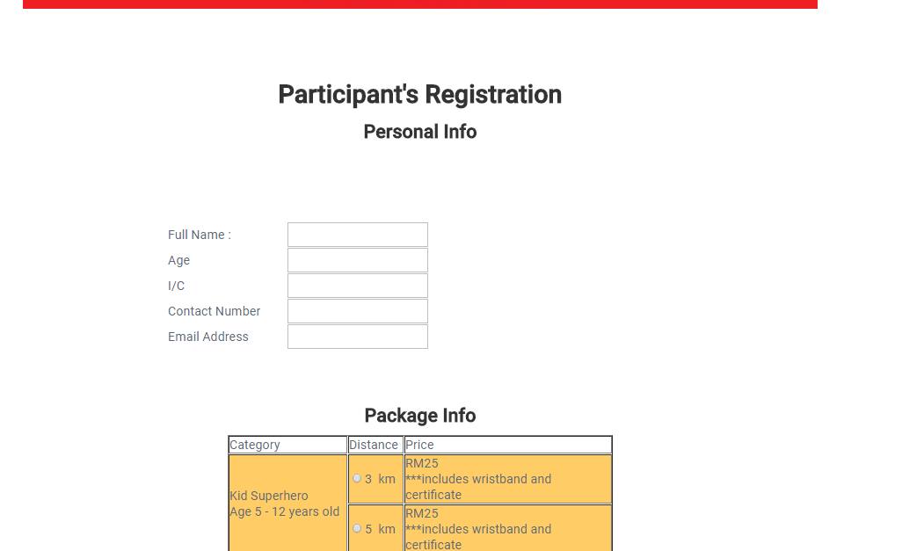

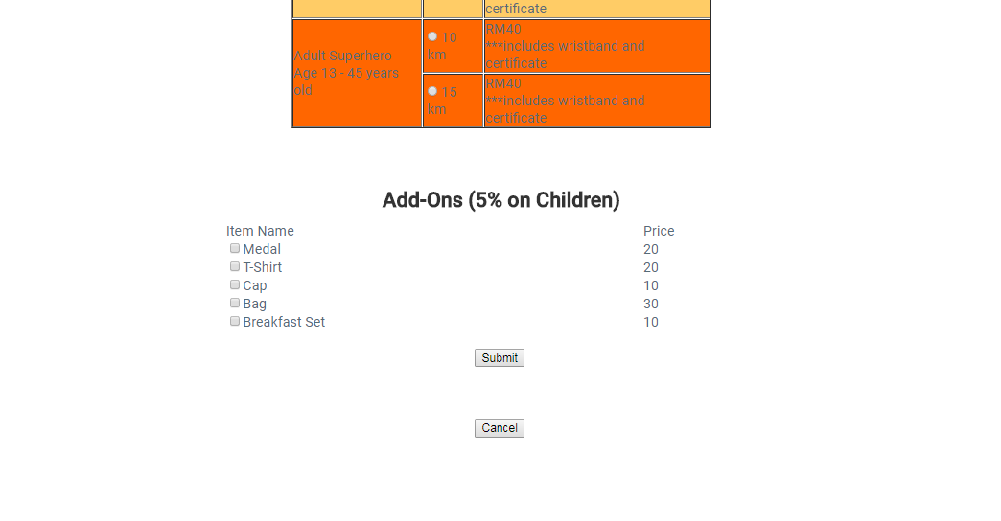

Figure 2 is a screen shot for the stated webpage.

|  |
| --- |
| Related Code/ Configuration |
| **.Aspx**  <%@ Page Title="" Language="C#" MasterPageFile="~/participant.master" AutoEventWireup="true" CodeFile="participant_register.aspx.cs" Inherits="participant_register" %>  <asp:Content ID="Content1" ContentPlaceHolderID="head" Runat="Server">  <style type="text/css">  .style1  {  width: 100%;  }  </style>  </asp:Content>  <asp:Content ID="Content2" ContentPlaceHolderID="ContentPlaceHolder1" Runat="Server">  <div class="main">  <h1>  <br />  Participant&#39;s Registration</h1>  <h2>  Personal Info</h2>  <table class="style1">  <tr>  <td>  Full Name :</td>  <td>  <asp:TextBox ID="txtName" runat="server"></asp:TextBox>  </td>  <td>  <asp:RequiredFieldValidator ID="RequiredFieldValidator1" runat="server"  ControlToValidate="txtName" ErrorMessage="Name is Required" ForeColor="#FF3300"></asp:RequiredFieldValidator>  </td>  </tr>  <tr>  <td>  Age</td>  <td>  <asp:TextBox ID="txtAge" runat="server"></asp:TextBox>  </td>  <td>  <asp:RequiredFieldValidator ID="RequiredFieldValidator2" runat="server"  ControlToValidate="txtAge" ErrorMessage="Age is Required" ForeColor="#FF3300"></asp:RequiredFieldValidator>  </td>  </tr>  <tr>  <td>  I/C</td>  <td>  <asp:TextBox ID="txtIC" runat="server"></asp:TextBox>  </td>  <td>  <asp:RequiredFieldValidator ID="RequiredFieldValidator3" runat="server"  ControlToValidate="txtIC" ErrorMessage="IC is Required" ForeColor="#FF3300"></asp:RequiredFieldValidator>  </td>  </tr>  <tr>  <td>  Contact Number</td>  <td>  <asp:TextBox ID="txtNum" runat="server"></asp:TextBox>  </td>  <td>  <asp:RequiredFieldValidator ID="RequiredFieldValidator4" runat="server"  ControlToValidate="txtNum" ErrorMessage="Contact Number is Required"  ForeColor="#FF3300"></asp:RequiredFieldValidator>  </td>  </tr>  <tr>  <td>  Email Address</td>  <td>  <asp:TextBox ID="txtEmail" runat="server"></asp:TextBox>  </td>  <td>  <asp:RegularExpressionValidator ID="RegularExpressionValidator1" runat="server"  ControlToValidate="txtEmail" ErrorMessage="Email is Required"  ForeColor="#FF3300"  ValidationExpression="\w+([-+.']\w+)*@\w+([-.]\w+)*\.\w+([-.]\w+)*"></asp:RegularExpressionValidator>  </td>  </tr>  </table>  <br />  <h2>Package Info</h2><br />  <table border="1" align="center">  <tr><td class="style21" bgcolor="White">Category</td><td class="style20"  bgcolor="White">Distance</td>  <td class="style44" bgcolor="White">Price</td></tr>  <tr><td class="style13" rowspan="2" bgcolor="#FFCC66"><span class="style46">Kid Superhero</span><br  class="style46" />  <span class="style46">Age 5 - 12 years old</span></td><td class="style16"  bgcolor="#FFCC66">  <asp:RadioButton ID="rb3km" runat="server" GroupName="rbGroupDistance"  Text="3" />  <span class="style46">&nbsp;km</span><br class="style46" />  </td><td class="style15" bgcolor="#FFCC66"><span class="style46">RM25</span><br  class="style46" />  <span class="style46">***includes wristband and certificate</span></td></tr>  <tr><td class="style47" bgcolor="#FFCC66">  <asp:RadioButton ID="rb5km" runat="server" GroupName="rbGroupDistance"  Text="5" />  &nbsp;km</td><td class="style15"  bgcolor="#FFCC66"><span class="style46">RM25</span><br class="style46" />  <span class="style46">***includes wristband and certificate</span></td></tr>  <tr><td class="style13" rowspan="2" bgcolor="#FF6600"><span class="style46">Adult Superhero</span><br  class="style46" />  <span class="style46">Age 13 - 45 years old</span></td><td class="style47"  bgcolor="#FF6600">  <asp:RadioButton ID="rb10km" runat="server" GroupName="rbGroupDistance"  Text="10" />  &nbsp;km</td>  <td class="style15" bgcolor="#FF6600"><span class="style46">RM40</span><br  class="style46" />  <span class="style46">***includes wristband and certificate</span></td></tr>  <tr><td class="style17" bgcolor="#FF6600">  <asp:RadioButton ID="rb15km" runat="server" GroupName="rbGroupDistance"  Text="15" />  &nbsp;km</td>  <td class="style18"  bgcolor="#FF6600"><span class="style46">RM40</span><br class="style46" />  <span class="style46">***includes wristband and certificate</span></td></tr>    </table>  <br />  <h2>Add-Ons (5% on Children)</h2><br />  <table class="style1">  <tr>  <td>  Item Name</td>  <td>  Price</td>  </tr>  <tr>  <td>  <asp:CheckBox ID="chckMedal" runat="server" Text="Medal" />  </td>  <td>  20</td>  </tr>  <tr>  <td>  <asp:CheckBox ID="chckTshirt" runat="server" AutoPostBack="True"  oncheckedchanged="chckTshirt_CheckedChanged" Text="T-Shirt" />  &nbsp;  <asp:Label ID="lblSize" runat="server" Text=" Size : " Visible="False"></asp:Label>  <asp:DropDownList ID="ddlSize" runat="server" Visible="False">  <asp:ListItem>Choose Size</asp:ListItem>  <asp:ListItem>S</asp:ListItem>  <asp:ListItem>M</asp:ListItem>  <asp:ListItem>L</asp:ListItem>  <asp:ListItem>XL</asp:ListItem>  </asp:DropDownList>  </td>  <td>  20</td>  </tr>  <tr>  <td>  <asp:CheckBox ID="chckCap" runat="server" Text="Cap" />  </td>  <td>  10</td>  </tr>  <tr>  <td>  <asp:CheckBox ID="chckBag" runat="server" Text="Bag" />  </td>  <td>  30</td>  </tr>  <tr>  <td>  <asp:CheckBox ID="chckBfast" runat="server" Text="Breakfast Set" />  </td>  <td>  10</td>  </tr>  </table>  <br />  <asp:Button ID="btnSubmit" runat="server" onclick="btnSubmit_Click"  Text="Submit" />  &nbsp;&nbsp;&nbsp;  <asp:Button ID="btnCancel" runat="server" CausesValidation="False"  onclick="btnCancel_Click" Text="Cancel" />  <br />  <br />  <asp:Label ID="lblTest" runat="server"></asp:Label>  </div>  </asp:Content>  **.Aspx.cs**  using System;  using System.Collections.Generic;  using System.Linq;  using System.Web;  using System.Web.UI;  using System.Web.UI.WebControls;  using System.Configuration;  using System.Data.Sql;  using System.Data.SqlClient;  public partial class participant_register : System.Web.UI.Page  {  SqlCommand cmd;  SqlConnection conn;  protected void Page_Load(object sender, EventArgs e)  {  }  protected void chckTshirt_CheckedChanged(object sender, EventArgs e)  {  lblSize.Visible = false;  ddlSize.Visible = false;  if (chckTshirt.Checked)  {  lblSize.Visible = true;  ddlSize.Visible = true;  }  }  protected void btnSubmit_Click(object sender, EventArgs e)  {  conn = new SqlConnection("Data Source=.\\SQLEXPRESS;Initial Catalog=dbtest;Integrated Security=True");    // variables  int total = 0, disc = 0;  // Personal Info (session test)  /*Session["name"] = txtName.Text;  Session["age"] = txtAge.Text;  Session["ic"] = txtIC.Text;  Session["contact"] = txtNum.Text;  Session["email"] = txtEmail.Text;*/  //insert to database personal info  cmd = new SqlCommand("INSERT INTO PARTICIPANT(part_name, part_icno, part_phoneno, part_email) VALUES (@v1, @v3, @v4, @v5)", conn);  cmd.Parameters.AddWithValue("@v1", txtName.Text);  //cmd.Parameters.AddWithValue("@v2", txtAge.Text);  cmd.Parameters.AddWithValue("@v3", txtIC.Text);  cmd.Parameters.AddWithValue("@v4", txtNum.Text);  cmd.Parameters.AddWithValue("@v5", txtEmail.Text);  conn.Open();  cmd.ExecuteNonQuery();  conn.Close();  //getting foreign key value for package  cmd = new SqlCommand("SELECT * FROM PARTICIPANT WHERE (part_icno = '" + txtIC.Text + "')", conn);  conn.Open();  String part_id = "0";  SqlDataReader read = cmd.ExecuteReader();  if (read.Read())  {  part_id = read.GetValue(0).ToString();  lblTest.Text = part_id;  }  int parto_id = Int32.Parse(part_id);  conn.Close();  // Package Info  String rb = "";  if (rb3km.Checked)  {  rb = rb3km.Text;  total += 25;  disc = 5;  }  else if (rb5km.Checked)  {  rb = rb5km.Text;  total += 25;  disc = 5;  }  else if (rb10km.Checked)  {  rb = rb10km.Text;  total += 40;  }  else if (rb15km.Checked)  {  rb = rb15km.Text;  total += 40;  }  /* Session Test  * Session["distance"] = rb;*/  // Add-Ons  String size = "NO"; //addons = "";  Boolean medal = false, tshirt = false, cap = false, bag = false, bfast = false;  if (chckMedal.Checked)  {  // addons = addons + "medal<br />";  total += 20;  medal = true;  }  if (chckTshirt.Checked)  {  // addons = addons + "T-Shirt<br />";  total += 20;  tshirt = true;  size = ddlSize.SelectedValue;  }  if (chckCap.Checked)  {  // addons = addons + "Cap<br />";  total += 10;  cap = true;  }  if (chckBag.Checked)  {  // addons = addons + "Bag<br />";  total += 30;  bag = true;  }  if (chckBfast.Checked)  {  //addons = addons + "BreakFast Set<br />";  total += 10;  bfast = true;  }  /*Session Test  * Session["addons"] = addons;  *Session["total"] = total;*/  //discount  total = total - packdiscount(total, disc);  //insert into database package info  cmd = new SqlCommand("INSERT INTO PACKAGE(pack_price, pack_shirt, shirt_size, pack_food, pack_discount,pack_medal,pack_category,pack_cap,pack_bag,part_ID) VALUES (@v1, @v2, @v3, @v4, @v5,@v6, @v7, @v8, @v9, @v10)", conn);  cmd.Parameters.AddWithValue("@v1", total);  cmd.Parameters.AddWithValue("@v2", tshirt);  cmd.Parameters.AddWithValue("@v3", size);  cmd.Parameters.AddWithValue("@v4", bfast);  cmd.Parameters.AddWithValue("@v5", packdiscount(total, disc));  cmd.Parameters.AddWithValue("@v6", medal);  cmd.Parameters.AddWithValue("@v7", rb);  cmd.Parameters.AddWithValue("@v8", cap);  cmd.Parameters.AddWithValue("@v9", bag);  cmd.Parameters.AddWithValue("@v10", parto_id);  conn.Open();  cmd.ExecuteNonQuery();  conn.Close();    // Test  /*String test = "";  for (int i = 0; i < Session.Count; i++)  {  var crntSession = Session.Keys[i];  test = test + string.Concat(crntSession, "=", Session[crntSession]) + "<br />";  }  lblTest.Text = test;*/  Response.Redirect("landing_page.aspx");  }  public int packdiscount(int totl, int disc)  {  disc = (totl * disc) / 100;  return disc;  }  protected void btnCancel_Click(object sender, EventArgs e)  {  Response.Redirect("landing_page.aspx");  }  } |
| Description |
| This page uses participant master page.  The usage of proper web controls and suitable labels to guide the participant on entering the required data.  The usage of proper web controls and suitable labels to guide the participant on entering the required data for the intended package.  Utilizing the usage of validations for better experience in data entry.  Calculate total of package price.  Acquire discount for some combination of choices.  Utilizing the usage of validations for better experience in data entry. |

## PARTICIPANT_VIEW

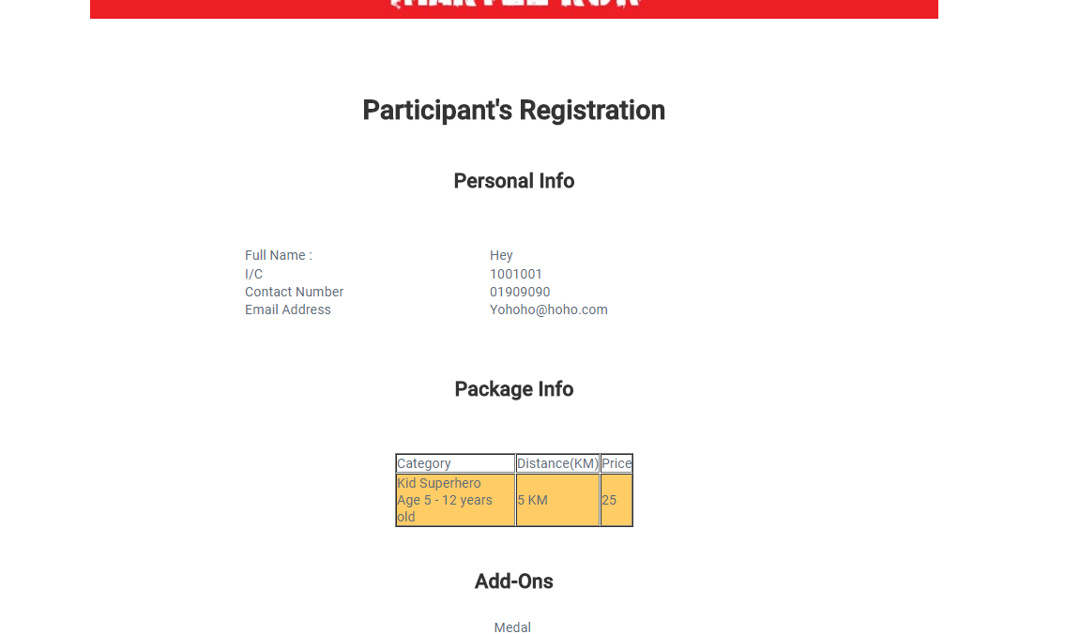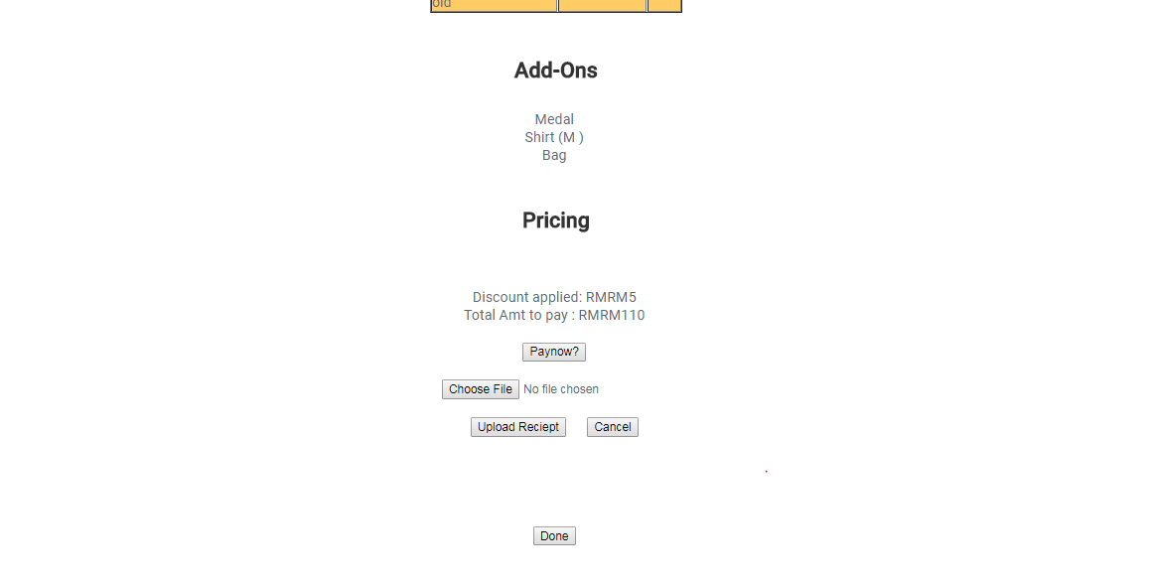

Figure 3 is a screen shot for the stated webpage.

|  |
| --- |
| Related Code/ Configuration |
| **.Aspx**  <%@ Page Title="" Language="C#" MasterPageFile="~/participant.master" AutoEventWireup="true" CodeFile="participant_view.aspx.cs" Inherits="participant_view" %>  <asp:Content ID="Content1" ContentPlaceHolderID="head" Runat="Server">  <style type="text/css">  .style1  {  width: 100%;  }  </style>  </asp:Content>  <asp:Content ID="Content2" ContentPlaceHolderID="ContentPlaceHolder1" Runat="Server">  <div class="main">  <div class="main">  <h1>  <br />  Participant&#39;s Registration</h1>  <h2>  Personal Info</h2>  <table class="style1">  <tr>  <td>  Full Name :</td>  <td>  <asp:Label ID="lblName" runat="server"></asp:Label>  </td>  </tr>  <tr>  <!--<td>  Age</td>  <td>  <asp:Label ID="lblAge" runat="server"></asp:Label>  </td>-->  </tr>  <tr>  <td>  I/C</td>  <td>  <asp:Label ID="lblIC" runat="server"></asp:Label>  </td>  </tr>  <tr>  <td>Contact Number</td>  <td>  <asp:Label ID="lblNumber" runat="server"></asp:Label>  </td>  </tr>  <tr>  <td>  Email Address</td>  <td>  <asp:Label ID="lblEmail" runat="server"></asp:Label>  </td>  </tr>  </table>  <br />  <h2>Package Info</h2>  <table border="1" align="center">  <tr><td class="style21" bgcolor="White">Category</td><td class="style20"  bgcolor="White">Distance(KM)</td>  <td class="style44" bgcolor="White">Price</td></tr>  <tr><td class="style21" bgcolor="#FFCC66"><asp:Label ID="lblCatg" runat="server"></asp:Label></td><td class="style20"  bgcolor="#FFCC66"><asp:Label ID="lblCatDist" runat="server"></asp:Label></td>  <td class="style44" bgcolor="#FFCC66"><asp:Label ID="lblCatPrice" runat="server"></asp:Label></td></tr>  </table>    <h2>Add-Ons</h2>  <asp:Label ID="lblAddons" runat="server"></asp:Label>  <h2>Pricing</h2>  Discount applied: RM<asp:Label ID="lblDiscount" runat="server"></asp:Label>  <br />  Total Amt to pay : RM<asp:Label ID="lblTotal" runat="server"></asp:Label>  <br />  <asp:Button ID="btnPay" runat="server" Text="Paynow?" />  <br />  <br />  <br />  <asp:Button ID="lblDone" runat="server" onclick="lblDone_Click" Text="Done" />  <br />  <asp:Label ID="lblTest" runat="server"></asp:Label>  </div>  </div>  </asp:Content>  **.Aspx.cs**  using System;  using System.Collections.Generic;  using System.Linq;  using System.Web;  using System.Web.UI;  using System.Web.UI.WebControls;  using System.Configuration;  using System.Data.Sql;  using System.Data.SqlClient;  public partial class participant_view : System.Web.UI.Page  {  SqlCommand cmd;  SqlConnection conn;  SqlDataReader Read;  protected void Page_Load(object sender, EventArgs e)  {  // Test  /*String test = "";  for (int i = 0; i < Session.Count; i++)  {  var crntSession = Session.Keys[i];  test = test + string.Concat(crntSession, "=", Session[crntSession]) + "<br />";  }*/  String id="",ic="",name="",email="", phoneno="", paid="",price="",shirt="",size="",food="",discount="",medal="",catg="",cap="",bag="";  //lblTest.Text = Session["IC"].ToString();  conn = new SqlConnection("Data Source=.\\SQLEXPRESS;Initial Catalog=dbtest;Integrated Security=True");  cmd = new SqlCommand("SELECT * FROM [PARTICIPANT] WHERE ([part_icno] = '" + Session["IC"].ToString() + "')", conn);  conn.Open();  Read = cmd.ExecuteReader();  while (Read.Read())  {  id = Read["part_ID"].ToString();  ic = Read["part_icno"].ToString();  name = Read["part_name"].ToString();  email = Read["part_email"].ToString();  phoneno = Read["part_phoneno"].ToString();  paid = Read["part_paid"].ToString();  }  conn.Close();  lblIC.Text = ic;  lblName.Text = name;  lblEmail.Text = email;  lblNumber.Text = phoneno;  cmd = new SqlCommand("SELECT * FROM [PACKAGE] WHERE ([part_ID] = '" + id + "')", conn);  conn.Open();  Read = cmd.ExecuteReader();  while (Read.Read())  {  price = Read["pack_price"].ToString();  shirt = Read["pack_shirt"].ToString();  size = Read["shirt_size"].ToString();  food = Read["pack_food"].ToString();  discount = Read["pack_discount"].ToString();  medal = Read["pack_medal"].ToString();  catg = Read["pack_category"].ToString();  cap = Read["pack_cap"].ToString();  bag = Read["pack_bag"].ToString();  }  conn.Close();  if (catg == "3" || catg == "5"){  lblCatg.Text = "Kid Superhero</br>Age 5 - 12 years old";  lblCatDist.Text = catg + "KM";  lblCatPrice.Text = "25";  }  else  {  lblCatg.Text = "Adult Superhero</br>Age 13 - 45 years old";  lblCatDist.Text = catg + "KM";  lblCatPrice.Text = "40";  }  if (medal == "True")  medal = "Medal <br/>";  else  medal = "";  if (shirt == "True")  shirt = "Shirt (" + size + ") <br/>";  else  shirt = "";  if (food == "1")  food = "Breakfast <br/>";  else  food = "";  if (bag == "True")  bag = "Bag <br/>";  else  bag = "";  lblAddons.Text = medal + shirt + food + bag;  lblDiscount.Text = "RM" + discount;  lblTotal.Text = "RM" + price;  if (paid == "True")  {  btnPay.Visible = true;  btnPay.Visible = false;  lblTest.Text = "You have paid";  }  else  lblTest.Text = " ";  }  protected void lblDone_Click(object sender, EventArgs e)  {  Response.Redirect("landing_page.aspx");  }  } |
| Description |
| This page uses participant master page.  Display registered information of the users.  Display whether the user is already picked a package or not, and whether the package is payed or not.  Able to pay the package choice based on register |

## ADMIN_MAIN

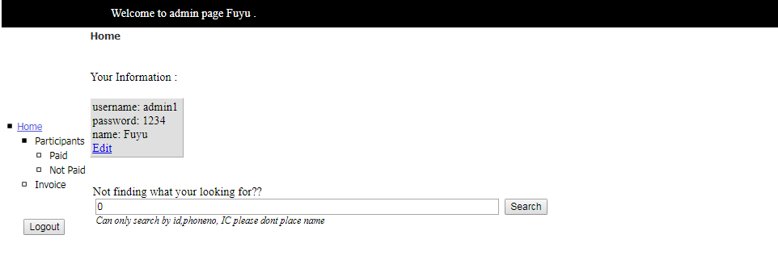

Figure 4 is a screen shot for the stated webpage.

|  |
| --- |
| Related Code/ Configuration |
| **.Aspx**  <%@ Page Title="" Language="C#" MasterPageFile="~/Admin/admin.master" AutoEventWireup="true" CodeFile="admin_main.aspx.cs" Inherits="Admin_admin_main" %>  <asp:Content ID="Content1" ContentPlaceHolderID="head" Runat="Server">  </asp:Content>  <asp:Content ID="Content2" ContentPlaceHolderID="ContentPlaceHolder1" Runat="Server">  <div>  <br />Your Information :<br />  <br />  <asp:FormView ID="FormView1" runat="server" BackColor="White"  BorderColor="White" BorderStyle="Ridge" BorderWidth="2px" CellPadding="3"  CellSpacing="1" DataKeyNames="username" DataSourceID="SqlDataSource1">  <EditItemTemplate>  username:  <asp:Label ID="usernameLabel1" runat="server" Text='<%# Eval("username") %>' />  <br />  password:  <asp:TextBox ID="passwordTextBox" runat="server"  Text='<%# Bind("password") %>' />  <br />  name:  <asp:TextBox ID="nameTextBox" runat="server" Text='<%# Bind("name") %>' />  <br />  <asp:LinkButton ID="UpdateButton" runat="server" CausesValidation="True"  CommandName="Update" Text="Update" />  &nbsp;<asp:LinkButton ID="UpdateCancelButton" runat="server"  CausesValidation="False" CommandName="Cancel" Text="Cancel" />  </EditItemTemplate>  <EditRowStyle BackColor="#9471DE" Font-Bold="True" ForeColor="White" />  <FooterStyle BackColor="#C6C3C6" ForeColor="Black" />  <HeaderStyle BackColor="#4A3C8C" Font-Bold="True" ForeColor="#E7E7FF" />  <InsertItemTemplate>  username:  <asp:TextBox ID="usernameTextBox" runat="server"  Text='<%# Bind("username") %>' />  <br />  password:  <asp:TextBox ID="passwordTextBox" runat="server"  Text='<%# Bind("password") %>' />  <br />  name:  <asp:TextBox ID="nameTextBox" runat="server" Text='<%# Bind("name") %>' />  <br />  <asp:LinkButton ID="InsertButton" runat="server" CausesValidation="True"  CommandName="Insert" Text="Insert" />  &nbsp;<asp:LinkButton ID="InsertCancelButton" runat="server"  CausesValidation="False" CommandName="Cancel" Text="Cancel" />  </InsertItemTemplate>  <ItemTemplate>  username:  <asp:Label ID="usernameLabel" runat="server" Text='<%# Eval("username") %>' />  <br />  password:  <asp:Label ID="passwordLabel" runat="server" Text='<%# Bind("password") %>' />  <br />  name:  <asp:Label ID="nameLabel" runat="server" Text='<%# Bind("name") %>' />  <br />  <asp:LinkButton ID="EditButton" runat="server" CausesValidation="False"  CommandName="Edit" Text="Edit" />  &nbsp;&nbsp;  </ItemTemplate>  <PagerStyle BackColor="#C6C3C6" ForeColor="Black" HorizontalAlign="Right" />  <RowStyle BackColor="#DEDFDE" ForeColor="Black" />  </asp:FormView>  <asp:SqlDataSource ID="SqlDataSource1" runat="server"  ConnectionString="<%$ ConnectionStrings:dbtestConnectionString %>"  DeleteCommand="DELETE FROM [ADMIN] WHERE [username] = @username"  InsertCommand="INSERT INTO [ADMIN] ([username], [password], [name]) VALUES (@username, @password, @name)"  SelectCommand="SELECT * FROM [ADMIN] WHERE ([name] = @name)"    UpdateCommand="UPDATE [ADMIN] SET [password] = @password, [name] = @name WHERE [username] = @username">  <DeleteParameters>  <asp:Parameter Name="username" Type="String" />  </DeleteParameters>  <InsertParameters>  <asp:Parameter Name="username" Type="String" />  <asp:Parameter Name="password" Type="String" />  <asp:Parameter Name="name" Type="String" />  </InsertParameters>  <SelectParameters>  <asp:SessionParameter Name="name" SessionField="name" Type="String" />  </SelectParameters>  <UpdateParameters>  <asp:Parameter Name="password" Type="String" />  <asp:Parameter Name="name" Type="String" />  <asp:Parameter Name="username" Type="String" />  </UpdateParameters>  </asp:SqlDataSource>  <br />  </div>  </asp:Content>  **.Aspx.cs**  using System;  using System.Collections.Generic;  using System.Linq;  using System.Web;  using System.Web.UI;  using System.Web.UI.WebControls;  public partial class Admin_admin_main : System.Web.UI.Page  {  protected void Page_Load(object sender, EventArgs e)  {  }  } |
| Description |
| Use the master page for admin.  Able to add a new fellow admin.  Able to edit current admin name.  Displays admin name according to database. |

## ADMIN_INVOICES

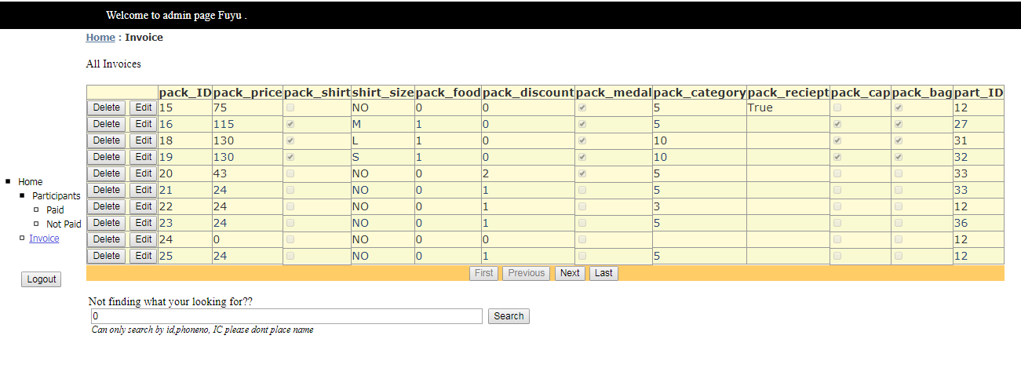

Figure 5 is a screen shot for the stated webpage.

|  |
| --- |
| Related Code/ Configuration |
| **.Aspx**  <%@ Page Title="" Language="C#" MasterPageFile="~/Admin/admin.master" AutoEventWireup="true" CodeFile="admin_invoices.aspx.cs" Inherits="Admin_admin_invoices" %>  <asp:Content ID="Content1" ContentPlaceHolderID="head" Runat="Server">  </asp:Content>  <asp:Content ID="Content2" ContentPlaceHolderID="ContentPlaceHolder1" Runat="Server">  <div>  <div>  All Invoices<br />  <br />  <asp:ListView ID="ListView1" runat="server" DataKeyNames="pack_ID"  DataSourceID="SqlDataSource1">  <AlternatingItemTemplate>  <tr style="background-color: #FAFAD2;color: #284775;">  <td>  <asp:Button ID="DeleteButton" runat="server" CommandName="Delete"  Text="Delete" />  <asp:Button ID="EditButton" runat="server" CommandName="Edit" Text="Edit" />  </td>  <td>  <asp:Label ID="pack_IDLabel" runat="server" Text='<%# Eval("pack_ID") %>' />  </td>  <td>  <asp:Label ID="pack_priceLabel" runat="server"  Text='<%# Eval("pack_price") %>' />  </td>  <td>  <asp:CheckBox ID="pack_shirtCheckBox" runat="server"  Checked='<%# Eval("pack_shirt") %>' Enabled="false" />  </td>  <td>  <asp:Label ID="shirt_sizeLabel" runat="server"  Text='<%# Eval("shirt_size") %>' />  </td>  <td>  <asp:Label ID="pack_foodLabel" runat="server"  Text='<%# Eval("pack_food") %>' />  </td>  <td>  <asp:Label ID="pack_discountLabel" runat="server"  Text='<%# Eval("pack_discount") %>' />  </td>  <td>  <asp:CheckBox ID="pack_medalCheckBox" runat="server"  Checked='<%# Eval("pack_medal") %>' Enabled="false" />  </td>  <td>  <asp:Label ID="pack_categoryLabel" runat="server"  Text='<%# Eval("pack_category") %>' />  </td>  <td>  <asp:Label ID="pack_recieptLabel" runat="server"  Text='<%# Eval("pack_reciept") %>' />  </td>  <td>  <asp:CheckBox ID="pack_capCheckBox" runat="server"  Checked='<%# Eval("pack_cap") %>' Enabled="false" />  </td>  <td>  <asp:CheckBox ID="pack_bagCheckBox" runat="server"  Checked='<%# Eval("pack_bag") %>' Enabled="false" />  </td>  <td>  <asp:Label ID="part_IDLabel" runat="server" Text='<%# Eval("part_ID") %>' />  </td>  </tr>  </AlternatingItemTemplate>  <EditItemTemplate>  <tr style="background-color: #FFCC66;color: #000080;">  <td>  <asp:Button ID="UpdateButton" runat="server" CommandName="Update"  Text="Update" />  <asp:Button ID="CancelButton" runat="server" CommandName="Cancel"  Text="Cancel" />  </td>  <td>  <asp:Label ID="pack_IDLabel1" runat="server" Text='<%# Eval("pack_ID") %>' />  </td>  <td>  <asp:TextBox ID="pack_priceTextBox" runat="server"  Text='<%# Bind("pack_price") %>' />  </td>  <td>  <asp:CheckBox ID="pack_shirtCheckBox" runat="server"  Checked='<%# Bind("pack_shirt") %>' />  </td>  <td>  <asp:TextBox ID="shirt_sizeTextBox" runat="server"  Text='<%# Bind("shirt_size") %>' />  </td>  <td>  <asp:TextBox ID="pack_foodTextBox" runat="server"  Text='<%# Bind("pack_food") %>' />  </td>  <td>  <asp:TextBox ID="pack_discountTextBox" runat="server"  Text='<%# Bind("pack_discount") %>' />  </td>  <td>  <asp:CheckBox ID="pack_medalCheckBox" runat="server"  Checked='<%# Bind("pack_medal") %>' />  </td>  <td>  <asp:TextBox ID="pack_categoryTextBox" runat="server"  Text='<%# Bind("pack_category") %>' />  </td>  <td>  <asp:TextBox ID="pack_recieptTextBox" runat="server"  Text='<%# Bind("pack_reciept") %>' />  </td>  <td>  <asp:CheckBox ID="pack_capCheckBox" runat="server"  Checked='<%# Bind("pack_cap") %>' />  </td>  <td>  <asp:CheckBox ID="pack_bagCheckBox" runat="server"  Checked='<%# Bind("pack_bag") %>' />  </td>  <td>  <asp:TextBox ID="part_IDTextBox" runat="server" Text='<%# Bind("part_ID") %>' />  </td>  </tr>  </EditItemTemplate>  <EmptyDataTemplate>  <table runat="server"  style="background-color: #FFFFFF;border-collapse: collapse;border-color: #999999;border-style:none;border-width:1px;">  <tr>  <td>  No data was returned.</td>  </tr>  </table>  </EmptyDataTemplate>  <InsertItemTemplate>  <tr style="">  <td>  <asp:Button ID="InsertButton" runat="server" CommandName="Insert"  Text="Insert" />  <asp:Button ID="CancelButton" runat="server" CommandName="Cancel"  Text="Clear" />  </td>  <td>  &nbsp;</td>  <td>  <asp:TextBox ID="pack_priceTextBox" runat="server"  Text='<%# Bind("pack_price") %>' />  </td>  <td>  <asp:CheckBox ID="pack_shirtCheckBox" runat="server"  Checked='<%# Bind("pack_shirt") %>' />  </td>  <td>  <asp:TextBox ID="shirt_sizeTextBox" runat="server"  Text='<%# Bind("shirt_size") %>' />  </td>  <td>  <asp:TextBox ID="pack_foodTextBox" runat="server"  Text='<%# Bind("pack_food") %>' />  </td>  <td>  <asp:TextBox ID="pack_discountTextBox" runat="server"  Text='<%# Bind("pack_discount") %>' />  </td>  <td>  <asp:CheckBox ID="pack_medalCheckBox" runat="server"  Checked='<%# Bind("pack_medal") %>' />  </td>  <td>  <asp:TextBox ID="pack_categoryTextBox" runat="server"  Text='<%# Bind("pack_category") %>' />  </td>  <td>  <asp:TextBox ID="pack_recieptTextBox" runat="server"  Text='<%# Bind("pack_reciept") %>' />  </td>  <td>  <asp:CheckBox ID="pack_capCheckBox" runat="server"  Checked='<%# Bind("pack_cap") %>' />  </td>  <td>  <asp:CheckBox ID="pack_bagCheckBox" runat="server"  Checked='<%# Bind("pack_bag") %>' />  </td>  <td>  <asp:TextBox ID="part_IDTextBox" runat="server" Text='<%# Bind("part_ID") %>' />  </td>  </tr>  </InsertItemTemplate>  <ItemTemplate>  <tr style="background-color: #FFFBD6;color: #333333;">  <td>  <asp:Button ID="DeleteButton" runat="server" CommandName="Delete"  Text="Delete" />  <asp:Button ID="EditButton" runat="server" CommandName="Edit" Text="Edit" />  </td>  <td>  <asp:Label ID="pack_IDLabel" runat="server" Text='<%# Eval("pack_ID") %>' />  </td>  <td>  <asp:Label ID="pack_priceLabel" runat="server"  Text='<%# Eval("pack_price") %>' />  </td>  <td>  <asp:CheckBox ID="pack_shirtCheckBox" runat="server"  Checked='<%# Eval("pack_shirt") %>' Enabled="false" />  </td>  <td>  <asp:Label ID="shirt_sizeLabel" runat="server"  Text='<%# Eval("shirt_size") %>' />  </td>  <td>  <asp:Label ID="pack_foodLabel" runat="server"  Text='<%# Eval("pack_food") %>' />  </td>  <td>  <asp:Label ID="pack_discountLabel" runat="server"  Text='<%# Eval("pack_discount") %>' />  </td>  <td>  <asp:CheckBox ID="pack_medalCheckBox" runat="server"  Checked='<%# Eval("pack_medal") %>' Enabled="false" />  </td>  <td>  <asp:Label ID="pack_categoryLabel" runat="server"  Text='<%# Eval("pack_category") %>' />  </td>  <td>  <asp:Label ID="pack_recieptLabel" runat="server"  Text='<%# Eval("pack_reciept") %>' />  </td>  <td>  <asp:CheckBox ID="pack_capCheckBox" runat="server"  Checked='<%# Eval("pack_cap") %>' Enabled="false" />  </td>  <td>  <asp:CheckBox ID="pack_bagCheckBox" runat="server"  Checked='<%# Eval("pack_bag") %>' Enabled="false" />  </td>  <td>  <asp:Label ID="part_IDLabel" runat="server" Text='<%# Eval("part_ID") %>' />  </td>  </tr>  </ItemTemplate>  <LayoutTemplate>  <table runat="server">  <tr runat="server">  <td runat="server">  <table ID="itemPlaceholderContainer" runat="server" border="1"  style="background-color: #FFFFFF;border-collapse: collapse;border-color: #999999;border-style:none;border-width:1px;font-family: Verdana, Arial, Helvetica, sans-serif;">  <tr runat="server" style="background-color: #FFFBD6;color: #333333;">  <th runat="server">  </th>  <th runat="server">  pack_ID</th>  <th runat="server">  pack_price</th>  <th runat="server">  pack_shirt</th>  <th runat="server">  shirt_size</th>  <th runat="server">  pack_food</th>  <th runat="server">  pack_discount</th>  <th runat="server">  pack_medal</th>  <th runat="server">  pack_category</th>  <th runat="server">  pack_reciept</th>  <th runat="server">  pack_cap</th>  <th runat="server">  pack_bag</th>  <th runat="server">  part_ID</th>  </tr>  <tr ID="itemPlaceholder" runat="server">  </tr>  </table>  </td>  </tr>  <tr runat="server">  <td runat="server"  style="text-align: center;background-color: #FFCC66;font-family: Verdana, Arial, Helvetica, sans-serif;color: #333333;">  <asp:DataPager ID="DataPager1" runat="server">  <Fields>  <asp:NextPreviousPagerField ButtonType="Button" ShowFirstPageButton="True"  ShowLastPageButton="True" />  </Fields>  </asp:DataPager>  </td>  </tr>  </table>  </LayoutTemplate>  <SelectedItemTemplate>  <tr style="background-color: #FFCC66;font-weight: bold;color: #000080;">  <td>  <asp:Button ID="DeleteButton" runat="server" CommandName="Delete"  Text="Delete" />  <asp:Button ID="EditButton" runat="server" CommandName="Edit" Text="Edit" />  </td>  <td>  <asp:Label ID="pack_IDLabel" runat="server" Text='<%# Eval("pack_ID") %>' />  </td>  <td>  <asp:Label ID="pack_priceLabel" runat="server"  Text='<%# Eval("pack_price") %>' />  </td>  <td>  <asp:CheckBox ID="pack_shirtCheckBox" runat="server"  Checked='<%# Eval("pack_shirt") %>' Enabled="false" />  </td>  <td>  <asp:Label ID="shirt_sizeLabel" runat="server"  Text='<%# Eval("shirt_size") %>' />  </td>  <td>  <asp:Label ID="pack_foodLabel" runat="server"  Text='<%# Eval("pack_food") %>' />  </td>  <td>  <asp:Label ID="pack_discountLabel" runat="server"  Text='<%# Eval("pack_discount") %>' />  </td>  <td>  <asp:CheckBox ID="pack_medalCheckBox" runat="server"  Checked='<%# Eval("pack_medal") %>' Enabled="false" />  </td>  <td>  <asp:Label ID="pack_categoryLabel" runat="server"  Text='<%# Eval("pack_category") %>' />  </td>  <td>  <asp:Label ID="pack_recieptLabel" runat="server"  Text='<%# Eval("pack_reciept") %>' />  </td>  <td>  <asp:CheckBox ID="pack_capCheckBox" runat="server"  Checked='<%# Eval("pack_cap") %>' Enabled="false" />  </td>  <td>  <asp:CheckBox ID="pack_bagCheckBox" runat="server"  Checked='<%# Eval("pack_bag") %>' Enabled="false" />  </td>  <td>  <asp:Label ID="part_IDLabel" runat="server" Text='<%# Eval("part_ID") %>' />  </td>  </tr>  </SelectedItemTemplate>  </asp:ListView>  <asp:SqlDataSource ID="SqlDataSource1" runat="server"  ConnectionString="<%$ ConnectionStrings:dbtestConnectionString %>"  SelectCommand="SELECT * FROM [PACKAGE]"  DeleteCommand="DELETE FROM [PACKAGE] WHERE [pack_ID] = @pack_ID"  InsertCommand="INSERT INTO [PACKAGE] ([pack_price], [pack_shirt], [shirt_size], [pack_food], [pack_discount], [pack_medal], [pack_category], [pack_reciept], [pack_cap], [pack_bag], [part_ID]) VALUES (@pack_price, @pack_shirt, @shirt_size, @pack_food, @pack_discount, @pack_medal, @pack_category, @pack_reciept, @pack_cap, @pack_bag, @part_ID)"  UpdateCommand="UPDATE [PACKAGE] SET [pack_price] = @pack_price, [pack_shirt] = @pack_shirt, [shirt_size] = @shirt_size, [pack_food] = @pack_food, [pack_discount] = @pack_discount, [pack_medal] = @pack_medal, [pack_category] = @pack_category, [pack_reciept] = @pack_reciept, [pack_cap] = @pack_cap, [pack_bag] = @pack_bag, [part_ID] = @part_ID WHERE [pack_ID] = @pack_ID">  <DeleteParameters>  <asp:Parameter Name="pack_ID" Type="Int32" />  </DeleteParameters>  <InsertParameters>  <asp:Parameter Name="pack_price" Type="Int32" />  <asp:Parameter Name="pack_shirt" Type="Boolean" />  <asp:Parameter Name="shirt_size" Type="String" />  <asp:Parameter Name="pack_food" Type="String" />  <asp:Parameter Name="pack_discount" Type="Int32" />  <asp:Parameter Name="pack_medal" Type="Boolean" />  <asp:Parameter Name="pack_category" Type="String" />  <asp:Parameter Name="pack_reciept" Type="String" />  <asp:Parameter Name="pack_cap" Type="Boolean" />  <asp:Parameter Name="pack_bag" Type="Boolean" />  <asp:Parameter Name="part_ID" Type="Int32" />  </InsertParameters>  <UpdateParameters>  <asp:Parameter Name="pack_price" Type="Int32" />  <asp:Parameter Name="pack_shirt" Type="Boolean" />  <asp:Parameter Name="shirt_size" Type="String" />  <asp:Parameter Name="pack_food" Type="String" />  <asp:Parameter Name="pack_discount" Type="Int32" />  <asp:Parameter Name="pack_medal" Type="Boolean" />  <asp:Parameter Name="pack_category" Type="String" />  <asp:Parameter Name="pack_reciept" Type="String" />  <asp:Parameter Name="pack_cap" Type="Boolean" />  <asp:Parameter Name="pack_bag" Type="Boolean" />  <asp:Parameter Name="part_ID" Type="Int32" />  <asp:Parameter Name="pack_ID" Type="Int32" />  </UpdateParameters>  </asp:SqlDataSource>  </div>  </div>  </asp:Content>  **.Aspx.cs**  using System;  using System.Collections.Generic;  using System.Linq;  using System.Web;  using System.Web.UI;  using System.Web.UI.WebControls;  public partial class Admin_admin_invoices : System.Web.UI.Page  {  protected void Page_Load(object sender, EventArgs e)  {  }  } |
| Description |
| Use the master page for admin.  Able to view all information on invoice of every paid participant’s package according to database |

## ADMIN_ALL_PARTICPANT

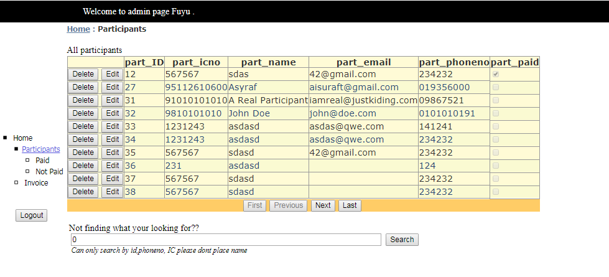

Figure 6 is a screen shot for the stated webpage.

|  |
| --- |
| Related Code/ Configuration |
| **.Aspx**  <%@ Page Title="" Language="C#" MasterPageFile="~/Admin/admin.master" AutoEventWireup="true" CodeFile="admin_all_participants.aspx.cs" Inherits="Admin_admin_all_participants" %>  <asp:Content ID="Content1" ContentPlaceHolderID="head" Runat="Server">  </asp:Content>  <asp:Content ID="Content2" ContentPlaceHolderID="ContentPlaceHolder1" Runat="Server">  <div>  All participants  <br />  <asp:ListView ID="ListView1" runat="server" DataKeyNames="part_ID"  DataSourceID="SqlDataSource1">  <AlternatingItemTemplate>  <tr style="background-color: #FAFAD2;color: #284775;">  <td>  <asp:Button ID="DeleteButton" runat="server" CommandName="Delete"  Text="Delete" />  <asp:Button ID="EditButton" runat="server" CommandName="Edit" Text="Edit" />  </td>  <td>  <asp:Label ID="part_IDLabel" runat="server" Text='<%# Eval("part_ID") %>' />  </td>  <td>  <asp:Label ID="part_icnoLabel" runat="server" Text='<%# Eval("part_icno") %>' />  </td>  <td>  <asp:Label ID="part_nameLabel" runat="server" Text='<%# Eval("part_name") %>' />  </td>  <td>  <asp:Label ID="part_emailLabel" runat="server"  Text='<%# Eval("part_email") %>' />  </td>  <td>  <asp:Label ID="part_phonenoLabel" runat="server"  Text='<%# Eval("part_phoneno") %>' />  </td>  <td>  <asp:CheckBox ID="part_paidCheckBox" runat="server"  Checked='<%# Eval("part_paid") %>' Enabled="false" />  </td>  </tr>  </AlternatingItemTemplate>  <EditItemTemplate>  <tr style="background-color: #FFCC66;color: #000080;">  <td>  <asp:Button ID="UpdateButton" runat="server" CommandName="Update"  Text="Update" />  <asp:Button ID="CancelButton" runat="server" CommandName="Cancel"  Text="Cancel" />  </td>  <td>  <asp:Label ID="part_IDLabel1" runat="server" Text='<%# Eval("part_ID") %>' />  </td>  <td>  <asp:TextBox ID="part_icnoTextBox" runat="server"  Text='<%# Bind("part_icno") %>' />  </td>  <td>  <asp:TextBox ID="part_nameTextBox" runat="server"  Text='<%# Bind("part_name") %>' />  </td>  <td>  <asp:TextBox ID="part_emailTextBox" runat="server"  Text='<%# Bind("part_email") %>' />  </td>  <td>  <asp:TextBox ID="part_phonenoTextBox" runat="server"  Text='<%# Bind("part_phoneno") %>' />  </td>  <td>  <asp:CheckBox ID="part_paidCheckBox" runat="server"  Checked='<%# Bind("part_paid") %>' />  </td>  </tr>  </EditItemTemplate>  <EmptyDataTemplate>  <table runat="server"  style="background-color: #FFFFFF;border-collapse: collapse;border-color: #999999;border-style:none;border-width:1px;">  <tr>  <td>  No data was returned.</td>  </tr>  </table>  </EmptyDataTemplate>  <InsertItemTemplate>  <tr style="">  <td>  <asp:Button ID="InsertButton" runat="server" CommandName="Insert"  Text="Insert" />  <asp:Button ID="CancelButton" runat="server" CommandName="Cancel"  Text="Clear" />  </td>  <td>  &nbsp;</td>  <td>  <asp:TextBox ID="part_icnoTextBox" runat="server"  Text='<%# Bind("part_icno") %>' />  </td>  <td>  <asp:TextBox ID="part_nameTextBox" runat="server"  Text='<%# Bind("part_name") %>' />  </td>  <td>  <asp:TextBox ID="part_emailTextBox" runat="server"  Text='<%# Bind("part_email") %>' />  </td>  <td>  <asp:TextBox ID="part_phonenoTextBox" runat="server"  Text='<%# Bind("part_phoneno") %>' />  </td>  <td>  <asp:CheckBox ID="part_paidCheckBox" runat="server"  Checked='<%# Bind("part_paid") %>' />  </td>  </tr>  </InsertItemTemplate>  <ItemTemplate>  <tr style="background-color: #FFFBD6;color: #333333;">  <td>  <asp:Button ID="DeleteButton" runat="server" CommandName="Delete"  Text="Delete" />  <asp:Button ID="EditButton" runat="server" CommandName="Edit" Text="Edit" />  </td>  <td>  <asp:Label ID="part_IDLabel" runat="server" Text='<%# Eval("part_ID") %>' />  </td>  <td>  <asp:Label ID="part_icnoLabel" runat="server" Text='<%# Eval("part_icno") %>' />  </td>  <td>  <asp:Label ID="part_nameLabel" runat="server" Text='<%# Eval("part_name") %>' />  </td>  <td>  <asp:Label ID="part_emailLabel" runat="server"  Text='<%# Eval("part_email") %>' />  </td>  <td>  <asp:Label ID="part_phonenoLabel" runat="server"  Text='<%# Eval("part_phoneno") %>' />  </td>  <td>  <asp:CheckBox ID="part_paidCheckBox" runat="server"  Checked='<%# Eval("part_paid") %>' Enabled="false" />  </td>  </tr>  </ItemTemplate>  <LayoutTemplate>  <table runat="server">  <tr runat="server">  <td runat="server">  <table ID="itemPlaceholderContainer" runat="server" border="1"  style="background-color: #FFFFFF;border-collapse: collapse;border-color: #999999;border-style:none;border-width:1px;font-family: Verdana, Arial, Helvetica, sans-serif;">  <tr runat="server" style="background-color: #FFFBD6;color: #333333;">  <th runat="server">  </th>  <th runat="server">  part_ID</th>  <th runat="server">  part_icno</th>  <th runat="server">  part_name</th>  <th runat="server">  part_email</th>  <th runat="server">  part_phoneno</th>  <th runat="server">  part_paid</th>  </tr>  <tr runat="server" ID="itemPlaceholder">  </tr>  </table>  </td>  </tr>  <tr runat="server">  <td runat="server"  style="text-align: center;background-color: #FFCC66;font-family: Verdana, Arial, Helvetica, sans-serif;color: #333333;">  <asp:DataPager ID="DataPager1" runat="server">  <Fields>  <asp:NextPreviousPagerField ButtonType="Button" ShowFirstPageButton="True"  ShowLastPageButton="True" />  </Fields>  </asp:DataPager>  </td>  </tr>  </table>  </LayoutTemplate>  <SelectedItemTemplate>  <tr style="background-color: #FFCC66;font-weight: bold;color: #000080;">  <td>  <asp:Button ID="DeleteButton" runat="server" CommandName="Delete"  Text="Delete" />  <asp:Button ID="EditButton" runat="server" CommandName="Edit" Text="Edit" />  </td>  <td>  <asp:Label ID="part_IDLabel" runat="server" Text='<%# Eval("part_ID") %>' />  </td>  <td>  <asp:Label ID="part_icnoLabel" runat="server" Text='<%# Eval("part_icno") %>' />  </td>  <td>  <asp:Label ID="part_nameLabel" runat="server" Text='<%# Eval("part_name") %>' />  </td>  <td>  <asp:Label ID="part_emailLabel" runat="server"  Text='<%# Eval("part_email") %>' />  </td>  <td>  <asp:Label ID="part_phonenoLabel" runat="server"  Text='<%# Eval("part_phoneno") %>' />  </td>  <td>  <asp:CheckBox ID="part_paidCheckBox" runat="server"  Checked='<%# Eval("part_paid") %>' Enabled="false" />  </td>  </tr>  </SelectedItemTemplate>  </asp:ListView>  <asp:SqlDataSource ID="SqlDataSource1" runat="server"  ConnectionString="<%$ ConnectionStrings:dbtestConnectionString %>"  DeleteCommand="DELETE FROM [PARTICIPANT] WHERE [part_ID] = @part_ID"  InsertCommand="INSERT INTO [PARTICIPANT] ([part_icno], [part_name], [part_email], [part_phoneno], [part_paid]) VALUES (@part_icno, @part_name, @part_email, @part_phoneno, @part_paid)"  SelectCommand="SELECT * FROM [PARTICIPANT]"  UpdateCommand="UPDATE [PARTICIPANT] SET [part_icno] = @part_icno, [part_name] = @part_name, [part_email] = @part_email, [part_phoneno] = @part_phoneno, [part_paid] = @part_paid WHERE [part_ID] = @part_ID">  <DeleteParameters>  <asp:Parameter Name="part_ID" Type="Int32" />  </DeleteParameters>  <InsertParameters>  <asp:Parameter Name="part_icno" Type="String" />  <asp:Parameter Name="part_name" Type="String" />  <asp:Parameter Name="part_email" Type="String" />  <asp:Parameter Name="part_phoneno" Type="String" />  <asp:Parameter Name="part_paid" Type="Boolean" />  </InsertParameters>  <UpdateParameters>  <asp:Parameter Name="part_icno" Type="String" />  <asp:Parameter Name="part_name" Type="String" />  <asp:Parameter Name="part_email" Type="String" />  <asp:Parameter Name="part_phoneno" Type="String" />  <asp:Parameter Name="part_paid" Type="Boolean" />  <asp:Parameter Name="part_ID" Type="Int32" />  </UpdateParameters>  </asp:SqlDataSource>  </div>  </asp:Content>  **.Aspx.cs**  using System;  using System.Collections.Generic;  using System.Linq;  using System.Web;  using System.Web.UI;  using System.Web.UI.WebControls;  public partial class Admin_admin_all_participants : System.Web.UI.Page  {  protected void Page_Load(object sender, EventArgs e)  {  }  } |
| Description |
| Use the master page for admin.  Able to view all information on all the participants.  Able to delete data on participant.  Able to sort the following data.  Able to update the following data. |

## ADMIN_PAID_PARTICIPANT

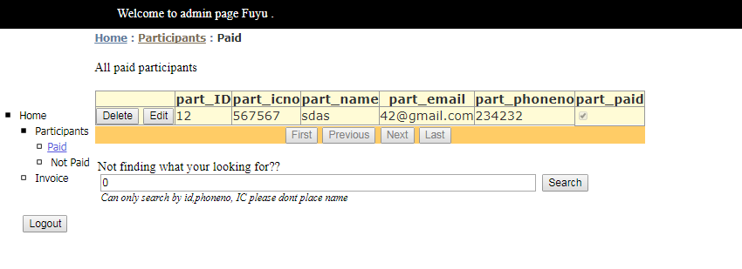

Figure 7 is a screen shot for the stated webpage.

|  |
| --- |
| Related Code/ Configuration |
| **.Aspx**  <%@ Page Title="" Language="C#" MasterPageFile="~/Admin/admin.master" AutoEventWireup="true" CodeFile="admin_paid_participant.aspx.cs" Inherits="Admin_admin_payed_participant" %>  <asp:Content ID="Content1" ContentPlaceHolderID="head" Runat="Server">  </asp:Content>  <asp:Content ID="Content2" ContentPlaceHolderID="ContentPlaceHolder1" Runat="Server">  <div>  All paid participants<br />  <br />  <asp:ListView ID="ListView1" runat="server" DataKeyNames="part_ID"  DataSourceID="SqlDataSource1">  <AlternatingItemTemplate>  <tr style="background-color: #FAFAD2;color: #284775;">  <td>  <asp:Button ID="DeleteButton" runat="server" CommandName="Delete"  Text="Delete" />  <asp:Button ID="EditButton" runat="server" CommandName="Edit" Text="Edit" />  </td>  <td>  <asp:Label ID="part_IDLabel" runat="server" Text='<%# Eval("part_ID") %>' />  </td>  <td>  <asp:Label ID="part_icnoLabel" runat="server" Text='<%# Eval("part_icno") %>' />  </td>  <td>  <asp:Label ID="part_nameLabel" runat="server" Text='<%# Eval("part_name") %>' />  </td>  <td>  <asp:Label ID="part_emailLabel" runat="server"  Text='<%# Eval("part_email") %>' />  </td>  <td>  <asp:Label ID="part_phonenoLabel" runat="server"  Text='<%# Eval("part_phoneno") %>' />  </td>  <td>  <asp:CheckBox ID="part_paidCheckBox" runat="server"  Checked='<%# Eval("part_paid") %>' Enabled="false" />  </td>  </tr>  </AlternatingItemTemplate>  <EditItemTemplate>  <tr style="background-color: #FFCC66;color: #000080;">  <td>  <asp:Button ID="UpdateButton" runat="server" CommandName="Update"  Text="Update" />  <asp:Button ID="CancelButton" runat="server" CommandName="Cancel"  Text="Cancel" />  </td>  <td>  <asp:Label ID="part_IDLabel1" runat="server" Text='<%# Eval("part_ID") %>' />  </td>  <td>  <asp:TextBox ID="part_icnoTextBox" runat="server"  Text='<%# Bind("part_icno") %>' />  </td>  <td>  <asp:TextBox ID="part_nameTextBox" runat="server"  Text='<%# Bind("part_name") %>' />  </td>  <td>  <asp:TextBox ID="part_emailTextBox" runat="server"  Text='<%# Bind("part_email") %>' />  </td>  <td>  <asp:TextBox ID="part_phonenoTextBox" runat="server"  Text='<%# Bind("part_phoneno") %>' />  </td>  <td>  <asp:CheckBox ID="part_paidCheckBox" runat="server"  Checked='<%# Bind("part_paid") %>' />  </td>  </tr>  </EditItemTemplate>  <EmptyDataTemplate>  <table runat="server"  style="background-color: #FFFFFF;border-collapse: collapse;border-color: #999999;border-style:none;border-width:1px;">  <tr>  <td>  No data was returned.</td>  </tr>  </table>  </EmptyDataTemplate>  <InsertItemTemplate>  <tr style="">  <td>  <asp:Button ID="InsertButton" runat="server" CommandName="Insert"  Text="Insert" />  <asp:Button ID="CancelButton" runat="server" CommandName="Cancel"  Text="Clear" />  </td>  <td>  &nbsp;</td>  <td>  <asp:TextBox ID="part_icnoTextBox" runat="server"  Text='<%# Bind("part_icno") %>' />  </td>  <td>  <asp:TextBox ID="part_nameTextBox" runat="server"  Text='<%# Bind("part_name") %>' />  </td>  <td>  <asp:TextBox ID="part_emailTextBox" runat="server"  Text='<%# Bind("part_email") %>' />  </td>  <td>  <asp:TextBox ID="part_phonenoTextBox" runat="server"  Text='<%# Bind("part_phoneno") %>' />  </td>  <td>  <asp:CheckBox ID="part_paidCheckBox" runat="server"  Checked='<%# Bind("part_paid") %>' />  </td>  </tr>  </InsertItemTemplate>  <ItemTemplate>  <tr style="background-color: #FFFBD6;color: #333333;">  <td>  <asp:Button ID="DeleteButton" runat="server" CommandName="Delete"  Text="Delete" />  <asp:Button ID="EditButton" runat="server" CommandName="Edit" Text="Edit" />  </td>  <td>  <asp:Label ID="part_IDLabel" runat="server" Text='<%# Eval("part_ID") %>' />  </td>  <td>  <asp:Label ID="part_icnoLabel" runat="server" Text='<%# Eval("part_icno") %>' />  </td>  <td>  <asp:Label ID="part_nameLabel" runat="server" Text='<%# Eval("part_name") %>' />  </td>  <td>  <asp:Label ID="part_emailLabel" runat="server"  Text='<%# Eval("part_email") %>' />  </td>  <td>  <asp:Label ID="part_phonenoLabel" runat="server"  Text='<%# Eval("part_phoneno") %>' />  </td>  <td>  <asp:CheckBox ID="part_paidCheckBox" runat="server"  Checked='<%# Eval("part_paid") %>' Enabled="false" />  </td>  </tr>  </ItemTemplate>  <LayoutTemplate>  <table runat="server">  <tr runat="server">  <td runat="server">  <table ID="itemPlaceholderContainer" runat="server" border="1"  style="background-color: #FFFFFF;border-collapse: collapse;border-color: #999999;border-style:none;border-width:1px;font-family: Verdana, Arial, Helvetica, sans-serif;">  <tr runat="server" style="background-color: #FFFBD6;color: #333333;">  <th runat="server">  </th>  <th runat="server">  part_ID</th>  <th runat="server">  part_icno</th>  <th runat="server">  part_name</th>  <th runat="server">  part_email</th>  <th runat="server">  part_phoneno</th>  <th runat="server">  part_paid</th>  </tr>  <tr ID="itemPlaceholder" runat="server">  </tr>  </table>  </td>  </tr>  <tr runat="server">  <td runat="server"  style="text-align: center;background-color: #FFCC66;font-family: Verdana, Arial, Helvetica, sans-serif;color: #333333;">  <asp:DataPager ID="DataPager1" runat="server">  <Fields>  <asp:NextPreviousPagerField ButtonType="Button" ShowFirstPageButton="True"  ShowLastPageButton="True" />  </Fields>  </asp:DataPager>  </td>  </tr>  </table>  </LayoutTemplate>  <SelectedItemTemplate>  <tr style="background-color: #FFCC66;font-weight: bold;color: #000080;">  <td>  <asp:Button ID="DeleteButton" runat="server" CommandName="Delete"  Text="Delete" />  <asp:Button ID="EditButton" runat="server" CommandName="Edit" Text="Edit" />  </td>  <td>  <asp:Label ID="part_IDLabel" runat="server" Text='<%# Eval("part_ID") %>' />  </td>  <td>  <asp:Label ID="part_icnoLabel" runat="server" Text='<%# Eval("part_icno") %>' />  </td>  <td>  <asp:Label ID="part_nameLabel" runat="server" Text='<%# Eval("part_name") %>' />  </td>  <td>  <asp:Label ID="part_emailLabel" runat="server"  Text='<%# Eval("part_email") %>' />  </td>  <td>  <asp:Label ID="part_phonenoLabel" runat="server"  Text='<%# Eval("part_phoneno") %>' />  </td>  <td>  <asp:CheckBox ID="part_paidCheckBox" runat="server"  Checked='<%# Eval("part_paid") %>' Enabled="false" />  </td>  </tr>  </SelectedItemTemplate>  </asp:ListView>  <asp:SqlDataSource ID="SqlDataSource1" runat="server"  ConnectionString="<%$ ConnectionStrings:dbtestConnectionString %>"  DeleteCommand="DELETE FROM [PARTICIPANT] WHERE [part_ID] = @part_ID"  InsertCommand="INSERT INTO [PARTICIPANT] ([part_icno], [part_name], [part_email], [part_phoneno], [part_paid], [pack_ID]) VALUES (@part_icno, @part_name, @part_email, @part_phoneno, @part_paid, @pack_ID)"  SelectCommand="SELECT * FROM [PARTICIPANT] WHERE ([part_paid] = @part_paid)"    UpdateCommand="UPDATE [PARTICIPANT] SET [part_icno] = @part_icno, [part_name] = @part_name, [part_email] = @part_email, [part_phoneno] = @part_phoneno, [part_paid] = @part_paid, [pack_ID] = @pack_ID WHERE [part_ID] = @part_ID">  <DeleteParameters>  <asp:Parameter Name="part_ID" Type="Int32" />  </DeleteParameters>  <InsertParameters>  <asp:Parameter Name="part_icno" Type="String" />  <asp:Parameter Name="part_name" Type="String" />  <asp:Parameter Name="part_email" Type="String" />  <asp:Parameter Name="part_phoneno" Type="String" />  <asp:Parameter Name="part_paid" Type="Boolean" />  <asp:Parameter Name="pack_ID" Type="Int32" />  </InsertParameters>  <SelectParameters>  <asp:Parameter DefaultValue="True" Name="part_paid" Type="Boolean" />  </SelectParameters>  <UpdateParameters>  <asp:Parameter Name="part_icno" Type="String" />  <asp:Parameter Name="part_name" Type="String" />  <asp:Parameter Name="part_email" Type="String" />  <asp:Parameter Name="part_phoneno" Type="String" />  <asp:Parameter Name="part_paid" Type="Boolean" />  <asp:Parameter Name="pack_ID" Type="Int32" />  <asp:Parameter Name="part_ID" Type="Int32" />  </UpdateParameters>  </asp:SqlDataSource>  </div>  </asp:Content>  **.Aspx.cs**  using System;  using System.Collections.Generic;  using System.Linq;  using System.Web;  using System.Web.UI;  using System.Web.UI.WebControls;  public partial class Admin_admin_payed_participant : System.Web.UI.Page  {  protected void Page_Load(object sender, EventArgs e)  {  }  } |
| Description |
| Use the master page for admin.  Able to view all information on all the participants that payed.  Able to delete data on participant.  Able to sort the following data.  Able to update the following data.  This page is mainly a filter page. |

## ADMIN_NON_PAID_PARTICIPANT

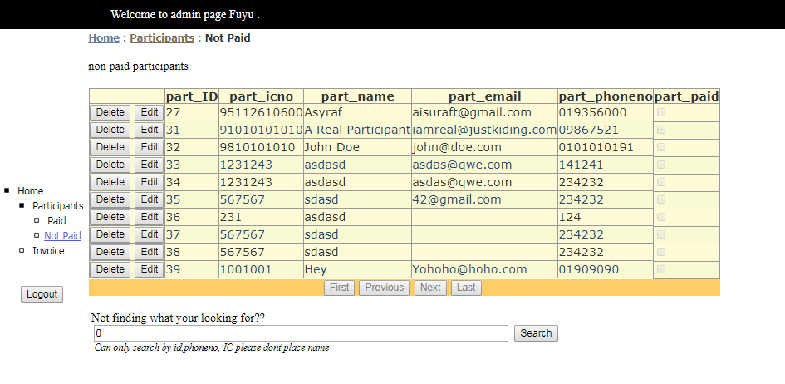

Figure 8 is a screen shot for the stated webpage.

|  |
| --- |
| Related Code/ Configuration |
| **.Aspx**  <%@ Page Title="" Language="C#" MasterPageFile="~/Admin/admin.master" AutoEventWireup="true" CodeFile="admin_non_paid_participant.aspx.cs" Inherits="Admin_admin_non_payed_participant" %>  <asp:Content ID="Content1" ContentPlaceHolderID="head" Runat="Server">  </asp:Content>  <asp:Content ID="Content2" ContentPlaceHolderID="ContentPlaceHolder1" Runat="Server">  <div>  non paid participants  <br />  <br />  <asp:ListView ID="ListView1" runat="server" DataKeyNames="part_ID"  DataSourceID="SqlDataSource1">  <AlternatingItemTemplate>  <tr style="background-color: #FAFAD2;color: #284775;">  <td>  <asp:Button ID="DeleteButton" runat="server" CommandName="Delete"  Text="Delete" />  <asp:Button ID="EditButton" runat="server" CommandName="Edit" Text="Edit" />  </td>  <td>  <asp:Label ID="part_IDLabel" runat="server" Text='<%# Eval("part_ID") %>' />  </td>  <td>  <asp:Label ID="part_icnoLabel" runat="server" Text='<%# Eval("part_icno") %>' />  </td>  <td>  <asp:Label ID="part_nameLabel" runat="server" Text='<%# Eval("part_name") %>' />  </td>  <td>  <asp:Label ID="part_emailLabel" runat="server"  Text='<%# Eval("part_email") %>' />  </td>  <td>  <asp:Label ID="part_phonenoLabel" runat="server"  Text='<%# Eval("part_phoneno") %>' />  </td>  <td>  <asp:CheckBox ID="part_paidCheckBox" runat="server"  Checked='<%# Eval("part_paid") %>' Enabled="false" />  </td>  </tr>  </AlternatingItemTemplate>  <EditItemTemplate>  <tr style="background-color: #FFCC66;color: #000080;">  <td>  <asp:Button ID="UpdateButton" runat="server" CommandName="Update"  Text="Update" />  <asp:Button ID="CancelButton" runat="server" CommandName="Cancel"  Text="Cancel" />  </td>  <td>  <asp:Label ID="part_IDLabel1" runat="server" Text='<%# Eval("part_ID") %>' />  </td>  <td>  <asp:TextBox ID="part_icnoTextBox" runat="server"  Text='<%# Bind("part_icno") %>' />  </td>  <td>  <asp:TextBox ID="part_nameTextBox" runat="server"  Text='<%# Bind("part_name") %>' />  </td>  <td>  <asp:TextBox ID="part_emailTextBox" runat="server"  Text='<%# Bind("part_email") %>' />  </td>  <td>  <asp:TextBox ID="part_phonenoTextBox" runat="server"  Text='<%# Bind("part_phoneno") %>' />  </td>  <td>  <asp:CheckBox ID="part_paidCheckBox" runat="server"  Checked='<%# Bind("part_paid") %>' />  </td>  </tr>  </EditItemTemplate>  <EmptyDataTemplate>  <table runat="server"  style="background-color: #FFFFFF;border-collapse: collapse;border-color: #999999;border-style:none;border-width:1px;">  <tr>  <td>  No data was returned.</td>  </tr>  </table>  </EmptyDataTemplate>  <InsertItemTemplate>  <tr style="">  <td>  <asp:Button ID="InsertButton" runat="server" CommandName="Insert"  Text="Insert" />  <asp:Button ID="CancelButton" runat="server" CommandName="Cancel"  Text="Clear" />  </td>  <td>  &nbsp;</td>  <td>  <asp:TextBox ID="part_icnoTextBox" runat="server"  Text='<%# Bind("part_icno") %>' />  </td>  <td>  <asp:TextBox ID="part_nameTextBox" runat="server"  Text='<%# Bind("part_name") %>' />  </td>  <td>  <asp:TextBox ID="part_emailTextBox" runat="server"  Text='<%# Bind("part_email") %>' />  </td>  <td>  <asp:TextBox ID="part_phonenoTextBox" runat="server"  Text='<%# Bind("part_phoneno") %>' />  </td>  <td>  <asp:CheckBox ID="part_paidCheckBox" runat="server"  Checked='<%# Bind("part_paid") %>' />  </td>  </tr>  </InsertItemTemplate>  <ItemTemplate>  <tr style="background-color: #FFFBD6;color: #333333;">  <td>  <asp:Button ID="DeleteButton" runat="server" CommandName="Delete"  Text="Delete" />  <asp:Button ID="EditButton" runat="server" CommandName="Edit" Text="Edit" />  </td>  <td>  <asp:Label ID="part_IDLabel" runat="server" Text='<%# Eval("part_ID") %>' />  </td>  <td>  <asp:Label ID="part_icnoLabel" runat="server" Text='<%# Eval("part_icno") %>' />  </td>  <td>  <asp:Label ID="part_nameLabel" runat="server" Text='<%# Eval("part_name") %>' />  </td>  <td>  <asp:Label ID="part_emailLabel" runat="server"  Text='<%# Eval("part_email") %>' />  </td>  <td>  <asp:Label ID="part_phonenoLabel" runat="server"  Text='<%# Eval("part_phoneno") %>' />  </td>  <td>  <asp:CheckBox ID="part_paidCheckBox" runat="server"  Checked='<%# Eval("part_paid") %>' Enabled="false" />  </td>  </tr>  </ItemTemplate>  <LayoutTemplate>  <table runat="server">  <tr runat="server">  <td runat="server">  <table ID="itemPlaceholderContainer" runat="server" border="1"  style="background-color: #FFFFFF;border-collapse: collapse;border-color: #999999;border-style:none;border-width:1px;font-family: Verdana, Arial, Helvetica, sans-serif;">  <tr runat="server" style="background-color: #FFFBD6;color: #333333;">  <th runat="server">  </th>  <th runat="server">  part_ID</th>  <th runat="server">  part_icno</th>  <th runat="server">  part_name</th>  <th runat="server">  part_email</th>  <th runat="server">  part_phoneno</th>  <th runat="server">  part_paid</th>  </tr>  <tr ID="itemPlaceholder" runat="server">  </tr>  </table>  </td>  </tr>  <tr runat="server">  <td runat="server"  style="text-align: center;background-color: #FFCC66;font-family: Verdana, Arial, Helvetica, sans-serif;color: #333333;">  <asp:DataPager ID="DataPager1" runat="server">  <Fields>  <asp:NextPreviousPagerField ButtonType="Button" ShowFirstPageButton="True"  ShowLastPageButton="True" />  </Fields>  </asp:DataPager>  </td>  </tr>  </table>  </LayoutTemplate>  <SelectedItemTemplate>  <tr style="background-color: #FFCC66;font-weight: bold;color: #000080;">  <td>  <asp:Button ID="DeleteButton" runat="server" CommandName="Delete"  Text="Delete" />  <asp:Button ID="EditButton" runat="server" CommandName="Edit" Text="Edit" />  </td>  <td>  <asp:Label ID="part_IDLabel" runat="server" Text='<%# Eval("part_ID") %>' />  </td>  <td>  <asp:Label ID="part_icnoLabel" runat="server" Text='<%# Eval("part_icno") %>' />  </td>  <td>  <asp:Label ID="part_nameLabel" runat="server" Text='<%# Eval("part_name") %>' />  </td>  <td>  <asp:Label ID="part_emailLabel" runat="server"  Text='<%# Eval("part_email") %>' />  </td>  <td>  <asp:Label ID="part_phonenoLabel" runat="server"  Text='<%# Eval("part_phoneno") %>' />  </td>  <td>  <asp:CheckBox ID="part_paidCheckBox" runat="server"  Checked='<%# Eval("part_paid") %>' Enabled="false" />  </td>  </tr>  </SelectedItemTemplate>  </asp:ListView>  <asp:SqlDataSource ID="SqlDataSource1" runat="server"  ConnectionString="<%$ ConnectionStrings:dbtestConnectionString %>"      SelectCommand="SELECT * FROM [PARTICIPANT] WHERE ([part_paid] = @part_paid)"  DeleteCommand="DELETE FROM [PARTICIPANT] WHERE [part_ID] = @part_ID"  InsertCommand="INSERT INTO [PARTICIPANT] ([part_icno], [part_name], [part_email], [part_phoneno], [part_paid], [pack_ID]) VALUES (@part_icno, @part_name, @part_email, @part_phoneno, @part_paid, @pack_ID)"  UpdateCommand="UPDATE [PARTICIPANT] SET [part_icno] = @part_icno, [part_name] = @part_name, [part_email] = @part_email, [part_phoneno] = @part_phoneno, [part_paid] = @part_paid, [pack_ID] = @pack_ID WHERE [part_ID] = @part_ID">  <DeleteParameters>  <asp:Parameter Name="part_ID" Type="Int32" />  </DeleteParameters>  <InsertParameters>  <asp:Parameter Name="part_icno" Type="String" />  <asp:Parameter Name="part_name" Type="String" />  <asp:Parameter Name="part_email" Type="String" />  <asp:Parameter Name="part_phoneno" Type="String" />  <asp:Parameter Name="part_paid" Type="Boolean" />  <asp:Parameter Name="pack_ID" Type="Int32" />  </InsertParameters>  <SelectParameters>  <asp:Parameter DefaultValue="False" Name="part_paid" Type="Boolean" />  </SelectParameters>  <UpdateParameters>  <asp:Parameter Name="part_icno" Type="String" />  <asp:Parameter Name="part_name" Type="String" />  <asp:Parameter Name="part_email" Type="String" />  <asp:Parameter Name="part_phoneno" Type="String" />  <asp:Parameter Name="part_paid" Type="Boolean" />  <asp:Parameter Name="pack_ID" Type="Int32" />  <asp:Parameter Name="part_ID" Type="Int32" />  </UpdateParameters>  </asp:SqlDataSource>  </div>  </asp:Content>  **.Aspx.cs**  using System;  using System.Collections.Generic;  using System.Linq;  using System.Web;  using System.Web.UI;  using System.Web.UI.WebControls;  public partial class Admin_admin_non_payed_participant : System.Web.UI.Page  {  protected void Page_Load(object sender, EventArgs e)  {  }  } |
| Description |
| Use the master page for admin.  Able to view all information on all the participants that did not payed yet.  Able to delete data on participant.  Able to sort the following data.  Able to update the following data.  This page is mainly a filter page. |

# CONCLUSION

This project is made through varies meetings and hard driven discussions to create a system that would reach expectations of the lecturer and be subpar to systems that exist nowadays.

In this project we also discovered new cases and problems that could occur in creating this system in the C# language and Visual Studio medium. Steadily solving the problems together, we achieved new sense of problem solving skills and team work. Working in a team prove different than innovating a project alone which both have its pros and cons. We also were able to explore and manipulate web service components, configuration, securing and deployment in web application through this project. Last but not least, come with variety of solutions using C# and visual basic through exploration and also guidance that our lecturer provided.

Being able to master the usage of web development through C# was a challenging task. Not to mention being able to create a system through a few scratches of ideas. However, we don’t intend to leave this system half way through, but in hopes, we also see that in the future we could expand this system to be centralized with other bigger systems.

# References

2017 Marriott International. (2017). *Ways to measure event success*. Retrieved from meetings unagined: https://meetingsimagined.com/tips-trends/ways-measure-event-success

Mustafa, D. Z. (13 September, 2017). *BCS2203 WEB APPLICATION DEVELOPMENT*. Retrieved from UMP Kalam: https://kalam.ump.edu.my/course/view.php?id=301

Wikipedia. (19 November, 2017). *Marathon*. Retrieved from Wikipedia: https://en.wikipedia.org/wiki/Marathon

We have been using git to do our project.. <https://github.com/iceraft/WAD_Project>