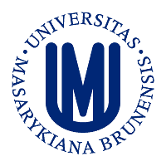
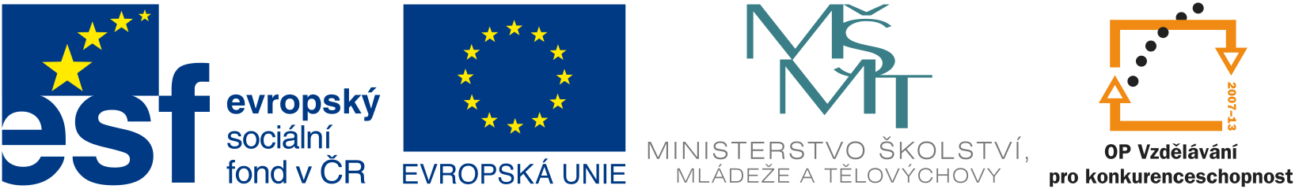

Application form

KI-MU Kick Off Meeting: Oct 25-27, 2012

Name: ………………………………………………………. …

Position (e.g. PhD Student, scientist etc.): ……………………..

Institution: ………………………………………………………

I want to participate at: (please select the event you want to attend)

Talks/coffee breaks Lunch Dinner

Thursday 25.10. YES/ NO YES/ NO YES/ NO
Friday 26.10. YES/ NO YES/ NO

Friday (Afternoon/evening program) YES/NO

Saturday (please write down the name of the KI scientist you would like to meet individually)

Please, send the filled application form to:
Barbora Valnohová - barva@sci.muni.cz by 30. 9. 2012

