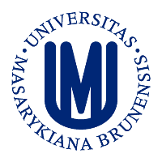
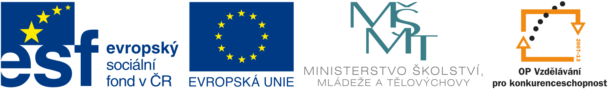

Cooperation between Masaryk University and Karolinska Institutet, Stockholm in the field of biomedicine

Institute of Experimental Biology, Faculty of Science, MU
invites you to the workshop:

Cooperation with Karolinska Institute: Kick Off Meeting

October 25 -27, 2012
Hotel Myslivna, Brno

Why to attend:

Karolinska Institute (KI) in Stockholm is the world top class biomedical university. Masaryk University has established the official collaboration with KI and obtained the grant of the Czech Ministry of Education, Youth and Sports to support joint activities. MU can currently support bilateral collaboration between the groups from both institutes and fund the medium/long-term research stays of the MU PhD students in Sweden. The kick-off meeting provides the initial possibility to learn about the research topics studied at KI, to establish personal contacts with the researchers from KI and to discuss in the informal atmosphere the possibilities of future collaboration. KI will be represented by 20 scientists including two members of the famous Nobel Assembly, which selects the laureates of the Nobel Prize in Physiology and Medicine. The conference is free and open to public; both senior researchers and students are very welcome to attend.

Take your chance and register for the conference using the attached application form (to be sent to Barbora Valnohová, barva@sci.muni.cz, 549493200)
For more information see www.sci.muni.cz/ofiz/kimu

The talks will be held in the congress center of the Hotel Myslivna
Nad Pisárkami 276/1, bus 52 from Mendlovo nám. or Pisárky
Kick Off meeting of KI-MU (preliminary programme)
Schedule of the talks:
Thursday - 25.10.2012

8:45-9:00 | Ernest Arenas/Vítězslav Bryja – Welcome, introduction
9:00-9:25 | KI - Ernest Arenas | Function of Wnt proteins in dopaminergic neuron development
9:25-9:50 | MU - Vítězslav Bryja | Dissecting the Wnt signaling pathway by proteomic approaches
9:50-10:15 | KI - Boris Zhivotovsky/ Magnus Olsson | 5-Fluouracilsignaling through a calcium-calmodulin-dependent pathway is required for p53 activation and apoptosis in colon carcinoma cells
10:15-10:40 | MU - Alena Vaculová-Hyršlová | Chemotherapeutic drug-mediated enhancement of TRAIL-induced apoptosis
10:40-11:15 | Coffee break
11:15-11:40 | KI - Carlos Villaescusa | Role of the homeodomain Pbx1 in midbrain dopaminergic development
11:40-12:05 | MU - Martin Trbušek | Functional consequences of TP53 and ATM mutations in chronic lymphocytic leukemia - implications for therapy
12:05-12:30 | KI – Enrique Toledo/ Spyridon Theofilopoulos | Function of liver X Receptors in dopaminergic development
12:30-14:00 | LUNCH
14:00-14:25 | KI - Lars Ahrlund Richter | In vivo studies of neuroectodermal childhood tumors, utilizing a human neoplastic niche induced by pluripotent stem cells.
14:25-14:50 | MU - Aleš Hampl | Human embryonic stem cells – strong or vurnelable?
14:50-15:15 | KI - Andrej Chagin | Both g-protein stimulatory subunit alpha and Gq/11 family are required for stem-like chondrocytes to stay in quiescent stage
15:15-15:40 | MU – Lukáš Trantírek | Characterization of protein binding sites in Axin and Dvl scaffolds
15:40-16:10 | Coffee break
16:10-16:35 | KI – Theresa Vincent | Epigenetics, Epithelial to Mesenchymal transition and beyond
16:35-17:00 | MU – Jiřina Procházková | ABC transporters in health and disease
17:00-17:25 | KI - Lorenz Poellinger | Epigenetic mechanisms regulating the response to hypoxia
17:25-17:50 | MU – Jan Vondráček | Interactions of the aryl hydrocarbon receptor with other signaling pathways as a key factor defining toxicity of its ligands
17:50-18:15 | KI – Petra Sekyrová | Zebrafish and mouse embryonic stem cells: pluripotency and development governed by ion currents
18:30 | DINNER
Friday - 26.10.2012

8:30-8:55 | KI - Gunnar Schulte | Novel insights into the FZD-G protein liasion
8:55-9:20 | MU - Karel Souček | Pathological plasticity of prostate cancer epithelial cells: the role of androgen depletion and high cell density
9:20-9:45 | KI - Michael Andang | Cell growth, unconventional cell cycle regulators and cellular physical behavior. Impact on regeneration and cancer.
9:45-10:10 | MU – Martin Anger | The function of spindle assembly checkpoint in mammalian oocytes
10:10-10:35 | KI - Arne Lindqvist | Checkpoint recovery
10:35-11:05 | Coffee break
11:05-11:30 | KI - Emma Andersson | Wnt and Notch synergy and antagonism in development and disease
11:30-11:55 | MU - Dalibor Blažek | Regulation of transcription by cyclin-dependent kinases: Cyclin K/Cdk12-an emerging player in the transcription-coupled genome stability
11:55-12:20 | KI – Shanzheng Yang | Role of Cxcl12/Cxcr4 during migration of embryonic midbrain dopaminergic neurons
12:30-14:00 | LUNCH
14:00 -20:00 |  | visit of the Pálava region, dinner in the wine cellar

Saturday - 27.10.2012

Individual discussions (contact organizers if you wish to arrange a meeting with the KI researcher)

