*Working document for Focus Group on Western Horse Mackerel 2020*

**Evaluation of rebuilding plans for Western horse mackerel**

Martin Pastoors, 13/08/2020

**Abstract**

*To be done*

# Introduction

A technical subgroup of the PELAC Focus Group on Western horse mackerel has developed and applied several evaluation tools to evaluate potential rebuilding plans for western horse mackerel. Although in the most recent assessment of western horse mackerel (WGWIDE 2019), the stock was assessed to be above Blim, there is a general perception that the stock is not doing well and that the development of a rebuilding plan would be appropriate.

# Data and methods

The approach to evaluate potential harvest control rules (HCR) for western horse mackerel is based on two different assessments (Stock synthesis and SAM) and two different evaluation methods (EqSim and SAM HCR forecast). Both evaluation methods are of the ‘short cut’ type to allow for a rapid evaluation process.

# Results

## EqSim and Stock Synthesis

### Constant F strategy

MP5.00 constant F; MP5.01 constant F with minimum TAC of 50kT; MP5.03 constant F with 20% IAV constraint above Btrigger.

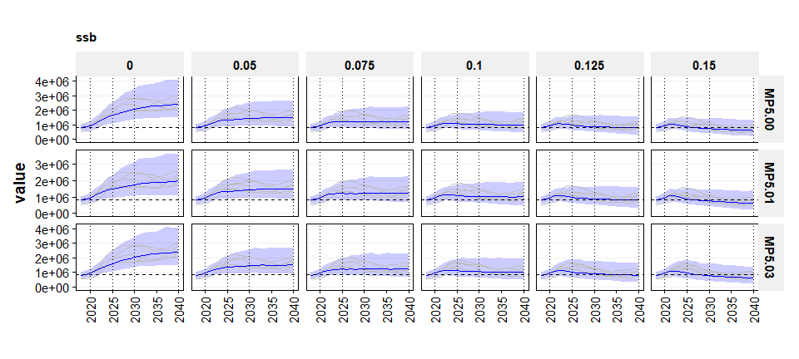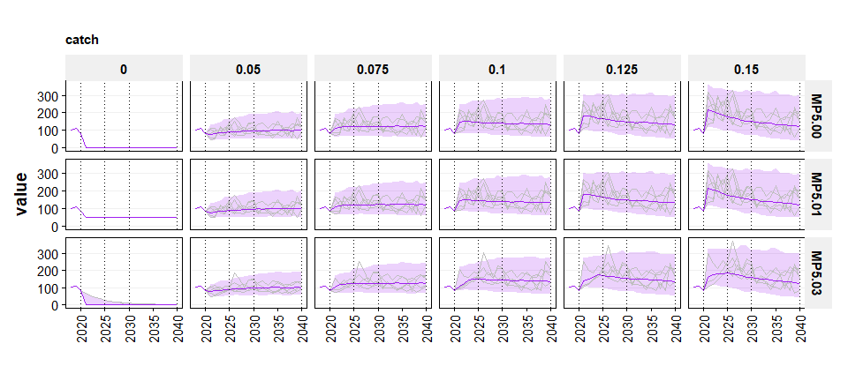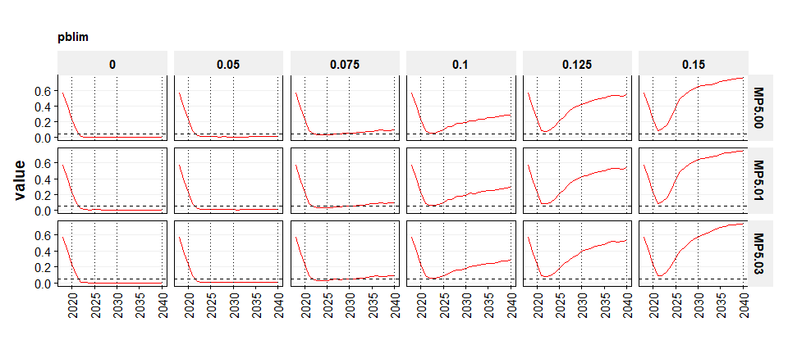

### ICES advice rule

MP5.10 ICES AR; MP5.11 ICES AR with minimum TAC of 50kT; MP5.13 ICES AR with 20% IAV constraint above Btrigger.

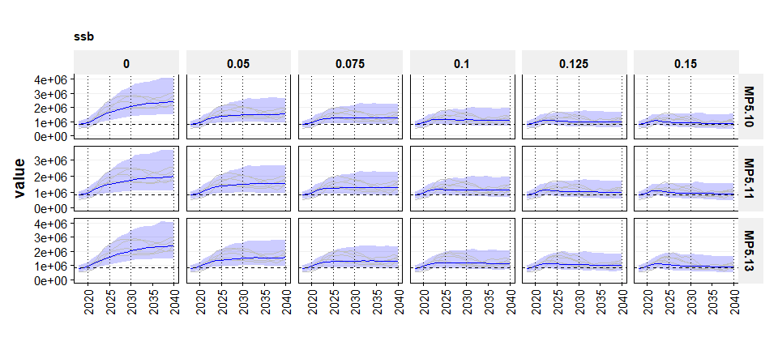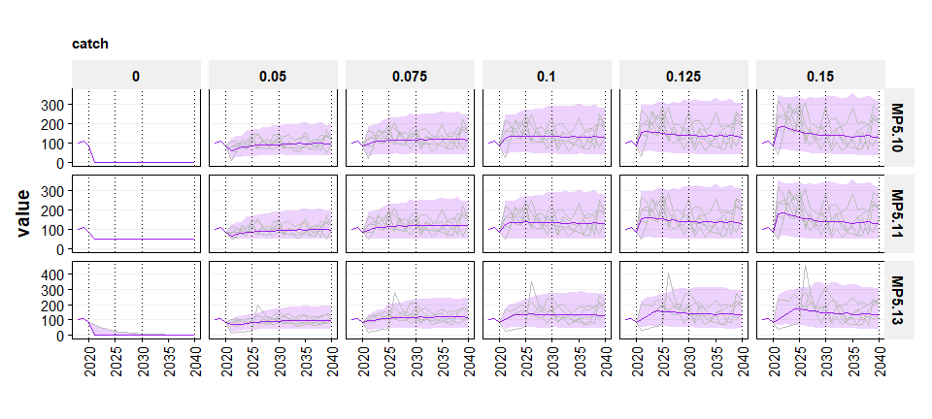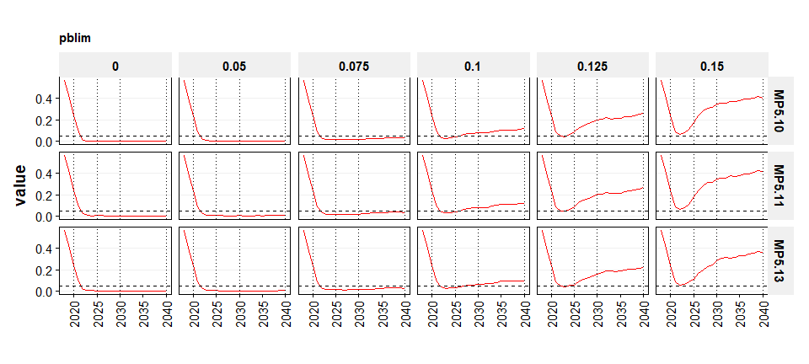

### Double breakpoint rule

MP5.20 Double BP; MP5.11 Double BP with minimum TAC of 50kT; MP5.13 Doubl BP with 20% IAV constraint above Btrigger. Minimum F in Double BP is 20% of Fmsy.

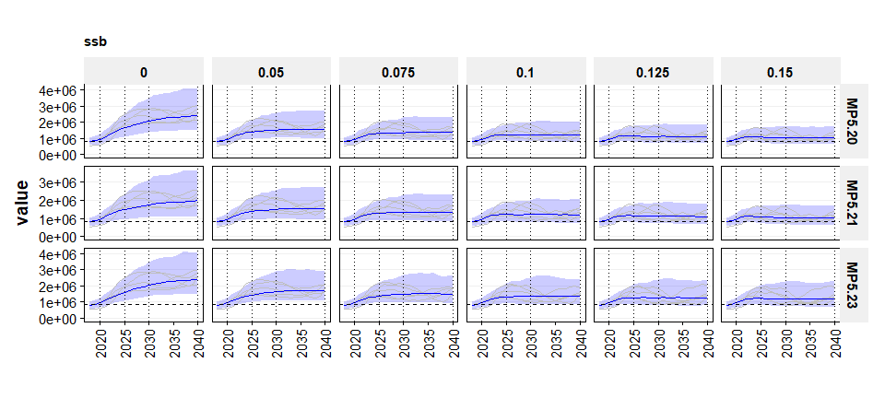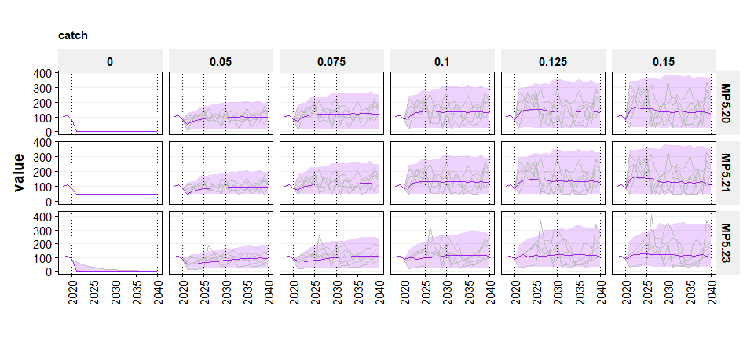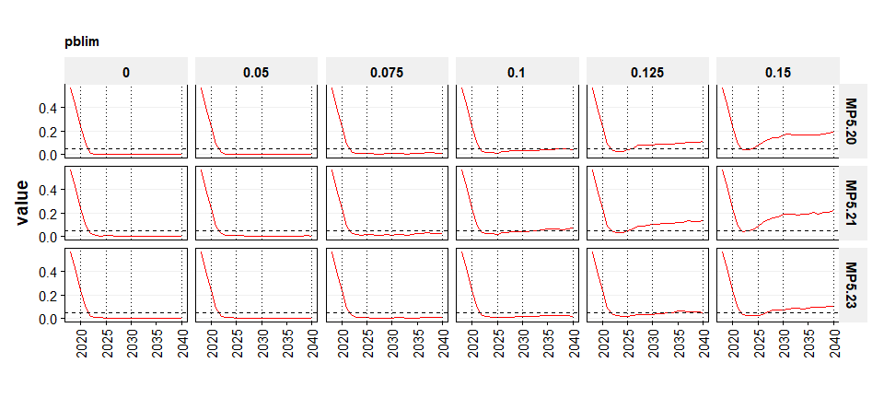

### Probability of achieving rebuilding with 20% IAV constraint above Btrigger

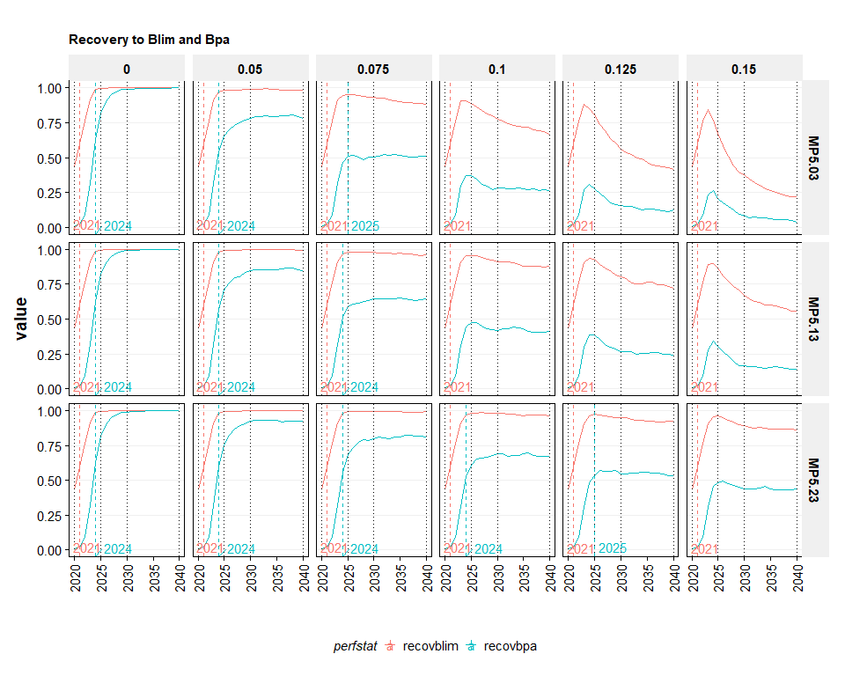

## EqSim and SAM

### Constant F rule with SAM assessment

Results for the constant F rule are not presented because it was clear that this option would not be selected by the PELAC for the potential rebuilding plan.

### ICES Advice Rule with SAM assessment

MP5.10 ICES AR; MP5.11 ICES AR with minimum TAC of 50kT; MP5.13 ICES AR with 20% IAV constraint above Btrigger.

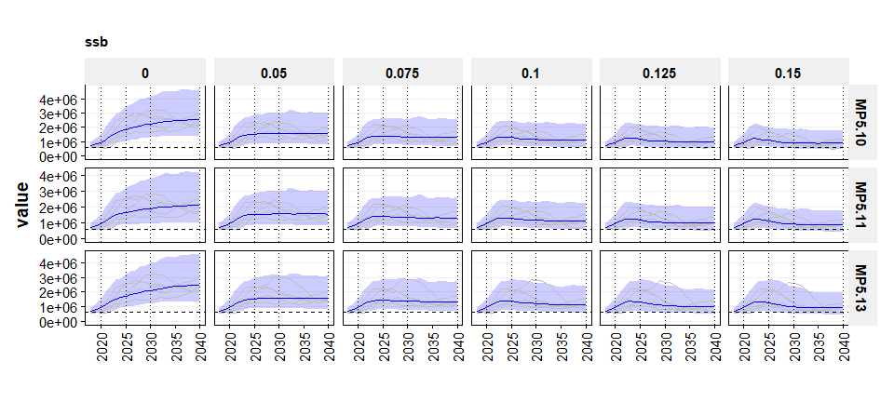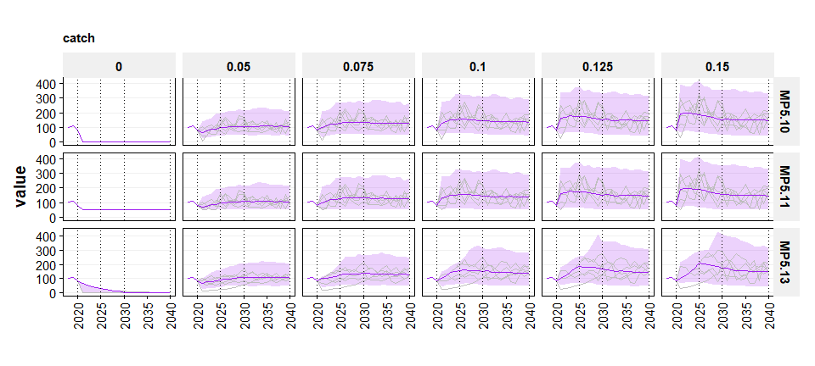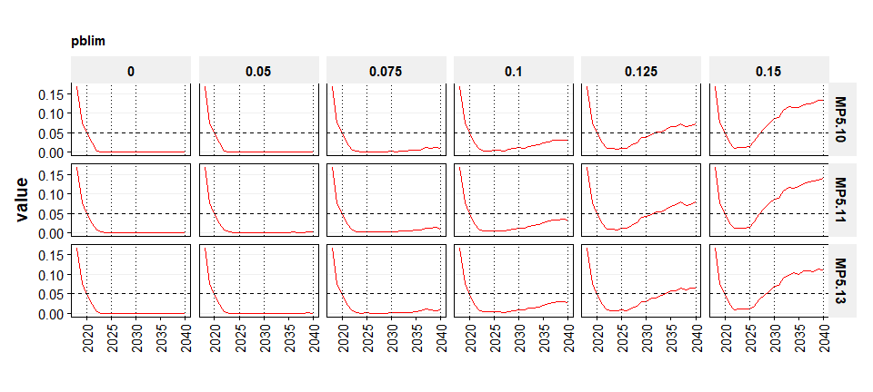

### Double breakpoint rule with SAM assessment

SAM Assessment.

MP5.20 Double BP; MP5.11 Double BP with minimum TAC of 50kT; MP5.13 Doubl BP with 20% IAV constraint above Btrigger. Minimum F in Double BP is 20% of Fmsy.

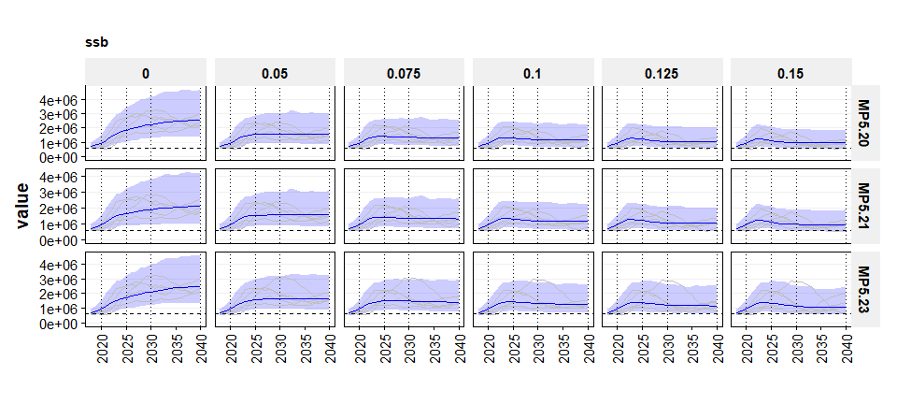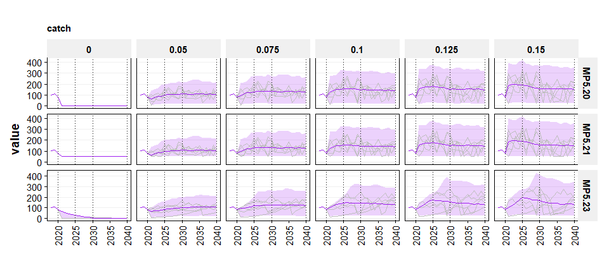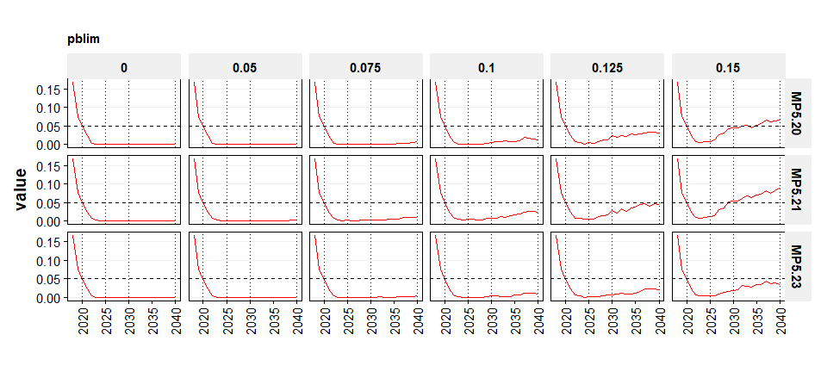

### EqSim SAM: probability of achieving rebuilding with 20% IAV constraint above Btrigger

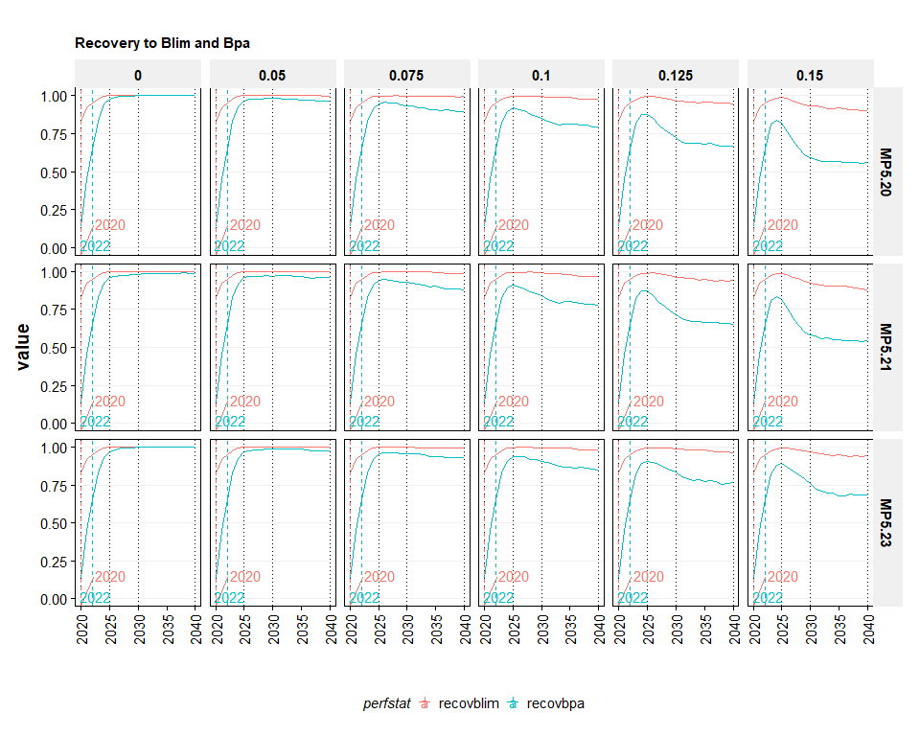

## SAM and SAM HCR forecast

SAM Assessment.

MP5.10 ICES AR.

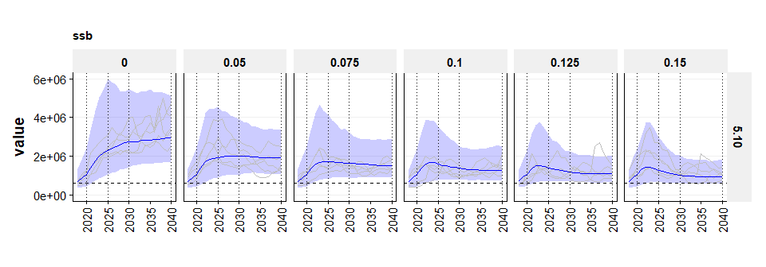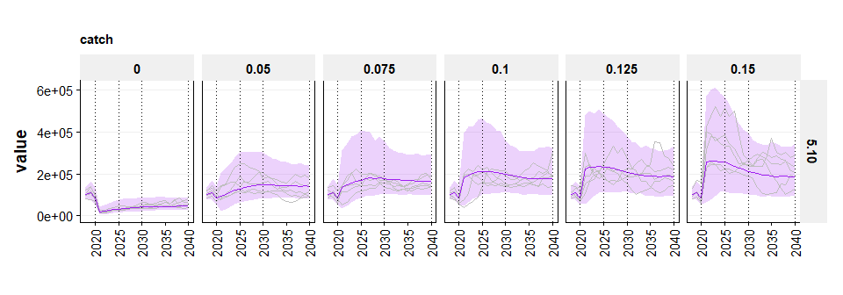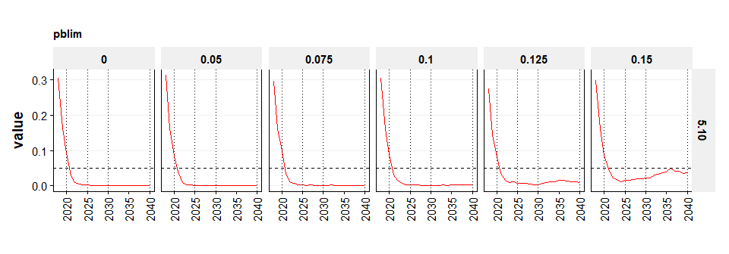

## Comparison of SS & SAM / EqSim & SAM HCR

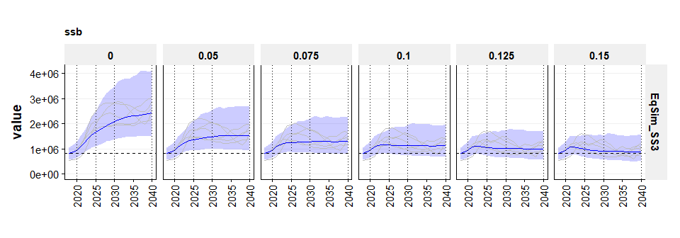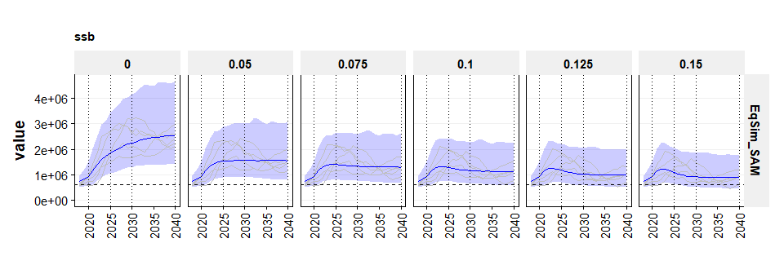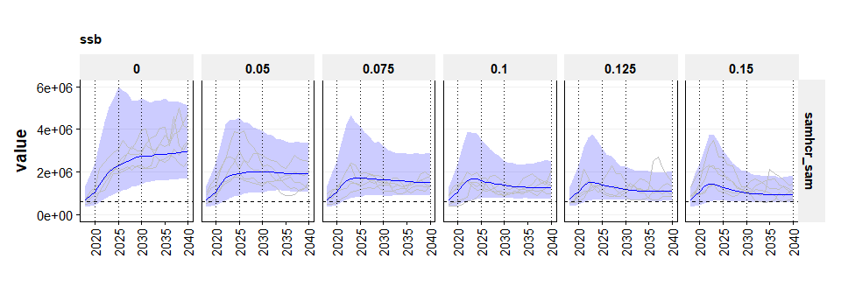

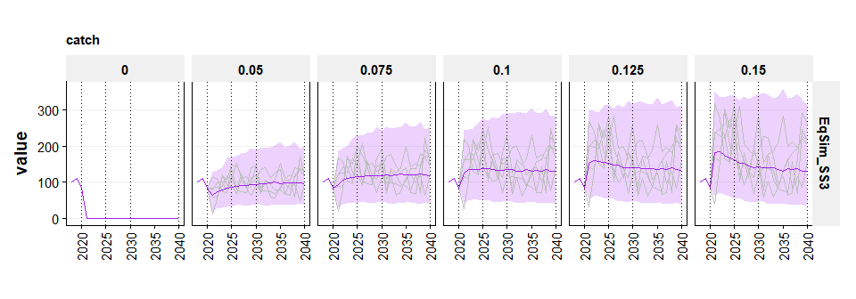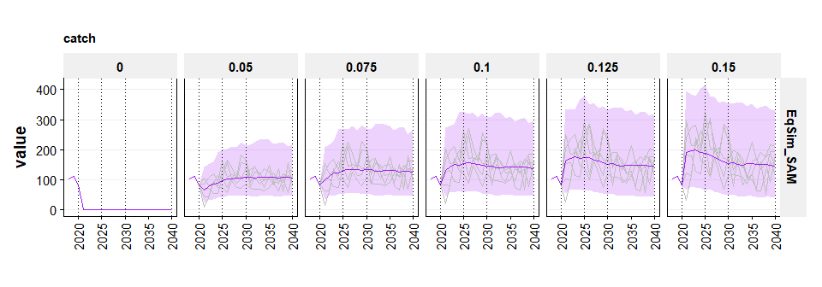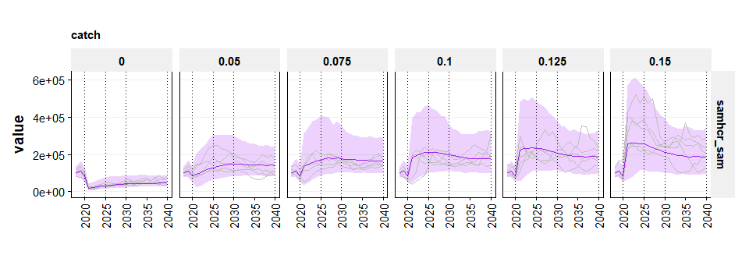

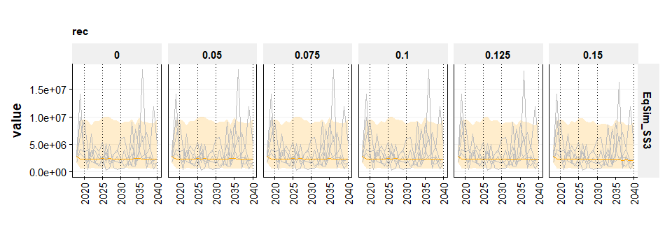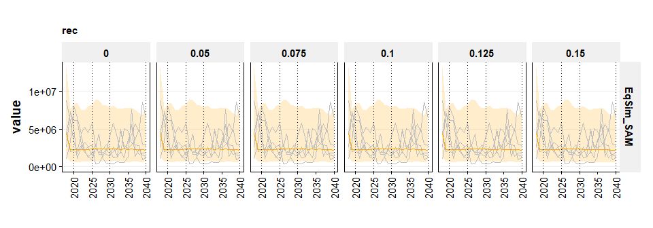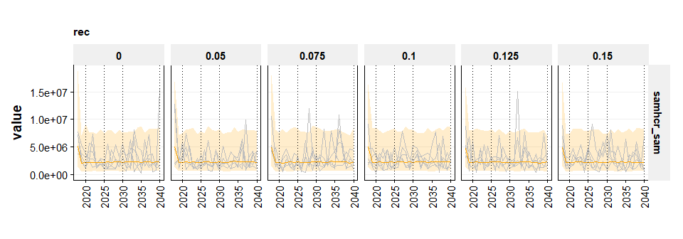

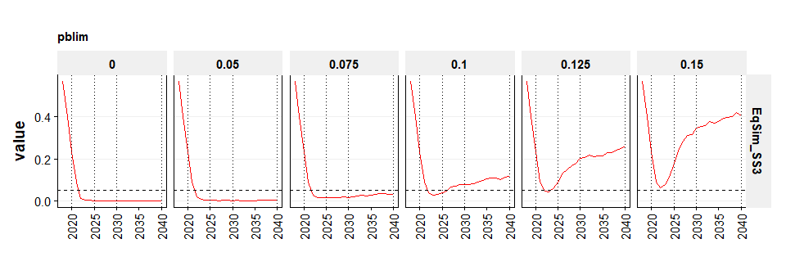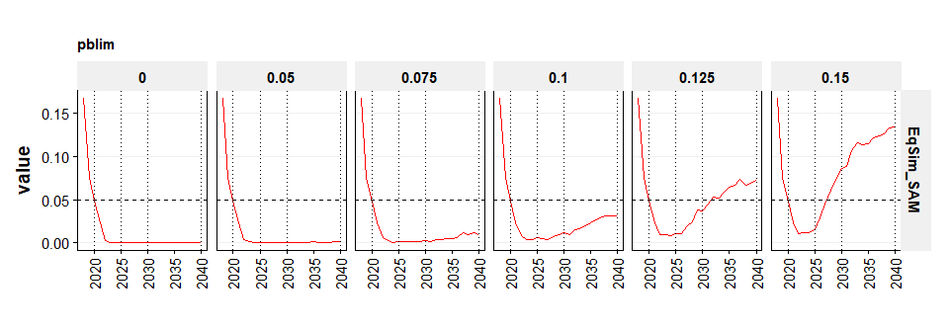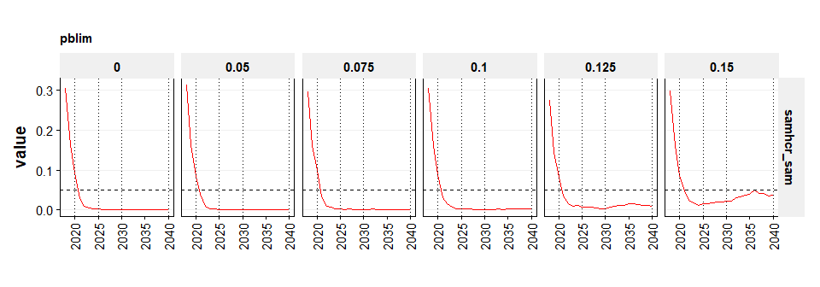

[ Recovery to Blim and Bpa not available for SAM HCR? ]

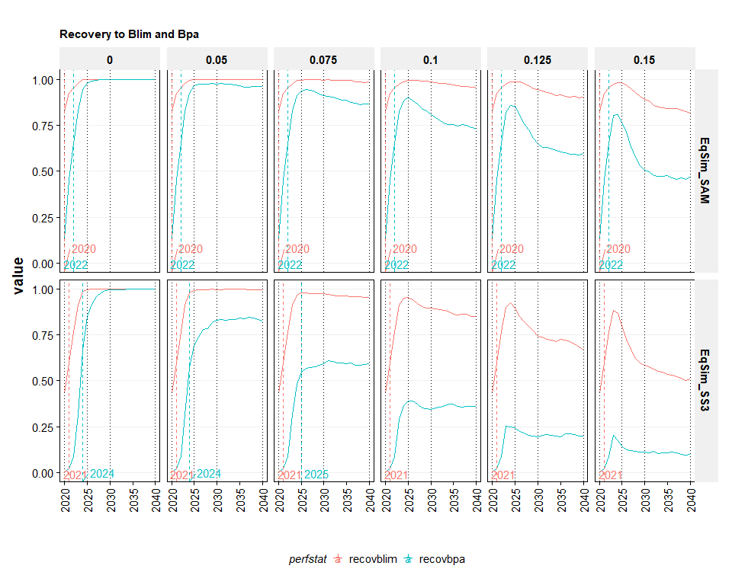

# Discussion

Two different assessment methods (SS, SAM); two different MSE methods (EqSim, SAM HCR)

##### page break

# Preferred rebuilding plan option by PELAC

The PELAC selected the following preferred option for the Western horse mackerel rebuilding plan:

* Evaluation method: EqSim
* Assessment: Stock Synthesis (WGWIDE 2019)
* Target fishing mortality at Fmsy = 0.074 (approximated by 0.075 in the simulations)
* Blim at ICES Blim (834 480 t)
* Btrigger at MSY Btrigger (1 168 272 t)
* Double breakpoint rule with 20% constraint on IAV above Btrigger
* Minimum F when stock is below Blim at 20% of Fmsy = 0.015
* 50% probability of rebuilding to Blim by 2021 (simular to zero catch option)
* 50% probability of rebuilding to Bpa by 2024 (similar to zero catch option)

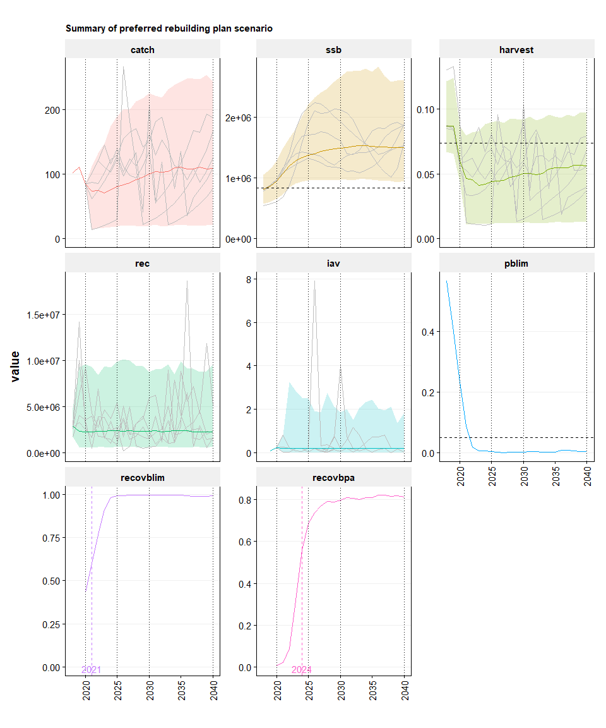 ##### page break

Table of results

perfstat yearrange period median range   
---------- ----------- -------- ----------- ---------------------  
   
catch 2018-2020 CU 102 84 - 110   
catch 2021-2025 ST 75 17 - 167   
catch 2026-2030 MT 92 20 - 210   
catch 2031-2040 LT 107 21 - 242   
   
ssb 2018-2020 CU 872,454 608,164 - 1,210,564   
ssb 2021-2025 ST 1,249,710 832,465 - 1,902,950   
ssb 2026-2030 MT 1,451,882 966,840 - 2,506,102   
ssb 2031-2040 LT 1,514,418 958,213 - 2,740,040   
   
harvest 2018-2020 CU 0.080 0.048 - 0.118   
harvest 2021-2025 ST 0.044 0.011 - 0.085   
harvest 2026-2030 MT 0.047 0.012 - 0.092   
harvest 2031-2040 LT 0.054 0.012 - 0.095   
   
rec 2018-2020 CU 2,599,180 696,645 - 7,944,499   
rec 2021-2025 ST 2,363,631 606,888 - 9,317,602   
rec 2026-2030 MT 2,361,298 599,077 - 9,438,791   
rec 2031-2040 LT 2,321,690 612,371 - 9,088,107   
   
iav 2018-2020 CU 0.162 0.086 - 0.239   
iav 2021-2025 ST 0.200 0.021 - 2.576   
iav 2026-2030 MT 0.200 0.018 - 2.083   
iav 2031-2040 LT 0.200 0.017 - 2.032   
   
pblim 2018-2020 CU 0.401 0.243 - 0.560   
pblim 2021-2025 ST 0.006 0.005 - 0.082   
pblim 2026-2030 MT 0.002 0.001 - 0.003   
pblim 2031-2040 LT 0.004 0.002 - 0.009

Table of settings

[1] "stats" "runName" "lStatPer" "OM" "MP" "settings"  
[7] "df"

class desc value   
------- -------------------- ------------------------------------  
OM code OM2.2   
OM desc WGWIDE19   
OM IM   
OM SRR SRR.WG19.SegReg_Blim.exterm   
OM RecAR TRUE   
OM maxRecRes1 3   
OM maxRecRes2 -3   
OM BioYrs1 2008   
OM BioYrs2 2017   
OM BioConst FALSE   
OM SelYrs1 2008   
OM SelYrs2 2017   
OM SelConst FALSE   
OM Obs   
OM refPts.Fpa 0.074   
OM refPts.Flim 0.103   
OM refPts.Fmsy 0.074   
OM refPts.Bpa 1168272   
OM refPts.Blim 834480   
OM refPts.MSYBtrigger 1168272   
OM refPts.Bloss 761613   
OM pBlim 0.05   
MP code MP5.23   
MP desc Double BP HCR   
MP xlab Double BP IAVBtrig   
MP HCRName DoubleBP   
MP F_target1 0   
MP F_target2 0.025   
MP F_target3 0.05   
MP F_target4 0.075   
MP F_target5 0.1   
MP F_target6 0.125   
MP F_target7 0.15   
MP B_trigger MSYBtrigger   
MP minTAC   
MP maxTAC   
MP TAC_IAV1 0.2   
MP TAC_IAV2 0.2   
MP Obs.cvF 0.22   
MP Obs.phiF 0.03   
MP Obs.cvSSB 0.36   
MP Obs.phiSSB 0.51   
OTHER niters 1000   
OTHER nyr 23   
OTHER CU 2018-2020   
OTHER ST 2021-2025   
OTHER MT 2026-2030   
OTHER LT 2031-2040   
OTHER flstock WGWIDE19.RData   
OTHER flstock_sim MSE_WGWIDE19_FLStocks_1k15PG.RData

##### page break