# GitHub - repositories

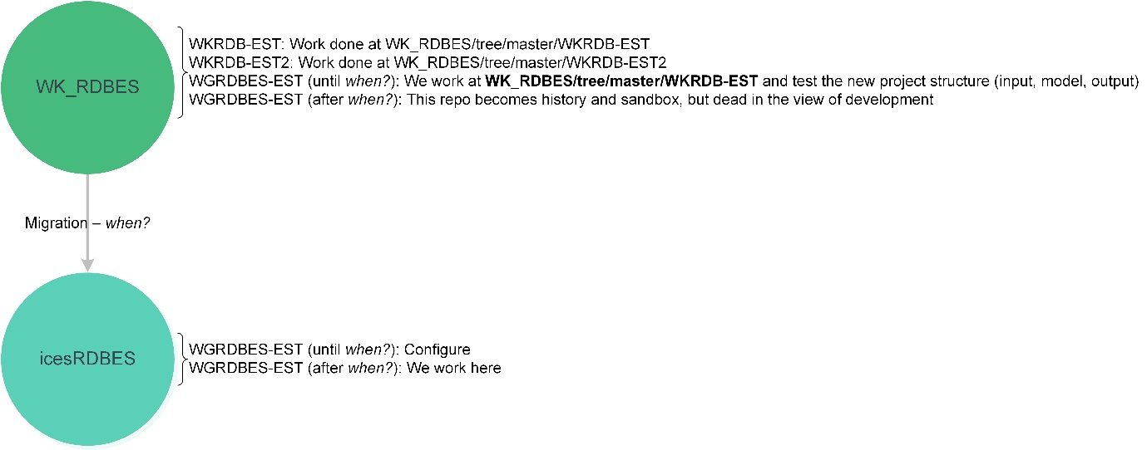

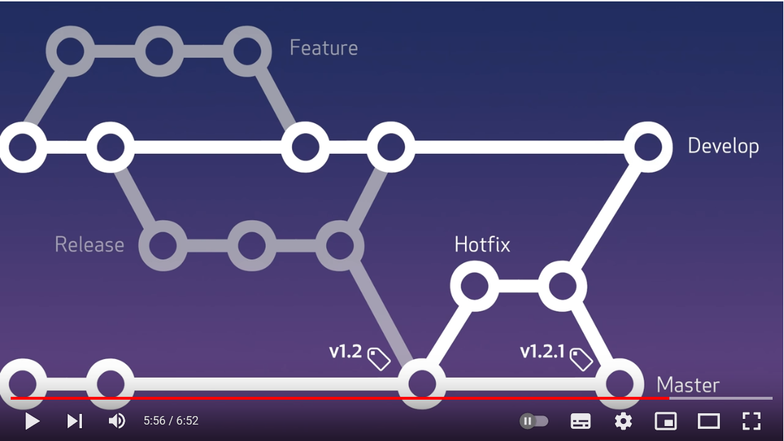

Figure 1 Workflow on icesRDBES. Figure from <https://www.youtube.com/watch?v=aJnFGMclhU8>

## icesRDBES

### Roles

Public repo under ices-tools-dev

Write access: people from WGRDBES-EST

Structure under icesRDBES

Possible to have a folder that can be included in Rbuildignore