MULTI FLEET DETERMINISTIC PROJECTION

(MFDP)

18/4/2000

CONTENTS Page

BACKGROUND 3
General 3
Inputs 3

Functionality 3
Outputs 4
File formats 4

Output from catch-at-age analysis 4

Fleet disaggregated catch data 5

Short term catch forecast results 6
Program log files 8

MFDP 9

Introduction 9

Program overview 10

Terminology 10
Units 11
Types of projection 11

Running the program 13
Inputs dialog 13
Run type dialog 15
Control file dialog 16
Multi fleet multi target interim years scenarios dialog 18
Averaging options dialog 19
Inspection options dialog 20
Inspecting dialog 21
New input file set 22
Controlling scenarios and single option detailed
output 22

The index file 23
Historic data 23
Future data 24

The control file 26

Data files 28

Output files 29

Modifications to WSATWG output format 29

Fleet disaggregation 31

Data checking 31

Methods 31

Truncation of the plus group 31

Steady state vectors 33

Fishing mortality 33

Weight, maturity and natural mortality 33

Proportions of F and M before spawning 33

Estimation of Fbar 33

Minimisations 34

POPULATION DYNAMICS 35

REFERENCES 37

BACKGROUND

General

The ICES Workshop on Standard Assessment Tools for Working Groups (1999) noted the need for the development of a stand-alone forecast program to replace the IFAP prediction program as ICES moves away from IFAP and implements PC based systems. It was recognised that ad hoc spreadsheet based predictions allow flexibility to address specific problems with individual stocks, but are notoriously error prone, and it was considered desirable that such spreadsheets be replaced by fully tested and documented programs. A specification for a short term forecast program and appropriate exchange file formats were developed during the workshop and are briefly outlined below.

Inputs

The basic data required for short term catch prediction are:
1) Starting population numbers and fishing mortalities derived from catch-at-age analysis.
2) Estimates of weights at age, natural mortality, maturity at age etc. derived from the input data to the catch-at-age analysis.
3) Estimates of recruitment during the prediction period, which may be available externally (e.g from RCT3).

In addition, information on catch at age and weight at age by fleet/category will be necessary if the forecast is to be disaggregated by fleet/category.

Most of the requisite data are available in Lowestoft format files used as input to or output from the catch-at-age analysis. The main exception is information on catch numbers and weights at age by fleet/category, for which an exchange format is given. in the section, Fleet disaggregated catch data. The file formats used by RCT3 are not compatible with those used by other programs so it is envisaged that recruitment estimates will continue to be entered manually.

Functionality

The ICES Workshop on Standard Assessment Tools for Working Groups (1999) stated that the high degree of complexity required for catch predictions for some stocks, notably the North Sea Herring, in which different catch constraints are applied to different fleets, was not required. Multi-annual management strategies, requiring predictions over a longer period than is currently conventional were also considered beyond the scope of the specification. The program specified would be of general application and some limitations on its functionality could be accepted. The minimum specification considered desirable was:

Forecast can be disaggregated for a minimum of three fleets either independent (i.e. subject to different effort multipliers) or combined (i.e. discards and landings from the same fleet).

The prediction should run for at least one year ahead, with or without a TAC constraint, on the basis of a single option prediction for the intermediate year, followed by a range of options for the prediction year, and the resultant estimates of SSB.

Outputs

The primary outputs from the forecast program will be two output files; a file containing the prediction results and a log file. The log file should conform to the general standards given the Program log files section. The key information to be contained in the results file is the information to be summarised in the management options table, given in the format specified in the Short term catch forecast results section. Information on the detailed output from the prediction (i.e. catches at age as well as aggregate weights) for one catch option (e.g status quo) should also be available in the program output. Since the main use of this information is as a diagnostic it need not be held in a formally described format. The management option information needs to be available for subsequent plotting, and also for formatting in a tidy format for inclusion in e.g. the ACFM report. Whilst it is desirable that the catch prediction program produces a comprehensible management options table, this is a non-trivial task, and it should be considered optional provided an external program is available to pick-up the results file and turn that into formatted output. It would be most appropriate for the ICES secretariat to develop the latter program.

File formats

Output from catch-at-age analysis

Current catch-at-age analysis methods in use by ICES use data aggregated to total international, annual catches. Standard file formats specified by Darby and Flatman (1994) are already in routine use for input data. File formats for the results of catch-at-age analysis were put forward at the ICES Workshop on Standard Assessment Tools for Working Groups (1999). To allow compatibility with existing data structures and data entry routines, these are based on the Lowestoft data format as ASCII files with space or comma separation. Outputs from catch-at-age analysis are typically matrices of population numbers and fishing mortalities by age and year. The schematic below shows the file format for population numbers or fishing mortality.

Title.

Sex ID, Index No
First Year, Last Year
First age, Last age
DFI
N/F ⇨ by age
⇩
by year

Row 1 is the run title and may include the stock name, and run identifier.
Row 2 contains the sex identifier which is not generally used and is set to 1 for combined sex analysis and the index number, a reference for file identification. To be consistent with the current Lowestoft format, suggested values are 12 for fishing mortalities at age and 13 for population numbers.
Row 3 gives the first and last age. The last age is the plus group.
Row 4 contains the first and last year as four digit integers.
Row 5 is a data format identifier (DFI) in accordance with the Lowestoft format protocol. This identifies the data structure to follow. For a 2 dimensional array this is set to 1.

The population numbers file includes estimates of survivors so will have information for an additional year. Recruit calibration is not yet integrated into XSA, so there is no estimate for recruitment in the final year and this is given as a missing value (i.e. a negative number) in the file. Population numbers are given in thousands.

The use of this file format for output data results in some complications. In particular the input files will often contain the full age-range of data (e.g. 0-15+), where as this may be truncated prior to the catch-at-age analysis (e.g to 0-10+), so the data files will only contain estimates for this reduced age range. Also subsequent analyses, such as catch prediction, may need to identify whether or not the oldest age is a plus-group.

Fleet disaggregated catch data

If catch predictions are to be disaggregated by fleet/category then catch and weight-at-age information disaggregated by fleet/category is necessary. The ICES Workshop on Standard Assessment Tools for Working Groups (1999) suggested that these data be stored as two separate files for each fleet, a catch numbers at age file and a catch weight at age file, with the file structure based on the Lowestoft format. The files are space or comma separated and missing values are indicated by negative numbers. In each category the data format identifier (DFI) is used to identify the format of the following data structure (row vector or array). In the file for the catch weights the "total" weights would be the catch weighted average values.

An example for catch numbers at age is given below.

Stock/file title.
Sex ID, File ID (e.g. catch numbers-at-age 2, catch weights-at-age 3)
Number of categories (no more than 2 per fleet, i.e. landings & discards)

Total catch title
First Year, Last Year
First age, Last age
DFI
Total catch numbers → by age
↓
by year

Landings title
First Year, Last Year
First age, Last age
DFI
Landings catch numbers → by age
↓
by year

Discards title
First Year, Last Year
First age, Last age
DFI
Discard catch numbers → by age
↓
by year

Short term catch forecast results

The ICES Workshop on Standard Assessment Tools for Working Groups (1999) considered that the complexity required for some stocks, notably the North Sea herring, and multi-annual management strategies requiring predictions over more than 1 year ahead would be outwith the standard specification for a short term prediction program. Nonetheless it was considered desirable that the basic output format be sufficiently flexible to handle the extra fleets and years which the above extensions would require.

The output should as minimum provide details of F and yields (catches in weight) for a single option in the intermediate year, which could be managed on the basis of F multiplier or through a catch constraint, followed by a range of F multiplier options for the projection year. Spawning stock biomass estimates, at the time of spawning, should be provided for the interim year, the projection year and the subsequent year.

A conventional catch forecast will typically consist of a single multiplier applied to all fleets in the interim year, followed by a range of multipliers applied to the principal fleet in the prediction year. However, it is possible to envisage more complex scenarios. To allow for increased flexibility in this respect, the results of the catch forecast will be presented as individually numbered scenarios. Thus for a prediction involving I fleets over J years, each scenario can be described as a combination of I x J effort multipliers, α_{i,j,} where α_{i,j} is the effort multiplier to be applied to fleet i in year j. For the ‘typical’ situation described above, and assuming status quo F in the interim year and two fleets, with the second to be held constant in all catch options, all scenarios would have α_{1,1} = α_{2,1} = α_{2,2} = 1, but α_{1,2} would take a range of values.

In order that the output format can allow for multiple fleets/categories, it is assumed that catches by all fleets can be either landed or discarded. In addition, the first fleet will be regarded as the reference fleet. Typically this will be the fleet which accounts for the highest proportion of the catches, and which is likely to be subject to management action.

Taking account of these requirements the format below was specified as the basis for a standard output.

The top of the file consists of four lines giving the following information:

Header (Run specific includes: date and software version)
I (No. Fleets)
J (No. Years)
K (No. Scenarios)

This is followed by J blocks of information; one per year. The first J-1 of these will consist of the year followed by a separate block of information for each fleet, with SSB estimates given along with the reference fleet data. The final block will give only SSB estimates in the final year corresponding to each scenario.

For each fleet, the block would consist of a header:

Name(i)
Fbar_{land,i} Fbar_{disc,i} age(1,i) age(2,i)

i.e name of fleet i followed by the landings and discards reference Fs for that fleet and the age range used to calculate the reference F.

This would then be followed by K rows as follows

k α _{i,j,k} Land_{i,j,k} Disc_{i,j,k} [SSB_{j,k}]

where k is the scenario number, α_{i,j,k} is the effort multiplier applied to fleet i in year j under scenario k, Land_{i,j,k} and Disc_{i,j,k} are the landings and discards by fleet i in year j resulting from scenario k, and SSB_{j,k} is the SSB at spawning time in year j resulting from scenario k. This will only be given with the reference fleet data, i.e. when i = 1.

For the last prediction year, j = J, the block will be as follows:

Year J
K rows : k SSB_{J,k}

To summarise, the prediction results format can be specified:

Header
I
J
K
Year1
Block for fleet 1 (inc SSBs)
Block for fleet 2
...
Block for fleet I
Year2
Block for fleet 1 (inc SSBs)
...
Block for fleet I

Year(J-1)
Block for fleet 1 (inc SSBs)
...
Block for fleet I
Year(J)
Block of SSBs only

The short-term prediction program should also produce a file giving the detailed (i.e. age-structured) summary for a single option projection. The format for this file is not defined, as this information is largely diagnostic. A log file should also be produced.

Program log files

The essential requirement of a log file is that it should completely document a program run and thus enable it to be reconstructed subsequently. For this reason, the following requirements are suggested:

The log file should record the program name and version numbers, and the time and date of the run.
The log file should include filenames (i.e. including path names) for all input data files and the data contained in the files should also be reproduced in the log file.
All options chosen while running the program should be recorded.
The output filenames and essential components of the output should also be given.
MFDP

Introduction

MFDP was developed to address the need for a short-term prediction program identified at the ICES Workshop on Standard Assessment Tools for Working Groups (1999).

It exceeds the minimum specification laid down by the workshop in that it allows for multi-fleet catch constraints and multi-annual prediction. In the latter case the population is taken forward through a number of interim years according to user specified catch constraints or F multipliers, prior to prediction over a range of F multipliers for the prediction year. Up to 10 fleets may be included and the projection extended for up to 10 years.

Data are input via Lowestoft format files, with catch at age results and fleet disaggregated data in the file formats suggested by the ICES Workshop on Standard Assessment Tools for Working Groups (1999). An index file specifies the data files while catch and effort targets, and recruitment values may be entered in a control file or through a dialog during the program run.

To access the input data the program reads directly from these files, then carries out intermediate processing to estimate current selection pattern, average weight at age, etc. This approach has the advantage that no intermediate files, which can be mislaid or used mistakenly, are produced. The run is fully specified by the input data and parameters. There is a small time penalty in this approach.

Scaling and averaging options for exploitation pattern and biological vectors are user defined interactively during the program run. The user may alter these state vectors, prior to running the projection though a dialog box.

A log file records all input files, data and options used during the run.

Output is appended to comma separated text files which have the run identifier as the filename and the following file extensions:

.prd : prediction data
.pro : prediction output
.prl : prediction log
.prm : prediction management options table
.prs : prediction single option table

During development and testing it became apparent that when the state vectors were modified it would be advantageous to save the modified data in a form, which could be read by the program, thus enabling the run to be replicated easily. Modifications to the input data sometimes involve using different state vectors in each year of the projection and the data must therefore have a time as well as age dimension.

Although these input data can be stored in Lowestoft format files they differ from standard VPA input data in that they represent the future and importantly they require different handling by the projection program, i.e. no averaging over years. An identifier has therefore been included in the index file to specify past or future input data.

Program overview

The program reads an index file, which specifies:
- Whether the data are historic or future.
- The projection input data which may be:
- The assessment input data, in Lowestoft vpa file formats, i.e. catch numbers, natural mortality, maturity, proportions of F and M before spawning and weights at age and the assessment output data, also in Lowestoft vpa file formats, produced by the latest version of the Lowestoft VPA suite i.e. stock numbers and fishing mortality at age.
OR
- A set of projection input data, in Lowestoft vpa file formats, i.e. natural mortality, maturity, proportions of F and M before spawning and weights at age and fishing mortality at age, for each year of the projection and stock numbers for the first year.
- An optional control file, which contains other details including the number of years to project, reference ages for Fbar estimation, recruitment for future years and details of the projection F multiplier or catch constraint targets.

The data are read in and if historic are summarised to produce vectors according to instructions provided through the inputs dialog box. If the data are for the future period then they are read directly into the state vectors.

The user may inspect and modify these state vectors interactively if they wish through the user inspection dialogs. If the input data are historic or modifications are made to the run options or data then a new input file set will be produced. This consists of an index file, data files and control file, all of which will have names prefixed by the run identifier.

The program runs the required projection and produces 5 output files detailed under output files.

Terminology

For an assessment being carried out in 1998, data would be available up to 1997. A standard projection can be considered as a 3 year projection as there is one projection to bring the population through the assessment year, a second projection though the projection year to determine next years yields, and a third projection into the final year to determine SSB at spawning time.

For such a 3 year projection the following terminology could be used to describe the years in the prediction.

- Last data year
- Assessment year (Interim year)
- Projection year
- Final year (Projection year + 1)

For the same data with a 5 year projection the following terminology describes the years in the prediction.

- Last data year
- Assessment year (Interim year)
- First future interim year
- Second future interim year
- Projection year
- Final year (Projection year + 1)

Units

MFDP prompts the user, via the inputs dialog, to indicate what units are being used for the projection. 3 combinations are allowed and the units will be indicated in the output. However, no checks on the units are actually carried out and it is the responsibility of the user to ensure they are consistent.

The table below summarises the recommended combinations of input units and resultant output unit:

Inputs |  | Outputs
Stock or catch numbers | Weight at age | Units of biomass or yield
thousands | kilograms | tonnes
millions | grams | tonnes
millions | kilograms | kilotonnes

Types of projection

There are 3 possible options:

- Total - no fleet disaggregation and no discards. For each interim year an F multiplier or catch constraint is applied to the population using the overall selection pattern. In the projection year a range of F multipliers are applied using the overall selection pattern.
- Multi target - fleet disaggregated with F multipliers or catch constraints by fleet. For each interim year an F multiplier or catch constraint is applied to each fleet selection pattern. In the projection year a range of F multipliers are applied to the primary fleet, with remaining fleets receiving an F multiplier of 1.
- Single target - Fleet disaggregated with a single F multiplier or catch constraint. For each interim year F multipliers for each fleet are equal and a single F multiplier or overall catch constraint is used. In the projection year a range of F multipliers are applied to the primary fleet, with remaining fleets receiving an F multiplier of 1.

MFDP will in most cases determine the type of run from the input data. If fleet disaggregated data files are absent from the index file then the run will be of the "total" type.

If fleet disaggregated data files are present in the index file and a control file is included in the input files then the number of catch constraint flags indicates whether the run is single or multi target. If no control file is present then the user is prompted with a dialog box.

Note that where discards are present they are treated as an extra component of the relevant fleet(s), not as a separate fleet.
Running the program

The user is first presented with the inputs dialog.

Inputs dialog

The run code should be entered, the plus group specified and the index file located using the browse button. If errors are encountered in the input data then control returns to the inputs dialog and an error message is displayed. The user can makes changes to the files without closing the program and press browse again to continue.

Once the index file has been successfully browsed a message is displayed indicating the directory in which output will be saved (the directory containing the index file) and the Continue button is enabled.

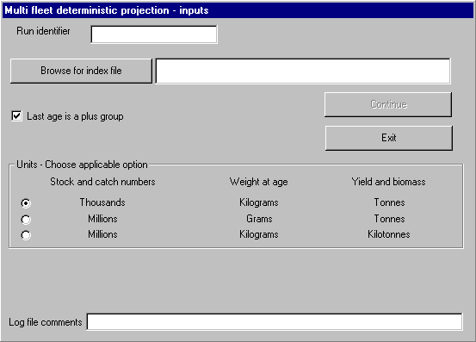

Run identifier

The user must type in a run identifier. If this field is left blank then when the user clicks Continue control will be returned to the inputs dialog and a message prompting for a run identifier displayed in the lower part of the dialog.

Browse for index file

The browse for index file button enables the user to locate and select the index file, and runs input routines to read in and check the data for type and range. If errors are encountered control is returned to the inputs dialog with a message displayed in the lower part of the dialog. If the data are successfully read in the Continue button is enabled and a message displayed, indicating the directory where the output files will be saved.

Last age is plus group

By default checked. Unchecking produces a projection with no plus group.

Units

The user selects the combination of units used for the projection. These will be indicated in the output files The default is for input in thousands and kilograms and output of SSB and yields in tonnes, but 2 other alternatives are presented. Consistency of the units is the responsibility of the user and MFDP does not carry out any checks on the units.

Continue

If the data are read in successfully the Continue will be enabled and clicking on it will continue the run by displaying the Control file dialog, or the Run type dialog if the run is fleet disaggregated and has no control file.

Exit

Clicking the Exit button terminates the program.

Log file comments

This text box allows the user to enter pertinent comments which will be output in the log file.

Run type dialog

If the data are fleet disaggregated and no control file is present then this dialog enables the user to specify whether a single target (F multiplier or TAC) is required for all fleets, or whether targets (F multipliers or quotas) are required for each fleet individually during the interim years.

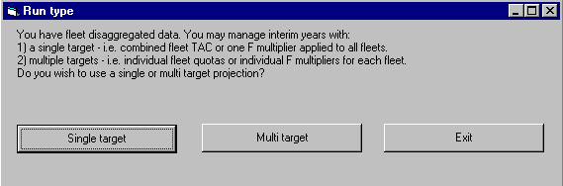

Single target

Clicking the single target button specifies that during interim years the same F multiplier will be applied to all fleets. This will be the specified F multiplier target or the F multiplier such that the combined landings yield of all fleets equals the catch constraint target. Once clicked the program continues to the Control file dialog.

Multi target

Clicking the multi target button specifies that during interim years each fleet will have an individual F multiplier applied to it. This will be the specified F multiplier target for that fleet, or the F multiplier such that the landings yield for the fleet equals the specified catch constraint for that fleet. Once clicked the program continues to the Control file dialog.

Exit

Clicking the Exit button terminates the program.
Control file dialog

If a control file is specified in the data then the dialog will be initialised with the values from it. Otherwise default values based on the age range of the data are used.

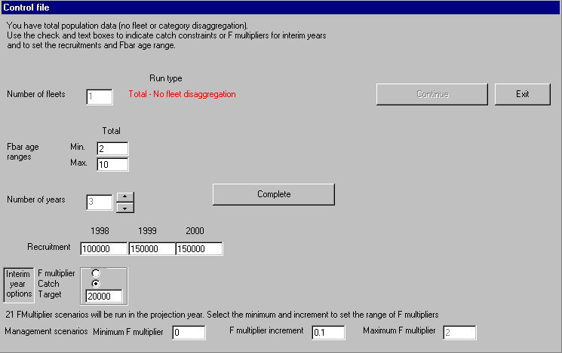

Number of fleets

Set according to the number of fleets specified in the index file. The user is not able to alter this control.

Run type

Informs the type of run being undertaken.

Fbar age ranges

2 text boxes for the population and each fleet present (up to 10). The user specifies the minimum and maximum age over which they wish the reference F to be averaged. If the run is multi fleet then additional text boxes will be available for each fleet. The ranges are automatically checked against the population ages ranges and the user informed and prompted to re-enter if inappropriate values are entered. 5 attempts to re-enter data are allowed. In excess of 5 re-entries causes the program to terminate.

Number of years

Set using the associated spinners this specifies the number of years over which the projection will be run (up to 10). As the number of years is increased or decreased additional controls are made available or removed from the dialog.

Recruitment

The user is able to enter the recruitment for each year of the projection. Values are automatically type and range checked with 5 attempts at re-entry permitted. If the number of years is altered Recruitment text boxes will be added, or removed.

F multiplier and catch option buttons

These options allow the user to specify whether a catch or F multiplier is to be used in each interim year. If the number of years is altered then F multiplier and catch option buttons will be added to, or removed from the dialog. If the run is multi target these controls are not visible and are presented by fleet on a subsequent dialog.

Target

The F multiplier or catch constraint to be used in each interim year. If the number of years is altered then F multiplier and catch option buttons will be added to, or removed from the dialog. Values are automatically type and range checked with 5 attempts at re-entry permitted. If the run is multi target these controls are not visible and are presented by fleet on a subsequent dialog.

Minimum F multiplier

By default 0. The minimum F multiplier to be used in the range of 21 F multiplier scenarios for the prediction with management table. The user may alter this and the F multiplier increment to control the range of fishing mortalities explored. Values are automatically type and range checked with 5 attempts at re-entry permitted.

F multiplier increment

By default 0.1. The increment by which the F multiplier will be increased in each of the 21 scenarios for the prediction with management table. The user may alter this and the F multiplier increment to control the range of fishing mortalities explored. Values are type and range checked with 5 attempts at re-entry permitted.

Maximum F multiplier

For information only. Informs the user of the maximum F multiplier in the range of 21 F multiplier scenarios for the prediction with management table.

Complete

When the above controls have been completed this button is clicked to enable the Continue button (single target run), or the show interim scenarios button (multi target run).

Continue

Continues the projection by showing the averaging options dialog if the run is based on historic data or the inspection options dialog if the run is based on future data.

Show interim scenarios

Displays the multi fleet multi target interim years scenarios dialog.

Exit

Clicking the Exit button terminates the program.
Multi fleet multi target interim years scenarios dialog

This dialog is only displayed where the data are multi fleet and the run type is multi target, i.e. each fleet has an individual F multiplier or catch constraint in the interim years.

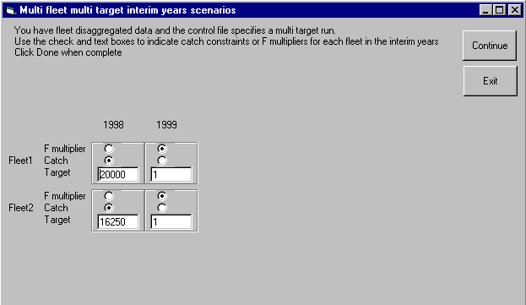

F multiplier and catch option buttons

These options allow the user to specify whether a catch or F multiplier is to be used for each fleet in each interim year. The number of fleets is determined from the index file. The number of years is that specified in the control dialog.

Target

The F multiplier or catch constraint to be used for each fleet in each interim year. The number of fleets is determined from the index file. The number of years is that specified in the control dialog.

Continue

Clicking the continue button shows the averaging options dialog if the run is based on historic data or the inspection options dialog if the run is based on future data.

Exit

Clicking the Exit button terminates the program.
Averaging options dialog

This dialog is shown when the input files are historic. It enables the user to specify options for summarising the data to average state vectors.

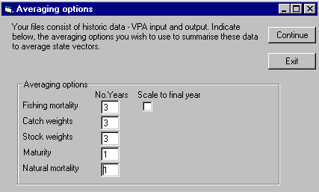

Averaging options - No. years

Allow the user to specify over how many years to average the selection pattern, weight at age in the catch, weight at age in stock, maturity at age and natural mortality at age.

Scale to final year

Check box which allows the user to indicate whether or not the average F should be scaled to final year Fbar.

Continue

Clicking continue displays the inspection options dialog.

Exit

Clicking the Exit button terminates the program.
Inspection options dialog

This dialog enables the user to specify if they wish to view or modify the state vectors to be used during the projection.

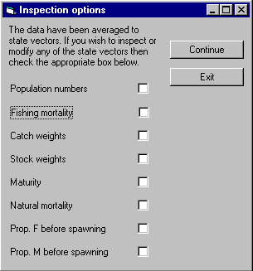

Population numbers, Fishing mortality, Catch weights, Stock weights, Maturity, Prop. F before spawning and Prop. M before spawning

Check boxes allow the user to indicate which state variables they wish inspect and/or modify.

Continue

Clicking continue displays the inspecting dialog if any boxes have been checked. If no check boxes are checked the projection is run.

Exit

Clicking the Exit button terminates the program.

Inspecting dialog

This dialog enables the user to view data to be used during the projection, and if they wish to modify particular values.

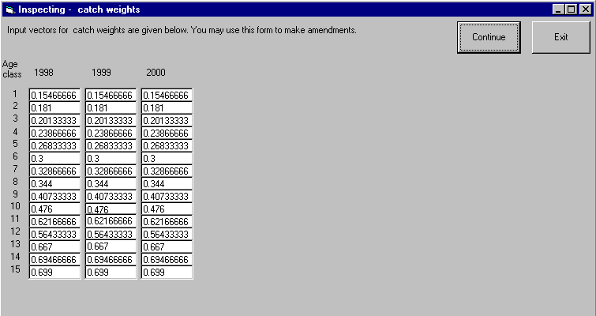

The user can alter the data by typing into the test boxes displayed. Values are interactively type and range checked with 5 attempts at re-entry permitted.

Continue

Clicking continue displays the next variable to be viewed or if all variables indicated in the inspection options dialog have been displayed runs the projection.

Exit

Clicking the Exit button terminates the program.

If the number of ages used for projection exceeds 31 then the user inspection option is not available.

New input file set

If the data are historic or any run options or data are changed during the run then a new input file set (future data) will be created (excluding the catch numbers file).

File contents | Filename
Index | RunCode + "ind.txt"
Population numbers | RunCode + "N.txt"
Total fishing mortality | RunCode + "F.txt"
Natural mortality | RunCode + "M.txt"
Total catch weight | RunCode + "CWt.txt"
Stock weight | RunCode + "SWt.txt"
Maturity | RunCode + "Mat.txt"
Proportion of F before spawning | RunCode + "PF.txt"
Proportion of M before spawning | RunCode + "PM.txt"
Control file | RunCode + "Ctrl.txt"

If the data are fleet disaggegated then fleet disaggegated files will be produced giving the fleet selection patterns and catch weights and the total fishing mortality and total catch weight files will not be created.

File contents | Filename
Disaggregated selection pattern | RunCode + “FleetF” + fleet number + “.txt”
Disaggregated catch weights | RunCode + “FleetCWt” + fleet number + “.txt”

Producing the modified file set allows repeat or subsequent runs to be undertaken without editing the data on each occasion.

Controlling scenarios and single option detailed output

MFDP runs 21 F multiplier scenarios for the final 2 years of the projection. These 2 years of the single option prediction are based on scenario 11, i.e. the middle scenario.
These are controlled using the Minimum F multiplier and F multiplier increment controls on the control file dialog.

The default settings for the Minimum F multiplier and F multiplier increment controls are 0 and 0.1, respectively. These settings result in scenarios ranging from 0 to 2 in steps of 0.1 and with the single option detailed tables for the final 2 years corresponding to status quo F.

If the user consider it desirable to maintain this but use a finer scale of F multipliers then the symmetry of F multipliers around 1 needs to be maintained. For example by using a Minimum F multiplier of 0.5 and an F multiplier increment of 0.05.

Control of the single option detailed output for the final years can be achieved by extending the projection by 2 years, which makes the previously final years interim years and thus subject to F multiplier or catch targets specified in the control file.
The index file

The index file structure depends on whether the run uses historic or future data.

Historic data

The structure of the index file for historic data is given below:

Index file contents | Index number
Title
Historic data flag (1 = Historic, 0 = Future)
Total catch numbers at age numbers file name and path | 2
Weight at age in the catch file name and path | 3
Weight at age in the stock file name and path | 4
Natural mortality file name and path | 5
Proportion mature file name and path | 6
Proportion of F before spawning file name and path | 7
Proportion of M before spawning file name and path | 8
Fishing mortality file name and path | 12
Population numbers file name and path | 13

If the prediction is not fleet or category disaggregated then this is sufficient, however if fleet or category disaggregation is required then the following lines are required.

Index file contents | Index number
Number of fleets
Fleet 1 catch numbers at age file name and path | 2
… | 2
Fleet n catch numbers at age file name and path | 2
Fleet 1 weight at age in the catch file name and path | 3
… | 3
Fleet n weight at age in the catch file name and path | 3

If a control file is specified it must always be the last file.

An example is given below for a disaggregated prediction with 2 fleets using historic data without a control file is given below:

Atlantic_egfish index file 15/3/99. Historic data
1
c:\vbprojection\data\canum.txt
c:\vbprojection\data\weca.txt
c:\vbprojection\data\west.txt
c:\vbprojection\data\natmor.txt
c:\vbprojection\data\matprop.txt
c:\vbprojection\data\fprop.txt
c:\vbprojection\data\mprop.txt
c:\vbprojection\data\F.txt
c:\vbprojection\data\n.txt
2
c:\vbprojection\data\Fleetnum.txt
c:\vbprojection\data\Fleetnum2.txt
c:\vbprojection\data\FleetCWt.txt
c:\vbprojection\data\FleetCWt2.txt

Note the stock name is read in as the first delimited field of the title line. If the stock name is to be complete it must not include any delimiters, i.e. space, comma, tab.

Future data

The structure of the index file for future data is dependent on whether or not the data are fleet disaggregated. If the projection is for the total population only the the structure would be as given below:

Index file contents | Index number
Title
Historic data flag (1 = Historic, 0 = Future)
**** (Catch data not required or available)
Weight at age in the catch file name and path | 3
Weight at age in the stock file name and path | 4
Natural mortality file name and path | 5
Proportion mature file name and path | 6
Proportion of F before spawning file name and path | 7
Proportion of M before spawning file name and path | 8
Fishing mortality file name and path | 12
Population numbers file name and path | 13
Control file name and path (optional)

An example is given below of total population (no fleet disaggregation) index file, including a control file.

Atlantic_egfish index file Future data Total popn
0
****
c:\vbprojection\data\weca.txt
c:\vbprojection\data\west.txt
c:\vbprojection\data\natmor.txt
c:\vbprojection\data\matprop.txt
c:\vbprojection\data\fprop.txt
c:\vbprojection\data\mprop.txt
c:\vbprojection\data\F.txt
c:\vbprojection\data\n.txt
c:\vbprojection\data\Ctrl.txt

However if fleet disaggregated data are used then in addition to not requiring catch numbers the aggregated F and catch weights files are not required. The structure thus becomes:

Index file contents | Index number
Title
Historic data flag (1 = Historic, 0 = Future)
**** (Catch data N/A)
**** (Weight at age in the catch N/A)
Weight at age in the stock file name and path | 4
Natural mortality file name and path | 5
Proportion mature file name and path | 6
Proportion of F before spawning file name and path | 7
Proportion of M before spawning file name and path | 8
**** (Fishing mortality N/A)
Population numbers file name and path | 13
Number of fleets
Fleet 1 selection pattern at age file name and path | 12
… | 12
Fleet n selection pattern at age file name and path | 12
Fleet 1 weight at age in the catch file name and path | 3
… | 3
Fleet n weight at age in the catch file name and path | 3
Control file name and path (optional)

Note that for future data fleet disaggregated runs the fleet catch numbers files are replaced by fleet selection files and the index is also changed.

An example is given below for a disaggregated prediction with 2 fleets using future data and including a control file is given below:

Atlantic_egfish index file future data.
0
****
****
c:\vbprojection\data\west.txt
c:\vbprojection\data\natmor.txt
c:\vbprojection\data\matprop.txt
c:\vbprojection\data\fprop.txt
c:\vbprojection\data\mprop.txt
****
c:\vbprojection\data\n.txt
2
c:\vbprojection\data\FleetSel.txt
c:\vbprojection\data\FleetSel2.txt
c:\vbprojection\data\FleetCWt.txt
c:\vbprojection\data\FleetCWt2.txt
c:\vbprojection\data\Control2.txt

The control file

The control file is used to specify the number of years for the projection as well as recruitment values and target F multipliers or catch constraints for interim years.
It also serves as a means of entry for the Fbar age ranges.

The program can be run without a control file in which case the user will have the opportunity to enter these data at the control file dialog stage. If a control file has been specified then the control file dialog will be displayed with values from the file.

The control file has the format specified below.

Title line.
Number of years
Fbar minimum age and Fbar maximum age for the total followed by each fleet
↓
by fleet
Recruits for each year →
Flag to indicate if target is catch (1) or F multiplier (0) for interim years only (single flag for multi fleet single target or 1 flag per fleet for multi fleet multi target (see Running the program)) → by fleet
↓
by year
Target (catch or F multiplier) (single target applied to all fleets or fleet targets applied to individual fleets (see Running the program)) → by fleet
↓
by year

Four examples of control files and brief explanations, covering a range of management possibilities are given below:

Example 1. Standard 3 year status quo projection with no fleet disaggregation.

Fbar is calculated over ages 3 – 7.
Recruitment is 100000 for all years.
The catch constraint flag is set to 0 (= false), therefore an F multiplier will be used.
Status quo F, i.e. F multiplier of 1 will be used for the interim year.

Atlantic_egfish Control file - standard 3yr status quo projection
3
3 7
100000 100000 100000
0
1

Example 2. 3 year projection with discards and a catch constraint in the assessment year.

Fbar is given for the total stock and for each fleet file, i.e. twice
Recruitment is 100000 in all years.
The catch constraint flag is set to 1 (= true).
A catch constraint of 20000 t will be used for the interim year.

Atlantic_egfish Control file - 3yr projection 1 fleet + discards + catch constraint
3
3 7
3 7
100000 100000 100000
1
20000

Example 3. 4 year fleet disaggregated prediction with 2 fleets managed with fleet specific catch/effort targets.

Fbar is calculated over ages 2 – 8 for the total and both fleets.
Recruitment 100000 in the assessment year, in the first future interim year is 150000 and 100000 in the projection year and projection year +1.
The population will be brought through the assessment year using a catch constraint of 20000 tonnes for Fleet 1 and with status quo F for Fleet 2.
The population will be brought through the first future interim year using status quo F for both fleets.

Atlantic_egfish Control file Multi fleet multi target 4 year projection C + F constraint
4
2
2 8
2 8
2 8
100000 150000 100000 100000
1 0
0 0
20000 1
1 1
Example 4. 3 year fleet disaggregated prediction with 2 fleets managed with combined catch constraint (TAC).

Fbar is calculated over ages 2 – 8 for the total and both fleets.
Recruitment in the assessment year is 100000 and 150000 in the projection year and projection year + 1.
The population will be brought through the assessment year using a catch constraint of 20000 tonnes for combined Fleet 1 and Fleet 2 landings.

Atlantic_egfish Control file Multi fleet single target 3 year projection C constraint
3
2
2 8
2 8
2 8
100000 150000 150000
1
20000

Note the following points:

- If total catch with discards are used enter 1 for the number of fleets but enter the Fbar age ranges twice (once for the total and once because there is 1 fleet catch file present).
- Discards and human consumption Fbars have the same age range within fleet.
- Fleet flags and targets are required for the assessment year and any other interim years. The projection year is consists of a range of F multiplier options so targets are not required.

Data files

The files containing data are standard Lowestoft format data files used for input to the Lowestoft VPA suite, the proposed output files for population numbers and fishing mortality (in Lowestoft format) described under Output from catch-at-age analysis, and the proposed fleet disaggregated catch and catch weight files described in the Fleet disaggregated catch data section. Fleet names are picked up as the first delimited field of the title line in the fleet catch file.
Output files

The following 5 files of output are produced:

Results in a comma delimited file with a format based on that specified by the ICES Workshop on Standard Assessment Tools for Working Groups (1999), but with minor modifications (see Modifications to Workshop on Standard Assessment Tools for Working Groups output format, below). This file is named with a filename of the run index and the file extension .pro. If no run index has been specified then results will be appended to a file named MFDP.pro. The results for each run are appended to the file along with the run name, program name and version, stock name, time and date.

Results in a comma delimited file with a structure similar to that of the prediction with management options table currently used by ICES. This file is named with a filename of the run index and the file extension .prm. If no run index has been specified then results will be appended to a file named MFDP.prm. The results for each run are appended to the file along with the run name, program name and version, stock name, time and date.

Results in a comma delimited file with a structure similar to the single option prediction: detailed tables currently used by ICES. This file is named with a filename of the run index and the file extension .prs. If no run index has been specified then results will be appended to a file named MFDP.prs. The results for each run are appended to the file along with the run name, program name and version, stock name, time and date.

- A comma delimited file containing the steady state vectors used for the projection, in a form similar to the prediction with management: input data table used by ICES. This file is named with a filename of the run index and the file extension .prd. If no run index has been specified then results will be appended to a file named MFDP.prd. The data for each run are appended to the file along with the run name, program name and version, stock name, time and date.

- A log file in comma delimited format containing the files used for the run, the raw data, the options chosen, truncated data when appropriate, the steady state vectors, and a summary of the results. The log file is named with the run code and the file extension .prl. If no run code has been specified then this file is named MFDP.prl.

Modifications to WSATWG output format

Some minor changes have been made to the format proposed by the Workshop on Standard Assessment Tools for Working Groups. The Fbar age ranges are included with the fleet heading only for the first interim year, and the landings and discards Fbars are included in each row of results, rather than only with the heading.

The format is detailed below:

The top of the file consists of four lines giving the following information:

Header (Run specific includes: date and software version)
I (No. Fleets)
J (No. Years)
K (No. Scenarios)

This is followed by J blocks of information; one per year. The first block (assessment year) will give the year, followed by a fleet block. In subsequent interim years fleet blocks will not specify the Fbar age range.

For each fleet, the block would consist of a header:

Name(i)
age(1,i) age(2,i)

i.e name of fleet i and the age range used to calculate the reference F.

This would then be followed by 1 row of results as follows

k α _{i,j,k} FbarLand FbarDisc Land_{i,j,k} Disc_{i,j,k} [SSB_{j,k}]

where k is the scenario number, α_{i,j,k} is the effort multiplier applied to fleet i in year j under scenario k, Land_{i,j,k} and Disc_{i,j,k} are the landings and discards by fleet i in year j resulting from scenario k, and SSB_{j,k} is the SSB at spawning time in year j resulting from scenario k. This will only be given with the reference fleet data, i.e. when i = 1. In interim years including the assessment year only 1 scenario is applied and for these years k is denoted in MFDP by -99 (missing value, as it does not correspond to anyone of the specified scenarios).

The year J-1 will consist of the year followed by a separate block of information for each fleet, with SSB estimates given along with the reference fleet data. The final block will give only SSB estimates in the final year corresponding to each scenario.

For each fleet, the block would consist of a header followed by K rows as follows:

Name(i)
K rows :
k α _{i,j,k} FbarLand_{i,j,k} FbarDisc_{i,j,k} Land_{i,j,k} Disc_{i,j,k} [SSB_{j,k}]

where k is the scenario number, α_{i,j,k} is the effort multiplier applied to fleet i in year j under scenario k, FbarLand_{i,j,k} and FbarDisc_{i,j,k} are the Fbars for landings and discards by fleet i in year j resulting from scenario k, Land_{i,j,k} and Disc_{i,j,k} are the landings and discards by fleet i in year j resulting from scenario k, and SSB_{j,k} is the SSB at spawning time in year j resulting from scenario k. This will only be given with the reference fleet data, i.e. when i = 1.

For the last prediction year, j = J, the block will be as follows:

Year J
K rows : k SSB_{J,k}

Fleet disaggregation

MFDP uses the fleet disaggregated file format suggested by the WSATWG.

Fleet names are picked up as the first delimited field of the title line for the total component in the fleet catch file or fleet partial F file. Since this is used as a label in the output it is recommended that a meaningful string is used. Since a space will be identified as a delimiter if multiple words are required they must be linked, e.g. IndustrialFishery or HC_Fishery. It is also recommended that the string be kept to a reasonable length, i.e. < 20 characters.

When reading the fleet disaggregated file if the number of categories is specified as 2, then both the landings and discards components are read in and used. However, if
the number of categories is specified as 1, then MFDP reads in and uses only the total component for that fleet. This means that if only one component is required for a fleet it is possible to end the fleet disaggregated file immediately after the total component for that fleet.

Data checking

Input data are checked to ensure they are numeric and, if integers are within the MAXINT limit. They are subsequently checked for the presence of negative values. If any negative values are found a message is issued in the lower part of the inputs dialog and the files closed to allow modification.

Within the projection routines a further check is carried out to test if total mortality at age is zero, in which case the catch is set to zero and the program continues.

Dialogs used during the program runs interactively check that data are numeric and in an appropriate range, allowing 5 attempts to enter sensible data before terminating the program.

Methods

Truncation of the plus group

During the assessment process the plus group may set to a lower age than in the original data files. MFDP checks the maximum age indices in the data files against the corresponding index in the fishing mortality file. If the fishing mortality file has a lower age then the data will be truncated to the new plus group.

Total and fleet catches in the excess ages are summed to provide the plus group catches. Natural mortality, total catch weight, stock weight, maturity, proportion of F before spawning and proportion of M before spawning are aggregated into the plus group as a catch numbers weighted average. An example is given for M below.

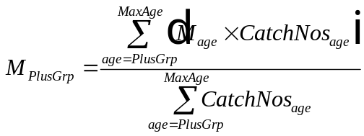

Fleet catch weights are averaged in the same fashion but are weighted by the fleet catch rather than total catch.

The truncation process is carried out only over the years, which will be averaged to produce the steady state vectors.

If the program detects that truncation to a new plus group is required but the “Last age is a plus group” check box is unchecked then the program will exit with an error message.
Steady state vectors

If the input data are 'historic data' then the steady state vectors are produced by averaging over a user defined number of years (in reverse chronological order), which need not be the same for all vectors.

Alternatively if the data file consist of 'future data', vectors by age for each year of the projection, then these values are read in used directly. They are not processed as described below.

Fishing mortality

Fishing mortality at age is averaged over the required number of years. The resultant selection pattern may be scaled to the final year Fbar if required.

Where fleet disaggregated data are involved fleet partial F at age is averaged over the required number of years. If scaling is required then the average fleet partial F at age is summed over fleets (including discard partial F) and an Fbar (SigmaFleetFbar) calculated over the total Fbar age range. Each fleet exploitation pattern is scaled by the ratio of total Fbar final year divided by SigmaFleetFbar.

Note. By estimating the human consumption and discard components by year and averaging them independently the sum of the averaged exploitation patterns may not be equal to the overall average exploitation pattern. In this way MFDP differs from current practise where the overall exploitation pattern is averaged and then partitioned in to human consumption and discard components. If the latter situation is required the exploitation patterns can be estimated externally and manually entered at the inspecting dialog.

Weight, maturity and natural mortality

The simple average over the specified number of years is taken.

Fleet disaggregated catch weights at age are provided as input where appropriate, but historic data may be averaged over a number of years.

Proportions of F and M before spawning

The final year is used.

Estimation of Fbar

Fbar is estimated as the simple mean over the specified age range. Discards have the same age range for Fbar as the landings component. No account is taken of the age range of the discard component, i.e. if Fbar is specified as ages 2-8 but the discard exploitation pattern only extends to age 5 then the discard Fbar will be the sum of partial F at ages 2-5 divided by 7. The partial F of the older ages is considered to be zero and these age classes are included in the Fbar estimation.
Minimisations

Prior to minimisation a check on the maximum possible yield is made using the product of population numbers and total catch weights. If the projection is considering total population only then if the target yield exceeds this the user is informed and the program terminated. For a multiple fleet projections it may be possible to exceed this yield, as the catch weight structure used will be an aggregate of fleet catch weights and altering the influence of fleets may alter the overall catch weight applied. In this case the user is warned and then minimisation is attempted.

For the single fleet (total population) option the program uses the amoeba simplex minimisation algorithm (Nelder & Mead, 1965) to obtain an F multiplier corresponding to the catch (TAC) constraint. The particular implementation is a modification of that described by Dixon, 1972. If the minimisation fails to converge within a set number of iterations, it is re-started with a different set of starting parameters. If the program fails to find a solution within 10 starts the user is notified and the program terminated.

For the multi fleet single target catch constraint a linear probing algorithm is used to obtain the F multiplier which is applied equally to all fleets, while for the and multi fleet multi target option where catch constraints are used a direct probing algorithm is applied iteratively to obtain independent F multipliers for each fleet.

POPULATION DYNAMICS

The projection is based on an age structured catch equation (Baranov, 1918).

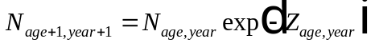

where

N : population numbers
Z : total mortality

Total mortality is made up of fishing mortality (F) and natural mortality (M).

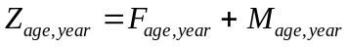

and fishing mortality is the product of an F multiplier (FMult) and selection pattern (Selection). For a fleet disaggregated projection total fishing mortality is given by

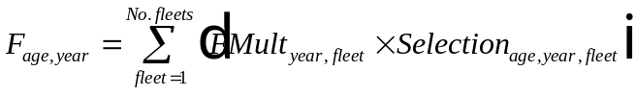

If the last age in the population is considered to be a plus group then numbers in this age group will be made up of the survivors from the previous age class and the plus group in the previous year.

Catch in numbers is given by

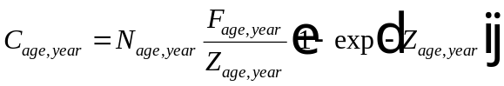

Yield to the fishery is

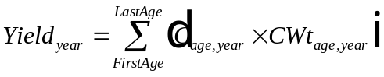

where

CWt : average weight at age in the catch.

Spawning stock biomass is estimated

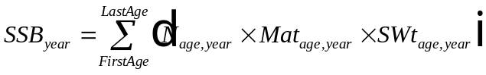
where

Mat : proportion mature at age
SWt : average weight at age in the stock.

If spawning takes place other than at the start of the year then SSB at spawning time can be estimated by adjusting the population numbers to take account of the mortality which will occur before spawning. The spawning time numbers are given by

where

PF : proportion of fishing mortality occurring before spawning

PM : proportion of natural mortality occurring before spawning.

REFERENCES

Anon, 1999. Report of the ICES workshop on Standard Assessment Tools for Working Groups. Aberdeen. 3rd – 5th March 1999.

Baranov, F.I. 1918. On the question of the biological basis of fisheries. Nauchn. Issled. Ikhtiologicheskii. Inst. Izv. 1: 81-128.

Darby, C.D. & Flatman, S. 1994. Virtual Population Analysis: version 3.1 (Windows/DOS) user guide. MAFF Information Technology Series No 1. Directorate of Fisheries Research, Lowestoft.

Dixon, C.W., 1972. Nonlinear Optimisation. The English Universities Press Ltd, London.

Nelder, J.A. & Mead, R.1965. A simplex method for function minimization. The Computer Journal 5.

