Base run script 05_ with 2017 data included, settings equal to IBP2017 script 05_ baserun. Without AR correction on SNS.

The WGNSSK 2018 run should look like the FSB 2018 run as they have similar settings and identical data input. The IPB 2017 and SSB 2018 run should look similar since they have the same setting for biomass survey treatment (but some differences in parameter binding and data input (IBP 2017 extents up till 2016 while SSB 2018 includes one extra year of data).

## Baserun:

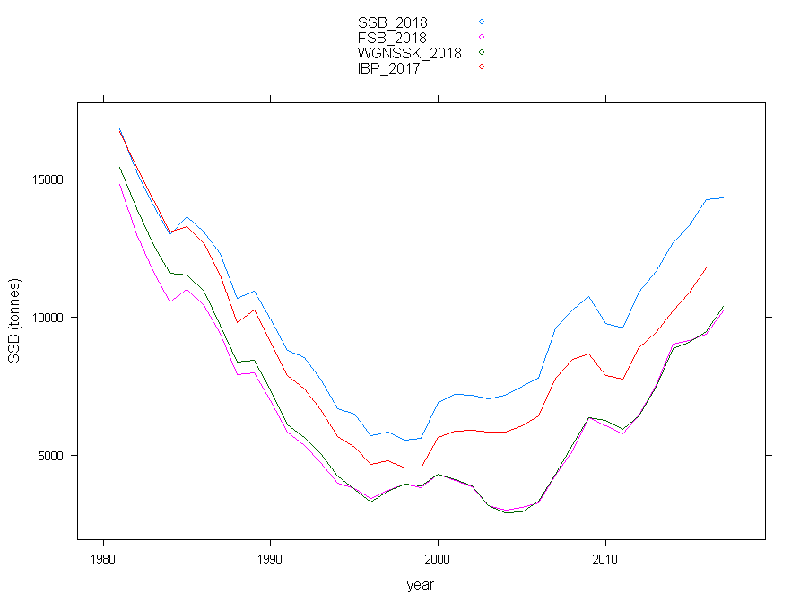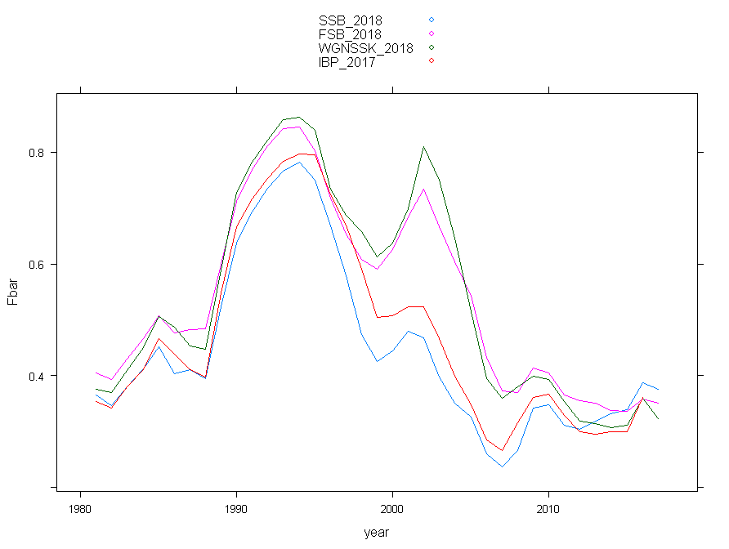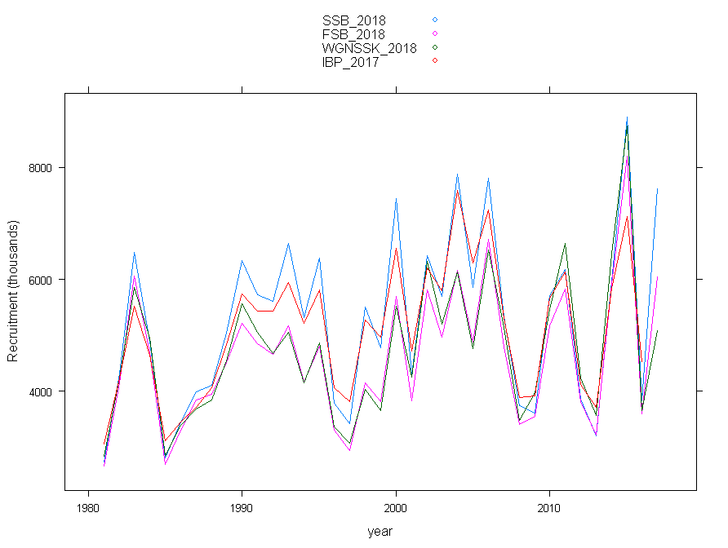

## Catch plusgroup run

Mohns rho catch plusgroup run

| | 10| 9| 8| 7| 6|

|:----|-----:|-----:|-----:|-----:|------:|

|ssb | -1.80| -4.66| -5.69| -7.87| -32.13|

|fbar | -3.05| -0.89| -2.56| 0.04| 14.99|

|rec | 4.48| 3.88| 5.23| 4.35| -2.73|

|mean | 3.11| 3.14| 4.49| 4.08| 16.62|

|sum | 9.33| 9.43| 13.48| 12.25| 49.85|

Mohns rho in catch in absolute terms

| | 10| 9| 8| 7| 6|

|:----|---------:|---------:|---------:|---------:|--------:|

|ssb | 6.639742| 5.706439| 8.903751| 8.761848| 32.13361|

|fbar | 9.471535| 7.768224| 11.446381| 9.041804| 15.77105|

|rec | 17.072630| 16.944724| 18.158233| 18.425777| 18.05613|

|mean | 11.061302| 10.139795| 12.836122| 12.076476| 21.98693|

|sum | 33.183907| 30.419387| 38.508364| 36.229429| 65.96079|

Decision: PG -> 9+

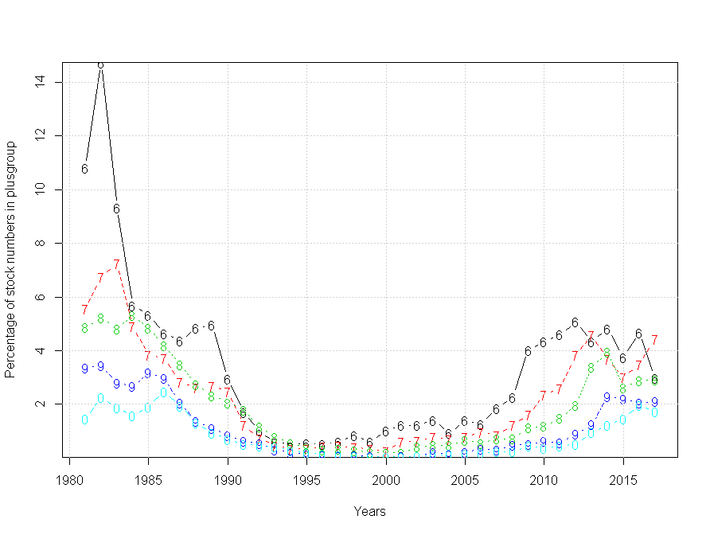

## Survey plusgroup run

Mohns rho for survey plusgroup runs

| | 7| 6| 5| 4| 3|

|:----|----------:|----------:|----------:|----------:|----------:|

|ssb | -0.3148403| 0.5057707| 0.5587811| -0.1675543| -0.4983251|

|fbar | -5.1945187| -5.2667259| -4.8683139| -6.0499862| -6.5064285|

|rec | 0.7289518| 0.1721194| -0.8902935| -0.7959869| -0.1440081|

|mean | 2.0794369| 1.9815387| 2.1057962| 2.3378425| 2.3829206|

|sum | 6.2383108| 5.9446160| 6.3173885| 7.0135274| 7.1487617|

Absolute Mohns rho survey plusgroup runs

| | 7| 6| 5| 4| 3|

|:----|---------:|---------:|---------:|---------:|---------:|

|ssb | 7.696275| 7.628546| 5.836193| 5.616079| 5.882534|

|fbar | 10.550144| 10.660765| 8.915697| 8.652512| 8.573124|

|rec | 17.154640| 17.009300| 16.947875| 16.247152| 17.041285|

|mean | 11.800353| 11.766204| 10.566589| 10.171914| 10.498981|

|sum | 35.401058| 35.298611| 31.699766| 30.515743| 31.496944|

Decision is to keep 7 and 6 as max age for SNS and BTS respectively because the extra age group in BTS may provide more information in the long run if the stock keeps increasing.