Spict with prior sdi on LPUE

> inp$priors$logsdi = list( c(1,1,0), c(0.1,0.5,1), c(1,1,0))

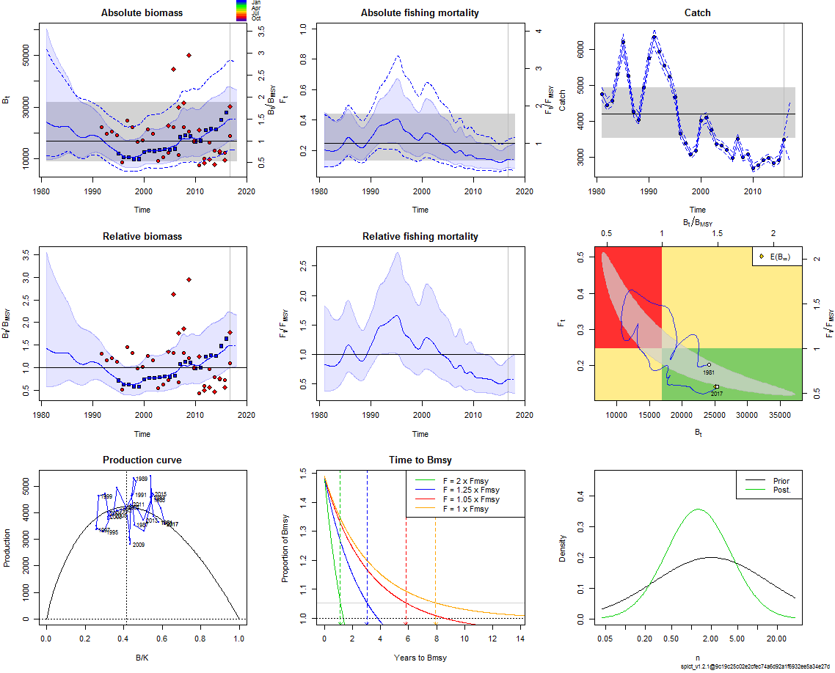

> summary(fit)

Convergence: 0 MSG: relative convergence (4)

Objective function at optimum: 17.5057463

Euler time step (years): 1/16 or 0.0625

Nobs C: 36, Nobs I1: 26, Nobs I2: 22, Nobs I3: 13

Priors

logn ~ dnorm[log(2), 2^2]

logalpha ~ dnorm[log(1), 2^2]

logbeta ~ dnorm[log(1), 2^2]

logsdi2 ~ dnorm[log(1.105), 0.5^2]

Fixed parameters

fixed.value

phi NA

Model parameter estimates w 95% CI

estimate cilow ciupp log.est

alpha1 6.276218e+00 2.340769e+00 1.682819e+01 1.8367675

alpha2 1.556549e+00 5.052996e-01 4.794869e+00 0.4424713

alpha3 9.787650e+00 3.546689e+00 2.701057e+01 2.2811214

beta 1.511806e-01 2.676450e-02 8.539491e-01 -1.8892805

r 3.142110e-01 3.403990e-02 2.900381e+00 -1.1576905

rc 4.939299e-01 2.755461e-01 8.853938e-01 -0.7053616

rold 1.153958e+00 3.405000e-04 3.911219e+03 0.1431978

m 4.222412e+03 3.527504e+03 5.054216e+03 8.3481619

K 4.140222e+04 1.469412e+04 1.166551e+05 10.6310897

q1 9.300000e-05 4.590000e-05 1.882000e-04 -9.2831096

q2 3.500000e-06 1.700000e-06 7.100000e-06 -12.5668100

q3 3.069300e-03 1.388200e-03 6.786000e-03 -5.7863085

n 1.272290e+00 1.417894e-01 1.141638e+01 0.2408183

sdb 7.198560e-02 2.843830e-02 1.822162e-01 -2.6312891

sdf 1.267982e-01 8.321890e-02 1.931986e-01 -2.0651585

sdi1 4.517974e-01 3.386797e-01 6.026958e-01 -0.7945215

sdi2 1.120491e-01 6.352320e-02 1.976446e-01 -2.1888178

sdi3 7.045699e-01 4.808454e-01 1.032388e+00 -0.3501677

sdc 1.916940e-02 3.770400e-03 9.746030e-02 -3.9544389

Deterministic reference points (Drp)

estimate cilow ciupp log.est

Bmsyd 17097.212180 9111.700875 3.208124e+04 9.746671

Fmsyd 0.246965 0.137773 4.426969e-01 -1.398509

MSYd 4222.412458 3527.503950 5.054216e+03 8.348162

Stochastic reference points (Srp)

estimate cilow ciupp log.est rel.diff.Drp

Bmsys 1.699097e+04 9063.5287166 3.185216e+04 9.740437 -0.006253030

Fmsys 2.466192e-01 0.1373852 4.427045e-01 -1.399910 -0.001402032

MSYs 4.190262e+03 3554.1033244 4.940289e+03 8.340519 -0.007672571

States w 95% CI (inp$msytype: s)

estimate cilow ciupp log.est

B_2016.75 2.530676e+04 1.333980e+04 4.800913e+04 10.1388267

F_2016.75 1.420489e-01 7.415380e-02 2.721086e-01 -1.9515837

B_2016.75/Bmsy 1.489424e+00 9.963305e-01 2.226555e+00 0.3983896

F_2016.75/Fmsy 5.759848e-01 3.597757e-01 9.221260e-01 -0.5516740

Predictions w 95% CI (inp$msytype: s)

prediction cilow ciupp log.est

B_2017.00 2.533921e+04 1.338875e+04 4.795637e+04 10.1401084

F_2017.00 1.426697e-01 7.380080e-02 2.758051e-01 -1.9472234

B_2017.00/Bmsy 1.491334e+00 1.004546e+00 2.214013e+00 0.3996712

F_2017.00/Fmsy 5.785018e-01 3.567249e-01 9.381579e-01 -0.5473136

Catch_2017.00 3.613798e+03 2.901701e+03 4.500647e+03 8.1925145

E(B_inf) 2.517540e+04 NA NA 10.1336225

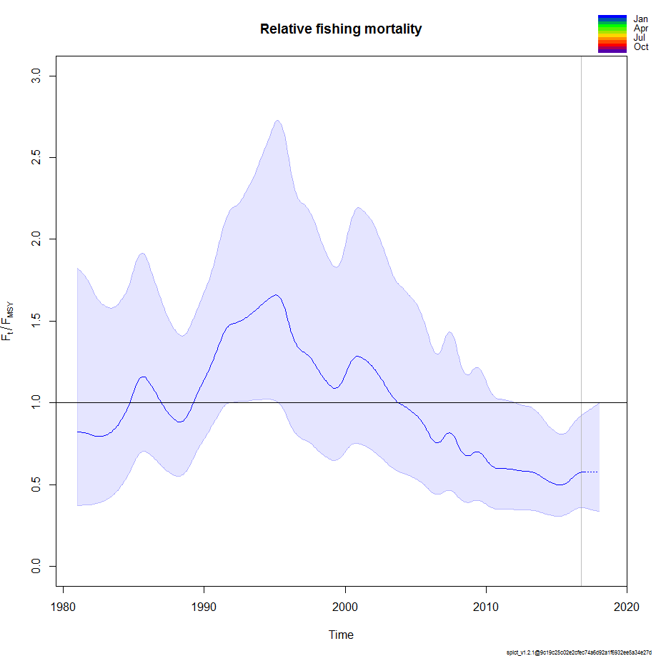

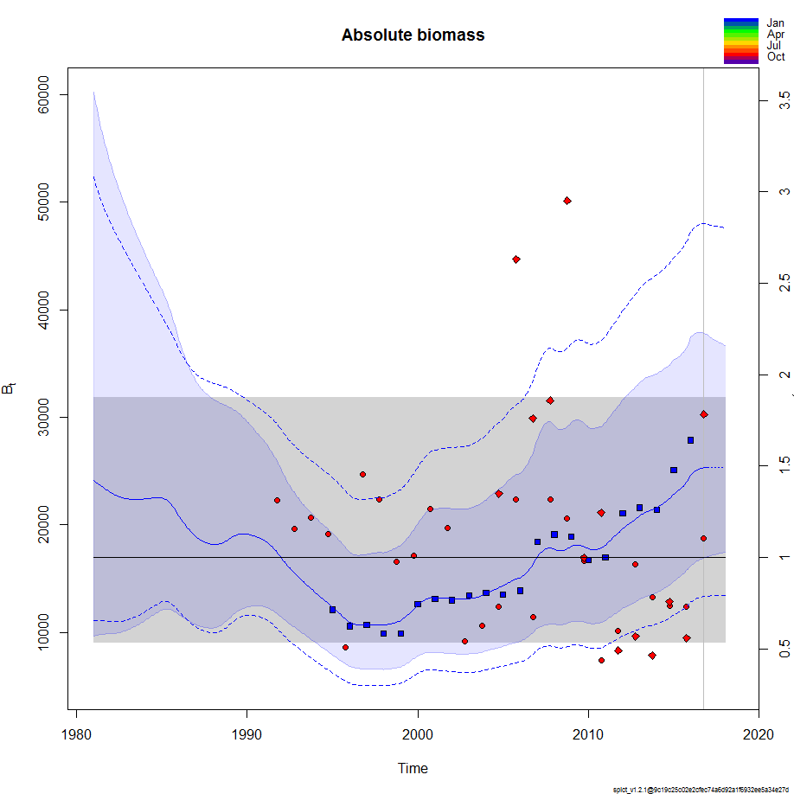

> ### check convergence

> lapply(model_list, function(x){ x$opt$convergence})

$`2015`

[1] 0

$`2014`

[1] 0

$`2013`

[1] 0

$`2012`

[1] 0

$`2016`

[1] 0

> lapply(model_list, function(x){ x$opt$message})

$`2015`

[1] "relative convergence (4)"

$`2014`

[1] "relative convergence (4)"

$`2013`

[1] "relative convergence (4)"

$`2012`

[1] "relative convergence (4)"

$`2016`

[1] "relative convergence (4)"

