Get Blim and Bpa

> FITlim <- eqsr_fit(TUR, nsamp = 5000, models = c( "Segreg"),

+ remove.years=c(2014, 2015, 2016))

> eqsr_plot(FITlim, n = 5000)

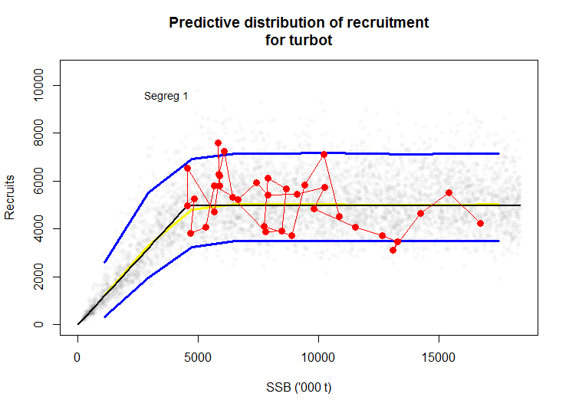

> print(Blim <- FITlim[["sr.det"]][,"b"])

[1] 4554.678

> print(Bpa <- 1.4 * Blim)

[1] 6376.549

> SIM101 <- eqsim_run(FITlim, bio.years = c(2007, 2016), bio.const = FALSE,

+ sel.years = c(2007, 2016), sel.const = FALSE,

+ Fcv=0, Fphi=0,

+ Btrigger = 0,Blim=Blim,Bpa=NA,

+ Fscan = seq(0,1.2,len=61),verbose=FALSE)

> print(Flim <- SIM101$Refs2[1,3])

[1] 0.4978544

> print(Fpa <- Flim/1.4)

[1] 0.3556103

> eqsim_plot(SIM101,catch="FALSE")

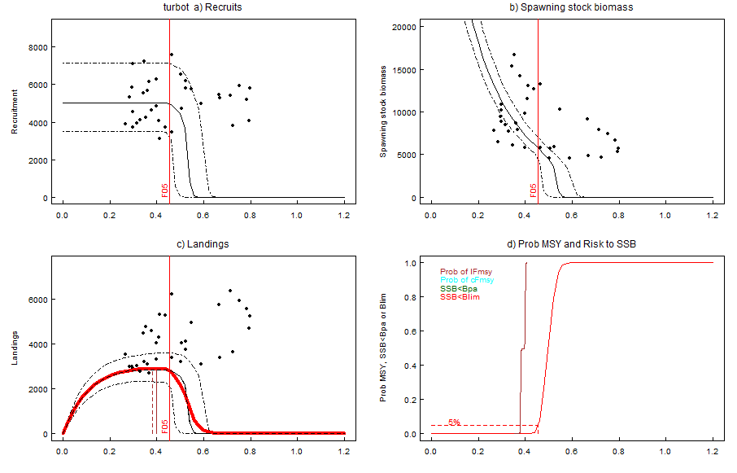

> Coby.fit(SIM101,outfile='aa')

Reference point estimates:

F05 F10 F50 medianMSY meanMSY Medlower Meanlower

catF 0.452 0.462 0.497 NA 0.380 NA NA

lanF NA NA NA 0.449 0.380 0.245 0.247

catch 2794.876 2766.433 2572.656 NA 2845.001 NA NA

landings NA NA NA 2911.494 2845.001 2703.917 2737.030

catB 5788.798 5517.245 4555.360 NA 7894.755 NA NA

lanB NA NA NA 6027.746 7894.755 14528.304 NA

Medupper Meanupper

catF NA NA

lanF 0.474 0.459

catch NA NA

landings 2703.378 2737.710

catB NA NA

lanB 5156.253 NA

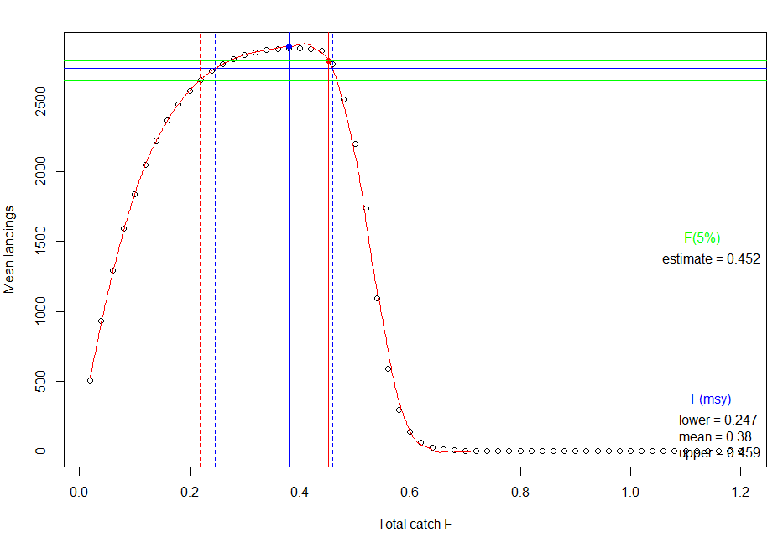

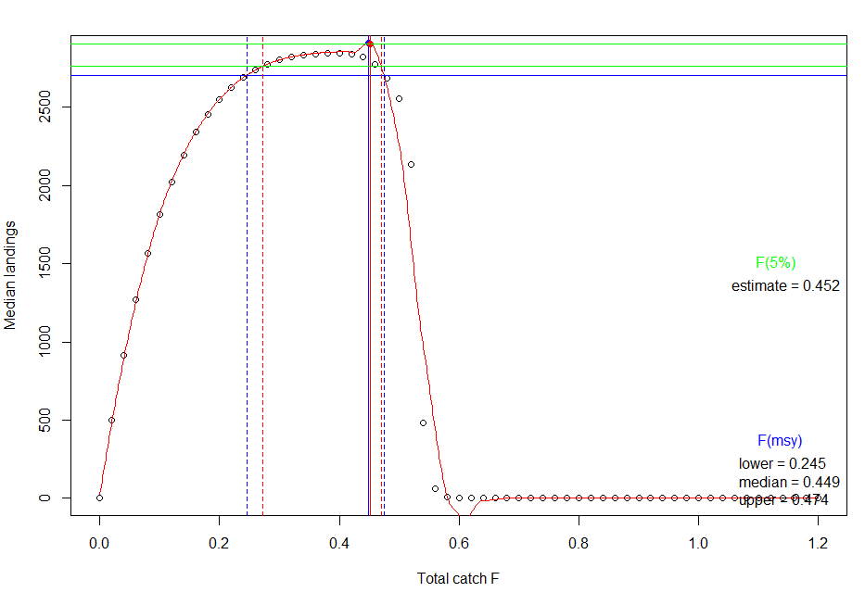

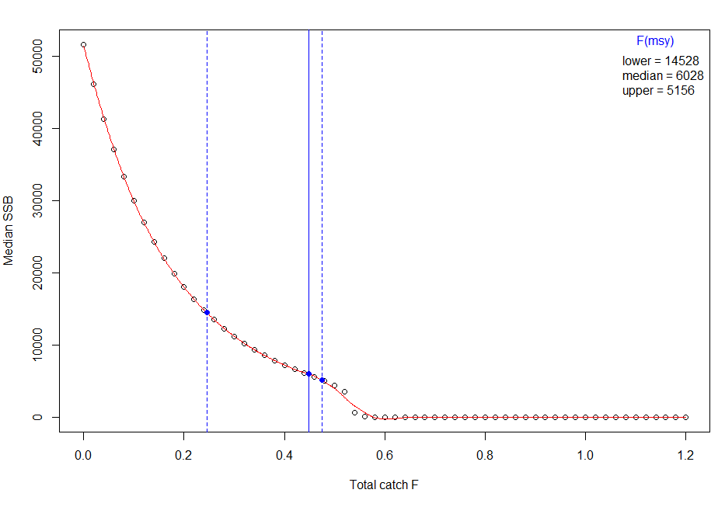

Explore some SR fits

> FITs <- eqsr_fit(TUR,

+ nsamp = 5000,

+ models = c("Segreg"),

+ remove.years=c(2014, 2015, 2016))

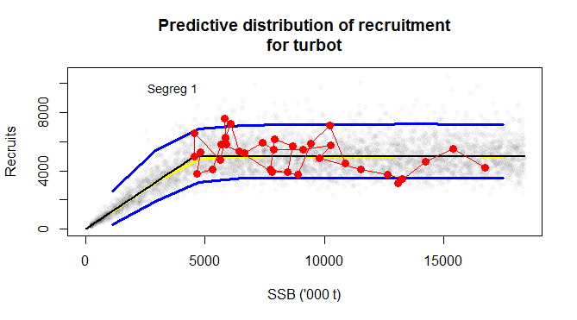

> FITr <- eqsr_fit(TUR,

+ nsamp = 5000,

+ models = c("Ricker"),

+ remove.years=c(2014, 2015, 2016))

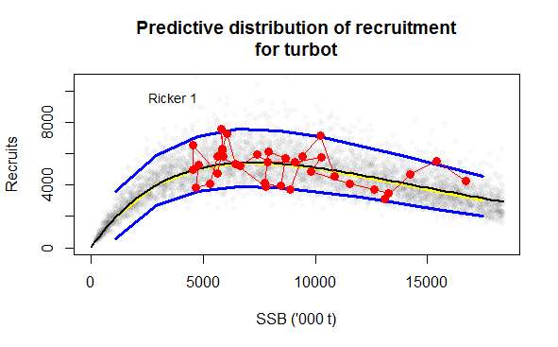

> FITrs <- eqsr_fit(TUR,

+ nsamp = 5000,

+ models = c("Ricker", "Segreg"),

+ remove.years=c(2014, 2015, 2016))

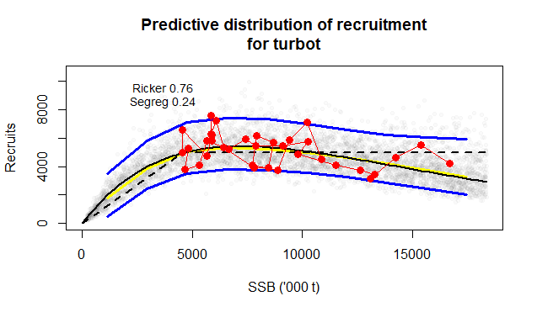

> FITb <- eqsr_fit(TUR,

+ nsamp = 5000,

+ models = c("Bevholt"),

+ remove.years = c(2014, 2015, 2016))

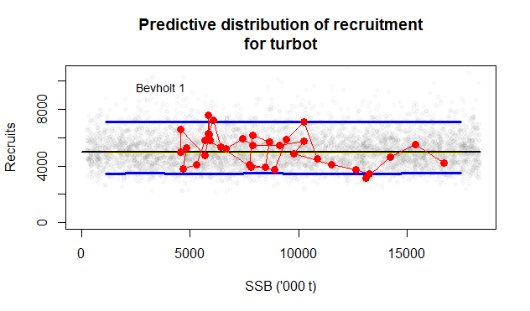

> FITbsr <- eqsr_fit(TUR,

+ nsamp = 5000,

+ models = c("Bevholt", "Segreg", "Ricker"),

+ remove.years = c(2014, 2015, 2016))

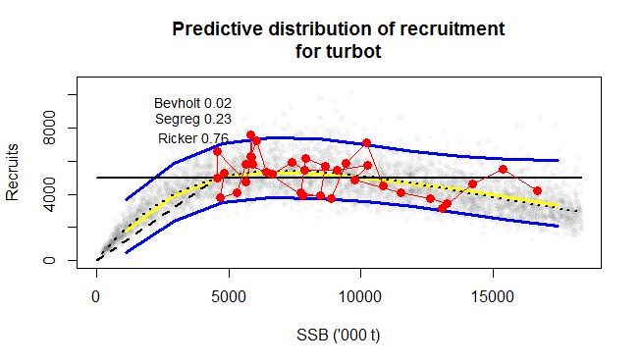

Go forward with SegReg and Ricker combi and SegReg solo fits

First, get Btrigger

> SIM2rs <- eqsim_run(FITrs, bio.years = c(2012, 2016), bio.const = FALSE,

+ sel.years = c(2012, 2016), sel.const = FALSE,

+ Fcv=0, Fphi=0,

+ Btrigger = 0,Blim=Blim,Bpa=Bpa,Fscan = seq(0.1,0.5,len=41),verbose=FALSE)

>

> SIM2s <- eqsim_run(FITs, bio.years = c(2012, 2016), bio.const = FALSE,

+ sel.years = c(2012, 2016), sel.const = FALSE,

+ Fcv=0, Fphi=0,

+ Btrigger = 0,Blim=Blim,Bpa=Bpa,Fscan = seq(0.1,0.5,len=41),verbose=FALSE)

Btrigger with SegReg and Ricker combi

> print(Btrigrs <- SIM2rs$rbp[,4][SIM2rs$rbp$variable=='Spawning stock biomass'& SIM2rs$rbp$Ftarget==0.40])

[1] 6570.293

Btrigger with SegReg solo

> print(Btrigs <- SIM2s$rbp[,4][SIM2s$rbp$variable=='Spawning stock biomass'& SIM2s$rbp$Ftarget==0.40])

[1] 6234.485

Fmsy and F05

Ricker and SegReg combi

> SIM3rs <- eqsim_run(FITrs, bio.years = c(2012, 2016), bio.const = FALSE,

+ sel.years = c(2012, 2016), sel.const = FALSE,

+ Fcv=0.212, Fphi=0.423, # these are defauts, taken from WKMSYREF4, as used in Saithe assessments

+ Btrigger = Btrigrs ,Blim=Blim,Bpa=Bpa,Fscan = seq(0,1.2,len=61),verbose=FALSE)

|  |
| --- |
| > Coby.fit(SIM3rs,outfile='turbot RS with Btrigger and Fcv and Fphi')  Reference point estimates:  F05 F10 F50 medianMSY meanMSY Medlower Meanlower Medupper  catF 0.528 0.567 0.731 NA 0.44 NA NA NA  lanF NA NA NA 0.431 0.44 0.327 0.326 0.625  catch 2907.035 2870.839 2698.364 NA 2959.95 NA NA NA  landings NA NA NA 2960.726 2959.95 2812.831 2864.036 2813.195  catB 5774.823 5478.235 4555.034 NA 6743.79 NA NA NA  lanB NA NA NA 6900.132 6743.79 9588.368 NA 5107.507  Meanupper  catF NA  lanF 0.644  catch NA  landings 2862.474  catB NA  lanB NA |
|  |
| |  | | --- | | > | |

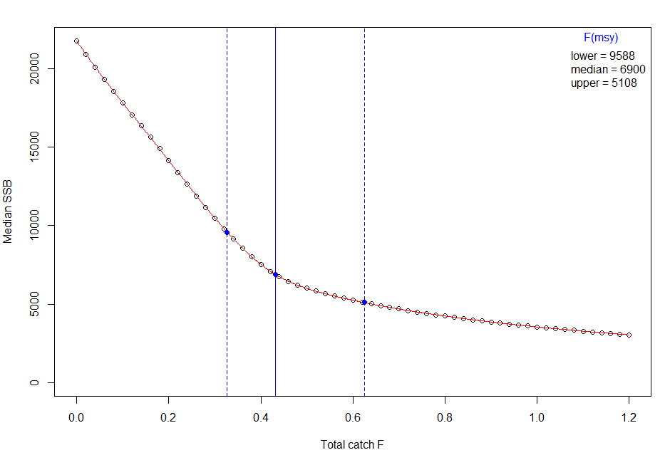 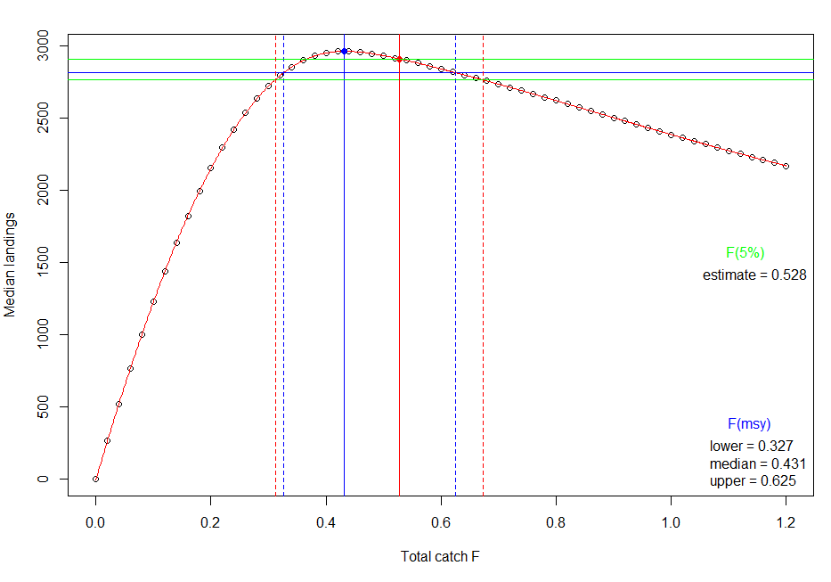 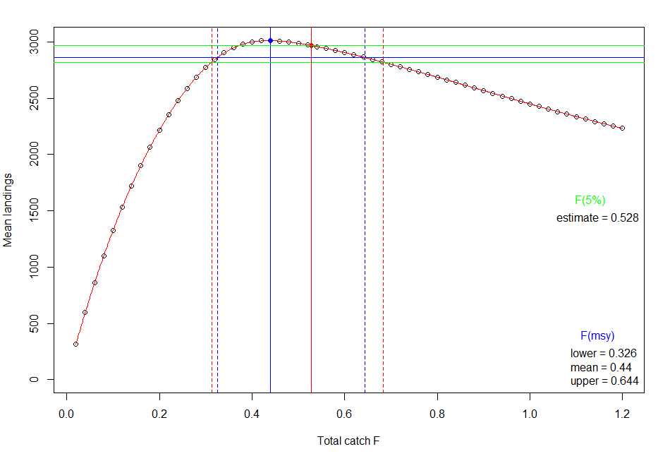

> print(Fmsyrs <- SIM3rs$Refs2[2,4])

[1] 0.4312312

> print(F05rs <- SIM3rs$Refs2[1,1])

[1] 0.5275108

SegReg solo

> SIM3s <- eqsim_run(FITs, bio.years = c(2012, 2016), bio.const = FALSE,

+ sel.years = c(2012, 2016), sel.const = FALSE,

+ Fcv=0.212, Fphi=0.423, # these are defauts, taken from WKMSYREF4, as used in Saithe assessments

+ Btrigger = Btrigs ,Blim=Blim,Bpa=Bpa,Fscan = seq(0,1.2,len=61),verbose=FALSE)

> Coby.fit(SIM3s,outfile='turbot S with Btrigger and Fcv and Fphi')

Reference point estimates:

F05 F10 F50 medianMSY meanMSY Medlower Meanlower

catF 0.490 0.526 0.672 NA 0.380 NA NA

lanF NA NA NA 0.389 0.380 0.243 0.239

catch 2778.223 2745.960 2561.464 NA 2821.995 NA NA

landings NA NA NA 2822.801 2821.995 2683.261 2732.858

catB 5792.226 5483.113 4554.603 NA 7699.005 NA NA

lanB NA NA NA 7451.312 7699.005 13852.596 NA

Medupper Meanupper

catF NA NA

lanF 0.584 0.596

catch NA NA

landings 2681.504 2732.708

catB NA NA

lanB 5066.580 NA

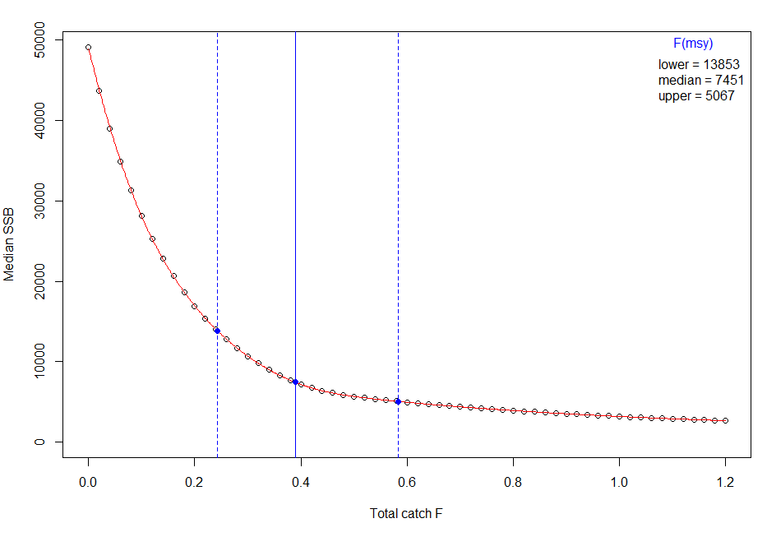 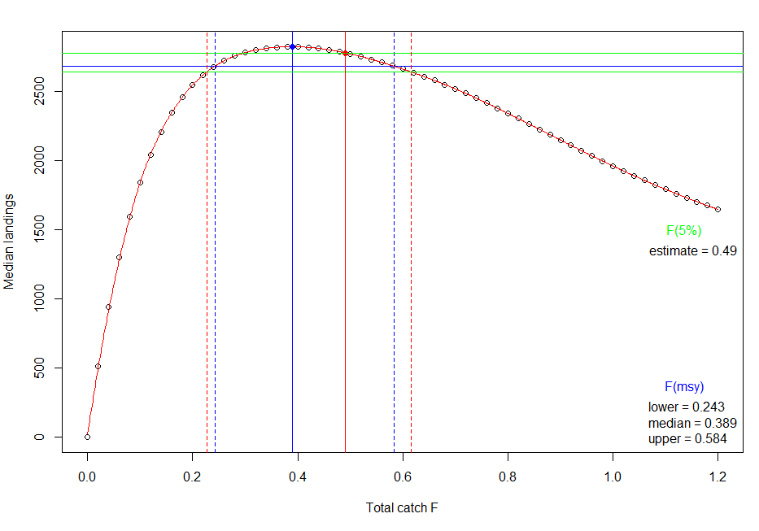 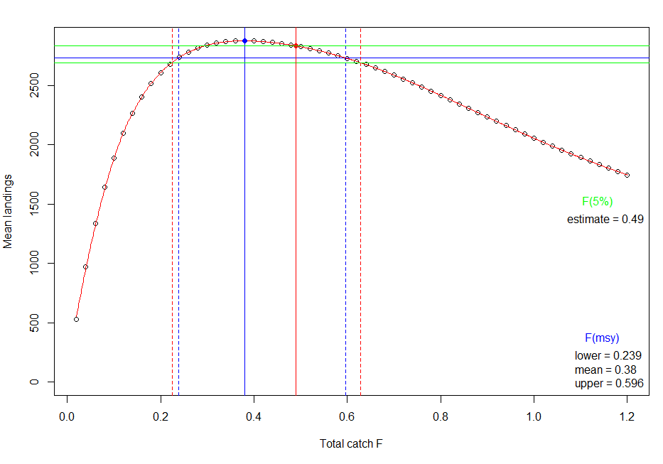

> print(Fmsys <- SIM3s$Refs2[2,4])

[1] 0.3891892

> print(F05s <- SIM3s$Refs2[1,1])

[1] 0.4902807