Spict run turbot ibp 2017

Input:

Catch observations from 1981 – 2016

Index 1: BTS-ISIS

Index 2 NL-LPUE

Index 3: SNS

BTS-ISIS and SNS age aggregated and made biomass using stock weights:

obsI <- list()

obsI$index1 <- c(apply(index(TUR.tun[[2]])[2:7,] * stock.wt(TUR)[ac(2:7),ac(1991:2016)],

FUN = sum, 2)) ##BTS-ISIS

obsI$index2 <- c(TUR.tun[[3]]@index)#NL_LPUE

obsI$index3 <- c(apply(index(TUR.tun[[1]])[2:6,] * stock.wt(TUR)[ac(2:6),ac(2004:2016)],

FUN = sum, 2))##SNS

Priors:

inp$priors$logn <- c(log(2), 1, 0)

inp$priors$logalpha <- c(log(2), 3, 0)

inp$priors$logbeta <- c(log(2), 1, 0)

|  |
| --- |
| > summary(fit)  Convergence: 0 MSG: both X-convergence and relative convergence (5)  Objective function at optimum: 7.9313578  Euler time step (years): 1/16 or 0.0625  Nobs C: 36, Nobs I1: 26, Nobs I2: 22, Nobs I3: 13  Residual diagnostics (p-values)  shapiro bias acf LBox shapiro bias acf LBox  C 0.2538 0.7754 0.0480 0.0972 - - * .  I1 0.7237 0.6519 0.0021 0.0002 - - ** ***  I2 0.4744 0.9918 0.0875 0.3141 - - . -  I3 0.3685 0.9891 0.0220 0.0176 - - * *  Model parameter estimates w 95% CI  estimate cilow ciupp log.est  alpha1 4.960137e+00 3.1489514 7.813065e+00 1.6014334  alpha2 1.196369e-01 0.0000816 1.754187e+02 -2.1232941  alpha3 7.687052e+00 4.5233648 1.306345e+01 2.0395373  beta 3.577090e-02 0.0000302 4.242571e+01 -3.3306200  r 2.402434e-01 0.0087836 6.570982e+00 -1.4261029  rc 5.570380e-01 0.2489503 1.246399e+00 -0.5851218  rold 1.748170e+00 0.0000000 2.419633e+09 0.5585694  m 4.287111e+03 3586.5805255 5.124470e+03 8.3633684  K 4.513327e+04 6317.1339573 3.224582e+05 10.7173749  q1 1.146000e-04 0.0000589 2.230000e-04 -9.0739089  q2 4.300000e-06 0.0000022 8.300000e-06 -12.3509722  q3 3.710700e-03 0.0017199 8.005900e-03 -5.5965431  n 8.625744e-01 0.0505801 1.471002e+01 -0.1478339  sdb 9.581800e-02 0.0665961 1.378623e-01 -2.3453046  sdf 1.215013e-01 0.0857153 1.722278e-01 -2.1078306  sdi1 4.752705e-01 0.3607752 6.261020e-01 -0.7438712  sdi2 1.146340e-02 0.0000093 1.411794e+01 -4.4685987  sdi3 7.365580e-01 0.5010226 1.082821e+00 -0.3057672  sdc 4.346200e-03 0.0000038 5.014694e+00 -5.4384507    Deterministic reference points (Drp)  estimate cilow ciupp log.est  Bmsyd 15392.526454 6566.9207764 3.607929e+04 9.641637  Fmsyd 0.278519 0.1244752 6.231994e-01 -1.278269  MSYd 4287.111230 3586.5805255 5.124470e+03 8.363368  Stochastic reference points (Srp)  estimate cilow ciupp log.est rel.diff.Drp  Bmsys 1.524843e+04 6530.2398757 3.560583e+04 9.632232 -0.009449893  Fmsys 2.788262e-01 0.1258981 6.175155e-01 -1.277167 0.001101726  MSYs 4.251706e+03 3600.0872308 5.021268e+03 8.355076 -0.008327321  States w 95% CI (inp$msytype: s)  estimate cilow ciupp log.est  B_2016.75 2.337392e+04 1.207222e+04 4.525598e+04 10.0593764  F_2016.75 1.545035e-01 7.960620e-02 2.998679e-01 -1.8675382  B_2016.75/Bmsy 1.532874e+00 7.565896e-01 3.105651e+00 0.4271445  F_2016.75/Fmsy 5.541214e-01 2.687584e-01 1.142478e+00 -0.5903715  Predictions w 95% CI (inp$msytype: s)  prediction cilow ciupp log.est  B_2017.00 2.346066e+04 1.208349e+04 4.554998e+04 10.0630802  F_2017.00 1.550850e-01 7.921400e-02 3.036253e-01 -1.8637817  B_2017.00/Bmsy 1.538562e+00 7.732731e-01 3.061239e+00 0.4308484  F_2017.00/Fmsy 5.562068e-01 2.679242e-01 1.154678e+00 -0.5866150  Catch_2017.00 3.645997e+03 2.888802e+03 4.601665e+03 8.2013853  E(B_inf) 2.396382e+04 NA NA 10.0843006 |
|  |
| |  | | --- | | > | |

Summary plot spict run



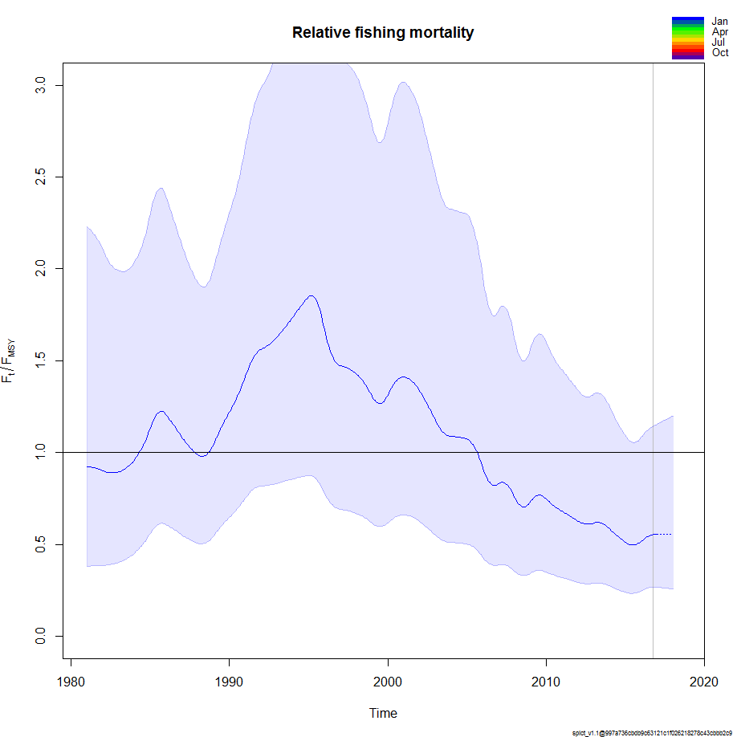

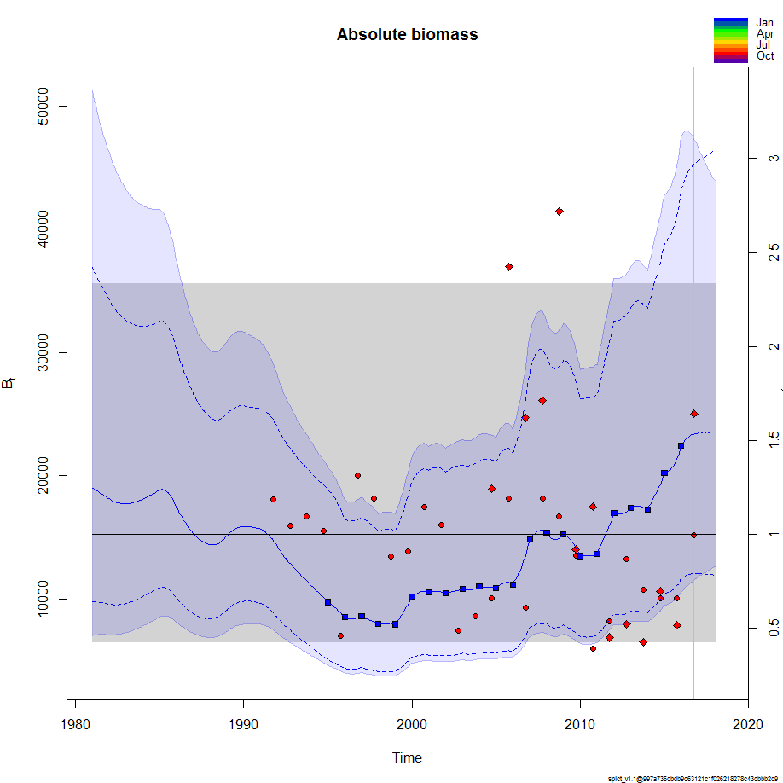

retrospective



Parameter estimates retrospective



With error bars



Without priors:

Input:

> inp_no$priors$logn <- c(1, 1, 0)

> inp_no$priors$logalpha <- c(1, 1, 0)

> inp_no$priors$logbeta <- c(1, 1, 0)

> summary(fit_no)

Convergence: 0 MSG: both X-convergence and relative convergence (5)

Objective function at optimum: 7.9313578

Euler time step (years): 1/16 or 0.0625

Nobs C: 36, Nobs I1: 26, Nobs I2: 22, Nobs I3: 13

Residual diagnostics (p-values)

shapiro bias acf LBox shapiro bias acf LBox

C 0.2538 0.7754 0.0480 0.0972 - - * .

I1 0.7237 0.6519 0.0021 0.0002 - - ** ***

I2 0.4744 0.9918 0.0875 0.3141 - - . -

I3 0.3685 0.9891 0.0220 0.0176 - - * *

Model parameter estimates w 95% CI

estimate cilow ciupp log.est

alpha1 4.960137e+00 3.1489514 7.813065e+00 1.6014334

alpha2 1.196369e-01 0.0000816 1.754187e+02 -2.1232941

alpha3 7.687052e+00 4.5233648 1.306345e+01 2.0395373

beta 3.577090e-02 0.0000302 4.242571e+01 -3.3306200

r 2.402434e-01 0.0087836 6.570982e+00 -1.4261029

rc 5.570380e-01 0.2489503 1.246399e+00 -0.5851218

rold 1.748170e+00 0.0000000 2.419633e+09 0.5585694

m 4.287111e+03 3586.5805255 5.124470e+03 8.3633684

K 4.513327e+04 6317.1339573 3.224582e+05 10.7173749

q1 1.146000e-04 0.0000589 2.230000e-04 -9.0739089

q2 4.300000e-06 0.0000022 8.300000e-06 -12.3509722

q3 3.710700e-03 0.0017199 8.005900e-03 -5.5965431

n 8.625744e-01 0.0505801 1.471002e+01 -0.1478339

sdb 9.581800e-02 0.0665961 1.378623e-01 -2.3453046

sdf 1.215013e-01 0.0857153 1.722278e-01 -2.1078306

sdi1 4.752705e-01 0.3607752 6.261020e-01 -0.7438712

sdi2 1.146340e-02 0.0000093 1.411794e+01 -4.4685987

sdi3 7.365580e-01 0.5010226 1.082821e+00 -0.3057672

sdc 4.346200e-03 0.0000038 5.014694e+00 -5.4384507

Deterministic reference points (Drp)

estimate cilow ciupp log.est

Bmsyd 15392.526454 6566.9207764 3.607929e+04 9.641637

Fmsyd 0.278519 0.1244752 6.231994e-01 -1.278269

MSYd 4287.111230 3586.5805255 5.124470e+03 8.363368

Stochastic reference points (Srp)

estimate cilow ciupp log.est rel.diff.Drp

Bmsys 1.524843e+04 6530.2398757 3.560583e+04 9.632232 -0.009449893

Fmsys 2.788262e-01 0.1258981 6.175155e-01 -1.277167 0.001101726

MSYs 4.251706e+03 3600.0872308 5.021268e+03 8.355076 -0.008327321

States w 95% CI (inp$msytype: s)

estimate cilow ciupp log.est

B_2016.75 2.337392e+04 1.207222e+04 4.525598e+04 10.0593764

F_2016.75 1.545035e-01 7.960620e-02 2.998679e-01 -1.8675382

B_2016.75/Bmsy 1.532874e+00 7.565896e-01 3.105651e+00 0.4271445

F_2016.75/Fmsy 5.541214e-01 2.687584e-01 1.142478e+00 -0.5903715

Predictions w 95% CI (inp$msytype: s)

prediction cilow ciupp log.est

B_2017.00 2.346066e+04 1.208349e+04 4.554998e+04 10.0630802

F_2017.00 1.550850e-01 7.921400e-02 3.036253e-01 -1.8637817

B_2017.00/Bmsy 1.538562e+00 7.732731e-01 3.061239e+00 0.4308484

F_2017.00/Fmsy 5.562068e-01 2.679242e-01 1.154678e+00 -0.5866150

Catch_2017.00 3.645997e+03 2.888802e+03 4.601665e+03 8.2013853

E(B_inf) 2.396382e+04 NA NA 10.0843006

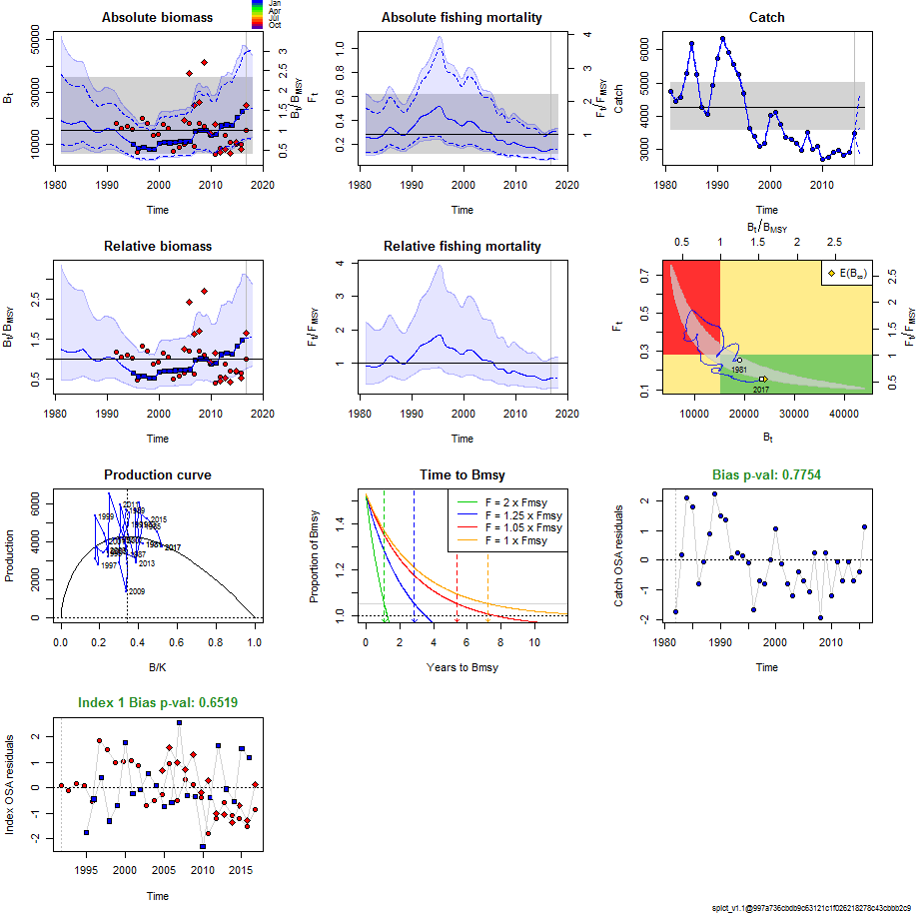





No sns run (with standard (uninformative) priors)

> summary(fit_nosns)

Convergence: 0 MSG: both X-convergence and relative convergence (5)

Objective function at optimum: -14.9310407

Euler time step (years): 1/16 or 0.0625

Nobs C: 36, Nobs I1: 26, Nobs I2: 22

Residual diagnostics (p-values)

shapiro bias acf LBox shapiro bias acf LBox

C 0.0525 0.3266 0.1035 0.1565 . - - -

I1 0.8076 0.7118 0.0023 0.0002 - - ** ***

I2 0.5131 0.9561 0.0857 0.3232 - - . -

Priors

logn ~ dnorm[log(2), 2^2]

logalpha ~ dnorm[log(1), 2^2]

logbeta ~ dnorm[log(1), 2^2]

Model parameter estimates w 95% CI

estimate cilow ciupp log.est

alpha1 5.113813e+00 3.198344e+00 8.176444e+00 1.6319452

alpha2 2.772210e-01 4.227330e-02 1.817966e+00 -1.2829403

beta 1.394869e-01 2.388700e-02 8.145251e-01 -1.9697847

r 3.049723e-01 3.416360e-02 2.722431e+00 -1.1875345

rc 5.529451e-01 2.871321e-01 1.064835e+00 -0.5924965

rold 2.958505e+00 0.000000e+00 2.827748e+08 1.0846841

m 4.329053e+03 3.669837e+03 5.106686e+03 8.3731042

K 4.055828e+04 1.163976e+04 1.413238e+05 10.6104952

q1 1.100000e-04 5.770000e-05 2.096000e-04 -9.1154514

q2 4.100000e-06 2.200000e-06 7.800000e-06 -12.3937528

n 1.103083e+00 1.629970e-01 7.465121e+00 0.0981092

sdb 9.226540e-02 6.278890e-02 1.355798e-01 -2.3830859

sdf 1.178486e-01 8.220070e-02 1.689558e-01 -2.1383549

sdi1 4.718281e-01 3.589991e-01 6.201178e-01 -0.7511406

sdi2 2.557790e-02 4.718100e-03 1.386643e-01 -3.6660262

sdc 1.643830e-02 3.057200e-03 8.838810e-02 -4.1081396

Deterministic reference points (Drp)

estimate cilow ciupp log.est

Bmsyd 1.565817e+04 7688.9314728 3.188715e+04 9.658748

Fmsyd 2.764726e-01 0.1435661 5.324175e-01 -1.285644

MSYd 4.329053e+03 3669.8366799 5.106686e+03 8.373104

Stochastic reference points (Srp)

estimate cilow ciupp log.est rel.diff.Drp

Bmsys 1.551598e+04 7641.9679002 3.150311e+04 9.649626 -0.0091635093

Fmsys 2.762588e-01 0.1440138 5.299417e-01 -1.286417 -0.0007738097

MSYs 4.286397e+03 3671.8922841 5.003742e+03 8.363202 -0.0099514518

States w 95% CI (inp$msytype: s)

estimate cilow ciupp log.est

B_2016.75 2.409242e+04 1.273210e+04 4.558904e+04 10.0896524

F_2016.75 1.490618e-01 7.845490e-02 2.832128e-01 -1.9033943

B_2016.75/Bmsy 1.552748e+00 9.471086e-01 2.545671e+00 0.4400263

F_2016.75/Fmsy 5.395730e-01 3.234324e-01 9.001540e-01 -0.6169773

Predictions w 95% CI (inp$msytype: s)

prediction cilow ciupp log.est

B_2017.00 2.414934e+04 1.272346e+04 4.583587e+04 10.0920125

F_2017.00 1.496019e-01 7.806530e-02 2.866926e-01 -1.8997774

B_2017.00/Bmsy 1.556417e+00 9.617068e-01 2.518891e+00 0.4423864

F_2017.00/Fmsy 5.415281e-01 3.214357e-01 9.123214e-01 -0.6133603

Catch_2017.00 3.612966e+03 2.880642e+03 4.531464e+03 8.1922844

E(B_inf) 2.410930e+04 NA NA 10.0903531

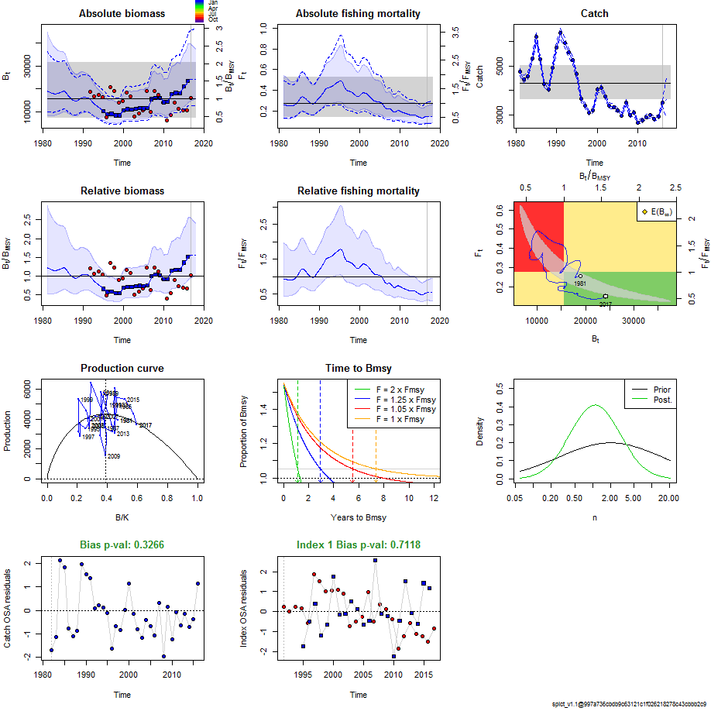

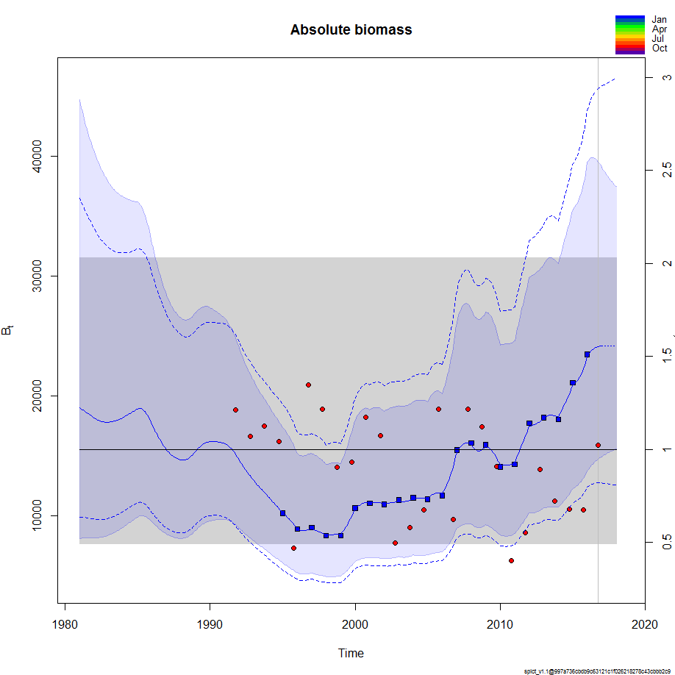

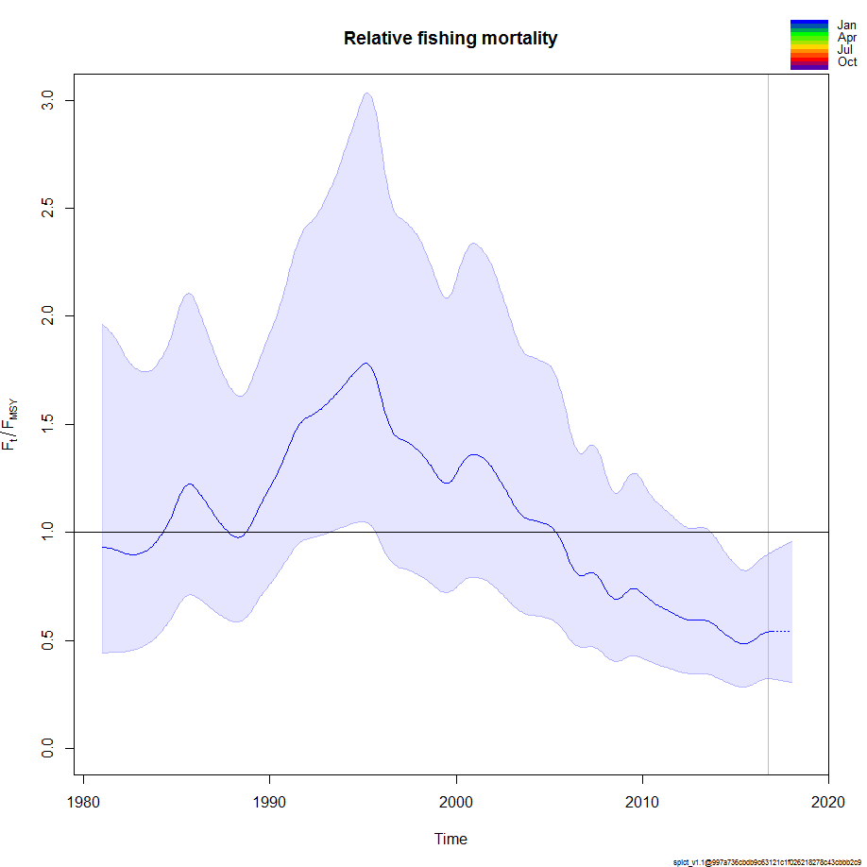

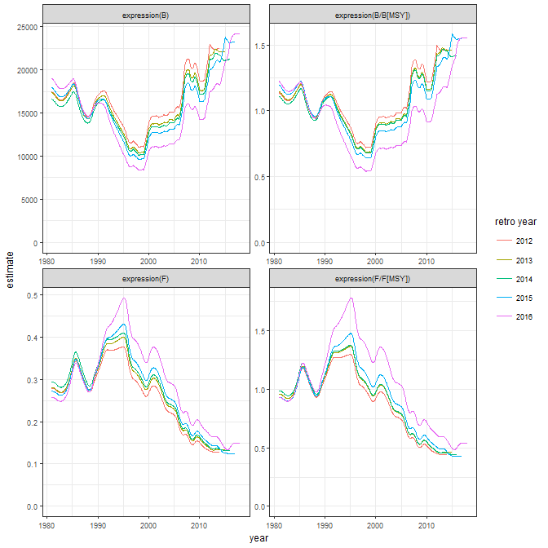

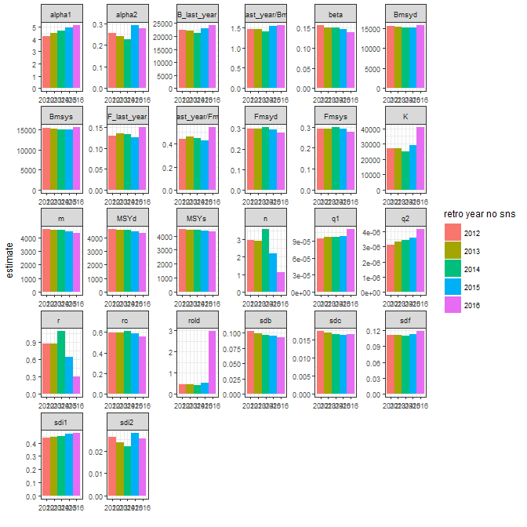

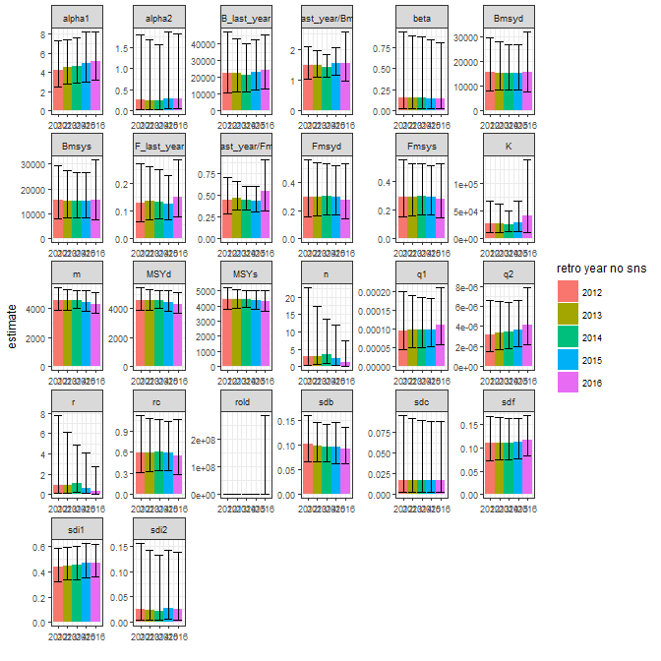

No sns, no priors

> summary(fit_nosns_no)

Convergence: 0 MSG: both X-convergence and relative convergence (5)

Objective function at optimum: -9.8144859

Euler time step (years): 1/16 or 0.0625

Nobs C: 36, Nobs I1: 26, Nobs I2: 22

Residual diagnostics (p-values)

shapiro bias acf LBox shapiro bias acf LBox

C 0.2406 0.7785 0.0461 0.0957 - - * .

I1 0.7228 0.6529 0.0021 0.0002 - - ** ***

I2 0.4943 0.9911 0.0833 0.3067 - - . -

Model parameter estimates w 95% CI

estimate cilow ciupp log.est

alpha1 4.973847e+00 3.1891434 7.757304e+00 1.6041936

alpha2 1.092792e-01 0.0000583 2.049736e+02 -2.2138490

beta 3.550920e-02 0.0000301 4.187244e+01 -3.3379642

r 2.413627e-01 0.0089574 6.503700e+00 -1.4214547

rc 5.579222e-01 0.2508789 1.240747e+00 -0.5835358

rold 1.790787e+00 0.0000000 3.399646e+09 0.5826552

m 4.286684e+03 3587.1872111 5.122583e+03 8.3632688

K 4.498497e+04 6369.8856710 3.176897e+05 10.7140836

q1 1.149000e-04 0.0000593 2.229000e-04 -9.0710343

q2 4.300000e-06 0.0000023 8.300000e-06 -12.3480290

n 8.652198e-01 0.0513292 1.458439e+01 -0.1447717

sdb 9.570320e-02 0.0673741 1.359440e-01 -2.3465035

sdf 1.217264e-01 0.0859755 1.723435e-01 -2.1059796

sdi1 4.760131e-01 0.3613764 6.270152e-01 -0.7423099

sdi2 1.045840e-02 0.0000065 1.685799e+01 -4.5603524

sdc 4.322400e-03 0.0000038 4.960812e+00 -5.4439438

Deterministic reference points (Drp)

estimate cilow ciupp log.est

Bmsyd 1.536660e+04 6595.3934357 3.580264e+04 9.639952

Fmsyd 2.789611e-01 0.1254394 6.203735e-01 -1.276683

MSYd 4.286684e+03 3587.1872111 5.122583e+03 8.363269

Stochastic reference points (Srp)

estimate cilow ciupp log.est rel.diff.Drp

Bmsys 1.522323e+04 6559.0375743 3.533242e+04 9.630578 -0.009418177

Fmsys 2.792616e-01 0.1268646 6.147268e-01 -1.275606 0.001076089

MSYs 4.251306e+03 3600.6090945 5.019596e+03 8.354981 -0.008321742

States w 95% CI (inp$msytype: s)

estimate cilow ciupp log.est

B_2016.75 2.330962e+04 1.207174e+04 4.500914e+04 10.0566216

F_2016.75 1.549680e-01 8.006830e-02 2.999325e-01 -1.8645365

B_2016.75/Bmsy 1.531188e+00 7.599122e-01 3.085273e+00 0.4260439

F_2016.75/Fmsy 5.549206e-01 2.706025e-01 1.137968e+00 -0.5889302

Predictions w 95% CI (inp$msytype: s)

prediction cilow ciupp log.est

B_2017.00 2.339684e+04 1.208349e+04 4.530246e+04 10.0603560

F_2017.00 1.555615e-01 7.967430e-02 3.037292e-01 -1.8607138

B_2017.00/Bmsy 1.536917e+00 7.766127e-01 3.041559e+00 0.4297783

F_2017.00/Fmsy 5.570460e-01 2.697633e-01 1.150268e+00 -0.5851075

Catch_2017.00 3.647259e+03 2.889746e+03 4.603345e+03 8.2017312

E(B_inf) 2.389619e+04 NA NA 10.0814743

