Spict only effort – no LPUE – with priors

Input:

> obsI <- list()

> obsI$index1 <- c(apply(index(TUR.tun[[2]])[2:7,] * stock.wt(TUR)[ac(2:7),ac(1991:2016)],

+ FUN = sum, 2)) ##BTS-ISIS

> d <- read.csv("D:/wg_IBPTur.27.4/refpoints/effort_lpue.csv") # from LPUE aggdata9516.rdata dataset

> obsE <- c(d$effort)#NL_LPUE

> obsI$index2 <- c(apply(index(TUR.tun[[1]])[2:6,] * stock.wt(TUR)[ac(2:6),ac(2004:2016)],

+ FUN = sum, 2))##SNS

> summary(fit)

Convergence: 0 MSG: relative convergence (4)

Objective function at optimum: -1.401445

Euler time step (years): 1/16 or 0.0625

Nobs C: 36, Nobs I1: 26, Nobs I2: 13, Nobs E: 22

Residual diagnostics (p-values)

shapiro bias acf LBox shapiro bias acf LBox

C 0.3842 0.3878 0.1785 0.4378 - - - -

E 0.7508 0.3249 0.0769 0.1571 - - . -

I1 0.3939 0.5266 0.0253 0.0377 - - * *

I2 0.3100 0.9487 0.0173 0.0140 - - * *

Model parameter estimates w 95% CI

estimate cilow ciupp log.est

alpha1 3.630135e+00 2.4096056 5.468893e+00 1.2892697

alpha2 6.318287e+00 3.8676905 1.032160e+01 1.8434482

beta 3.176910e-02 0.0000293 3.445099e+01 -3.4492602

r 1.734251e-01 0.0005928 5.073501e+01 -1.7520095

rc 4.570342e-01 0.0875687 2.385330e+00 -0.7829970

rold 7.193531e-01 0.0000000 1.568594e+08 -0.3294030

m 4.379009e+03 3337.2543432 5.745956e+03 8.3845776

K 6.017355e+04 1285.7759083 2.816087e+06 11.0049882

q1 1.064000e-04 0.0000420 2.695000e-04 -9.1479779

q2 3.655600e-03 0.0013195 1.012810e-02 -5.6114845

qf 5.380000e-05 0.0000212 1.367000e-04 -9.8308756

n 7.589152e-01 0.0101108 5.696420e+01 -0.2758653

sdb 1.193246e-01 0.0881696 1.614883e-01 -2.1259076

sdf 1.069250e-01 0.0786884 1.452940e-01 -2.2356275

sdi1 4.331644e-01 0.3289220 5.704434e-01 -0.8366379

sdi2 7.539272e-01 0.5130217 1.107957e+00 -0.2824595

sde 5.729200e-03 0.0000122 2.699258e+00 -5.1621857

sdc 3.396900e-03 0.0000031 3.664584e+00 -5.6848878

Deterministic reference points (Drp)

estimate cilow ciupp log.est

Bmsyd 1.916272e+04 3161.6469581 1.161451e+05 9.860722

Fmsyd 2.285171e-01 0.0437844 1.192665e+00 -1.476144

MSYd 4.379009e+03 3337.2543432 5.745956e+03 8.384578

Stochastic reference points (Srp)

estimate cilow ciupp log.est rel.diff.Drp

Bmsys 18836.195744 3164.4464912 1.121214e+05 9.843536 -0.017334748

Fmsys 0.229361 0.0459033 1.146028e+00 -1.472458 0.003679314

MSYs 4320.564088 3300.1016096 5.656576e+03 8.371141 -0.013527047

States w 95% CI (inp$msytype: s)

estimate cilow ciupp log.est

B_2016.75 2.551911e+04 1.003185e+04 6.491573e+04 10.1471827

F_2016.75 1.421845e-01 5.576710e-02 3.625155e-01 -1.9506298

B_2016.75/Bmsy 1.354791e+00 2.481957e-01 7.395205e+00 0.3036471

F_2016.75/Fmsy 6.199158e-01 1.313945e-01 2.924745e+00 -0.4781717

Predictions w 95% CI (inp$msytype: s)

prediction cilow ciupp log.est

B_2017.00 2.580512e+04 1.013762e+04 6.568641e+04 10.1583281

F_2017.00 1.422046e-01 5.551290e-02 3.642783e-01 -1.9504882

B_2017.00/Bmsy 1.369975e+00 2.574410e-01 7.290337e+00 0.3147925

F_2017.00/Fmsy 6.200035e-01 1.310589e-01 2.933066e+00 -0.4780301

Catch_2017.00 3.691650e+03 2.879376e+03 4.733067e+03 8.2138288

E(B_inf) 2.780557e+04 NA NA 10.2329915

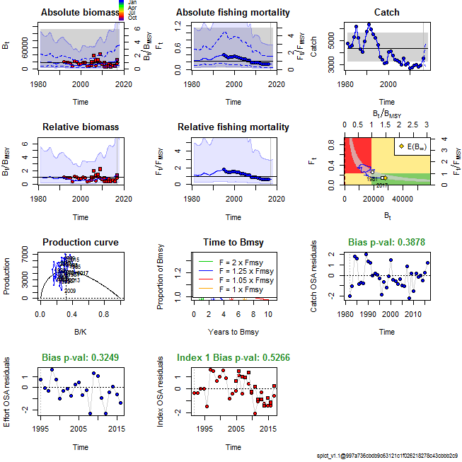

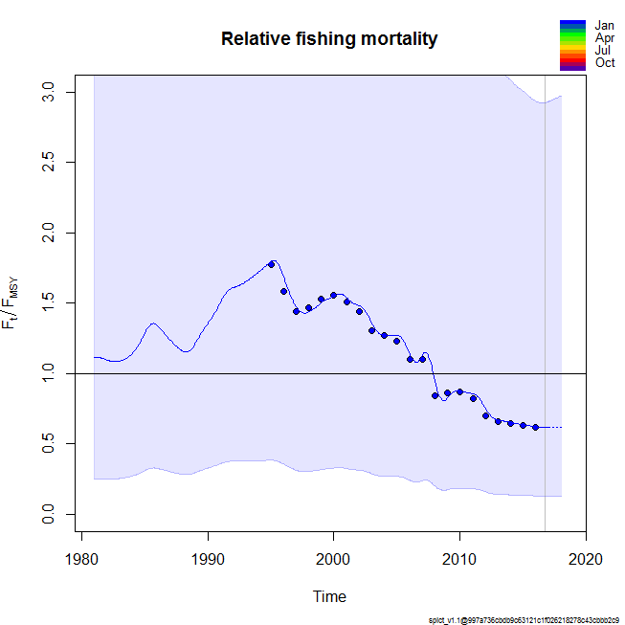

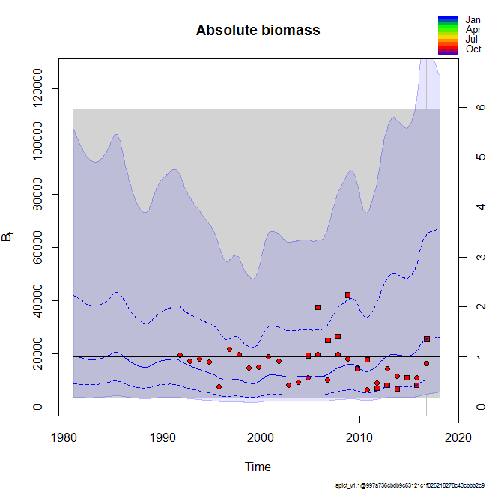

Retro

> ### check convergence

> lapply(model_list, function(x){ x$opt$convergence})

$`2015`

[1] 0

$`2014`

[1] 0

$`2013`

[1] 0

$`2012`

[1] 0

$`2016`

[1] 0

> lapply(model_list, function(x){ x$opt$message})

$`2015`

[1] "relative convergence (4)"

$`2014`

[1] "relative convergence (4)"

$`2013`

[1] "relative convergence (4)"

$`2012`

[1] "relative convergence (4)"

$`2016`

[1] "relative convergence (4)"

