Without LPUE – with priors

> inp$priors$logn <- c(log(2), 1, 0)

> inp$priors$logalpha <- c(log(2), 3, 0)

> inp$priors$logbeta <- c(log(2), 1, 0)

> summary(fit)

Convergence: 0 MSG: relative convergence (4)

Objective function at optimum: 14.9389154

Euler time step (years): 1/16 or 0.0625

Nobs C: 36, Nobs I1: 26, Nobs I2: 13

Residual diagnostics (p-values)

shapiro bias acf LBox shapiro bias acf LBox

C 0.6774 0.8398 0.1176 0.2446 - - - -

I1 0.1083 0.9256 0.3798 0.6654 - - - -

I2 0.1955 0.8563 0.0698 0.0805 - - . .

Model parameter estimates w 95% CI

estimate cilow ciupp log.est

alpha1 2.344753e+00 1.2982042 4.234979e+00 0.8521801

alpha2 4.330820e+00 2.2832640 8.214557e+00 1.4657569

beta 7.468060e-02 0.0000304 1.833764e+02 -2.5945350

r 2.751336e-01 0.0448993 1.685960e+00 -1.2904986

rc 2.294816e+00 0.0000428 1.229351e+05 0.8306526

rold 3.619165e-01 0.0064285 2.037529e+01 -1.0163419

m 6.132848e+04 8.5509746 4.398542e+08 11.0239996

K 3.497313e+05 129.3240150 9.457795e+08 12.7649205

q1 4.500000e-06 0.0000000 1.766920e-02 -12.3100973

q2 1.957000e-04 0.0000000 7.742962e-01 -8.5388703

n 2.397871e-01 0.0000044 1.302761e+04 -1.4280040

sdb 1.311568e-01 0.0780127 2.205040e-01 -2.0313615

sdf 7.571080e-02 0.0261889 2.188764e-01 -2.5808346

sdi1 3.075304e-01 0.2290368 4.129246e-01 -1.1791814

sdi2 5.680166e-01 0.3786778 8.520247e-01 -0.5656047

sdc 5.654100e-03 0.0000025 1.299407e+01 -5.1753696

Deterministic reference points (Drp)

estimate cilow ciupp log.est

Bmsyd 53449.586870 0.6032400 4.735857e+09 10.8864942

Fmsyd 1.147408 0.0000214 6.146757e+04 0.1375054

MSYd 61328.477586 8.5509746 4.398542e+08 11.0239996

Stochastic reference points (Srp)

estimate cilow ciupp log.est

Bmsys 53460.435361 0.7210541 3.963667e+09 10.8866971

Fmsys 1.144756 0.0000274 4.789444e+04 0.1351915

MSYs 61199.182924 8.5025527 4.404959e+08 11.0218891

rel.diff.Drp

Bmsys 0.0002029256

Fmsys -0.0023165531

MSYs -0.0021126861

States w 95% CI (inp$msytype: s)

estimate cilow ciupp

B_2016.75 3.312051e+05 84.8757529 1.292440e+09

F_2016.75 1.102350e-02 0.0000028 4.303478e+01

B_2016.75/Bmsy 6.195331e+00 0.0029072 1.320245e+04

F_2016.75/Fmsy 9.629500e-03 0.0000000 7.233820e+03

log.est

B_2016.75 12.710493

F_2016.75 -4.507728

B_2016.75/Bmsy 1.823796

F_2016.75/Fmsy -4.642920

Predictions w 95% CI (inp$msytype: s)

prediction cilow ciupp

B_2017.00 3.321089e+05 85.1984760 1.294581e+09

F_2017.00 1.103810e-02 0.0000028 4.310455e+01

B_2017.00/Bmsy 6.212236e+00 0.0029220 1.320745e+04

F_2017.00/Fmsy 9.642400e-03 0.0000000 7.246140e+03

Catch_2017.00 3.657779e+03 2938.3376479 4.553373e+03

E(B_inf) 3.336984e+05 NA NA

log.est

B_2017.00 12.713218

F_2017.00 -4.506399

B_2017.00/Bmsy 1.826521

F_2017.00/Fmsy -4.641590

Catch_2017.00 8.204611

E(B_inf) 12.717993

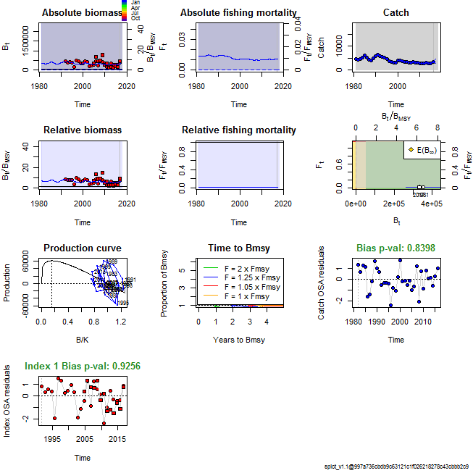

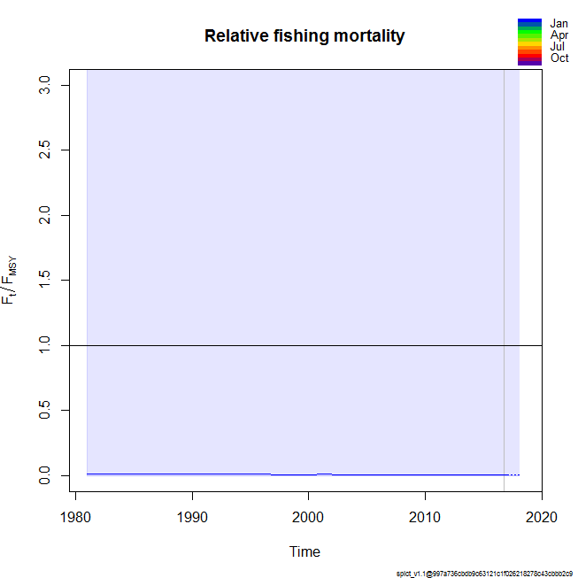

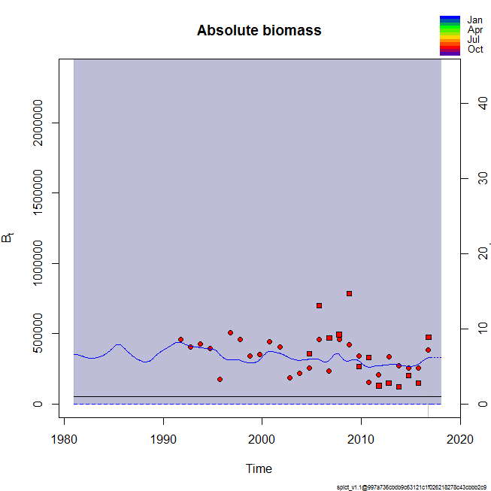

> ### check convergence

> lapply(model_list, function(x){ x$opt$convergence})

$`2015`

[1] 0

$`2014`

[1] 0

$`2013`

[1] 0

$`2012`

[1] 0

$`2016`

[1] 0

> lapply(model_list, function(x){ x$opt$message})

$`2015`

[1] "relative convergence (4)"

$`2014`

[1] "relative convergence (4)"

$`2013`

[1] "relative convergence (4)"

$`2012`

[1] "relative convergence (4)"

$`2016`

[1] "relative convergence (4)"

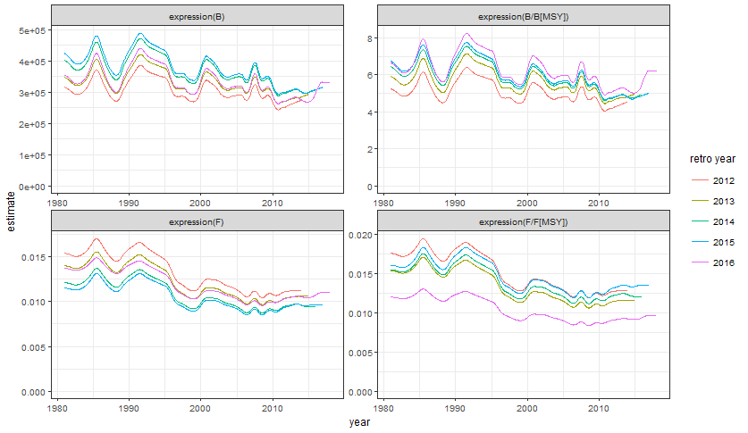

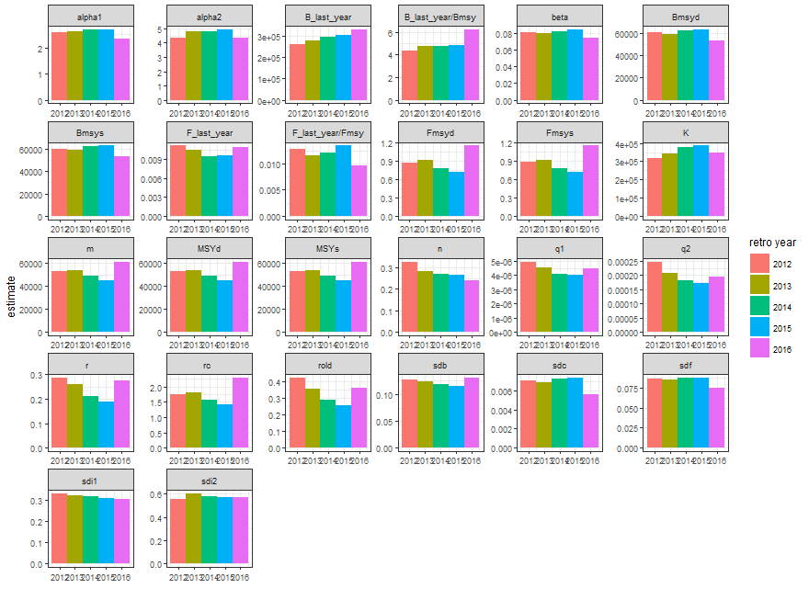

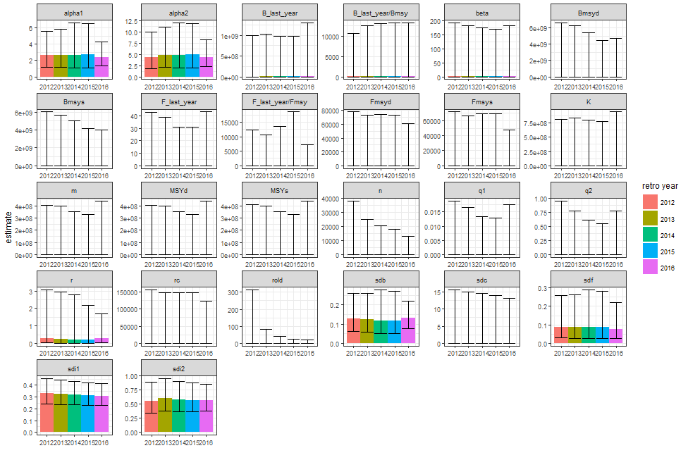

Without LPUE – without priors

> inp_no <- inp

> inp_no$priors$logn <- c(1, 1, 0)

> inp_no$priors$logalpha <- c(1, 1, 0)

> inp_no$priors$logbeta <- c(1, 1, 0)

> summary(fit_no)

Convergence: 0 MSG: relative convergence (4)

Objective function at optimum: 14.9389154

Euler time step (years): 1/16 or 0.0625

Nobs C: 36, Nobs I1: 26, Nobs I2: 13

Residual diagnostics (p-values)

shapiro bias acf LBox shapiro bias acf LBox

C 0.6774 0.8398 0.1176 0.2446 - - - -

I1 0.1083 0.9256 0.3798 0.6654 - - - -

I2 0.1955 0.8563 0.0698 0.0805 - - . .

Model parameter estimates w 95% CI

estimate cilow ciupp log.est

alpha1 2.344753e+00 1.2982042 4.234979e+00 0.8521801

alpha2 4.330820e+00 2.2832640 8.214557e+00 1.4657569

beta 7.468060e-02 0.0000304 1.833764e+02 -2.5945350

r 2.751336e-01 0.0448993 1.685960e+00 -1.2904986

rc 2.294816e+00 0.0000428 1.229351e+05 0.8306526

rold 3.619165e-01 0.0064285 2.037529e+01 -1.0163419

m 6.132848e+04 8.5509746 4.398542e+08 11.0239996

K 3.497313e+05 129.3240150 9.457795e+08 12.7649205

q1 4.500000e-06 0.0000000 1.766920e-02 -12.3100973

q2 1.957000e-04 0.0000000 7.742962e-01 -8.5388703

n 2.397871e-01 0.0000044 1.302761e+04 -1.4280040

sdb 1.311568e-01 0.0780127 2.205040e-01 -2.0313615

sdf 7.571080e-02 0.0261889 2.188764e-01 -2.5808346

sdi1 3.075304e-01 0.2290368 4.129246e-01 -1.1791814

sdi2 5.680166e-01 0.3786778 8.520247e-01 -0.5656047

sdc 5.654100e-03 0.0000025 1.299407e+01 -5.1753696

Deterministic reference points (Drp)

estimate cilow ciupp log.est

Bmsyd 53449.586870 0.6032400 4.735857e+09 10.8864942

Fmsyd 1.147408 0.0000214 6.146757e+04 0.1375054

MSYd 61328.477586 8.5509746 4.398542e+08 11.0239996

Stochastic reference points (Srp)

estimate cilow ciupp log.est

Bmsys 53460.435361 0.7210541 3.963667e+09 10.8866971

Fmsys 1.144756 0.0000274 4.789444e+04 0.1351915

MSYs 61199.182924 8.5025527 4.404959e+08 11.0218891

rel.diff.Drp

Bmsys 0.0002029256

Fmsys -0.0023165531

MSYs -0.0021126861

States w 95% CI (inp$msytype: s)

estimate cilow ciupp

B_2016.75 3.312051e+05 84.8757529 1.292440e+09

F_2016.75 1.102350e-02 0.0000028 4.303478e+01

B_2016.75/Bmsy 6.195331e+00 0.0029072 1.320245e+04

F_2016.75/Fmsy 9.629500e-03 0.0000000 7.233820e+03

log.est

B_2016.75 12.710493

F_2016.75 -4.507728

B_2016.75/Bmsy 1.823796

F_2016.75/Fmsy -4.642920

Predictions w 95% CI (inp$msytype: s)

prediction cilow ciupp

B_2017.00 3.321089e+05 85.1984760 1.294581e+09

F_2017.00 1.103810e-02 0.0000028 4.310455e+01

B_2017.00/Bmsy 6.212236e+00 0.0029220 1.320745e+04

F_2017.00/Fmsy 9.642400e-03 0.0000000 7.246140e+03

Catch_2017.00 3.657779e+03 2938.3376479 4.553373e+03

E(B_inf) 3.336984e+05 NA NA

log.est

B_2017.00 12.713218

F_2017.00 -4.506399

B_2017.00/Bmsy 1.826521

F_2017.00/Fmsy -4.641590

Catch_2017.00 8.204611

E(B_inf) 12.717993







> lapply(model_list, function(x){ x$opt$convergence})

$`2015`

[1] 0

$`2014`

[1] 0

$`2013`

[1] 0

$`2012`

[1] 0

$`2016`

[1] 0

> lapply(model_list, function(x){ x$opt$message})

$`2015`

[1] "relative convergence (4)"

$`2014`

[1] "relative convergence (4)"

$`2013`

[1] "relative convergence (4)"

$`2012`

[1] "relative convergence (4)"

$`2016`

[1] "relative convergence (4)"

