Monitoring method

# Text

TO BE DONE (in 2024...)

# Figures

## Figure 1

Proportion of monitored/observed days-at sea-reported per monitoring method from 2017 to 2022 (2023 data call).

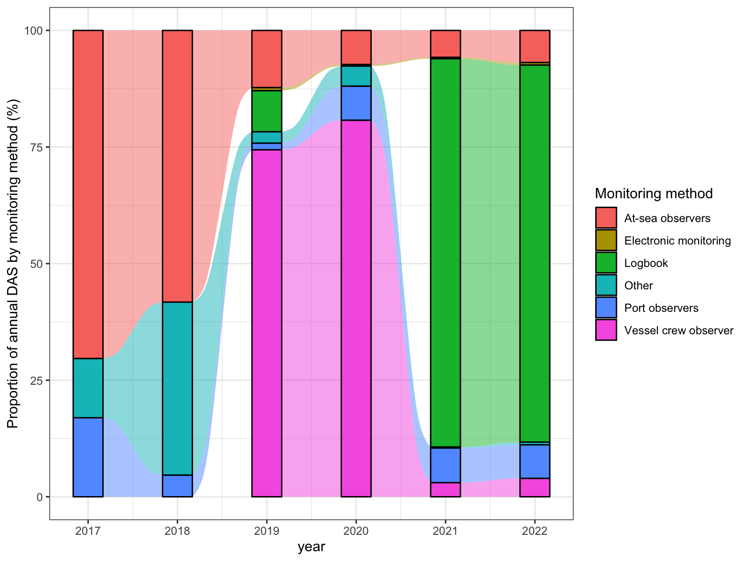

## Figure 2

Proportion of monitored/observed days-at sea-reported per monitoring method from 2017 to 2022 by countries (2023 data call).

