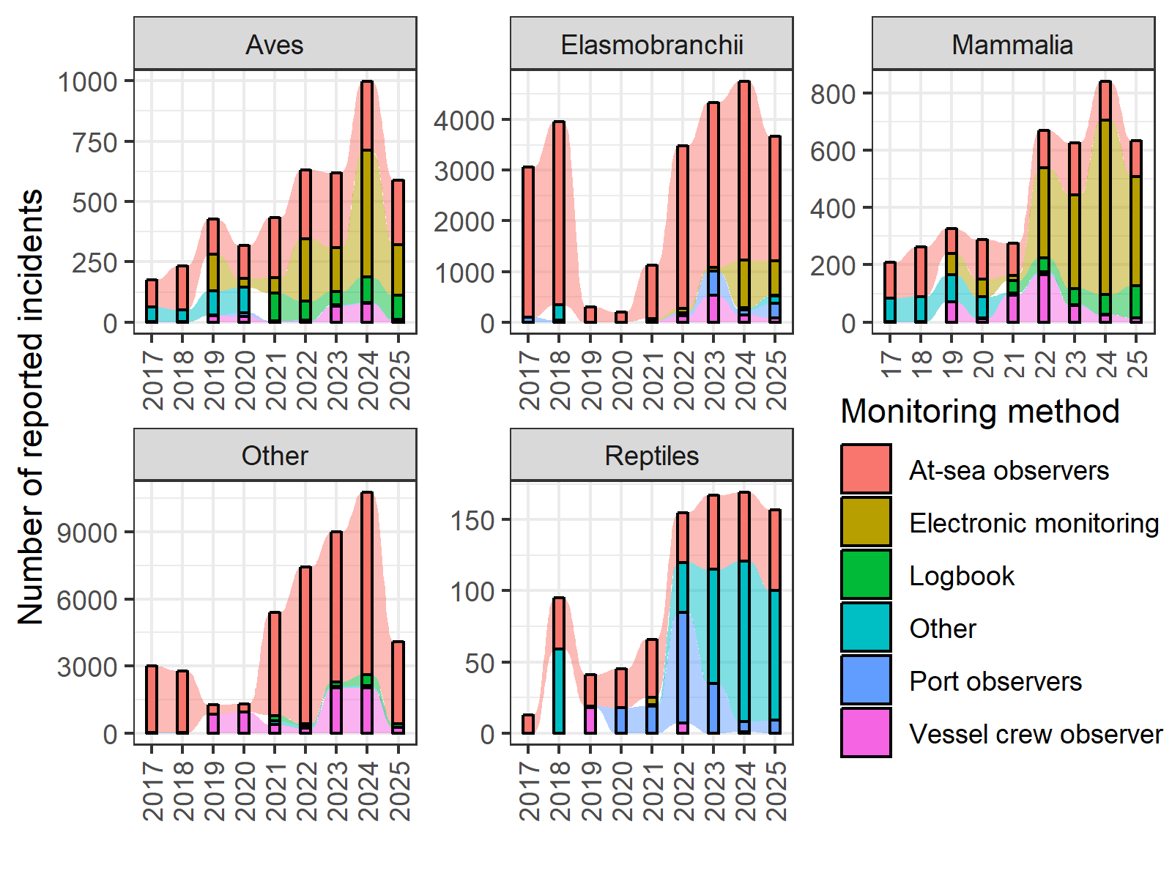
Total number of bycatch incidents for each taxa (birds, elasmobranchs, mammals, other fish species, and rep-tiles) reported by each monitoring method (2017-2025): at-sea-observers, electronic monitoring, port observers, and vessel crew observers, logbooks, other.

