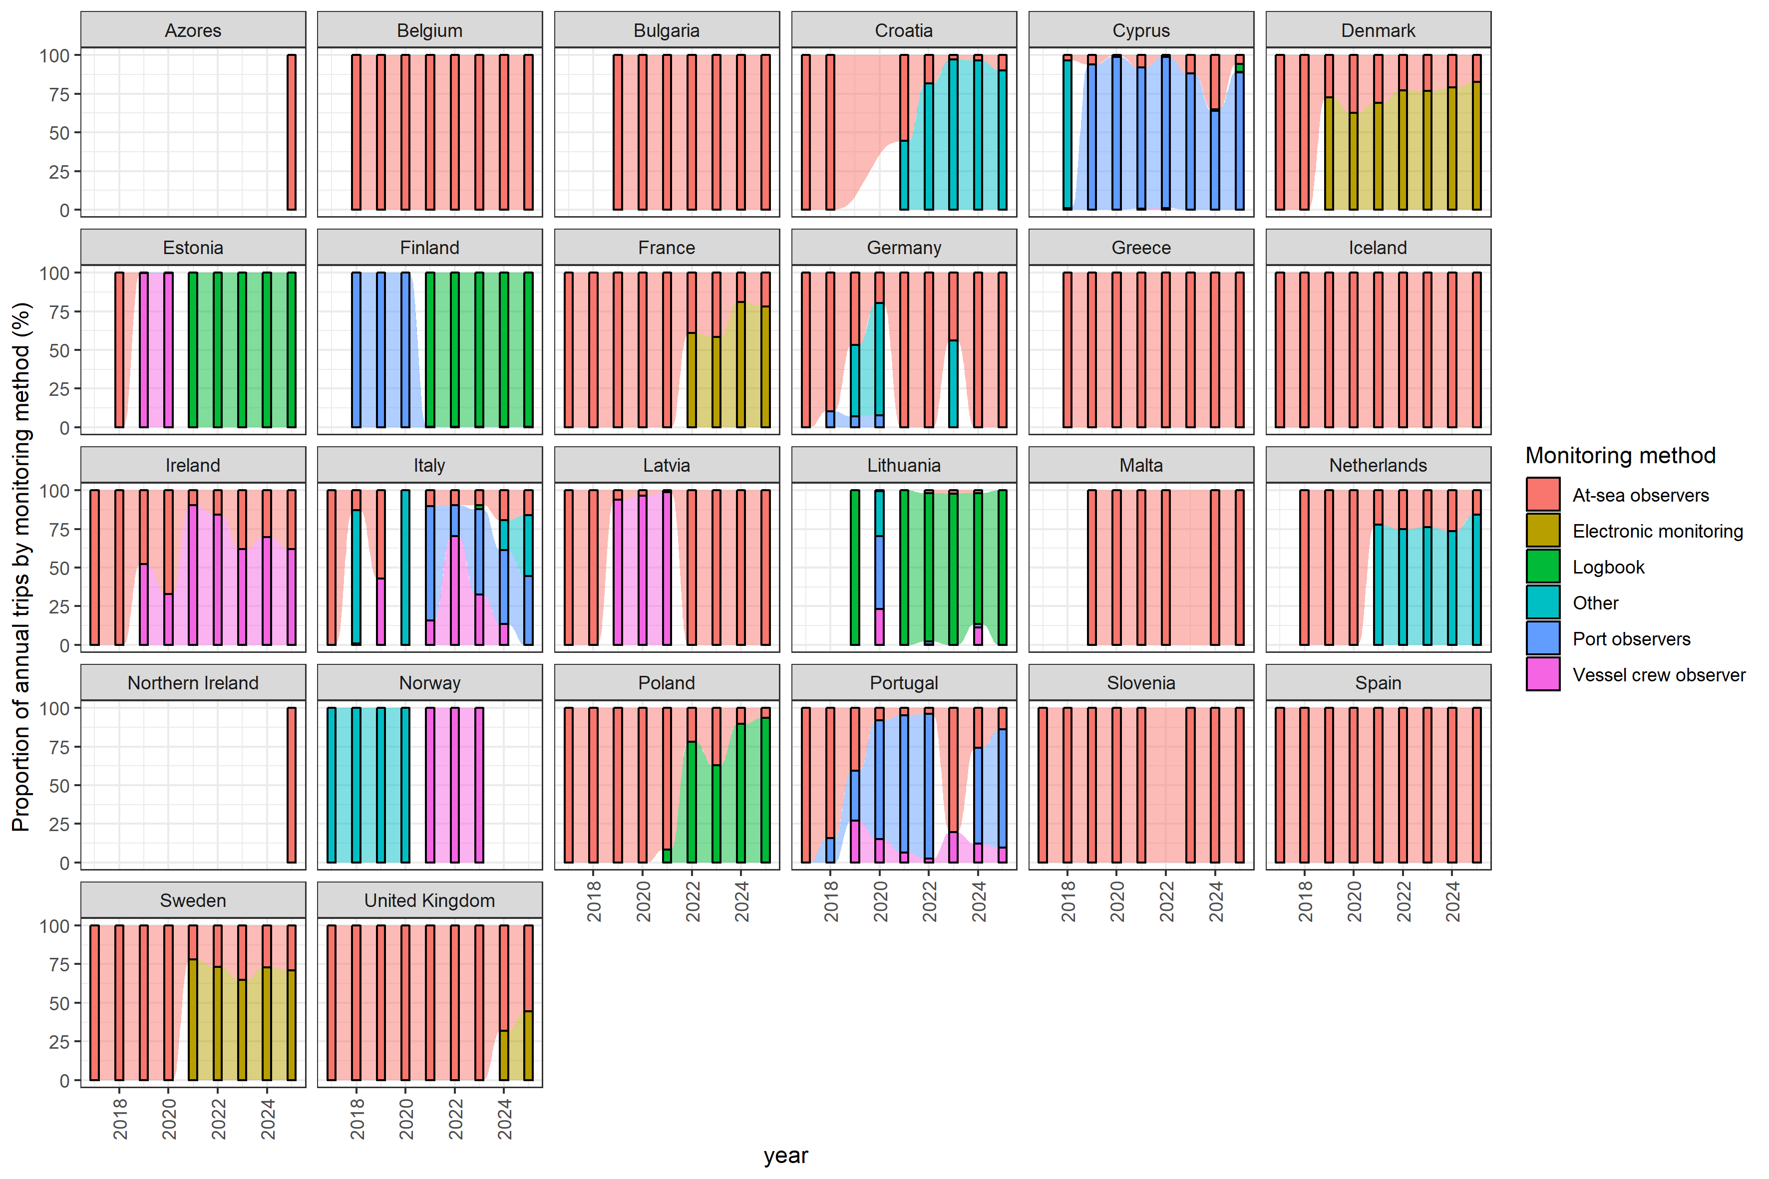
Total monitored (observed) days at sea reported by each country for each monitoring method (2017-2025); at-sea-observers, electronic monitoring, port observers, vessel crew observers, logbooks, other.

