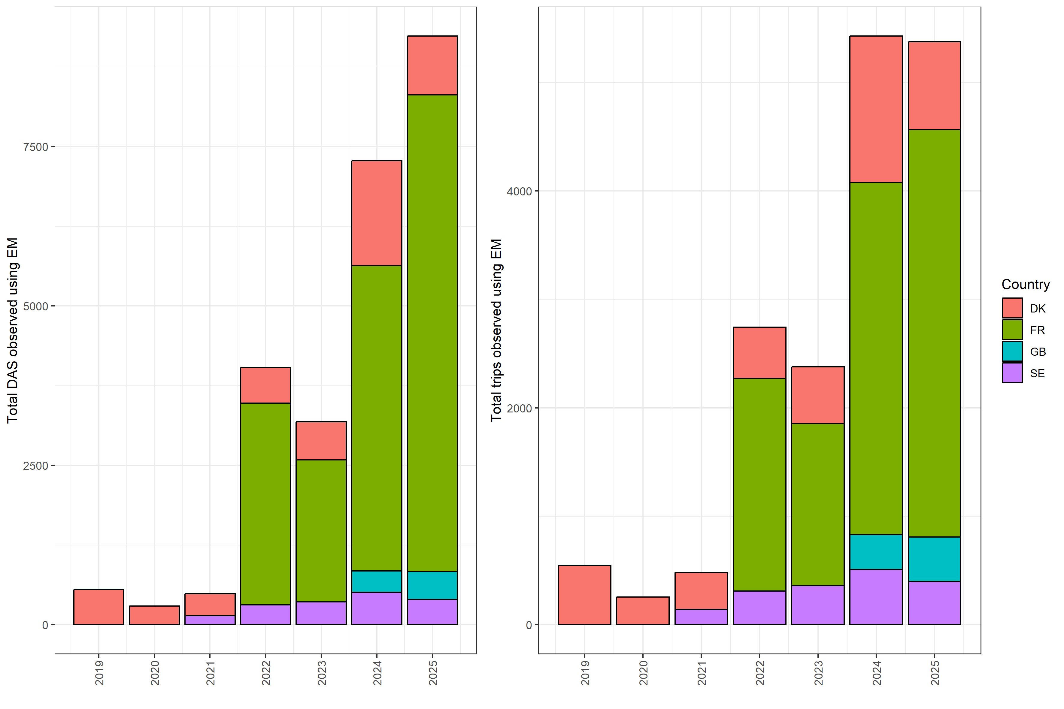
Total monitored (observed) number of trip reported by each country with electronic monitoring.

