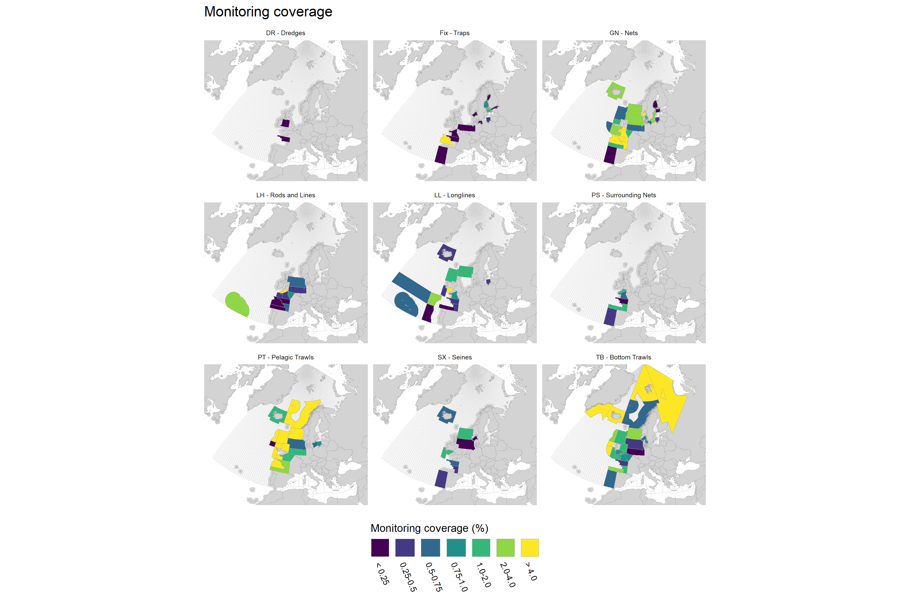
Metier level 3 monitoring coverage of 2025 data submitted to the WGBYC database for monitoring methods retained for use under ToR C for the calculation of bycatch estimates for 2024. This includes all scientific observer data, all electronic mon-itoring data, and all vessel crew data (except for Estonia) but excludes reports from logbooks and port observers. Transparent = no data or zero. Coverage calculated as monitoring effort as a percentage of fishing effort (using numbers presented in Figures X3 & X4 above). Transparent = no data or zero.

