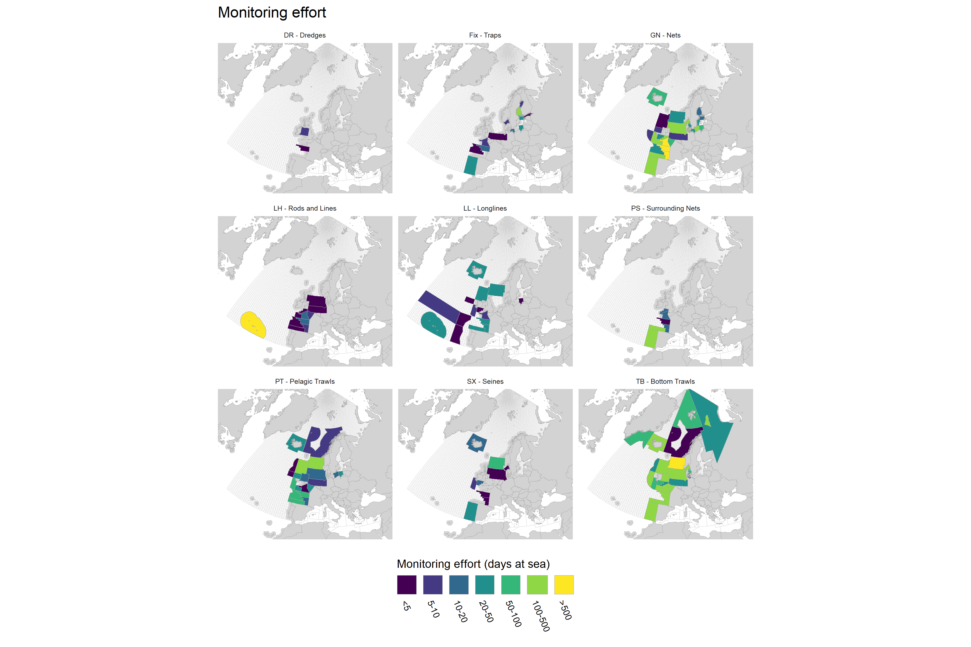
Metier level 3 monitoring effort for 2025 (days at sea) submitted to the WGBYC database for monitoring methods retained for use under ToR C for the calculation of bycatch estimates for 2024. This includes all scientific observer data, all elec-tronic monitoring data, and all vessel crew data (except for Estonia) but excludes reports from logbooks and port observers. Transparent = no data or zero.

