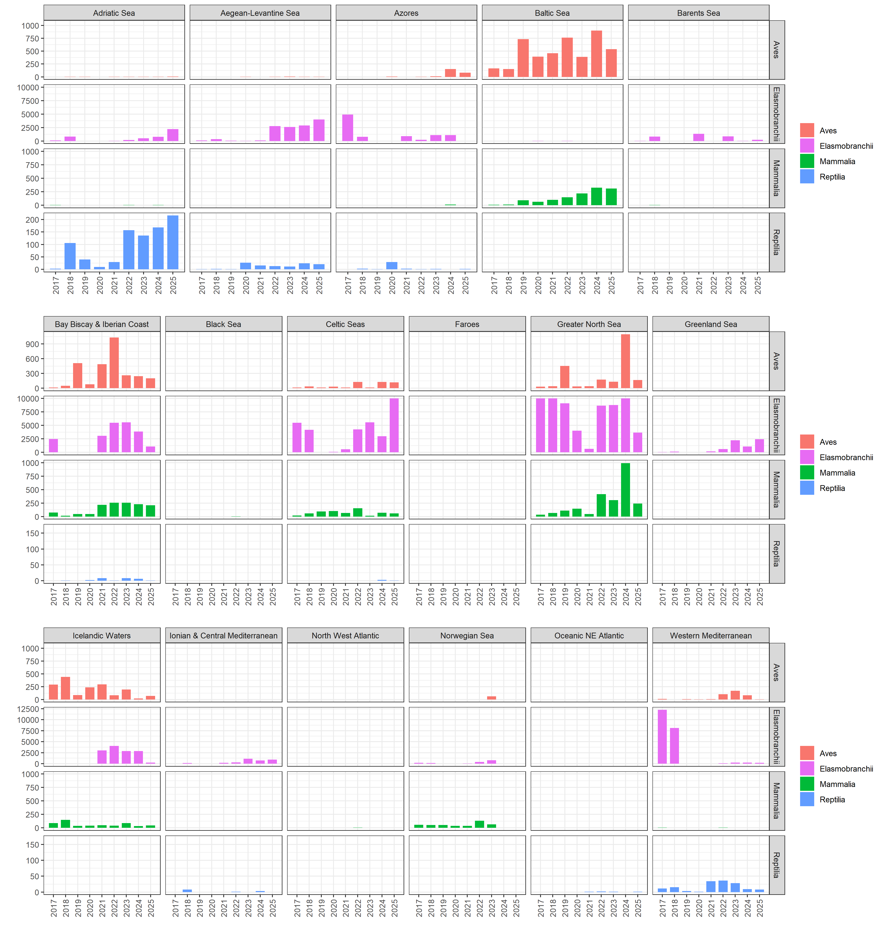
Bycatch reporting (individual numbers) by ecoregion from 2017 to 2024, across all metiers. Note that in 2017 and 2018 numbers are capped at 14,000 from 66,524 and 19,206 respectively to improve visualization

