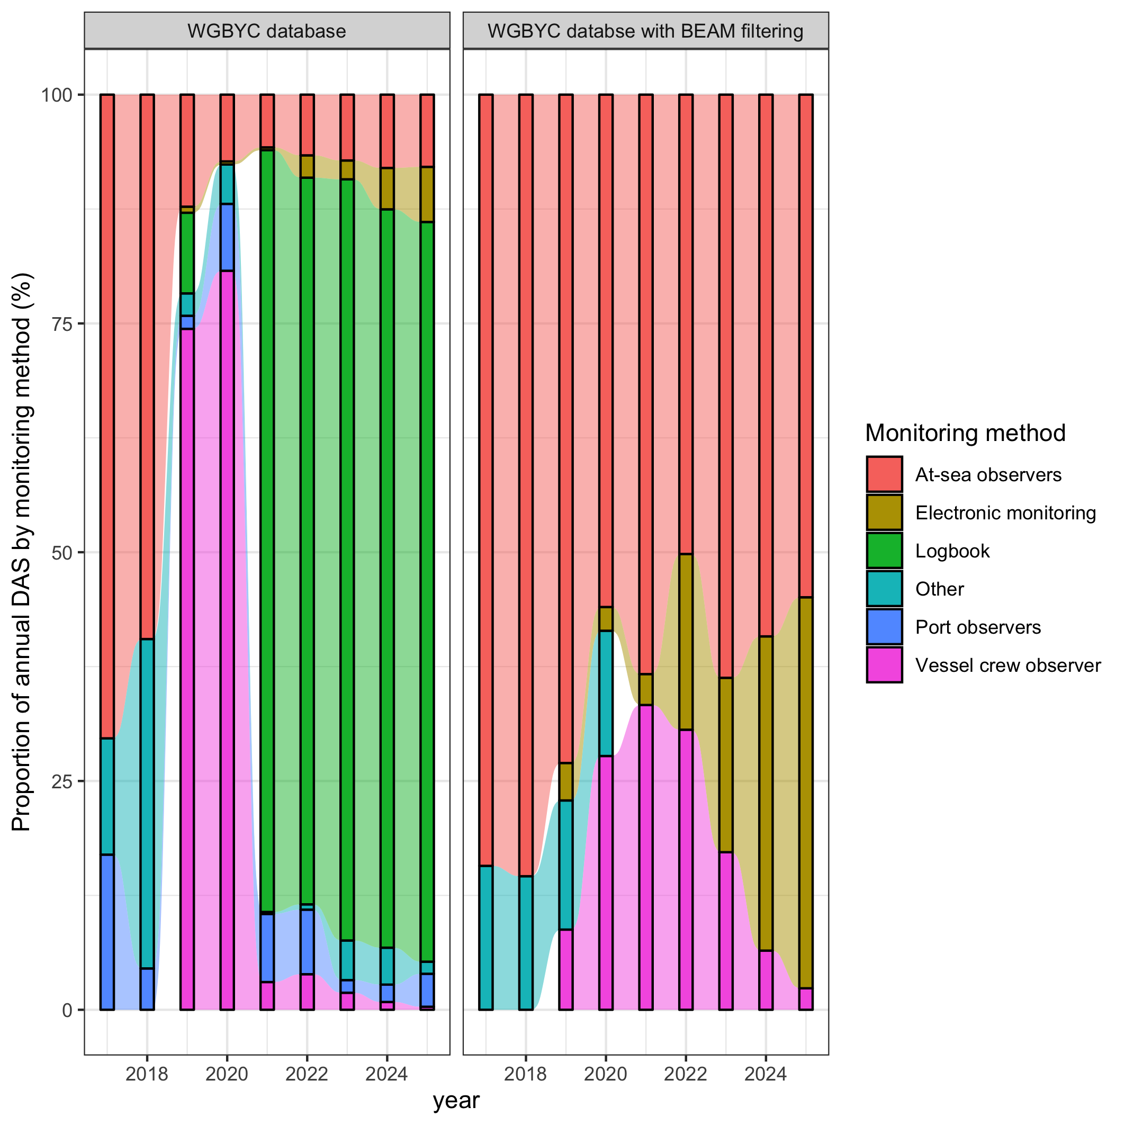
Total monitored (observed) days at sea reported in the WGBYC database and in the data filtered to compute BEAM estimatess per monitoring method (2017-2025) at-sea-observers,
electronic monitoring, port observers, and vessel crew observers, logbooks, other. The BEAM
filtered for use in ToR C (see specific section, BEAM): at-sea-observ-
ers, electronic monitoring, vessel crew observers except for Estonia, and
other only for Norway.

