sg1

none

30/11/2021

# Downloading data

# Missing countries

## not reported country

## [1] "AL" "AX" "BA" "CY" "CZ" "DZ" "EG" "IL" "IS" "IT" "LB" "LU" "LY" "MA" "ME"  
## [16] "MT" "RU" "SI" "SY" "TN" "TR"

## [1] "CY" "CZ" "IT" "LU" "MT" "SI"

## Importance of landings in these countries

Values of reported landings, averaged over 5 last years:

| eel_cou_code | G | Y | YS | S |
| --- | --- | --- | --- | --- |
| AL |  |  |  | 24.8 |
| DZ |  |  | 10.2 |  |
| IT | 0.0 | 40.4 |  | 67.6 |
| LY |  |  | 1.4 |  |
| TN | 0.0 | 0.0 | 110.1 | 0.0 |
| TR | 0.0 | 0.0 | 304.8 | 0.0 |
| OVERALL TOTAL | 57.0 | 535.3 | 1,276.9 | 419.8 |

| eel_cou_code | G | Y | YS | S |
| --- | --- | --- | --- | --- |
| IT | 0.0 | 40.4 |  | 67.6 |
| OVERALL TOTAL | 57.0 | 535.3 | 1,276.9 | 419.8 |

## Italy check

Italy reported indicators in the past, but during the 2024 WGEEL Italy had no indicators with quality ID 1 in the database, as all Italy indicators were deleted prior to the 2021 datacall. Check these deleted indicators, put them in a readable format to send to Italy for double-checking. From 2019 onwards no new assessment estimates have been made, so indicator values from 2019 onwards should be NR.

# Data availability

## Spatial coverage

Maps showings data avaibility. The symbol indicates wether the country have provided estimates for at least one (whatever year), two , three distinct indicators. 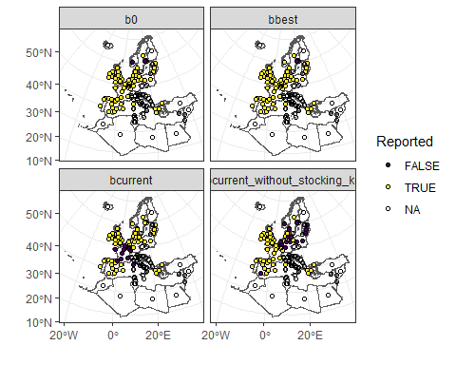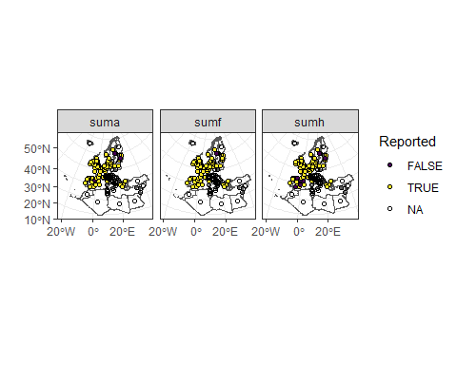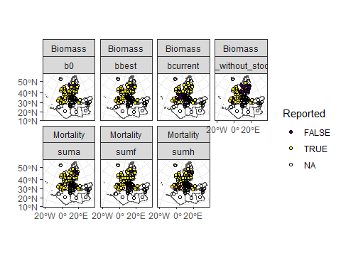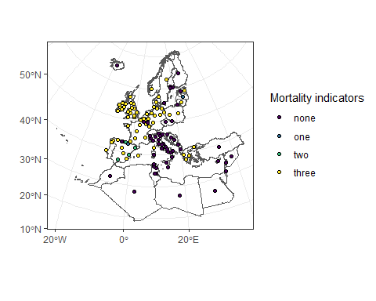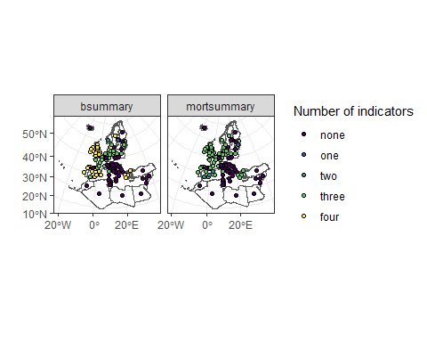

## Habitat coverage

We asked aggregated data at the EMU scale, but asked for habitat coverage within indicator. Here, we look at how well the EMU biomass and mortality indicator estimates cover each habitat type within an EMU. For all biomass indicators taken together, and for all mortality indicators taken together, we calculate the percentage of EMUs whose indicator estimate covers either 0% or 100% of a given habitat type. This relies on data providers correctly filling in that habitat coverage for a given indicator is NP/-1 when that habitat is not present in the EMU, and only fill in a cover of 0% when the habitat is present in the EMU, but not assessed.

## [1] "LT_Lith" "LT_total" "BE_Meus" "BE_Sche" "DE_Eide" "DE_Ems"   
## [7] "DE_Maas" "DE_Oder" "DE_Rhei" "DE_Schl" "DE_Warn" "DE_Wese"   
## [13] "GB_Angl" "GB_Dee" "GB_Humb" "GB_Neag" "GB_NorE" "GB_Nort"   
## [19] "GB_NorW" "GB_Scot" "GB_Seve" "GB_Solw" "GB_SouE" "GB_SouW"   
## [25] "GB_Tham" "GB_Wale" "ES_Cast" "ES_Inne" "ES_Nava" "ES_Basq"   
## [31] "ES_Gali" "ES_Astu" "ES_Cant" "ES_Cata" "ES_Vale" "ES_Bale"   
## [37] "EE_Narv" "LV_Latv" "NL_Neth" "ES_Minh" "PT_Port" "DK_Inla"   
## [43] "SE_East" "SE_Inla" "SE_West" "NO_total" "IE_East" "IE_NorW"   
## [49] "IE_Shan" "IE_SouE" "IE_SouW" "IE_West" "ES_Anda" "FR_Adou"   
## [55] "FR_Arto" "FR_Cors" "EE_total" "DE_Elbe" "PL_Oder" "PL_Vist"   
## [61] "GR_CeAe" "GR_EaMT" "GR_WePe" "GR_NorW" "GR_total" "FR_Sein"   
## [67] "FR_Bret" "FR_Meus" "FR_Garo" "FR_Rhin" "FR_Loir" "FR_Rhon"   
## [73] "LV_total" "PT_total" "ES_Murc"

| type | freq0_C | freq0_F | freq0_MO | freq0_T | freq100_C | freq100_F | freq100_MO | freq100_T |
| --- | --- | --- | --- | --- | --- | --- | --- | --- |
| biomass | 80 | 15 | 99 | 16 | 20 | 85 | 1 | 84 |
| mortality | 56 | 20 | 100 | 15 | 44 | 79 | 0 | 85 |

Marine open and coastal waters are rarely accounted for in indicator estimates. Some fresh and transitional waters not accounted for.

## Individual EMU indicator data

Inspect the indicator data of individual EMUs to spot outliers, discrepancies, missing , etc Then, check which EMUs had reported indicators three years ago, but failed to report indicators now 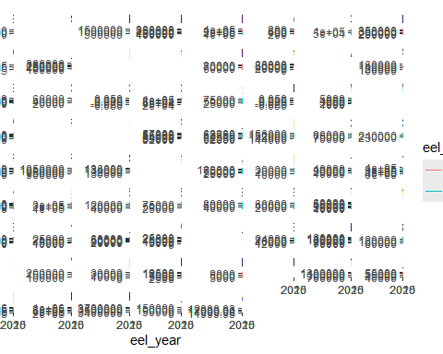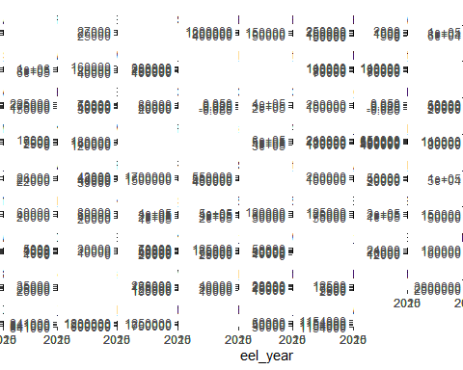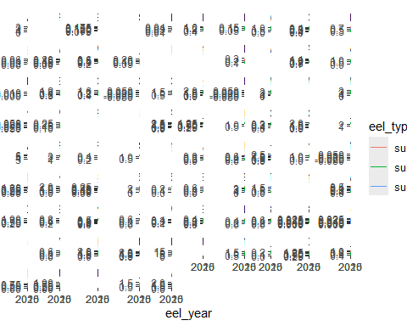

| eel_cou_code | eel_emu_nameshort | bbest | bcurrent | sumA | sumF | sumH | bcurrent_without_restocking |
| --- | --- | --- | --- | --- | --- | --- | --- |
| BE | BE_Meus | 2,020 | 2,020 | 2,020 | 2,020 | 2,020 |  |
| BE | BE_Rhin | 2,020 | 2,020 | 2,020 | 2,020 | 2,020 |  |
| BE | BE_Sche | 2,020 | 2,020 | 2,020 | 2,020 | 2,020 |  |
| BE | BE_Sein | 2,020 | 2,020 | 2,020 | 2,020 | 2,020 |  |
| DE | DE_Eide | 2,022 | 2,022 | 2,022 | 2,022 | 2,022 | 2,022 |
| DE | DE_Elbe | 2,022 | 2,022 | 2,022 | 2,022 | 2,022 | 2,022 |
| DE | DE_Ems | 2,022 | 2,022 | 2,022 | 2,022 | 2,022 | 2,022 |
| DE | DE_Maas | 2,022 | 2,022 | 2,022 | 2,022 | 2,022 | 2,022 |
| DE | DE_Oder | 2,022 | 2,022 | 2,022 | 2,022 | 2,022 | 2,022 |
| DE | DE_Rhei | 2,022 | 2,022 | 2,022 | 2,022 | 2,022 | 2,022 |
| DE | DE_Schl | 2,022 | 2,022 | 2,022 | 2,022 | 2,022 | 2,022 |
| DE | DE_Warn | 2,022 | 2,022 | 2,022 | 2,022 | 2,022 | 2,022 |
| DE | DE_Wese | 2,022 | 2,022 | 2,022 | 2,022 | 2,022 | 2,022 |
| DK | DK_Inla | 2,023 | 2,023 | 2,023 | 2,023 | 2,023 | 2,023 |
| DK | DK_Mari | 2,023 | 2,023 | 2,023 | 2,023 | 2,023 | 2,023 |
| DK | DK_total | 2,023 | 2,023 | 2,023 | 2,023 | 2,023 | 2,023 |
| EE | EE_Narv | 2,023 | 2,023 | 2,023 | 2,023 | 2,023 | 2,023 |
| EE | EE_West | 2,023 | 2,023 | 2,020 | 2,020 | 2,020 | 2,023 |
| EE | EE_total | 2,023 | 2,023 |  |  |  | 2,023 |
| ES | ES_Anda | 2,023 | 2,023 | 2,023 | 2,023 | 2,023 | 2,023 |
| ES | ES_Astu | 2,023 | 2,023 | 2,023 | 2,023 | 2,023 | 2,022 |
| ES | ES_Bale | 2,023 | 2,023 | 2,023 | 2,023 | 2,023 | 2,023 |
| ES | ES_Basq | 2,023 | 2,023 | 2,023 | 2,023 | 2,023 | 2,023 |
| ES | ES_Cant | 2,023 | 2,023 | 2,023 | 2,023 | 2,023 | 2,023 |
| ES | ES_Cast | 2,023 | 2,023 | 2,023 | 2,023 | 2,023 | 2,023 |
| ES | ES_Cata | 2,023 | 2,023 | 2,023 | 2,023 | 2,023 | 2,023 |
| ES | ES_Gali | 2,023 | 2,023 | 2,023 | 2,023 | 2,023 | 2,023 |
| ES | ES_Inne | 2,023 | 2,023 | 2,023 | 2,023 | 2,023 | 2,023 |
| ES | ES_Mino | 2,020 | 2,020 | 2,020 |  | 2,020 |  |
| ES | ES_Murc | 2,023 | 2,023 | 2,023 | 2,023 | 2,023 | 2,023 |
| ES | ES_Nava | 2,020 | 2,023 | 2,023 | 2,023 | 2,023 | 2,023 |
| ES | ES_Vale | 2,023 | 2,023 | 2,023 | 2,023 | 2,023 | 2,023 |
| FI | FI_Finl | 2,023 | 2,023 | 2,023 | 2,023 | 2,023 | 2,023 |
| FI | FI_total | 2,023 | 2,023 | 2,023 | 2,023 | 2,023 | 2,023 |
| FR | FR_Adou | 2,023 | 2,023 | 2,023 | 2,023 | 2,023 | 2,023 |
| FR | FR_Arto | 2,023 | 2,023 | 2,023 | 2,023 | 2,023 | 2,023 |
| FR | FR_Bret | 2,023 | 2,023 | 2,023 | 2,023 | 2,023 | 2,023 |
| FR | FR_Cors | 2,023 | 2,023 | 2,023 | 2,023 | 2,023 | 2,023 |
| FR | FR_Garo | 2,023 | 2,023 | 2,023 | 2,023 | 2,023 | 2,023 |
| FR | FR_Loir | 2,023 | 2,023 | 2,023 | 2,023 | 2,023 | 2,023 |
| FR | FR_Meus | 2,023 | 2,023 | 2,023 | 2,023 | 2,023 | 2,023 |
| FR | FR_Rhin | 2,023 | 2,023 | 2,023 | 2,023 | 2,023 | 2,023 |
| FR | FR_Rhon | 2,023 | 2,023 | 2,023 | 2,023 | 2,023 | 2,023 |
| FR | FR_Sein | 2,023 | 2,023 | 2,023 | 2,023 | 2,023 | 2,023 |
| FR | FR_total | 2,023 | 2,023 | 2,023 | 2,023 | 2,023 | 2,023 |
| GB | GB_Angl | 2,023 | 2,023 | 2,023 | 2,023 | 2,023 | 2,023 |
| GB | GB_Dee | 2,023 | 2,023 | 2,023 | 2,023 | 2,023 | 2,023 |
| GB | GB_Humb | 2,023 | 2,023 | 2,023 | 2,023 | 2,023 | 2,023 |
| GB | GB_Neag | 2,023 | 2,023 | 2,023 | 2,023 | 2,023 | 2,023 |
| GB | GB_NorE | 2,023 | 2,023 | 2,023 | 2,023 | 2,023 | 2,023 |
| GB | GB_NorW | 2,023 | 2,023 | 2,023 | 2,023 | 2,023 | 2,023 |
| GB | GB_Nort | 2,023 | 2,023 | 2,023 | 2,023 | 2,023 | 2,023 |
| GB | GB_Scot | 2,023 | 2,023 | 2,023 | 2,023 | 2,023 | 2,023 |
| GB | GB_Seve | 2,023 | 2,023 | 2,023 | 2,023 | 2,023 | 2,023 |
| GB | GB_Solw | 2,023 | 2,023 | 2,023 | 2,023 | 2,023 | 2,023 |
| GB | GB_SouE | 2,023 | 2,023 | 2,023 | 2,023 | 2,023 | 2,023 |
| GB | GB_SouW | 2,023 | 2,023 | 2,023 | 2,023 | 2,023 | 2,023 |
| GB | GB_Tham | 2,023 | 2,023 | 2,023 | 2,023 | 2,023 | 2,023 |
| GB | GB_Wale | 2,023 | 2,023 | 2,023 | 2,023 | 2,023 | 2,023 |
| GB | GB_total | 2,023 | 2,023 | 2,023 | 2,023 | 2,023 | 2,023 |
| GR | GR_CeAe | 2,023 | 2,023 | 2,023 | 2,023 | 2,023 | 2,023 |
| GR | GR_EaMT | 2,023 | 2,023 | 2,023 | 2,023 | 2,023 | 2,023 |
| GR | GR_NorW | 2,023 | 2,023 | 2,023 | 2,023 | 2,023 | 2,023 |
| GR | GR_WePe | 2,023 | 2,023 | 2,023 | 2,023 | 2,023 | 2,023 |
| GR | GR_total | 2,023 | 2,023 | 2,023 | 2,023 | 2,023 | 2,023 |
| HR | HR_total | 2,023 | 2,023 |  |  |  | 2,023 |
| IE | IE_East | 2,023 | 2,023 | 2,023 | 2,023 | 2,023 | 2,023 |
| IE | IE_NorW | 2,023 | 2,023 | 2,023 | 2,023 | 2,023 | 2,023 |
| IE | IE_Shan | 2,023 | 2,023 | 2,023 | 2,023 | 2,023 | 2,023 |
| IE | IE_SouE | 2,023 | 2,023 | 2,023 | 2,023 | 2,023 | 2,023 |
| IE | IE_SouW | 2,023 | 2,023 | 2,023 | 2,023 | 2,023 | 2,023 |
| IE | IE_West | 2,023 | 2,023 | 2,023 | 2,023 | 2,023 | 2,023 |
| IE | IE_total | 2,023 | 2,023 | 2,023 | 2,023 | 2,023 | 2,023 |
| LT | LT_Lith | 2,020 | 2,020 | 2,020 | 2,020 | 2,020 |  |
| LT | LT_total | 2,023 | 2,023 | 2,023 | 2,023 | 2,023 |  |
| LV | LV_Latv | 2,023 | 2,023 | 2,023 | 2,023 | 2,023 | 2,023 |
| LV | LV_total | 2,023 | 2,023 | 2,023 | 2,023 | 2,023 | 2,023 |
| NL | NL_Neth | 2,023 | 2,023 | 2,023 | 2,023 | 2,023 | 2,023 |
| NO | NO_total | 2,020 | 2,020 | 2,020 | 2,020 | 2,020 |  |
| PL | PL_Oder | 2,023 | 2,023 | 2,023 | 2,023 | 2,023 |  |
| PL | PL_Vist | 2,023 | 2,023 | 2,023 | 2,023 | 2,023 |  |
| PT | ES_Minh | 2,023 | 2,023 | 2,023 | 2,023 | 2,023 | 2,023 |
| PT | PT_Port | 2,023 | 2,023 | 2,023 | 2,023 | 2,023 | 2,023 |
| PT | PT_total | 2,023 | 2,023 | 2,023 | 2,023 | 2,023 | 2,023 |
| SE | SE_East | 2,023 | 2,023 | 2,023 | 2,023 | 2,023 | 2,023 |
| SE | SE_Inla | 2,023 | 2,023 | 2,023 | 2,023 | 2,023 | 2,023 |
| SE | SE_West | 2,023 | 2,023 | 2,023 | 2,023 | 2,023 | 2,023 |

# Maps of indicators

Values averages from 2020 to 2023 (4 years)

## Data 2024

### biomass

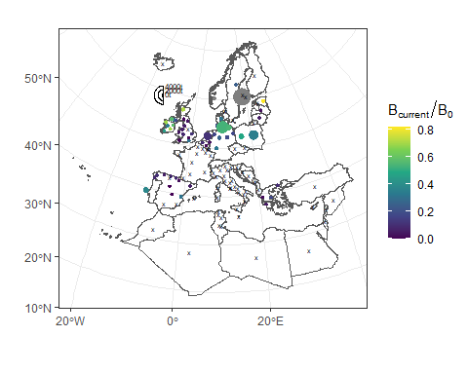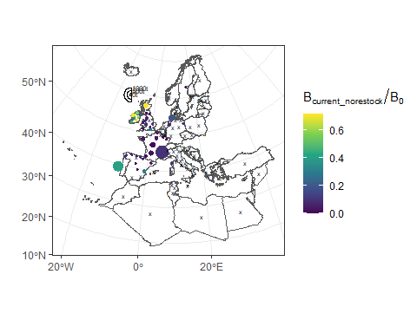

### mortality

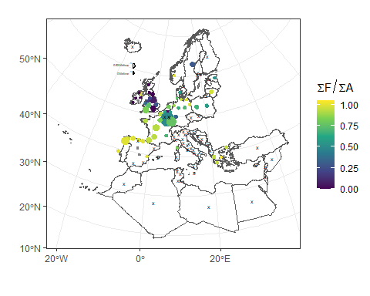

## with old data for not reported countries

Since mortality in Italy is fishery dominated, we can have a look to the trends in landings in early years.

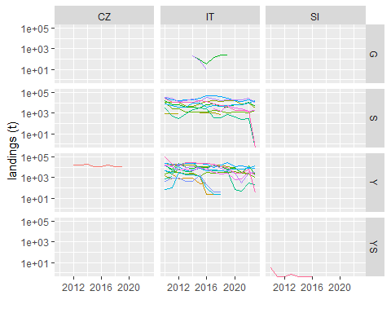

For Italy landings in some EMUs have decreased, or completely stopped. If that is due to management measures, then that could be a positive sign of possible improved escapement.

# Data quality check

## B0 less than Bbest

Normally, Bbest (that does not include restocking) stands for the best escapment that can occur in the absence of anthropogenic influence give the current recruitment. Since recruitment has collapsed, Bbest is supposed to be smaller than B0 which is the escapment that would occur in the absence of any anthropogenic influence, including a pristine recruitment, and is generally estimated using pre-1980s data.

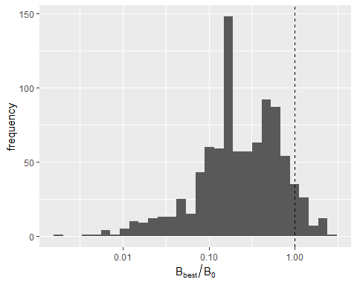

In a few situations, Bbest is greather than B0.

| eel_emu_nameshort | years | mean_bbest_b0 |
| --- | --- | --- |
| DE_Warn | 2007/2008/2009/2010/2011/2012/2013/2014/2015/2016 | 1.187674 |
| EE_Narv | 2016/2020/2021/2022/2023 | 1.140896 |
| EE_total | 2020/2021/2022/2023 | 1.143233 |
| ES_Minh | 2021/2023 | 1.445113 |
| GB_Neag | 2009/2010/2011/2012/2013/2014/2017/2018/2019 | 1.201426 |
| GB_Scot | 2009/2014/2021 | 1.343761 |
| GR_CeAe | 2007/2019 | 2.488813 |
| GR_WePe | 2007/2008/2011 | 1.187628 |
| PL_Oder | 2008 | 1.327143 |
| SE_Inla | 1960/1961/1962/1963/1964/1965/1966/1967/1968/1969/1970/1971/1972/1973/1974/1975/1976/1977/1978/1979 | 1.827249 |

For some SE_Inla, this is likely related to using a B0 that is coming from the late 80s situation. For EE, it seems rather due to the inclusion of restocking in Bbest (i.e. overestimation of Bbest). For others, B0 is likely underestimated.

## Bbest less than Bcurrent

In countries without (or with limited) restocking, Bcurrent should be less than Bbest

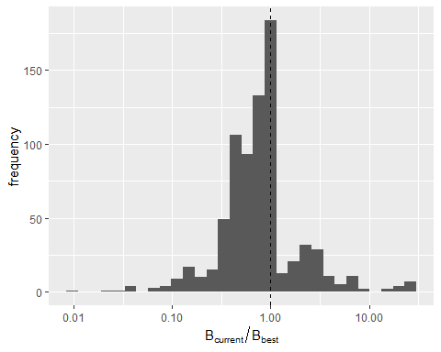

| eel_emu_nameshort | years | mean_bcurrent_bbest |
| --- | --- | --- |
| DE_Elbe | 2007/2008/2009/2010/2011/2012/2013/2014/2015/2016/2017/2018/2019/2020/2021/2022 | 3.728167 |
| DE_Ems | 2007/2008/2009/2010/2011/2012/2013/2014/2015/2016/2017/2018/2019/2020/2021/2022 | 1.828909 |
| DE_Maas | 2017/2018/2019/2020/2021/2022 | 3.092274 |
| DE_Oder | 2007/2008/2009/2010/2011/2012/2013/2014/2015/2016/2022 | 1.079432 |
| DE_Rhei | 2007/2008/2009/2010/2011/2012/2013/2014/2015/2016/2017/2018/2019/2020/2021/2022 | 18.734901 |
| DE_Schl | 2009/2016/2017/2018/2019/2020/2021/2022 | 1.143417 |
| DE_Wese | 2007/2008/2009/2010/2011/2012/2013/2014/2015/2016/2017/2018/2019/2020/2021/2022 | 2.792668 |
| ES_Nava | 2010/2011/2012/2016/2017 | 6.473557 |
| ES_Vale | 2007/2008/2009/2010 | 1.170825 |
| GR_CeAe | 2007/2019/2023 | 1.007915 |
| IE_SouE | 2015 | 1.000031 |
| IE_SouW | 2019/2020 | 1.002175 |
| IE_West | 2014/2018 | 1.000006 |
| PL_Oder | 2007/2008/2009/2010/2011/2012/2013/2014/2015/2016/2017/2018/2019/2020/2021/2022/2023 | 2.940764 |
| PL_Vist | 2007/2008/2009/2010/2011/2012/2013/2014/2015/2016/2017/2018/2019/2020/2021/2022/2023 | 3.668484 |
| SE_Inla | 2002/2003/2004/2005/2006/2007/2008/2009/2010/2011/2012/2013/2014/2015/2016/2017/2018/2019/2020/2021/2022/2023 | 2.794387 |

For German EMUs, this shows the massive effect of restocking which is also visible in Sweden or in Poland. For Ireland, the anthropogenic mortality is so low in recent years that Bcurrent and Bbest can be very similar. Results are more doubtful in ES_Anda.

## Only Bcurrent without restocking reported

Before looking at EMUs where Bcurrent without restocking exceeds either Bbest or B0, it is worthwhile to look at countries that have only reported Bcurrent without restocking, and no bcurrent which may or may not include restocking.

| eel_emu_nameshort | years | mean_bcurrent_norestock_bbest |
| --- | --- | --- |
| EE_total | 2007/2008/2009/2010/2011/2012/2013/2014/2015/2016 |  |
| ES_Gali | 2018 | 0.12878481 |
| FR_Adou | 2010/2011/2012/2013/2014/2015/2016/2017/2018/2019/2020/2021 | 0.13930647 |
| FR_Arto | 2010/2011/2012/2013/2014/2015/2016/2017/2018/2019/2020/2021 | 0.33876895 |
| FR_Bret | 2010/2011/2012/2013/2014/2015/2016/2017/2018/2019/2020/2021 | 0.31792632 |
| FR_Cors | 2010/2011/2012/2013/2014/2015/2016/2017/2018/2019/2020/2021 | 0.80600686 |
| FR_Garo | 2010/2011/2012/2013/2014/2015/2016/2017/2018/2019/2020/2021 | 0.18123397 |
| FR_Loir | 2010/2011/2012/2013/2014/2015/2016/2017/2018/2019/2020/2021 | 0.09097521 |
| FR_Meus | 2010/2011/2012/2013/2014/2015/2016/2017/2018/2019/2020/2021 | 0.00000000 |
| FR_Rhin | 2010/2011/2012/2013/2014/2015/2016/2017/2018/2019/2020/2021 | 0.03607633 |
| FR_Rhon | 2010/2011/2012/2013/2014/2015/2016/2017/2018/2019/2020/2021 | 0.61909641 |
| FR_Sein | 2010/2011/2012/2013/2014/2015/2016/2017/2018/2019/2020/2021 | 0.28951604 |

It is mostly French EMUs that have reported an estimate of Bcurrent without restocking, while not having reported on regular Bcurrent. Is there a hidden additional production of restocked silver eel in French EMUs?

## Bbest less than Bcurrent without restocking

This year, for the first time, countries were asked to also report Bcurrent values without the effect of restocking, if available. Run the above analysis again with Bcurrent without restocking, for those countries that have reported this.

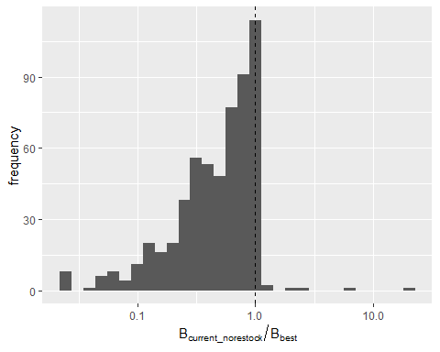

| eel_emu_nameshort | years | mean_bcurrent_norestock_bbest |
| --- | --- | --- |
| ES_Nava | 2011/2012/2016/2017 | 7.777654 |
| ES_Vale | 2007/2008/2009/2010 | 1.170825 |
| IE_SouW | 2019/2020 | 1.002175 |

Almost all estimates of Bcurrent without the effect of restocking show, as expected, that that Bcurrent estimate is lower than Bbest. There are only three EMU exceptions to this:

* ES_Nava, which shows strong fluctuations in the ratio between bbest and bcurrent (both with or without restocking). This warrants further investigation to see how these estimates were derived.
* ES_Vale, Less extreme fluctuations than ES_Nava, the years that bcurrent without stocking is higher than bbest are also years in which Bcurrent without stocking is equal to Bcurrent. Same as ES_Nava, closer look is needed to how these estimates are derived.
* IE_SouW, which seems to be a rounding error, and Bcurrent is equal to Bbest.

## Bbest less than Bcurrent without restocking

BUT: not all countries have reported a bcurrent estimate without restocking.

So, to complete the picture, here we show, for countries that have not reported an indicator for bcurrent without restocking, which years have a bcurrent that is higher than bbest. If these countries actually have a large restocking program, it is encouraged for them to try and work toward an estimate of bcurrent without restocking, if that is possible. If these countries have no restocking, then that warrants a closer look at the methods used to estimate bcurrent/bbest.

| eel_emu_nameshort | years | mean_bcurrent_bbest |
| --- | --- | --- |
| DE_Elbe | 2007/2008/2009/2010/2011/2012/2013/2014/2015/2016/2017/2018/2019/2020/2021/2022 | 3.728167 |
| DE_Maas | 2017/2018/2019/2020/2021/2022 | 3.092274 |
| DE_Rhei | 2007/2008/2009/2010/2011/2012/2013/2014/2015/2016/2017/2018/2019/2020/2021/2022 | 18.734901 |
| DE_Schl | 2009/2016/2017/2018/2019/2020/2021/2022 | 1.143417 |
| DE_Wese | 2007/2008/2009/2010/2011/2012/2013/2014/2015/2016/2017/2018/2019/2020/2021/2022 | 2.792668 |
| GR_CeAe | 2007/2019/2023 | 1.007915 |
| PL_Oder | 2007/2008/2009/2010/2011/2012/2013/2014/2015/2016/2017/2018/2019/2020/2021/2022/2023 | 2.940764 |
| PL_Vist | 2007/2008/2009/2010/2011/2012/2013/2014/2015/2016/2017/2018/2019/2020/2021/2022/2023 | 3.668484 |

Likely that Germany and Poland are effected by restocking, so for these countries it would be good if the possibility exists to work toward an estimate of bcurrent without restocking.

For GR_CeAe, indicators are strange. Sometimes Bcurrent is larger or equal to bbest, but at the same time sumA is also high. Sometimes, Bbest and bcurrent are 0, but sumA is also 0. I double-checked with the data provider, and all years with 0 values for biomass indicator estimates should be NC instead, since these are years with no landings (so sumA is 0). It remained unclear why bbest and bcurrent were higher than b0 for years with an estimate. Advise to remove this series from WKEMP analysis until the methods for deriving these estimates are better looked at.

## B0 less than Bcurrent

In countries without (or with limited) restocking, Bcurrent should be less than B0

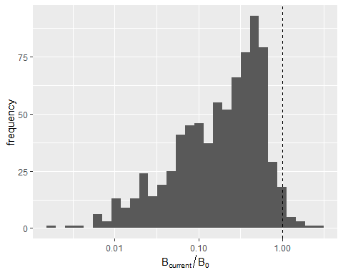

| eel_emu_nameshort | years | mean_bcurrent_bbest |
| --- | --- | --- |
| DE_Warn | 2007/2008/2009/2010/2011/2012/2013/2014/2015/2016 | 1.107296 |
| GB_Scot | 2014/2021 | 1.231877 |
| GR_CeAe | 2007/2019 | 2.508390 |
| PL_Oder | 2007/2008/2009/2010 | 1.621496 |
| PL_Vist | 2007/2008/2009/2010 | 1.248663 |

This indicates a massive effect of restocking in DE_Warn, and a likely underestimation of B0 in GB_Scot. From a scientific view, achieving a restocking leading to an escapment greater than pristine escapment probably leads to increase a lot density-dependent natural mortality (assuming a correct estimate of b0).

Again, as mentioned above already, for GR_CeAe, indicators are strange. Sometimes Bcurrent is larger or equal to bbest, but at the same time sumA is also high. Sometimes, Bbest and bcurrent are 0, but sumA is also 0. I double-checked with the data provider, and all years with 0 values for biomass indicator estimates should be NC instead, since these are years with no landings (so sumA is 0). It remained unclear why bbest and bcurrent were higher than b0 for years with an estimate. Advise to remove this series from WKEMP analysis until the methods for deriving these estimates are better looked at.

## B0 less than Bcurrent without restocking

This year, for the first time, countries were asked to also report Bcurrent values without the effect of restocking, if available. Run the above analysis again with Bcurrent without restocking, for those countries that have reported this.

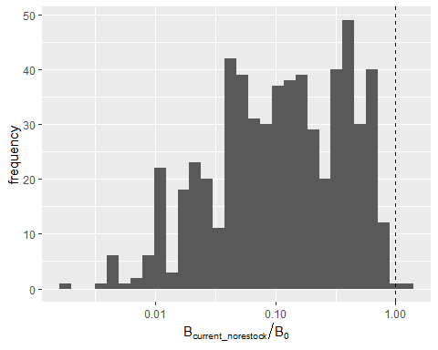

| eel_emu_nameshort | years | mean_bcurrentnorestock_bbest |
| --- | --- | --- |
| GB_Scot | 2014/2021 | 1.231877 |

As already mentioned above, without any restocking effects, bcurrent for GB_Scot is still estimated as higher than b0. This likely indicates an underestimate of b0.

## Check irregularities in combinations of Bcurrent, Bbest, and sumA

As found above, for GR_CeAe, indicators are strange. Sometimes Bcurrent is larger or equal to bbest, but at the same time sumA is also high. Sometimes, Bbest and bcurrent are 0, but sumA is also 0.

Here, we check for such unusual combinations of high Bcurrent vs Bbest while also having a high sumA, or the reverse of a low Bcurrent or Bbest while also having a low sumA

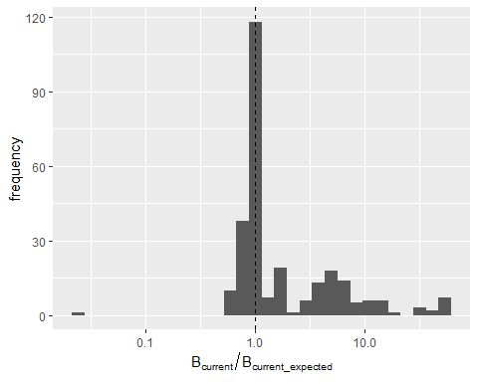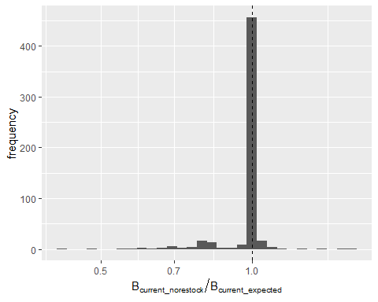

| eel_emu_nameshort | years | mean_b_bexpect |
| --- | --- | --- |
| DE_Elbe | 2007/2008/2009/2010/2011/2012/2013/2014/2015/2016/2017/2018/2019/2020/2021/2022 | 8.646937 |
| DE_Maas | 2007/2012/2013/2014/2016/2017/2018/2019/2020/2021/2022 | 2.573014 |
| DE_Rhei | 2007/2008/2009/2010/2011/2012/2013/2014/2015/2016/2017/2018/2019/2020/2021/2022 | 38.903806 |
| DE_Schl | 2018/2019/2020/2021/2022 | 1.263438 |
| DE_Warn | 2018/2019/2020/2021 | 1.112040 |
| DE_Wese | 2007/2008/2009/2010/2011/2012/2013/2014/2015/2016/2017/2018/2019/2020/2021/2022 | 4.354206 |
| GR_CeAe | 2007/2023 | 2.761879 |
| GR_EaMT | 2007/2008/2009/2010/2011/2012/2013/2014/2015/2016/2017/2018/2019/2020/2021/2022/2023 | 1.784155 |
| GR_NorW | 2018 | 1.149310 |
| PL_Oder | 2011/2012/2013/2014/2015/2016/2017/2018/2019/2020/2021/2022/2023 | 7.401182 |
| PL_Vist | 2011/2012/2013/2014/2015/2016/2017/2018/2019/2020/2021/2022/2023 | 5.406279 |

| eel_emu_nameshort | years | mean_b_bexpect |
| --- | --- | --- |
| ES_Vale | 2007/2008/2009/2010/2011/2012/2013 | 1.300181 |

For EMUs which have no estimate for Bcurrent without restocking, only EMUs from Germany, Greece, and Poland had a Bcurrent that differed more than 10% from the expected Bcurrent. For Germany and Poland, this is likely the result of restocking. For Greece, could it also be restocking?

For EMUs that did have an estimate for Bcurrent without restocking, only the ES_Vale EMU had Bcurrent estimates that differed more than 10% to the expected Bcurrent. This needs further investigation.

## Checking B0

ALL CODE BELOW STILL NEEDS REWRITING AFTER WGEEL 2024

The EU regulation states that Member States should implement management measures in order to achieve an escapement equal to 40 % of the pristine recruitment. As such, the standard precautionary diagram show the lifespan anthropogenic mortality against the ratio of Bcurrent over B0. However, the pristine situation is difficult to define and B0 is even harder to estimate. As such, some countries have used observations of past productivity in some water bodies, multiplied by the total water surface to extrapolate pristine escapement. However, the availability of historical data does not allow to go back far in time, rarely before the 80s, which was not a pristine situation. Other countries have used the current escapement, corrected for anthropogenic mortality (i.e. Bbest) and use this to extrapolate Bcurrent. However, the extrapolation methods vary among countries, especially regarding the integration of mortality density dependence or not (accounting for mortality density dependent mortality leads to smaller B0 since it postulates that natural mortality increases with abundance). As such, B0 are hardly comparable among countries, and the status of EMUs with respect to the EU regulation target depends a lot on this estimation of B0. To avoid these inconsistencies, we propose here an alternative method. First, let remind that, by definition:

$$B_{current}=R_{current}⋅\exp^{\left(−ΣA−ΣM\right)}$$

and that if we do not account for any density dependence, we also have

$$B_{best}=R_{current}⋅\exp^{\left(−ΣM\right)}$$

$$B_{0}=R_{0}⋅\exp^{\left(−ΣM\right)}$$

As such, we can get an estimate of B0 as:

$${B}_{0} \sim {{{R}_{0}} \over {{R}_{current}}} \cdot {B}_{best}$$

Since recruitment was assumed to be closed to a pristine situation in the 1980s, we can directly use the WGEEL recruitment indices to get $R_{0}/R_{current}$ and to have a standard and consistent estimates of B0 using Bbest reported by countries. Moreover, since these estimates are based on Bbest, they are more comparable with Bcurrent (Bbest and Bcurrent are generally based on a same method), instead of having a ratio based on a value based on current observations mixed with value based on historical values or on extra-assumptions. Those new estimates would not account for mortality dependence, as such they would be seen as a upper bound for B0.

Some preliminary steps are required. First, it is be required to choose the appropriate recruitment indices (elsewhere Europe, North Sea, yellow eel). Here we associated each EMU with a recruitment index according to Figure 3.1 from latest WGEEL report (ICES, 2021). Then, for countries using a cohort wise estimation of escapment, it is required to account for a lag between recruitment and escapement, corresponding to the lifespan. Since lifespan is not available, we used an ad-hoc rule: for EMUs with a year-wise process, we used the average value of the recruitment indices from latest 5 years as $R_{c}urrent$. For EMUs associated with the Elsewhere index, we took the average value of the index from 7 to 12 years ago. We took 12 to 17 for North Sea and 17 to 22 for yellow eel indices.

Results show that the discrepancy between the two indicators is very heterogeneous among countries / EMUs. Unsurprisingly, the reported $B\left[0\right]$ are generally less than the estimated ones, but this is not always the case (e.g. SE, ES). More surprisingly, estimated $B\left[0\right]$ are highly variable, indicating that reported $B\left[best\right]$ are much more variable than variations in recruitment. Finally, the ratio between reported and estimated $B\left[0\right]$ are very contrasted among countries, either because of inappropriate accounting of restocking in $B\left[best\right]$ or because of inconsistencies in $B\left[0\right]$ estimations. Anyway, this questions the comparisons of $B\left[0\right]$ among EMUs.

As such, it is worthwhile checking whether is has consequences on the ratio $B_{current}/B_{0}$. The plot clearly shows the effect of the estimation of $B_{0}$ on estimated ratio. For some countries, effects are limited (e.g. SE, LT). But for most countries, estimated $B_{0}$ lead to much more lower estimated ratio (e.g. IE, GB, PT).

## effect of restocking

Theoretically, $B_{best}$ should not include restocking while B0 should include restocking. In the absence of restocking $ΣA∼−log\left(B_{best}/B_{current}\right)$, but this equation should not be valid in the presence of restocking since $B_{best}$ and $ΣA$ should not include restocking while $B_{c}urrent$ should include restocking.

Here, we see that many countries (except DE, SE and PL) seem to have accounted for restocking both in $B_{best}$ and $B_{current}$, with a possible double banking of restocking (i.e. both increasing escapment and decreasing mortality).