Trend in fisheries

WGEEL

23 september 2024

Table of Contents

1 Key numbers ii

1.1.1 Glass eel landings ii

1.1.2 Yellow and Silver com eels landings ii

1.1.3 Glass eel recreational landings ii

1.1.4 Yellow and Silver eel recreational landings ii

1.1.5 Aquaculture ii

1.1.6 Release ii

2 Trend in fisheries iv

2.1 Commercial fisheries landings iv

2.2 Recreational fisheries vii

2.3 Illegal, unreported and unregulated landings viii

2.4 Releases viii

2.4.1 Glass eel releases (G + QG) ix

2.4.2 Ongrown eel (OG) and yellow eel (Y) releases ix

2.4.3 Silver eel releases x

2.5 Other landings xi

2.5.1 Release all stage (remove me) xi

3 Aquaculture xii

4 tables xiii

# Key numbers

### Glass eel landings

Glass eel commercial fisheries within the EU in 2023 = 54.03 t countries where data were reported: PT,ES,FR,GB Glass eel commercial fisheries within the EU in 2024 = 56.08 t countries where data were reported: PT,FR,ES,GB Mean glass eel commercial fisheries for the previous 5 years ( 2018 - 2022 ) within the EU = 59.51 t

### Yellow and Silver com eels landings

Yellow and Silver eel commercial fisheries within the EU (Y, S, YS) in 2022 = 2366.48 t. Number of countries reporting: 23 Yellow and Silver eel commercial fisheries within the EU (Y, S, YS) in 2023 = 2027.22 t. Number of countries reporting: 21 Mean Yellow and Silver eel commercial fisheries for the previous 5 years ( 2017 - 2021 ) within the EU = 2615.344 t. Reconstructed Yellow and Silver eel commercial fisheries within the EU (Y, S, YS) in 2022 = 2377.1 t. Reconstructed Yellow and Silver eel commercial fisheries within the EU (Y, S, YS) in 2023 = 2151.38 t. Mean Reconstructed Yellow and Silver eel commercial fisheries for the previous 5 years ( 2017 - 2021 ) within the EU = 2621.852 t.

### Glass eel recreational landings

Glass eel recreational fisheries within the EU in 2023 = 1.32 t countries where data were reported: ES Glass eel recreational fisheries within the EU in 2024 = t countries where data were reported: Mean glass eel recreational fisheries for the previous 5 years ( 2018 - 2022 ) within the EU = 0.9925 t.

### Yellow and Silver eel recreational landings

Yellow and Silver eel recreational fisheries within the EU (Y, S, YS) in 2022 = 551.06 t. Number of countries reporting: 15 Yellow and Silver eel recreational fisheries within the EU (Y, S, YS) in 2023 = 86 t. Number of countries reporting: 10 Mean Yellow and Silver eel recreational fisheries for the previous 5 years ( 2017 - 2021 ) within the EU = 520.612 t.

### Aquaculture

Eel aquaculture within the EU in 2022 = 4994.92 t countries where data were reported: PT,SE,NL,GR,DK,DE,IT,ES,PL Data is shown until 2022 due to delayed reporting. Mean aquaculture for the previous 5 years ( 2017 - 2021 ) within the EU = 5076.632 t

### Release

Number of glass eels (G, QG) released in 2022 = 47.99 millions , Number of countries reporting: 11 Number of glass eels (G, QG) released in 2023 = 21.8 millions , Number of countries reporting: 12 Number of glass eels (G, QG) released in 2024 = 0 millions probably incomplete , Number of countries reporting: 0 Number of yellow eels (Y) released in 2023 = 0.37 millions , Number of countries reporting: 2 Number of yellow eels (Y) released in 2022 = 0.37 millions , Number of countries reporting: 3 Number of silver eels (S) released in 2023 = 0.35 millions , Number of countries reporting: 5 Number of silver eels (S) released in 2022 = 0.35 millions , Number of countries reporting: 7

Quantity of glass eels (G, QG) released in 2022 = 15.96 t , Number of countries reporting: 11 Quantity of glass eels (G, QG) released in 2023 = 8.94 t , Number of countries reporting: 12 Quantity of glass eels (G, QG) released in 2024 = 0 t probably incomplete , Number of countries reporting: 0 Quantity of yellow eels (Y) released in 2023 = 0.84 t , Number of countries reporting: 1 Quantity of yellow eels (Y) released in 2022 = 0.84 t , Number of countries reporting: 2 Quantity of silver eels (S) released in 2023 = 130.24 t , Number of countries reporting: 5 Quantity of silver eels (S) released in 2022 = 129.99 t , Number of countries reporting: 7

# Trend in fisheries

This section presents and describes data from commercial, recreational and non-commercial fisheries, aquaculture production and restocking of eel. Data can be reported by eel life stage (glass, yellow, silver), habitat type (freshwater, transitional, coastal, marine), and by eel management unit (EMU) where possible. Historical series for which these details are not available are reported by country. The current database structure allows aggregation by country or EMU. The landings data presented are those reported to the WGEEL through responses to Data calls.

## Commercial fisheries landings

Care should be taken with the interpretation of the landings as indicators of the stock, since the catch statistics now reflect the status of reduced activity as well as of stock levels. In summary, reported commercial landings are declining from a level of around 10,000 t in the 1960s to 2081 tonnes (glass eel + yellow eel + silver eel) in 2023.

#### Glass eel

Figure 1 presents the time-series up to and including 2024 for total commercial glass eel landings as reported by 5 countries in the Eel Data call (GB, FR, ES, PT, IT) and Figure 2 presents the time-series including reconstructed data to fill data gaps.

Glass eel landings show a sharp decline since 1980 from 2,000 t to around 40–60 t since 2009 onwards. In 2024, the raw (uncorrected) landings data for glass eels is 56.1 t, while it was 54 t in 2023 (Annex XXX Table XXX for raw data and Table XXX for raw and corrected data).

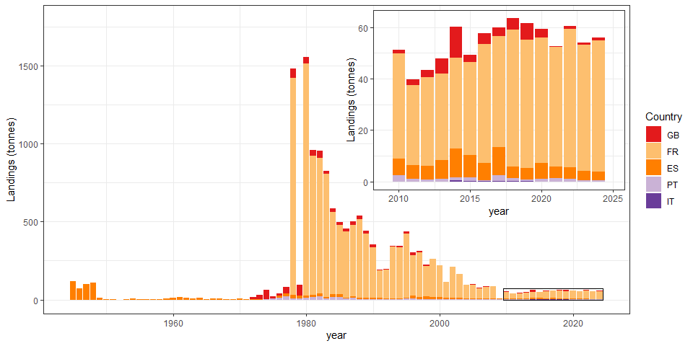

Figure 1: Time-series of reported commercial glass eel fishery landings (tonnes) by country. United Kingdom(GB), France(FR), Spain(ES), Portugal(PT), Italy(IT) are included combining information from the Data call 2024 and the WGEEL database updated to 2024 . The Portuguese catches correspond to glass eel catches from the Portuguese side of the Miño river. Catches from the Spanish side of the Miño river are included in the Spanish catches.

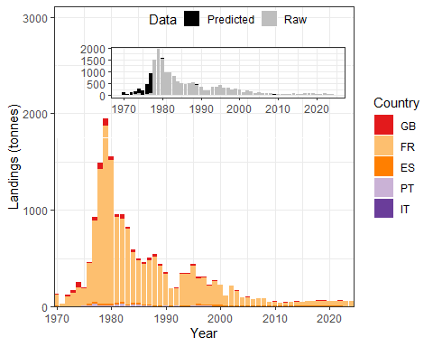

Figure 2: Time-series of reported or reconstructed commercial glass eel fishery landings (tonnes) by country and a reconstruction of the non-reported countries/years combinations. United Kingdom(GB), France(FR), Spain(ES), Portugal(PT), Italy(IT) are included, combining information from the Data call 2024 and the WGEEL database updated to 2024. The inset box shows the proportion of reconstructed landings per year.

#### Yellow and silver eel

Figure 3 presents aggregated landings data for yellow and silver eels coming from 23 countries and Figure 4 presents the time-series including reconstructed data to fill the gaps. The proportion of “corrected” landings was as high as 50% in the 1950s, but rather low since the mid-1980s. The total landings (including reconstructed) of yellow and silver eels decreased from 18,000–20,000 t in the 1950s to 2,000–3,500 t since 2009. Reported landings from yellow and silver eel commercial fisheries (Y, S, YS) add up to 2027 t in 2023 and 2366t in 2022 (Number of countries reporting 21). Yellow and silver eel commercial fisheries averaged 2615 t over the five previous years (from 2017 to 2021).

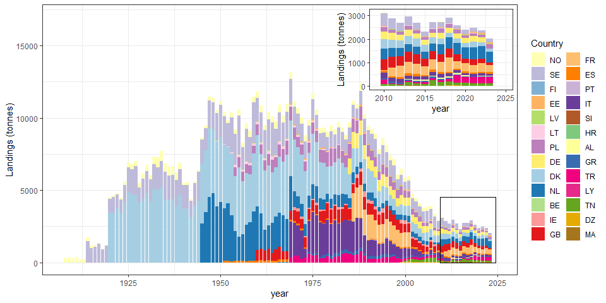

Figure 3: Time-series of reported commercial yellow (Y), silver (S) and yellow-silver (YS) eel fishery landings (tonnes) 1908-2023 by country, Norway(NO), Greece(GR), Finland(FI), France(FR), Tunisia(TN), Denmark(DK), Lithuania(LT), Germany(DE), Italy(IT), Ireland(IE), Poland(PL), Netherlands(NL), Croatia(HR), Libya(LY), Estonia(EE), Algeria(DZ), Sweden(SE), Turkey(TR), United Kingdom(GB), Albania(AL), Spain(ES), Latvia(LV), Belgium(BE), Morocco(MA), Slovenia(SI), Portugal(PT) are included, combining information from the Data call2024and the WGEEL database updated to2023

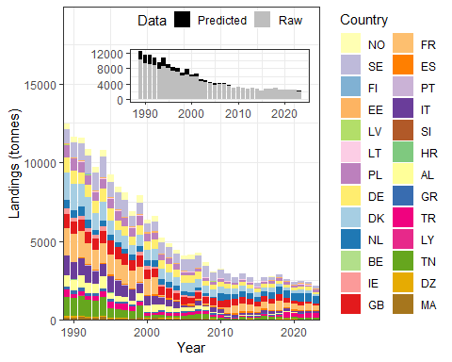

Figure 4: Time-series of reported commercial yellow (Y), silver (S) and yellow-silver (YS) eel fishery landings (tonnes) by country and a reconstruction of the non-reported countries/years combinations. Norway(NO), Greece(GR), Finland(FI), France(FR), Tunisia(TN), Denmark(DK), Lithuania(LT), Germany(DE), Italy(IT), Ireland(IE), Poland(PL), Netherlands(NL), Croatia(HR), Libya(LY), Estonia(EE), Algeria(DZ), Sweden(SE), Turkey(TR), United Kingdom(GB), Albania(AL), Spain(ES), Latvia(LV), Belgium(BE), Morocco(MA), Slovenia(SI), Portugal(PT) are included, combining information from the Data call 2024 and the WGEEL database updated to 2023 The inset box shows the proportion of reconstructed landings per year

## Recreational fisheries

Figure 6 presents data available to the WGEEL on recreational landings for glass eel from Spain and France. Recreational fisheries for glass eel were banned in in France in 2010. In Spain it was banned in 2023, in agreement with the 2023 EU Council Regulation 2023/194 and 2023/195, which banned all recreational fisheries in marine areas. The EU Council ban was continued in 2024 by Council Regulation 2024/257 and 2024/259. In the Mediterranean, all recreational fisheries in all habitats were banned since 2024 by EU Council Regulation 2023/2124. In some countries, recreational fisheries in freshwater were also banned through local regulations (e.g. UK, Portugal, Sweden, Norway).

Figure 5 presents the data available on recreational landings of yellow and silver eel combined. Recreational landings for yellow and silver eel combined were 551.06 t for 2022 (15 countries reporting) and 86 t for 2023 (10 countries reported). France has provided estimation for all freshwater recreational fisheries in 2006, while for other years, France provided declared catch by recreational fishers with gear in public rivers. The available data have been considered by the WGEEL jointly with the other series in Europe. The mean yellow and silver eel recreational fisheries for the previous five years (2017–2021) was 520.612 t. The data for 2023 is provisional and may change since some countries does not report the landings annually (e.g. Germany).

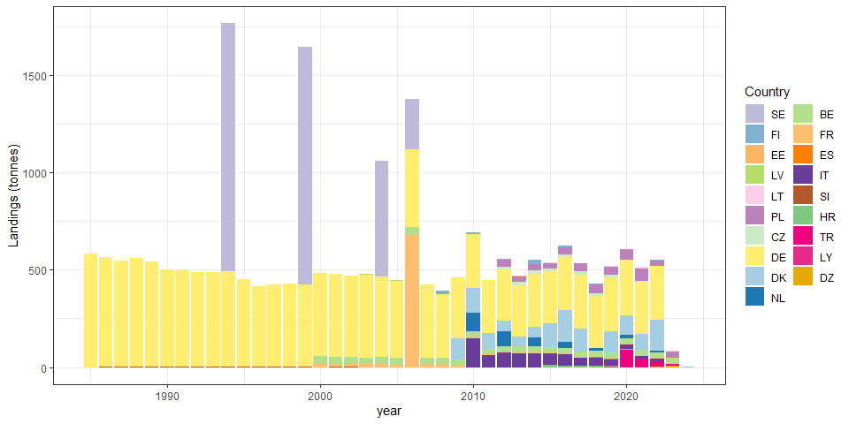

Figure 5: Time-series of reported or reconstructed recreational yellow and silver eel fishery landings (tonnes), by country. Ireland(IE), Spain(ES), Finland(FI), France(FR), Turkey(TR), Germany(DE), Latvia(LV), Czech republic(CZ), Lithuania(LT), Poland(PL), Italy(IT), Libya(LY), Algeria(DZ), Denmark(DK), Slovenia(SI), Croatia(HR), Estonia(EE), Belgium(BE), Netherlands(NL), Sweden(SE) .

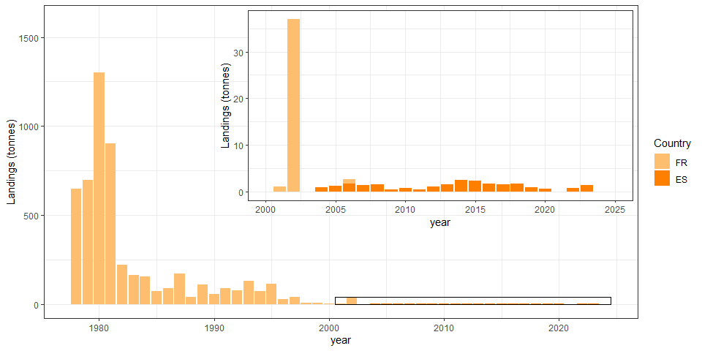

Figure 6: Time-series of reported recreational glass eel fishery landings (tonnes), 1978-2024 by country, France(FR), Spain(ES).

## Illegal, unreported and unregulated landings

Illegal, unreported, and unregulated fishing (IUU) is by its nature very difficult to quantify, and misreporting may therefore be substantial. Organised illegal glass eel trade is supplied by legally caught and IUU caught eel. This trade is considered high priority by Europol (the European Union’s law enforcement agency) among environmental crimes, due to its eco-nomic significance, the poor status of the eel stock, and the large number of organisations affected. Related police action and court decisions have been covered by many news reports during recent years. In addition, illegal eel trade from range states is an issue of concern for CITES (CITES, 2023). To summarize, while IUU fisheries certainly exist for glass, yellow and silver eel, there are insufficient data available to quantify their effect on the total stock size or status with any level of certainty. Thus, efforts to improve traceability (and better understanding of demand) will assist enforcement but also allow us to better understand what proportion of legal catch enters illegal trade, and thus estimate illegal catch which would be useful to informing characterization of the impacts of all fisheries on the stock.

## Releases

Data have been reported on restocking which includes eels released at the glass eel phase, either directly (G), or after a quarantine (QG), after a period of some months of growth in aquaculture (OG), at the yellow eel (Y) or silver eel (S) stage.There are also some releases of mixed life stages: Glass + Yellow eel (G+Y) and Yellow + Silver eel (Y+S) for Ireland and Spain, but they will not be presented in this report (see country reports for more details). To futher complicate the matter, displacements of eel can range from a few meters within the same waterbody (i.e. assisted migration to bypass an obstacle), to eel being moved between waterbodies and/or EMUs. There are still inconsistencies and variations in how countries report these displacements. Therefore, the WGEEL broadly categorizes them as “releases”.

### Glass eel releases (G + QG)

Restocking of glass eel (G + QG) peaked during 1980s and was followed by a decline to a low level in 2009 (Figure 7). The amount of restocked glass eels has increase since 2010 with high numbers in 2014, and from 2018 to 2022, when the lower market prices guaranteed a larger number of glass eels could be purchased for fixed restocking budgets. The quantity of glass eels (G + QG) released in 2022 and 2023 was 15.96 and 8.94 tonnes (Number of countries reporting: 11 and 12).

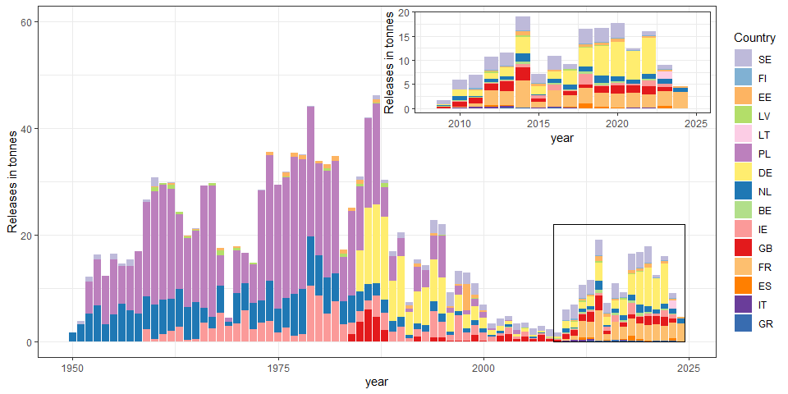

Figure 7: Reported releases of glass eel (G + QG, in tonnes) per country Ireland(IE), United Kingdom(GB), Estonia(EE), Netherlands(NL), Germany(DE), Latvia(LV), Lithuania(LT), Sweden(SE), Italy(IT), Poland(PL), Finland(FI), Spain(ES), Greece(GR), France(FR), Belgium(BE). Inset shows years since 2009 in greater resolution. 2024 and 2023 are provisional data (data are missing from 2024 because not all the countries have reported yet and from 2023 because German data have not been reported yet).

[**********move the figures related to other landings to the annex]

#*************************************************************************

#[remove this section, QG are now reported together with G] #Only Sweden and Finland have reported quarantined glass eel restocking. #Quarantined glass eel restocking peaked in the 1990s, decreased in the early #2000s and increased again after the implementation of the Eel Regulation.

#*************************************************************************

### Ongrown eel (OG) and yellow eel (Y) releases

Releases of ongrown eels are presented in Figure 9. It has constantly increased since 2000 and reached a maximum in 2022 (Figure 9 ).

Releases of yellow eel are represented in Figures 8. The quantity of yellow eels (Y) released in 2022 and 2023 was 2.44 and 0.84 tonnes (Number of countries reporting: 2 and 1).

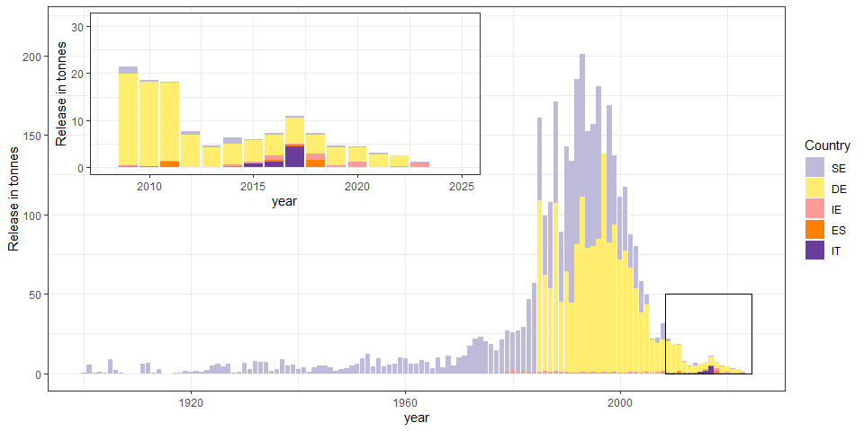

Figure 8: Reported releases of yellow eel (in tons) per country. Spain(ES), Italy(IT), Ireland(IE), Sweden(SE), Germany(DE). Inset shows the last 15 years in more detail. Data for recent years are provisional or incomplete and may change in future data calls.

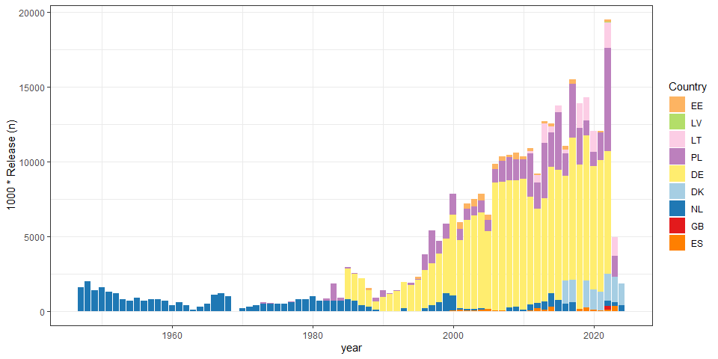

Figure 9: Reported releases of ongrown glass eel (OG, in thousands) per country, United Kingdom(GB), Lithuania(LT), Germany(DE), Poland(PL), Netherlands(NL), Estonia(EE), Denmark(DK), Latvia(LV), Spain(ES). Data for recent years are provisional or incomplete and may change in future data calls.

### Silver eel releases

A certain percentage of silver eels caught by the fishery, and therefore recorded as landings, are later released in the Mediterranean outside the lagoons in Greece (30% of caught silver eels) and France. These are reported as released silvers (Figure 10. Spain has made anecdotal releases of silver eels from farms. The quantity of silver eels (S) released in 2022 and 2023 is 129.99 and 130.24 tonnes (Number of countries reporting: 7 and 5).

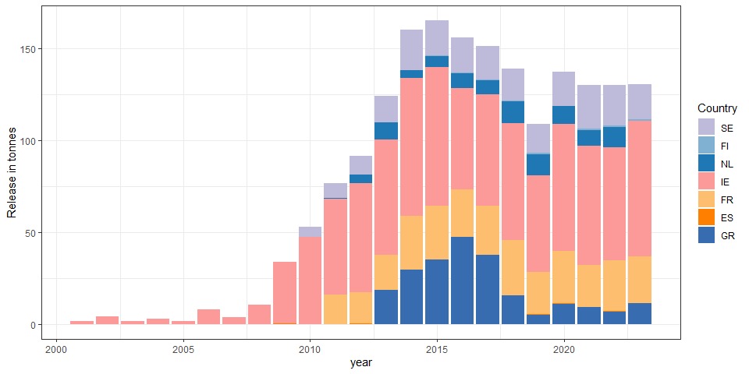

Figure 10: Reported releases of silver eel (in tonnes) per country, Netherlands(NL), Finland(FI), Ireland(IE), Sweden(SE), Greece(GR), France(FR), Spain(ES).

## Other landings

All other landings, coming neither from professional or recreational fisheries were recorded separately. Most of them concern translocation within an EMU to mitigate the impact of barriers to migration. Glass eel translocations (Annex XX). were only reported by Ireland (since 1959, by numbers and mass) and the United King-dom (since 1996, by mass only). Yellow eel translocations were only reported in Sweden and Ireland (Annex XX) and silver eel translocations in 5 countries: mainly in Sweden, Ireland and Finland, and to a lesser extend in Netherlands and Spain (Annex XX).

### Release all stage (remove me)

# Aquaculture

All aquaculture for eel currently depends upon wild eel for seeding. Aquaculture production data are derived from responses to the data call 2024. Aquaculture production increased from the 1980s, peaking in 2004 at just under 8,600 t. Since then it has steadily declined to approximately 4994.92 t by 2022 countries reporting: raqua_cou_CY2)(Figure 11). The mean aquaculture production for the 5-year period (2017-2021) is 5076.632 t. Lithuania had one farm in operation from 2017 to 2023 and cannot report production for that period due to confidentiality. Estonia has a similar situation, with less than 3 eel farms since 2018.

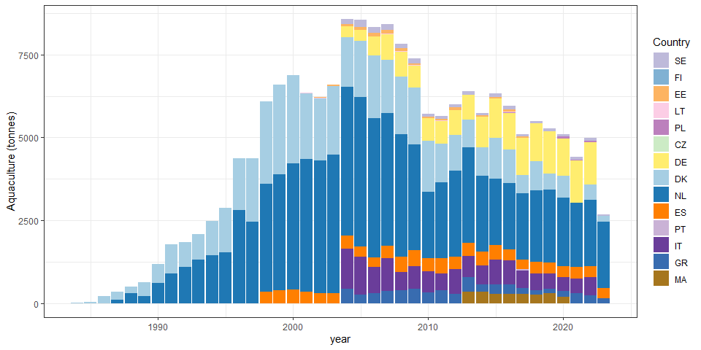

Figure 11: Reported aquaculture production of European eel in Europe from 1984 onwards, in tonnes, in Sweden (SE), Finland (FI), Estonia (EE), Lithuania (LT), Poland (PL), Germany (DE), Denmark (DK), Netherlands (NL), Ireland (IE), Spain (ES), Portugal (PT), Italy (IT) and Greece (GR).

# tables

Table 1: Table 1: Glass eel commercial fisheries landings (in tonnes) from 1984 to 2024, reported by countries: GB United Kingdom, FR France, ES Spain, PT Portugal, IT Italy.

| Year | GB | FR | ES | PT | IT | total |
| --- | --- | --- | --- | --- | --- | --- |
| 1945 |  |  | 119.2 |  |  | 119.2 |
| 1946 |  |  | 71.9 |  |  | 71.9 |
| 1947 |  |  | 100.1 |  |  | 100.1 |
| 1948 |  |  | 110.6 |  |  | 110.6 |
| 1949 |  |  | 9.3 |  |  | 9.3 |
| 1950 |  |  | 3.8 |  |  | 3.8 |
| 1951 |  |  | 2.1 |  |  | 2.1 |
| 1953 |  |  | 2.5 |  |  | 2.5 |
| 1954 |  |  | 5.9 |  |  | 5.9 |
| 1955 |  |  | 0.9 |  |  | 0.9 |
| 1956 |  |  | 0.9 |  |  | 0.9 |
| 1957 |  |  | 2.8 |  |  | 2.8 |
| 1958 |  |  | 0.4 |  |  | 0.4 |
| 1959 |  |  | 6.6 |  |  | 6.6 |
| 1960 |  |  | 9.5 |  |  | 9.5 |
| 1961 |  |  | 16.7 |  |  | 16.7 |
| 1962 |  |  | 11.1 |  |  | 11.1 |
| 1963 |  |  | 8 |  |  | 8 |
| 1964 |  |  | 11 |  |  | 11 |
| 1965 |  |  | 4 |  |  | 4 |
| 1966 |  |  | 6 |  |  | 6 |
| 1967 |  |  | 5 |  |  | 5 |
| 1968 |  |  | 4 |  |  | 4 |
| 1969 |  |  | 4 |  |  | 4 |
| 1970 |  |  | 5 |  |  | 5 |
| 1971 |  |  | 1 |  |  | 1 |
| 1972 | 16.7 |  | 1 |  |  | 17.7 |
| 1973 | 28.2 |  | 1 |  |  | 29.2 |
| 1974 | 57.5 |  | 2 | 1.6 |  | 61.1 |
| 1975 | 10.5 |  | 2.6 | 5.6 |  | 18.7 |
| 1976 | 13.1 |  | 11.6 | 12.5 |  | 37.2 |
| 1977 | 38.6 |  | 17.5 | 22.6 |  | 78.7 |
| 1978 | 61.2 | 1393 | 21.6 | 7.3 |  | 1483.1 |
| 1979 | 67 | 1850 | 17.3 | 8.8 |  | 1943.1 |
| 1980 | 40.1 | 1491 | 15.4 | 10.1 |  | 1556.6 |
| 1981 | 36.9 | 890 | 13 | 18 |  | 957.9 |
| 1982 | 48 | 866 | 19.3 | 22.2 |  | 955.5 |
| 1983 | 16.9 | 791 | 10.3 | 6.7 |  | 824.9 |
| 1984 | 25 | 528 | 16.4 | 16.1 |  | 585.5 |
| 1985 | 20 | 444 | 18.3 | 14.8 |  | 497.1 |
| 1986 | 19 | 423 | 6.4 | 7 |  | 455.4 |
| 1987 | 21.3 | 461 | 9.4 | 9.5 |  | 501.2 |
| 1988 | 21.4 | 504 | 9.9 | 2.6 |  | 537.9 |
| 1989 | 20.6 | 410 | 9.9 | 2.8 |  | 443.3 |
| 1990 | 20.9 | 325 | 5.3 | 4.5 |  | 355.7 |
| 1991 | 1.1 | 179 | 6.8 | 2.8 |  | 189.7 |
| 1992 | 5 | 183 | 3.7 | 4.5 |  | 196.2 |
| 1993 | 5.7 | 329 | 5.2 | 3.6 |  | 343.5 |
| 1994 | 9.5 | 329 | 2.4 | 2.9 |  | 343.8 |
| 1995 | 11.9 | 413 | 4.9 | 5.3 |  | 435.1 |
| 1996 | 18.8 | 262 | 14.5 | 8.7 |  | 304 |
| 1997 | 8.7 | 287 | 12 | 4.4 |  | 312.1 |
| 1998 | 11.2 | 195 | 14.1 | 4.5 |  | 224.8 |
| 1999 |  | 242 | 13.9 | 3.6 |  | 259.5 |
| 2000 |  | 206 | 11 | 3 |  | 220 |
| 2001 | 0.8 | 101 | 12 | 1.1 |  | 114.9 |
| 2002 | 0.5 | 202 | 8.6 | 0.8 |  | 211.9 |
| 2003 | 1.7 | 151 | 10 | 1.4 |  | 164.1 |
| 2004 | 1 | 89 | 5.1 | 0.8 |  | 95.9 |
| 2005 | 1.7 | 89 | 6.4 | 1.2 |  | 98.3 |
| 2006 | 1.3 | 67 | 4.1 | 2.7 |  | 75.1 |
| 2007 | 2.1 | 77 | 5.2 | 0.9 |  | 85.2 |
| 2008 | 0.8 | 79 | 5.1 | 0.8 |  | 85.7 |
| 2009 | 0.3 |  | 3.7 | 1.4 |  | 5.4 |
| 2010 | 1.3 | 41 | 6.5 | 2.4 |  | 51.2 |
| 2011 | 2.3 | 31.3 | 5.2 | 1.1 |  | 39.9 |
| 2012 | 2.8 | 34.3 | 5.3 | 0.8 |  | 43.2 |
| 2013 | 5.9 | 33.6 | 7.2 | 1.1 |  | 47.8 |
| 2014 | 12 | 35.3 | 11.3 | 1.2 | 0.4 | 60.2 |
| 2015 | 2.8 | 36.1 | 8.8 | 1.3 | 0.2 | 49.2 |
| 2016 | 4 | 46.4 | 6.6 | 0.4 | 0.1 | 57.5 |
| 2017 | 3.3 | 43.2 | 11.1 | 2.2 | 0.1 | 59.9 |
| 2018 | 4.2 | 53.4 | 4.5 | 1 | 0.2 | 63.3 |
| 2019 | 6.6 | 50 | 4.3 | 0.6 | 0.2 | 61.7 |
| 2020 | 3.4 | 48.7 | 6.3 | 0.9 |  | 59.3 |
| 2021 | 0.1 | 46.6 | 4.5 | 1.2 |  | 52.4 |
| 2022 | 1.1 | 53.9 | 4.7 | 0.9 |  | 60.6 |
| 2023 | 0.9 | 49 | 3.6 | 0.5 |  | 54 |
| 2024 | 1.4 | 50.9 | 3.3 | 0.5 |  | 56.1 |

Table 2: part a Commercial fisheries landings (in tonnes) for yellow eel and silver eel from 1908 to 2023 (part 1), reported by countries : Albania(AL), Belgium(BE), Germany(DE), Denmark(DK), Algeria(DZ), Estonia(EE), Spain(ES), Finland(FI), France(FR), United Kingdom(GB), Greece(GR) (to be continued for other countries in next table).

| Year | AL | BE | DE | DK | DZ | EE | ES | FI | FR | GB | GR |
| --- | --- | --- | --- | --- | --- | --- | --- | --- | --- | --- | --- |
| 1908 |  |  |  |  |  |  |  |  |  |  |  |
| 1909 |  |  |  |  |  |  |  |  |  |  |  |
| 1910 |  |  |  |  |  |  |  |  |  |  |  |
| 1911 |  |  |  |  |  |  |  |  |  |  |  |
| 1912 |  |  |  |  |  |  |  |  |  |  |  |
| 1913 |  |  |  |  |  |  |  |  |  |  |  |
| 1914 |  |  |  |  |  |  |  |  |  |  |  |
| 1915 |  |  |  |  |  |  |  |  |  |  |  |
| 1916 |  |  |  |  |  |  |  |  |  |  |  |
| 1917 |  |  |  |  |  |  |  |  |  |  |  |
| 1918 |  |  |  |  |  |  |  |  |  |  |  |
| 1919 |  |  |  |  |  |  |  |  |  |  |  |
| 1920 |  |  |  | 3413 |  |  |  |  |  |  |  |
| 1921 |  |  |  | 3443 |  |  |  |  |  |  |  |
| 1922 |  |  |  | 3760 |  |  |  |  |  |  |  |
| 1923 |  |  |  | 3396 |  |  |  |  |  |  |  |
| 1924 |  |  |  | 4130 |  |  |  |  |  |  |  |
| 1925 |  |  |  | 4880 |  |  |  |  |  |  |  |
| 1926 |  |  |  | 4726 |  |  |  |  |  |  |  |
| 1927 |  |  |  | 4648 |  |  |  |  |  |  |  |
| 1928 |  |  |  | 4117 |  |  |  |  |  |  |  |
| 1929 |  |  |  | 4375 |  |  |  |  |  |  |  |
| 1930 |  |  |  | 4773 |  |  |  |  |  |  |  |
| 1931 |  |  |  | 4195 |  |  |  |  |  |  |  |
| 1932 |  |  |  | 5088 |  |  |  |  |  |  |  |
| 1933 |  |  |  | 5014 |  |  |  |  |  |  |  |
| 1934 |  |  |  | 5171 |  |  |  |  |  |  |  |
| 1935 |  |  |  | 4316 |  |  |  |  |  |  |  |
| 1936 |  |  |  | 4332 |  |  |  |  |  |  |  |
| 1937 |  |  |  | 4329 |  |  |  |  |  |  |  |
| 1938 |  |  |  | 3849 |  |  |  |  |  |  |  |
| 1939 |  |  |  | 4662 |  |  |  |  |  |  |  |
| 1940 |  |  |  | 3709 |  |  |  |  |  |  |  |
| 1941 |  |  |  | 3717 |  |  |  |  |  |  |  |
| 1942 |  |  |  | 3140 |  |  |  |  |  |  |  |
| 1943 |  |  |  | 3917 |  |  |  |  |  |  |  |
| 1944 |  |  |  | 4245 |  |  |  |  |  |  |  |
| 1945 |  |  |  | 4169 |  |  |  |  |  |  |  |
| 1946 |  |  |  | 4269 |  |  |  |  |  |  |  |
| 1947 |  |  |  | 4784 |  |  |  |  |  |  |  |
| 1948 |  |  |  | 4386 |  |  |  |  |  |  |  |
| 1949 |  |  |  | 4492 |  |  |  |  |  |  |  |
| 1950 |  |  |  | 4500 |  |  |  |  |  |  |  |
| 1951 |  |  |  | 4400 |  |  | 90 |  |  |  |  |
| 1952 |  |  |  | 3900 |  |  | 102.2 |  |  |  |  |
| 1953 |  |  |  | 4300 |  |  | 80.2 |  |  |  |  |
| 1954 |  |  |  | 3800 |  |  | 97.7 |  |  |  |  |
| 1955 |  |  |  | 4800 |  |  | 102.9 |  |  |  |  |
| 1956 |  |  |  | 3700 |  |  | 106.1 |  |  |  |  |
| 1957 |  |  |  | 3600 |  |  | 80 |  |  |  |  |
| 1958 |  |  |  | 3300 |  |  | 115 |  |  |  |  |
| 1959 |  |  |  | 4000 |  |  | 100 |  |  |  |  |
| 1960 |  |  |  | 4937 |  |  | 98 |  |  | 771.7 |  |
| 1961 |  |  |  | 4110 |  |  | 153.8 |  |  | 768.4 |  |
| 1962 |  |  |  | 4122 |  |  | 114.9 |  |  | 696.1 |  |
| 1963 |  |  |  | 4166 |  |  | 136.9 |  |  | 787.8 |  |
| 1964 |  |  |  | 3505 |  | 3 | 91.5 |  |  | 548.9 |  |
| 1965 |  |  |  | 3402 |  | 0.3 | 130.4 |  |  | 783.8 |  |
| 1966 |  |  |  | 3901 |  | 1.9 | 191.5 |  |  | 881 | 14.9 |
| 1967 |  |  |  | 3679 |  | 2.7 | 163.8 |  |  | 568.7 | 19 |
| 1968 |  |  |  | 4476 |  | 2.9 | 175.6 |  |  | 585.6 | 4.9 |
| 1969 |  |  |  | 3878 |  | 49 | 136.4 |  |  | 605.6 | 2.9 |
| 1970 |  |  |  | 3558 |  | 61.5 | 119.4 |  |  | 752.1 | 0 |
| 1971 |  |  |  | 3378 |  | 59.5 | 107.4 |  |  | 842.2 | 0 |
| 1972 |  |  |  | 3429 |  | 73.4 | 119.4 |  |  | 632.6 | 4.3 |
| 1973 |  |  |  | 3656 |  | 69 | 100.2 |  |  | 723.2 | 15.5 |
| 1974 |  |  |  | 2977 |  | 51.1 | 93.4 |  |  | 765 | 129.8 |
| 1975 |  |  |  | 3485 |  | 82.1 | 78 |  |  | 762.2 | 133.8 |
| 1976 |  |  |  | 3054 |  | 71.6 | 82.7 |  |  | 621.7 | 158.7 |
| 1977 |  |  |  | 2502 |  | 65.8 | 79.9 |  |  | 690.5 | 89.2 |
| 1978 |  |  |  | 2492 |  | 63.2 | 67 |  |  | 823.6 | 225.3 |
| 1979 |  |  |  | 1904 |  | 28.5 | 96.8 |  |  | 1045 | 185.5 |
| 1980 |  |  |  | 2288 |  | 25.7 | 89.8 |  |  | 912.2 | 226.9 |
| 1981 |  |  |  | 2227 |  | 21.9 | 97.7 |  |  | 907.1 | 250.6 |
| 1982 |  |  |  | 2541 |  | 13.9 | 19.9 |  |  | 942.5 | 255.2 |
| 1983 |  |  |  | 2119 |  | 28.8 | 18.4 |  |  | 866.4 | 200.8 |
| 1984 |  |  |  | 1871 |  | 72.2 | 11 |  |  | 973.4 | 285.4 |
| 1985 |  |  | 1096.7 | 1630 |  | 75.1 | 16.5 |  |  | 750 | 189.6 |
| 1986 |  |  | 1118.7 | 1672 |  | 61.1 | 13.4 |  | 1944 | 650.8 | 151.6 |
| 1987 |  |  | 1031 | 1279 |  | 66.7 | 21.2 |  | 2062 | 684.1 | 266.3 |
| 1988 |  |  | 1018 | 1878 |  | 109.7 | 13.9 |  | 2265 | 933.6 | 268.1 |
| 1989 |  |  | 963.6 | 1696 |  | 54.8 | 5.3 |  | 1746 | 874.7 | 155.6 |
| 1990 |  |  | 829.7 | 1675 |  | 61.3 | 8.7 |  | 1778 | 783.9 | 194.2 |
| 1991 |  |  | 724.7 | 1465 |  | 52.4 | 49.8 |  | 1645 | 736.9 | 209.4 |
| 1992 |  |  | 761.7 | 1451 |  | 39.4 | 54.3 |  | 1321 | 715.4 | 184.8 |
| 1993 |  |  | 790.1 | 1080 |  | 59.2 | 66.5 |  | 1280 | 670.7 | 181.9 |
| 1994 |  |  | 833.1 | 1200 |  | 46.9 | 50.7 |  | 1280 | 777.8 | 200.5 |
| 1995 |  |  | 777.9 | 892 |  | 45.4 | 69.4 |  | 1280 | 899.6 | 201.4 |
| 1996 |  |  | 603 | 751.5 |  | 55.1 | 61.7 |  | 1280 | 805.2 | 151.3 |
| 1997 |  |  | 616.2 | 797 |  | 59.1 | 61.5 |  | 1223 | 730.7 | 136.5 |
| 1998 |  |  | 566.9 | 597 |  | 44.2 | 43.6 |  | 1150 | 693.4 | 87.6 |
| 1999 |  |  | 645.1 | 717 | 20.4 | 64.8 | 48.3 |  | 1005 | 667.8 | 80.7 |
| 2000 |  | 2.9 | 591.2 | 628 | 17.2 | 67 | 55.3 |  | 1008.8 | 587.2 | 88.1 |
| 2001 |  | 2.9 | 569 | 707 | 44.5 | 67 | 130.2 |  | 1024.1 | 582.7 | 93.4 |
| 2002 |  | 2.9 | 543.9 | 614 | 25.4 | 49.9 | 105.6 |  | 30.4 | 551.1 | 136.3 |
| 2003 |  | 2.9 | 497.9 | 648 | 25.2 | 48.6 | 95.6 |  | 21.4 | 552.3 | 76.5 |
| 2004 |  | 2.9 | 475.3 | 546 | 29 | 39.2 | 85.3 |  | 12.5 | 471.7 | 58.1 |
| 2005 |  | 2.9 | 454.8 | 534 | 7.6 | 30.7 | 88 |  | 7.8 | 477.2 | 116.1 |
| 2006 |  |  | 472.2 | 596 | 2.7 | 33.4 | 115.6 |  | 15 | 383.5 | 77.1 |
| 2007 |  |  | 423.6 | 537 | 14.6 | 31.1 | 82.1 |  | 26.1 | 450.4 | 89.7 |
| 2008 |  |  | 352.8 | 466 | 13.9 | 30.6 | 65.6 | 1 | 31.4 | 400.6 | 71.1 |
| 2009 |  |  | 311.6 | 467 | 14.2 | 22.1 | 89.2 | 1.8 | 42 | 462.4 | 78.5 |
| 2010 |  |  | 318.5 | 422 | 3.4 | 18.9 | 76.1 | 2.3 | 20.2 | 461.1 | 58.6 |
| 2011 |  |  | 287 | 370 |  | 16.2 | 61.6 | 1.5 | 368 | 455.9 | 83.2 |
| 2012 |  |  | 246.9 | 317 | 0.4 | 17.7 | 85.4 | 1.5 | 472.6 | 415.1 | 55.2 |
| 2013 | 47 |  | 265.9 | 356 | 3 | 17.4 | 86.7 | 1.3 | 504.1 | 426.5 | 38 |
| 2014 | 43 |  | 231.1 | 346 | 6 | 16.7 | 91.6 | 1 | 434.4 | 392.8 | 58.3 |
| 2015 | 50 |  | 213.7 | 282 | 3 | 14.2 | 63.7 | 0.6 | 356.9 | 341 | 60.2 |
| 2016 | 41 |  | 208.8 | 265 | 2 | 15.2 | 83 | 1.3 | 442.6 | 347.2 | 60.9 |
| 2017 | 47 | 0 | 244.3 | 257.3 | 10.6 | 15.7 | 76.7 | 1.1 | 434.1 | 321.8 | 48.3 |
| 2018 | 60 |  | 228.6 | 181.8 | 33 | 18.3 | 64.1 | 1.1 | 617.4 | 366.9 | 42.8 |
| 2019 | 70 |  | 209.7 | 183.3 | 25.2 | 21.7 | 57.6 | 0.4 | 309.6 | 295.6 | 20.4 |
| 2020 | 40 |  | 228.9 | 182.2 | 18 | 38.8 | 81.7 | 0.4 | 347.4 | 182.2 | 27.9 |
| 2021 | 22 |  | 223.4 | 233.7 | 4.7 | 47.9 | 69.6 | 0.4 | 309.4 | 244 | 19.2 |
| 2022 | 17 |  | 207.8 | 163.1 | 7.6 | 52.4 | 66.1 | 2.3 | 376.2 | 166.7 | 17.5 |
| 2023 | 20 |  |  | 125.2 | 3.4 | 59.5 | 69.5 |  | 308.4 | 104.7 | 19.4 |

Table 2: part b Commercial fisheries landings (in tonnes) for yellow eel and silver eel from 1908 to 2023 (part 2), reported by countries : Croatia(HR), Ireland(IE), Italy(IT), Lithuania(LT), Latvia(LV), Libya(LY), Morocco(MA), Netherlands(NL), Norway(NO), Poland(PL), Portugal(PT) (to be continued for other countries in next table).

| Year | HR | IE | IT | LT | LV | LY | MA | NL | NO | PL | PT |
| --- | --- | --- | --- | --- | --- | --- | --- | --- | --- | --- | --- |
| 1908 |  |  |  |  |  |  |  |  | 268.1 |  |  |
| 1909 |  |  |  |  |  |  |  |  | 326.6 |  |  |
| 1910 |  |  |  |  |  |  |  |  | 303.1 |  |  |
| 1911 |  |  |  |  |  |  |  |  | 383.8 |  |  |
| 1912 |  |  |  |  |  |  |  |  | 187.3 |  |  |
| 1913 |  |  |  |  |  |  |  |  | 212.7 |  |  |
| 1914 |  |  |  |  |  |  |  |  | 282 |  |  |
| 1915 |  |  |  |  |  |  |  |  | 143 |  |  |
| 1916 |  |  |  |  |  |  |  |  | 117 |  |  |
| 1917 |  |  |  |  |  |  |  |  | 44 |  |  |
| 1918 |  |  |  |  |  |  |  |  | 35 |  |  |
| 1919 |  |  |  |  |  |  |  |  | 64 |  |  |
| 1920 |  |  |  |  |  |  |  |  | 80 |  |  |
| 1921 |  |  |  |  |  |  |  |  | 79 |  |  |
| 1922 |  |  |  |  |  |  |  |  | 94 |  |  |
| 1923 |  |  |  |  |  |  |  |  | 140 |  |  |
| 1924 |  |  |  |  |  |  |  |  | 290 |  |  |
| 1925 |  |  |  |  |  |  |  |  | 325 |  |  |
| 1926 |  |  |  |  |  |  |  |  | 341 |  |  |
| 1927 |  |  |  |  |  |  |  |  | 354 |  |  |
| 1928 |  |  |  |  |  |  |  |  | 325 |  |  |
| 1929 |  |  |  |  |  |  |  |  | 425 |  |  |
| 1930 |  |  |  |  |  |  |  |  | 450 |  |  |
| 1931 |  |  |  |  |  |  |  |  | 329 |  |  |
| 1932 |  |  |  |  |  |  |  |  | 518 |  |  |
| 1933 |  |  |  |  |  |  |  |  | 694 |  |  |
| 1934 |  |  |  |  |  |  |  |  | 674 |  |  |
| 1935 |  |  |  |  |  |  |  |  | 564 |  |  |
| 1936 |  |  |  |  |  |  |  |  | 631 |  |  |
| 1937 |  |  |  |  |  |  |  |  | 603 |  |  |
| 1938 |  |  |  |  |  |  |  |  | 526 |  |  |
| 1939 |  |  |  |  |  |  |  |  | 434 |  |  |
| 1940 |  |  |  |  |  |  |  |  | 143 |  |  |
| 1941 |  |  |  |  |  |  |  |  | 174 |  |  |
| 1942 |  |  |  |  |  |  |  |  | 131 |  |  |
| 1943 |  |  |  |  |  |  |  |  | 136 |  |  |
| 1944 |  |  |  |  |  |  |  |  | 150 |  |  |
| 1945 |  |  |  |  |  |  |  | 2668 | 102 |  |  |
| 1946 |  |  |  |  |  |  |  | 3492 | 167 |  |  |
| 1947 |  |  |  | 8 | 10 |  |  | 4502 | 268 |  |  |
| 1948 |  |  |  | 14 | 10 |  |  | 4799 | 293 |  |  |
| 1949 |  |  |  | 21 | 50 |  |  | 3873 | 214 |  |  |
| 1950 |  |  |  | 29 | 10 |  |  | 4152 | 282 |  |  |
| 1951 |  |  |  | 32 | 10 |  |  | 3661 | 312 |  |  |
| 1952 |  |  |  | 39 | 10 |  |  | 3978 | 178 |  |  |
| 1953 |  |  |  | 80 | 20 |  |  | 3157 | 371 |  |  |
| 1954 |  |  |  | 147 | 20 |  |  | 2085 | 327 | 609 |  |
| 1955 |  |  |  | 163 | 40 |  |  | 1651 | 451 | 732 |  |
| 1956 |  |  |  | 131 | 20 |  |  | 1817 | 293 | 656 |  |
| 1957 |  |  |  | 168 | 20 |  |  | 2509 | 430 | 616 |  |
| 1958 |  |  |  | 149 | 20 |  |  | 2674 | 437 | 635 |  |
| 1959 |  |  |  | 155 | 24 |  |  | 3413 | 409 | 566 |  |
| 1960 |  |  |  | 165 | 37 |  |  | 2999 | 430 | 733 |  |
| 1961 |  |  |  | 139 | 43 |  |  | 2452 | 449 | 640 |  |
| 1962 |  |  |  | 155 | 41 |  |  | 1443 | 356 | 663 |  |
| 1963 |  |  |  | 260 | 56 |  |  | 1618 | 503 | 762 |  |
| 1964 |  |  |  | 225 | 37 |  |  | 2068 | 440 | 884 |  |
| 1965 |  |  |  | 125 | 35 |  |  | 2268 | 523 | 682 |  |
| 1966 |  |  |  | 238 | 33 |  |  | 2339 | 510 | 804 |  |
| 1967 |  |  |  | 153 | 39 |  |  | 2524 | 491 | 906 |  |
| 1968 |  |  |  | 165 | 28 |  |  | 2209 | 569 | 943 |  |
| 1969 |  |  | 2469 | 134 | 36 |  |  | 2389 | 522 | 935 |  |
| 1970 |  | 200 | 2300 | 118 | 29 |  |  | 1111 | 422 | 847 |  |
| 1971 |  | 200 | 2113 | 124 | 29 |  |  | 853 | 415 | 722 |  |
| 1972 |  | 200 | 1997 | 126 | 25 |  |  | 857 | 422 | 696 |  |
| 1973 |  | 91 | 588 | 120 | 27 |  |  | 823 | 409 | 644.7 |  |
| 1974 |  | 67 | 2122 | 86 | 20 |  |  | 840 | 368 | 691.1 |  |
| 1975 |  | 79 | 2886 | 114 | 19 |  |  | 1000 | 407 | 809.7 |  |
| 1976 |  | 150 | 2596 | 88 | 24 |  |  | 1172 | 386 | 760.5 |  |
| 1977 |  | 108 | 2390 | 68 | 16 |  |  | 783 | 352 | 867.8 |  |
| 1978 |  | 76 | 2172 | 70 | 18 |  |  | 719 | 347 | 910.4 |  |
| 1979 |  | 110 | 2354 | 57 | 21 |  |  | 530 | 374 | 978.9 |  |
| 1980 |  | 75 | 2198 | 45 | 9 |  |  | 664 | 387 | 1214 |  |
| 1981 |  | 94 | 2270 | 27 | 10 |  |  | 722 | 369 | 943.5 |  |
| 1982 |  | 144 | 2025 | 28 | 12 |  |  | 842 | 385 | 911.3 |  |
| 1983 |  | 117 | 2013 | 23 | 9 |  |  | 937 | 324 | 868 |  |
| 1984 |  | 88 | 2050 | 27 | 12 |  |  | 691 | 310 | 819.4 |  |
| 1985 |  | 87 | 2135 | 29 | 18 |  |  | 679 | 352 | 1022.5 |  |
| 1986 |  | 87 | 2134 | 32 | 19 |  |  | 721 | 272 | 920.7 |  |
| 1987 |  | 230 | 2265 | 20 | 25 |  |  | 538 | 282 | 886.6 |  |
| 1988 |  | 215 | 2027 | 23 | 15 |  |  | 425 | 513 | 943.3 |  |
| 1989 |  | 400 | 1243 | 21 | 13 |  |  | 526 | 313 | 812.8 | 13.5 |
| 1990 |  | 256 | 1088 | 19 | 13 |  |  | 472 | 336 | 768.1 | 13 |
| 1991 |  | 245 | 1097 | 16 | 14 |  |  | 573 | 323 | 669.7 | 23.5 |
| 1992 |  | 234 | 1084 | 12 | 17 |  |  | 548 | 372 | 638.2 | 29.7 |
| 1993 |  | 260 | 782 | 10 | 19 |  |  | 293 | 340 | 568 | 33.9 |
| 1994 |  | 300 | 771 | 12 | 19 |  |  | 330 | 472 | 635.1 | 26.6 |
| 1995 |  |  | 1047 | 9.4 | 38 |  |  | 354 | 454 | 641.9 | 23.7 |
| 1996 |  |  | 953 | 8.6 | 24 |  |  | 300 | 353 | 629 | 25.6 |
| 1997 |  |  | 727 | 10.7 | 25 |  |  | 285 | 467 | 526 | 24.7 |
| 1998 |  |  | 666 | 17.1 | 30 |  |  | 323 | 331 | 544.4 | 23.3 |
| 1999 |  | 250 | 634 | 17.9 | 26 |  |  | 357 | 447 | 599.1 | 23.1 |
| 2000 |  | 250 | 588 | 22 | 13.7 |  |  | 370.1 | 281 | 443.6 | 21.8 |
| 2001 |  | 98 | 520 | 23 | 17.4 |  |  | 439.5 | 304 | 434.5 | 15 |
| 2002 |  | 123 | 415 | 25.6 | 9.6 |  |  | 370.2 | 311 | 372.9 | 26.9 |
| 2003 |  | 111 | 446 | 23.5 | 10.3 |  |  | 309.8 | 240 | 365.5 | 10.6 |
| 2004 |  | 136 | 379 | 32 | 11.3 |  |  | 310.2 | 237 | 337.2 | 8.8 |
| 2005 |  | 101 | 75 | 44.6 | 10.3 |  |  | 255.2 | 249 | 219.9 | 7 |
| 2006 |  | 133 | 56 | 31.6 | 7.9 |  |  | 240.3 | 293 | 184.4 | 10.1 |
| 2007 |  | 114 | 277 | 29.8 | 9.6 |  |  | 197 | 194 | 180.7 | 10.5 |
| 2008 |  | 108.3 | 56 | 27 | 12.9 |  |  | 147.6 | 211 | 159.7 | 7 |
| 2009 |  | 0 | 289.9 | 17.2 | 4.9 |  |  | 108 | 69 | 160.6 | 8.2 |
| 2010 |  | 0 | 225.1 | 37.6 | 8.9 |  |  | 445 | 32 | 173.2 | 11 |
| 2011 |  | 0 | 149.7 | 22.6 | 6 |  |  | 370.6 | 0 | 118.8 | 5.9 |
| 2012 |  | 0 | 142.4 | 15.8 | 6.3 |  |  | 351.7 | 0 | 119.3 | 3.8 |
| 2013 |  | 0 | 129.8 | 28.4 | 4.7 |  | 23 | 318.9 | 0 | 137.4 | 2.7 |
| 2014 | 0.5 | 0 | 144.4 | 15.4 | 4.4 |  | 23 | 320.3 | 0 | 116.8 | 3.3 |
| 2015 | 0.1 | 0 | 129.2 | 11.8 | 5.2 |  | 4 | 293 | 0 | 102.4 | 2.9 |
| 2016 | 0.6 | 0 | 166.9 | 28.4 | 4.2 |  | 7 | 312.5 | 3 | 138.4 | 2.4 |
| 2017 | 0.6 | 0 | 165 | 24.3 | 8.6 |  | 2 | 421.3 | 10.9 | 172.6 | 1.5 |
| 2018 | 0.6 | 0 | 121.9 | 20.3 | 5.8 |  | 2 | 476.9 | 3.4 | 146.5 | 3.6 |
| 2019 | 0.4 | 0 | 126.6 | 4.6 | 6.1 | 1.3 |  | 484 | 4 | 167.5 | 1.9 |
| 2020 | 0.4 | 0 | 95.7 | 6.8 | 6.7 | 1.9 |  | 475.5 | 4 | 103.6 | 3.2 |
| 2021 | 0.4 | 0 | 82.9 | 9.9 | 6.4 | 0.2 |  | 523.7 | 5 | 126.6 | 2.4 |
| 2022 | 0.5 | 0 | 112.5 | 11.6 | 6.1 | 2.1 |  | 538.1 | 4 | 115.3 | 1.7 |
| 2023 | 0.5 | 0 | 85.8 | 6.3 | 5 | 0.9 |  | 456.3 | 5 | 192.8 | 2.8 |

Table 2: part c Commercial fisheries landings (in tonnes) for yellow eel and silver eel from 1908 to 2023 (part 3), reported by countries : Netherlands(NL), Norway(NO), Poland(PL), Portugal(PT), Sweden(SE), Slovenia(SI), Tunisia(TN), Turkey(TR), total.

| Year | NL | NO | PL | PT | SE | SI | TN | TR | total |
| --- | --- | --- | --- | --- | --- | --- | --- | --- | --- |
| 1908 |  | 268.1 |  |  |  |  |  |  | 268.1 |
| 1909 |  | 326.6 |  |  |  |  |  |  | 326.6 |
| 1910 |  | 303.1 |  |  |  |  |  |  | 303.1 |
| 1911 |  | 383.8 |  |  |  |  |  |  | 383.8 |
| 1912 |  | 187.3 |  |  |  |  |  |  | 187.3 |
| 1913 |  | 212.7 |  |  |  |  |  |  | 212.7 |
| 1914 |  | 282 |  |  | 1460.6 |  |  |  | 1742.6 |
| 1915 |  | 143 |  |  | 996.9 |  |  |  | 1139.9 |
| 1916 |  | 117 |  |  | 1078.2 |  |  |  | 1195.2 |
| 1917 |  | 44 |  |  | 1283.6 |  |  |  | 1327.6 |
| 1918 |  | 35 |  |  | 884.4 |  |  |  | 919.4 |
| 1919 |  | 64 |  |  | 1145.4 |  |  |  | 1209.4 |
| 1920 |  | 80 |  |  | 969.6 |  |  |  | 4462.6 |
| 1921 |  | 79 |  |  | 1072.4 |  |  |  | 4594.4 |
| 1922 |  | 94 |  |  | 925.9 |  |  |  | 4779.9 |
| 1923 |  | 140 |  |  | 947.7 |  |  |  | 4483.7 |
| 1924 |  | 290 |  |  | 1201.1 |  |  |  | 5621.1 |
| 1925 |  | 325 |  |  | 1714.2 |  |  |  | 6919.2 |
| 1926 |  | 341 |  |  | 1707.3 |  |  |  | 6774.3 |
| 1927 |  | 354 |  |  | 2011.5 |  |  |  | 7013.5 |
| 1928 |  | 325 |  |  | 1040.1 |  |  |  | 5482.1 |
| 1929 |  | 425 |  |  | 1393.7 |  |  |  | 6193.7 |
| 1930 |  | 450 |  |  | 1528.8 |  |  |  | 6751.8 |
| 1931 |  | 329 |  |  | 1531.4 |  |  |  | 6055.4 |
| 1932 |  | 518 |  |  | 1723.7 |  |  |  | 7329.7 |
| 1933 |  | 694 |  |  | 1546.2 |  |  |  | 7254.2 |
| 1934 |  | 674 |  |  | 1844.9 |  |  |  | 7689.9 |
| 1935 |  | 564 |  |  | 1950.9 |  |  |  | 6830.9 |
| 1936 |  | 631 |  |  | 1654.5 |  |  |  | 6617.5 |
| 1937 |  | 603 |  |  | 1725.1 |  |  |  | 6657.1 |
| 1938 |  | 526 |  |  | 1870.5 |  |  |  | 6245.5 |
| 1939 |  | 434 |  |  | 1774.4 |  |  |  | 6870.4 |
| 1940 |  | 143 |  |  | 1625.7 |  |  |  | 5477.7 |
| 1941 |  | 174 |  |  | 1629 |  |  |  | 5520 |
| 1942 |  | 131 |  |  | 1131.6 |  |  |  | 4402.6 |
| 1943 |  | 136 |  |  | 1546 |  |  |  | 5599 |
| 1944 |  | 150 |  |  | 2001.6 |  |  |  | 6396.6 |
| 1945 | 2668 | 102 |  |  | 1673.4 |  |  |  | 8612.4 |
| 1946 | 3492 | 167 |  |  | 1516.6 |  |  |  | 9444.6 |
| 1947 | 4502 | 268 |  |  | 1914.4 |  |  |  | 11486.4 |
| 1948 | 4799 | 293 |  |  | 1866.5 |  |  |  | 11368.5 |
| 1949 | 3873 | 214 |  |  | 1902 |  |  |  | 10552 |
| 1950 | 4152 | 282 |  |  | 2192 |  |  |  | 11165 |
| 1951 | 3661 | 312 |  |  | 1933 |  |  |  | 10438 |
| 1952 | 3978 | 178 |  |  | 1600 |  |  |  | 9807.2 |
| 1953 | 3157 | 371 |  |  | 2381 |  |  |  | 10389.2 |
| 1954 | 2085 | 327 | 609 |  | 2113 |  |  |  | 9198.7 |
| 1955 | 1651 | 451 | 732 |  | 2656 |  |  |  | 10595.9 |
| 1956 | 1817 | 293 | 656 |  | 1537 |  |  |  | 8260.1 |
| 1957 | 2509 | 430 | 616 |  | 2228 |  |  |  | 9651 |
| 1958 | 2674 | 437 | 635 |  | 1757 |  |  |  | 9087 |
| 1959 | 3413 | 409 | 566 |  | 2797 |  |  |  | 11464 |
| 1960 | 2999 | 430 | 733 |  | 1648 |  |  |  | 11818.7 |
| 1961 | 2452 | 449 | 640 |  | 2079 |  |  |  | 10834.2 |
| 1962 | 1443 | 356 | 663 |  | 1911 |  |  |  | 9502 |
| 1963 | 1618 | 503 | 762 |  | 2107 |  |  |  | 10396.7 |
| 1964 | 2068 | 440 | 884 |  | 2304 |  |  |  | 10106.4 |
| 1965 | 2268 | 523 | 682 |  | 1823 |  |  |  | 9772.5 |
| 1966 | 2339 | 510 | 804 |  | 1975 |  |  |  | 10889.3 |
| 1967 | 2524 | 491 | 906 |  | 1623 |  |  |  | 10169.2 |
| 1968 | 2209 | 569 | 943 |  | 1817 |  |  |  | 10976 |
| 1969 | 2389 | 522 | 935 |  | 1690 |  |  | 342 | 13188.9 |
| 1970 | 1111 | 422 | 847 |  | 1209 |  |  | 441 | 11168 |
| 1971 | 853 | 415 | 722 |  | 1391 |  |  | 460 | 10694.1 |
| 1972 | 857 | 422 | 696 |  | 1204 |  |  | 220 | 10005.7 |
| 1973 | 823 | 409 | 644.7 |  | 1212 |  |  | 315 | 8793.6 |
| 1974 | 840 | 368 | 691.1 |  | 1034 |  |  | 588 | 9832.4 |
| 1975 | 1000 | 407 | 809.7 |  | 1391 |  |  | 448 | 11694.8 |
| 1976 | 1172 | 386 | 760.5 |  | 935 |  |  | 499 | 10599.2 |
| 1977 | 783 | 352 | 867.8 |  | 989 |  |  | 282 | 9283.2 |
| 1978 | 719 | 347 | 910.4 |  | 1076 |  |  | 283 | 9342.5 |
| 1979 | 530 | 374 | 978.9 |  | 954 |  |  | 396 | 9034.7 |
| 1980 | 664 | 387 | 1214 |  | 1112 |  |  | 224 | 9470.6 |
| 1981 | 722 | 369 | 943.5 |  | 887 |  |  | 374 | 9200.8 |
| 1982 | 842 | 385 | 911.3 |  | 1161 | 0.8 |  | 424 | 9705.6 |
| 1983 | 937 | 324 | 868 |  | 1212 | 0.7 |  | 588 | 9325.1 |
| 1984 | 691 | 310 | 819.4 |  | 963 | 1.2 |  | 616 | 8790.6 |
| 1985 | 679 | 352 | 1022.5 |  | 1029 | 2.5 |  | 583 | 9694.9 |
| 1986 | 721 | 272 | 920.7 |  | 841.1 | 2.7 |  | 517 | 11158.1 |
| 1987 | 538 | 282 | 886.6 |  | 718.1 | 1.6 |  | 543 | 10919.6 |
| 1988 | 425 | 513 | 943.3 |  | 965.5 | 1.5 |  | 756 | 12370.6 |
| 1989 | 526 | 313 | 812.8 | 13.5 | 928.4 | 1.3 |  | 472 | 10240 |
| 1990 | 472 | 336 | 768.1 | 13 | 941.6 | 1.9 |  | 230 | 9469.4 |
| 1991 | 573 | 323 | 669.7 | 23.5 | 1084.4 | 1.4 |  | 262 | 9192.2 |
| 1992 | 548 | 372 | 638.2 | 29.7 | 1181.8 | 0.1 |  | 245 | 8889.4 |
| 1993 | 293 | 340 | 568 | 33.9 | 1145.9 | 0.1 |  | 261 | 7841.3 |
| 1994 | 330 | 472 | 635.1 | 26.6 | 1297.7 | 0.7 |  | 329 | 8582.1 |
| 1995 | 354 | 454 | 641.9 | 23.7 | 971.4 | 0 |  | 390 | 8095.1 |
| 1996 | 300 | 353 | 629 | 25.6 | 1053.3 | 0 |  | 342 | 7396.3 |
| 1997 | 285 | 467 | 526 | 24.7 | 1073.4 | 0 |  | 400 | 7162.8 |
| 1998 | 323 | 331 | 544.4 | 23.3 | 649.3 | 0 |  | 300 | 6066.8 |
| 1999 | 357 | 447 | 599.1 | 23.1 | 701.6 |  |  | 200 | 6504.8 |
| 2000 | 370.1 | 281 | 443.6 | 21.8 | 532 | 0 | 109.9 | 176 | 5853.8 |
| 2001 | 439.5 | 304 | 434.5 | 15 | 643.2 | 0 | 144.1 | 122 | 5981.5 |
| 2002 | 370.2 | 311 | 372.9 | 26.9 | 666.7 | 0 | 204.4 | 147 | 4731.8 |
| 2003 | 309.8 | 240 | 365.5 | 10.6 | 628.6 |  | 171.7 | 158 | 4443.4 |
| 2004 | 310.2 | 237 | 337.2 | 8.8 | 613.6 |  | 132.5 | 165 | 4082.6 |
| 2005 | 255.2 | 249 | 219.9 | 7 | 714.2 | 0 | 197 | 176 | 3768.3 |
| 2006 | 240.3 | 293 | 184.4 | 10.1 | 771.2 | 0 | 266.3 | 162 | 3851.3 |
| 2007 | 197 | 194 | 180.7 | 10.5 | 761.9 | 0 | 296.5 | 179 | 3904.6 |
| 2008 | 147.6 | 211 | 159.7 | 7 | 727 | 0 | 316.7 | 171 | 3377.2 |
| 2009 | 108 | 69 | 160.6 | 8.2 | 519 | 0 | 122.2 | 158 | 2945.8 |
| 2010 | 445 | 32 | 173.2 | 11 | 525.3 | 0 | 92.6 | 182 | 3113.8 |
| 2011 | 370.6 | 0 | 118.8 | 5.9 | 457 | 0 | 79.6 | 28.3 | 2881.9 |
| 2012 | 351.7 | 0 | 119.3 | 3.8 | 336.5 | 0 | 55 | 38 | 2680.6 |
| 2013 | 318.9 | 0 | 137.4 | 2.7 | 356.5 | 0 | 149.6 | 48.2 | 2945.1 |
| 2014 | 320.3 | 0 | 116.8 | 3.3 | 302 | 0 | 83.6 | 56 | 2690.6 |
| 2015 | 293 | 0 | 102.4 | 2.9 | 228.7 | 0 | 81.4 | 71 | 2315 |
| 2016 | 312.5 | 3 | 138.4 | 2.4 | 261.8 | 0 | 250.4 | 75 | 2717.6 |
| 2017 | 421.3 | 10.9 | 172.6 | 1.5 | 227.7 |  | 153 | 81 | 2725.4 |
| 2018 | 476.9 | 3.4 | 146.5 | 3.6 | 231.6 |  | 166.3 | 111 | 2903.9 |
| 2019 | 484 | 4 | 167.5 | 1.9 | 156.1 |  | 107 | 330 | 2583 |
| 2020 | 475.5 | 4 | 103.6 | 3.2 | 185.5 |  | 129.9 | 232.8 | 2393.5 |
| 2021 | 523.7 | 5 | 126.6 | 2.4 | 166.8 |  | 105.3 | 267.3 | 2471.2 |
| 2022 | 538.1 | 4 | 115.3 | 1.7 | 117.1 |  | 105 | 275.8 | 2366.5 |
| 2023 | 456.3 | 5 | 192.8 | 2.8 | 174.8 |  | 105 | 281.9 | 2027.2 |

Table 3: parta, Recreational fisheries landings (in tonnes) for yellow eel and silver eel from 1980 to 2024 (part 1), reported by countries: Belgium(BE), Czech republic(CZ), Germany(DE), Denmark(DK), Estonia(EE), Finland(FI), Lithuania(LT), Latvia(LV), Netherlands(NL), Poland(PL), Sweden(SE) (to be continued for other countries in next table).

| Year | SE | FI | EE | LV | LT | PL | CZ | DE | DK | NL | BE |
| --- | --- | --- | --- | --- | --- | --- | --- | --- | --- | --- | --- |
| 1980 |  |  |  |  |  |  |  |  |  |  |  |
| 1981 |  |  |  |  |  |  |  |  |  |  |  |
| 1982 |  |  |  |  |  |  |  |  |  |  |  |
| 1983 |  |  |  |  |  |  |  |  |  |  |  |
| 1984 |  |  |  |  |  |  |  |  |  |  |  |
| 1985 |  |  |  |  |  |  |  | 581.6 |  |  |  |
| 1986 |  |  |  |  |  |  |  | 562.8 |  |  |  |
| 1987 |  |  |  |  |  |  |  | 546.3 |  |  |  |
| 1988 |  |  |  |  |  |  |  | 558.5 |  |  |  |
| 1989 |  |  |  |  |  |  |  | 542.5 |  |  |  |
| 1990 |  |  |  |  |  |  |  | 501.3 |  |  |  |
| 1991 |  |  |  |  |  |  |  | 498.1 |  |  |  |
| 1992 |  |  |  |  |  |  |  | 488.5 |  |  |  |
| 1993 |  |  |  |  |  |  |  | 485.6 |  |  |  |
| 1994 | 1273.3 |  |  |  |  |  |  | 492.9 |  |  |  |
| 1995 |  |  |  |  |  |  |  | 452.2 |  |  |  |
| 1996 |  |  |  |  |  |  |  | 416.3 |  |  |  |
| 1997 |  |  |  |  |  |  |  | 423.7 |  |  |  |
| 1998 |  |  |  |  |  |  |  | 430.5 |  |  |  |
| 1999 | 1218 |  |  |  |  |  |  | 424.8 |  |  |  |
| 2000 |  |  |  | 1.7 |  |  |  | 428.9 |  |  | 33.6 |
| 2001 |  |  |  | 1.2 |  |  |  | 425.9 |  |  | 33.6 |
| 2002 |  |  |  | 1.1 |  |  |  | 417.3 |  |  | 33.6 |
| 2003 |  |  |  | 0.4 |  |  |  | 427.9 |  |  | 33.6 |
| 2004 | 594 |  |  | 0.7 |  |  |  | 413.9 |  |  | 33.6 |
| 2005 |  |  | 1.7 | 2.6 |  |  |  | 398.1 |  |  | 33.6 |
| 2006 | 259.9 |  | 1 | 0.3 |  |  |  | 399.1 |  |  | 33.6 |
| 2007 |  |  | 1 | 0.3 |  |  |  | 375.4 |  |  | 33.6 |
| 2008 |  | 17 | 1.1 | 0.2 |  |  |  | 326.4 |  |  | 33.6 |
| 2009 |  |  | 1.4 | 0.7 |  |  |  | 309.8 | 108 |  | 33.6 |
| 2010 |  | 10 | 1.1 | 0.3 |  |  |  | 276.7 | 125.5 | 95 | 30 |
| 2011 |  |  | 1 | 0.4 |  |  |  | 272 | 79.5 |  | 30 |
| 2012 |  | 5 | 0.6 | 0.4 | 1.4 | 32.4 | 17.1 | 262.3 | 52.3 | 77 | 30 |
| 2013 |  |  | 0.6 | 0.7 | 3 | 26.7 | 15.4 | 265.4 | 50.3 |  | 30 |
| 2014 |  | 20 | 0.5 | 0.5 | 1.8 | 29.5 | 18.8 | 270.3 | 57 | 46 | 30 |
| 2015 |  |  | 0.7 | 0.5 | 5 | 26.5 | 12.4 | 270.5 | 118.3 |  | 29.5 |
| 2016 |  | 8 | 0.6 | 0.2 | 1.6 | 34.2 | 12.4 | 273.9 | 164.3 | 29 | 29.5 |
| 2017 |  |  | 0.6 | 0.5 | 3 | 39.7 | 17.3 | 275.5 | 117.1 |  | 29.5 |
| 2018 |  | 2 | 0.6 | 0.2 | 0.6 | 45.3 | 11.5 | 271.1 |  | 13 | 29.7 |
| 2019 |  |  | 0.6 | 0.3 | 6 | 42.1 | 12.3 | 276 | 110 |  | 29.7 |
| 2020 |  | 2 | 1.1 | 0.5 | 1.2 | 49.8 |  | 285.5 | 98.9 | 18 | 29.7 |
| 2021 |  |  | 0.5 | 0.3 | 6.8 | 65.4 |  | 272.9 | 79 |  | 29.6 |
| 2022 |  | 5 | 0.4 | 0.2 |  | 25.9 |  | 274.7 | 160 | 10 | 29.5 |
| 2023 |  |  |  | 0.1 | 2.5 | 33.7 |  |  |  |  | 29.5 |
| 2024 |  |  |  |  |  |  |  |  | 4.1 |  |  |

Table 3: partb, Recreational fisheries landings (in tonnes) for yellow eel and silver eel from 1980 to 2024 (part 2), reported by countries: Algeria(DZ), Spain(ES), France(FR), Croatia(HR), Ireland(IE), Italy(IT), Libya(LY), Slovenia(SI), Turkey(TR) , total.

| Year | IE | FR | ES | IT | SI | HR | TR | LY | DZ | total |
| --- | --- | --- | --- | --- | --- | --- | --- | --- | --- | --- |
| 1980 |  |  |  |  | 0 |  |  |  |  | 0 |
| 1981 |  |  |  |  | 0 |  |  |  |  | 0 |
| 1982 |  |  |  |  | 0 |  |  |  |  | 0 |
| 1983 |  |  |  |  | 0 |  |  |  |  | 0 |
| 1984 |  |  |  |  | 0 |  |  |  |  | 0 |
| 1985 |  |  |  |  | 0 |  |  |  |  | 581.6 |
| 1986 |  |  |  |  | 0.1 |  |  |  |  | 562.9 |
| 1987 |  |  |  |  | 0.1 |  |  |  |  | 546.4 |
| 1988 |  |  |  |  | 0.1 |  |  |  |  | 558.6 |
| 1989 |  |  |  |  | 0.1 |  |  |  |  | 542.6 |
| 1990 |  |  |  |  | 0.1 |  |  |  |  | 501.4 |
| 1991 |  |  |  |  | 0.1 |  |  |  |  | 498.2 |
| 1992 |  |  |  |  | 0.1 |  |  |  |  | 488.6 |
| 1993 |  |  |  |  | 0.1 |  |  |  |  | 485.7 |
| 1994 |  |  |  |  | 0 |  |  |  |  | 1766.2 |
| 1995 |  |  |  |  | 0 |  |  |  |  | 452.2 |
| 1996 |  |  |  |  | 0.1 |  |  |  |  | 416.4 |
| 1997 |  |  |  |  | 0.2 |  |  |  |  | 423.9 |
| 1998 |  |  |  |  | 0.1 |  |  |  |  | 430.6 |
| 1999 |  |  |  |  | 0 |  |  |  |  | 1642.8 |
| 2000 |  | 20.9 |  |  | 0 |  |  |  |  | 485.1 |
| 2001 |  | 19.9 |  |  | 0 |  |  |  |  | 480.6 |
| 2002 |  | 19 |  |  | 0 |  |  |  |  | 471 |
| 2003 |  | 14.7 |  |  | 0 |  |  |  |  | 476.6 |
| 2004 |  | 16.8 |  |  | 0 |  |  |  |  | 1059 |
| 2005 |  | 12.9 |  |  | 0 |  |  |  |  | 448.9 |
| 2006 |  | 683.9 |  |  | 0 |  |  |  |  | 1377.8 |
| 2007 |  | 14.6 |  |  | 0 |  |  |  |  | 424.9 |
| 2008 |  | 14.9 |  |  | 0 |  |  |  |  | 393.2 |
| 2009 |  | 7.1 |  |  | 0 |  |  |  |  | 460.6 |
| 2010 |  | 4.9 |  | 149.5 | 0 |  |  |  |  | 693 |
| 2011 |  | 3.2 |  | 60.6 | 0 |  |  |  |  | 446.7 |
| 2012 |  | 4.6 |  | 73.6 | 0 |  |  |  |  | 556.7 |
| 2013 |  | 4.7 | 1 | 69.7 | 0 |  |  |  |  | 467.5 |
| 2014 |  | 4.3 | 1 | 69.8 | 0 |  |  |  |  | 549.5 |
| 2015 |  | 3.5 | 1 | 60.2 | 0 | 10.1 |  |  |  | 538.2 |
| 2016 |  | 3.1 | 0.8 | 56.8 | 0 | 8.9 |  |  |  | 623.3 |
| 2017 |  | 2.9 | 0.1 | 41.3 |  | 7.6 |  |  |  | 535.1 |
| 2018 |  | 3.6 | 0.9 | 42.3 |  | 6.8 |  |  |  | 427.6 |
| 2019 |  | 2.3 | 2.2 | 33.7 |  | 5.7 |  | 0.1 |  | 521 |
| 2020 |  | 2 |  | 24.5 |  | 5 | 87.2 | 0.1 |  | 605.5 |
| 2021 |  | 3.3 |  | 12.6 |  | 1.9 | 41.7 | 0 |  | 514 |
| 2022 | 0 | 1.7 |  | 17.1 |  | 1.3 | 24.2 | 0.2 | 0.9 | 551.1 |
| 2023 | 0 | 3.5 |  | 0.8 |  |  | 8.1 | 0.1 | 6 | 84.3 |
| 2024 | 0 |  |  |  |  |  |  |  |  | 4.1 |

Table 4: Table 4: Raw recreational landings (tonnes) for glass eels ( 1978 - 2023 ) for FR,ES.

| Year | FR | ES | total |
| --- | --- | --- | --- |
| 1978 | 647 |  | 647 |
| 1979 | 697 |  | 697 |
| 1980 | 1303 |  | 1303 |
| 1981 | 904 |  | 904 |
| 1982 | 219 |  | 219 |
| 1983 | 161 |  | 161 |
| 1984 | 156 |  | 156 |
| 1985 | 71 |  | 71 |
| 1986 | 87 |  | 87 |
| 1987 | 172 |  | 172 |
| 1988 | 40 |  | 40 |
| 1989 | 110 |  | 110 |
| 1990 | 54 |  | 54 |
| 1991 | 87 |  | 87 |
| 1992 | 77 |  | 77 |
| 1993 | 130 |  | 130 |
| 1994 | 74 |  | 74 |
| 1995 | 113 |  | 113 |
| 1996 | 25 |  | 25 |
| 1997 | 39 |  | 39 |
| 1998 | 6 |  | 6 |
| 1999 | 6 |  | 6 |
| 2000 | 2 |  | 2 |
| 2001 | 1 |  | 1 |
| 2002 | 37 |  | 37 |
| 2004 |  | 0.9 | 0.9 |
| 2005 | 0 | 1.2 | 1.2 |
| 2006 | 1 | 1.7 | 2.7 |
| 2007 | 0 | 1.3 | 1.3 |
| 2008 | 0 | 1.6 | 1.6 |
| 2009 | 0 | 0.4 | 0.4 |
| 2010 | 0 | 0.8 | 0.8 |
| 2011 | 0 | 0.4 | 0.4 |
| 2012 | 0 | 1.1 | 1.1 |
| 2013 | 0 | 1.6 | 1.6 |
| 2014 | 0 | 2.4 | 2.4 |
| 2015 | 0 | 2.3 | 2.3 |
| 2016 | 0 | 1.7 | 1.7 |
| 2017 | 0 | 1.5 | 1.5 |
| 2018 | 0 | 1.7 | 1.7 |
| 2019 | 0 | 0.9 | 0.9 |
| 2020 | 0 | 0.7 | 0.7 |
| 2022 |  | 0.7 | 0.7 |
| 2023 |  | 1.3 | 1.3 |

Table 5: parta: Release of glass eel (G) and quarantined glass eel (QG) in millions from 1950 to 2024), reported by countries Germany(DE), Estonia(EE), Finland(FI), Lithuania(LT), Latvia(LV), Poland(PL), Sweden(SE) (to be continued for other countries in next table).

| Year | SE | FI | EE | LV | LT | PL | DE |
| --- | --- | --- | --- | --- | --- | --- | --- |
| 1950 |  |  |  |  |  |  |  |
| 1951 | 0.1 |  |  |  |  |  |  |
| 1952 | 0.1 |  |  |  |  | 18 |  |
| 1953 | 0.2 |  |  |  |  | 26 |  |
| 1954 |  |  |  |  |  | 27 |  |
| 1955 | 0.2 |  |  |  |  | 31 |  |
| 1956 | 0.1 |  | 0.2 |  |  | 21 |  |
| 1957 | 0.2 |  |  |  |  | 25 |  |
| 1958 | 0 |  |  |  |  | 35 |  |
| 1959 | 0.1 |  |  |  |  | 53 |  |
| 1960 | 0.3 |  | 0.1 | 3.2 |  | 64 |  |
| 1961 | 0 |  |  | 1 |  | 65 |  |
| 1962 | 0 |  | 0.9 | 2.6 |  | 62 |  |
| 1963 |  |  |  | 1.9 |  | 42 |  |
| 1964 | 0 |  | 0.2 | 1.3 |  | 39 |  |
| 1965 | 0 |  | 0.7 | 0.7 |  | 40 |  |
| 1966 |  |  |  |  |  | 69 |  |
| 1967 |  |  |  | 1.8 |  | 74 |  |
| 1968 |  |  | 1.4 | 3.6 |  | 17 |  |
| 1969 |  |  |  |  |  | 2 |  |
| 1970 | 0 |  | 1 | 1.8 |  | 24 |  |
| 1971 |  |  |  |  |  | 17 |  |
| 1972 | 0 |  | 0.1 | 1.1 |  | 22 |  |
| 1973 | 0 |  |  |  |  | 61.9 |  |
| 1974 |  |  | 1.8 |  |  | 71 |  |
| 1975 |  |  |  |  |  | 70 |  |
| 1976 | 0.2 |  | 2.6 | 0.9 |  | 68 |  |
| 1977 |  |  | 2.1 | 0.5 |  | 77 |  |
| 1978 | 0.3 |  | 2.7 |  |  | 73 |  |
| 1979 | 0.2 |  |  |  |  | 73 |  |
| 1980 | 0.1 |  | 1.3 |  |  | 51.8 |  |
| 1981 |  |  | 2.7 | 1.8 |  | 60 |  |
| 1982 | 0 |  | 3 | 0.3 |  | 63.2 |  |
| 1983 |  |  | 2.5 | 1.9 |  | 25.1 |  |
| 1984 |  |  | 1.8 |  |  | 47.6 |  |
| 1985 | 0.6 |  | 2.4 | 1.5 |  | 36.3 | 22.6 |
| 1986 | 0.1 |  |  |  |  | 50.2 | 39.5 |
| 1987 | 0.6 |  | 2.5 | 0.3 |  | 56.9 | 41.4 |
| 1988 | 0.6 |  |  | 2.9 |  | 16.7 | 42.4 |
| 1989 | 0.9 |  |  |  |  | 14 | 21 |
| 1990 | 1.1 |  |  |  |  | 10.2 | 31.9 |
| 1991 | 0.6 |  | 2 |  |  | 1.7 | 13.2 |
| 1992 | 0.7 |  | 2.5 |  |  | 13.8 | 17.5 |
| 1993 | 1 |  |  |  |  | 9.7 | 20.5 |
| 1994 | 2.3 |  | 1.9 |  |  | 13.1 | 22.8 |
| 1995 | 2 |  |  | 0.6 |  | 23.7 | 19.9 |
| 1996 | 2.5 |  | 1.4 |  |  | 2.8 | 10.7 |
| 1997 | 2.5 |  | 0.9 |  |  | 5.1 | 9.5 |
| 1998 | 2.2 |  | 0.5 |  |  | 2.5 | 7.9 |
| 1999 | 3.2 |  | 2.3 | 0.3 |  | 4 | 8.5 |
| 2000 | 1.6 |  | 1.1 |  |  | 3.1 | 6.1 |
| 2001 | 0.9 |  |  |  |  | 0.7 | 3.3 |
| 2002 | 1.4 |  |  | 0.3 |  |  | 2.9 |
| 2003 | 0.7 |  |  |  |  | 0.5 | 2 |
| 2004 | 1.1 |  |  | 0.1 |  | 2.2 | 1.6 |
| 2005 | 1 |  |  | 0.1 |  |  | 1.9 |
| 2006 | 1.3 |  |  | 0 |  |  | 1.1 |
| 2007 | 1 |  |  | 0 |  |  | 1 |
| 2008 | 1.4 |  |  |  |  |  | 0.5 |
| 2009 | 0.8 |  |  |  |  |  | 0.8 |
| 2010 | 1.9 | 0.2 |  |  |  |  | 5 |
| 2011 | 2.6 | 0.3 | 0.7 | 0.3 |  |  | 3.4 |
| 2012 | 2.6 | 0.2 | 0.9 | 1 |  |  | 4 |
| 2013 | 2.7 | 0.2 | 0.9 |  |  |  | 5.1 |
| 2014 | 3 | 0.1 | 3 | 1.4 |  |  | 10.4 |
| 2015 | 1.9 | 0.1 | 1.9 |  |  |  | 6 |
| 2016 | 2.9 | 0.1 | 0.9 |  |  |  | 5 |
| 2017 | 0.9 | 0.1 |  | 1 |  |  | 9.8 |
| 2018 | 3.1 | 0.1 | 1.4 | 0.7 |  |  | 13.5 |
| 2019 | 2.9 | 0.1 | 1.6 | 0.7 |  |  | 21.5 |
| 2020 | 3.1 | 0.1 | 2 | 0 |  |  | 24.4 |
| 2021 | 0.4 | 0.2 |  | 0 |  |  | 19.3 |
| 2022 | 0.8 | 0.1 | 1.1 |  |  |  | 24.8 |
| 2023 | 0.8 | 0.1 | 1.1 |  | 3.1 | 0 |  |
| 2024 |  |  | 1.1 |  |  |  |  |

Table 5: partb: Release of glass eel in millions from 1950 to 2024), reported by countries: Belgium(BE), Spain(ES), France(FR), United Kingdom(GB), Greece(GR), Ireland(IE), Italy(IT), Netherlands(NL) , total

| Year | NL | BE | IE | GB | FR | ES | IT | GR | total |
| --- | --- | --- | --- | --- | --- | --- | --- | --- | --- |
| 1950 | 5.1 |  |  |  |  |  |  |  | 5.1 |
| 1951 | 10.2 |  |  |  |  |  |  |  | 10.3 |
| 1952 | 16.9 |  |  |  |  |  |  |  | 35 |
| 1953 | 21.9 |  |  |  |  |  |  |  | 48.1 |
| 1954 | 10.5 |  |  |  |  |  |  |  | 37.5 |
| 1955 | 16.5 |  |  |  |  |  |  |  | 47.7 |
| 1956 | 23.1 |  |  |  |  |  |  |  | 44.4 |
| 1957 | 19 |  |  |  |  |  |  |  | 44.2 |
| 1958 | 16.9 |  |  |  |  |  |  |  | 51.9 |
| 1959 | 20.1 |  | 6.6 |  |  |  |  |  | 79.8 |
| 1960 | 21.1 |  | 1 |  |  |  |  |  | 89.7 |
| 1961 | 21 |  | 3.7 |  |  |  |  |  | 90.7 |
| 1962 | 19.8 |  | 5.6 |  |  |  |  |  | 90.9 |
| 1963 | 23.2 |  | 7.8 |  |  |  |  |  | 74.9 |
| 1964 | 20 |  | 0.7 |  |  |  |  |  | 61.2 |
| 1965 | 22.5 |  | 1.3 |  |  |  |  |  | 65.2 |
| 1966 | 8.9 |  | 10 |  |  |  |  |  | 87.9 |
| 1967 | 6.9 |  | 6.9 |  |  |  |  |  | 89.6 |
| 1968 | 17 |  | 15 |  |  |  |  |  | 54 |
| 1969 | 2.7 |  | 8.2 |  |  |  |  |  | 12.9 |
| 1970 | 19 |  | 9.3 |  |  |  |  |  | 55.1 |
| 1971 | 17 |  | 16.4 |  |  |  |  |  | 50.4 |
| 1972 | 16.1 |  | 6.3 |  |  |  |  |  | 45.6 |
| 1973 | 13.6 |  | 10 |  |  |  |  |  | 85.5 |
| 1974 | 24.4 |  | 10.9 |  |  |  |  |  | 108.1 |
| 1975 | 14.4 |  | 4.8 |  |  |  |  |  | 89.2 |
| 1976 | 18 |  | 7.4 |  |  |  |  |  | 97.1 |
| 1977 | 25.8 |  | 2.9 |  |  |  |  |  | 108.3 |
| 1978 | 27.7 |  | 3.7 |  |  |  |  |  | 107.4 |
| 1979 | 30.6 |  | 29.6 |  |  |  |  |  | 133.4 |
| 1980 | 24.8 |  | 26.1 |  |  |  |  |  | 104.1 |
| 1981 | 22.3 |  | 17.5 |  |  |  |  |  | 104.3 |
| 1982 | 17.2 |  | 26.4 |  |  |  |  |  | 110.1 |
| 1983 | 14.1 |  | 9.9 |  |  |  |  |  | 53.5 |
| 1984 | 16.6 |  | 7.6 | 4 |  |  |  |  | 77.6 |
| 1985 | 11.8 |  | 6.1 | 11 |  |  |  |  | 92.3 |
| 1986 | 10.5 |  | 5.4 | 17.8 |  |  |  |  | 123.5 |
| 1987 | 7.9 |  | 13.9 | 13.7 |  |  |  |  | 137.2 |
| 1988 | 8.4 |  | 12.5 | 6.3 |  |  |  |  | 89.8 |
| 1989 | 6.8 |  | 6.9 | 0 |  |  |  |  | 49.6 |
| 1990 | 6.1 |  | 10.2 | 0 |  |  |  |  | 59.5 |
| 1991 | 1.9 |  | 2.2 | 0 |  |  |  |  | 21.6 |
| 1992 | 3.5 |  | 5.7 | 2.4 |  |  |  |  | 46.1 |
| 1993 | 3.8 |  | 7.2 | 0 |  |  |  |  | 42.2 |
| 1994 | 6.2 |  | 18.9 | 2.3 |  |  |  |  | 67.5 |
| 1995 | 4.8 |  | 11.3 | 2.1 |  |  |  |  | 64.4 |
| 1996 | 1.8 |  | 3.9 | 0.1 |  |  |  |  | 23.2 |
| 1997 | 2.3 |  | 15 | 0.2 |  |  |  |  | 35.5 |
| 1998 | 2.5 |  | 5.7 | 0.1 |  |  |  |  | 21.4 |
| 1999 | 2.9 |  | 7.7 | 3.6 |  |  |  |  | 32.5 |
| 2000 | 2.8 |  | 5.8 | 0.4 |  |  |  |  | 20.9 |
| 2001 | 0.9 | 0.2 | 3 | 0 |  |  |  |  | 9 |
| 2002 | 1.6 |  | 1.4 | 3 |  |  |  |  | 10.6 |
| 2003 | 1.6 | 0.3 | 4.2 | 3.9 |  |  |  |  | 13.2 |
| 2004 | 0.3 |  | 1.4 | 1.2 |  |  |  |  | 7.9 |
| 2005 | 0.1 |  | 3.7 | 2.4 |  |  |  |  | 9.2 |
| 2006 | 0.6 | 0.3 | 0.6 | 1 |  |  |  |  | 4.9 |
| 2007 | 0.2 |  | 1 | 3.6 |  |  |  |  | 6.8 |
| 2008 | 0 | 0.4 | 0.4 | 1.3 |  |  |  |  | 4 |
| 2009 | 0.3 | 0.5 | 0.4 | 0.7 |  |  | 0 |  | 3.5 |
| 2010 | 2.7 | 0.4 | 0.4 | 3.1 | 0.6 |  | 0.3 |  | 14.6 |
| 2011 | 0.5 | 0.5 | 0.3 | 3.3 | 2.4 |  | 0.9 |  | 15.2 |
| 2012 | 2.3 | 0.6 | 0.6 | 4 | 9.3 | 1.2 | 0.9 |  | 27.6 |
| 2013 | 1.9 | 0.4 | 1 | 5.8 | 8.8 | 1.2 | 0.9 | 0.4 | 29.3 |
| 2014 | 5.7 | 1.6 | 2.2 | 8.3 | 17 | 0.1 |  | 0.2 | 53 |
| 2015 | 0.9 |  | 2.9 | 1.9 | 3.5 | 0 | 0.4 | 0 | 19.5 |
| 2016 | 3 | 1.2 | 4.5 | 0.1 | 10.3 | 0 | 0.2 | 0.5 | 28.7 |
| 2017 | 3 | 0.7 | 0.7 | 2.5 | 7 | 0.8 | 0.4 | 0.1 | 27 |
| 2018 | 3.6 | 1.6 | 8.4 | 2.3 | 9.5 | 3.6 |  | 0.1 | 47.9 |
| 2019 | 4.7 | 2 | 0.5 | 3.8 | 9.7 | 1.2 |  | 0 | 48.7 |
| 2020 | 2.9 | 0.9 | 2 | 5.1 | 9.2 |  |  |  | 49.7 |
| 2021 | 2.4 | 0 | 1.7 | 4.6 | 10.3 |  | 0.2 | 0 | 39.1 |
| 2022 | 2.7 | 0.9 | 4.2 | 5.3 | 8 |  | 0.2 | 0 | 48.1 |
| 2023 | 2.3 | 0.4 | 2.7 | 2 | 7.3 | 1.9 |  | 0.2 | 21.9 |
| 2024 | 2.1 | 0 |  |  | 8 |  |  |  | 11.2 |

Table 6: Releases for yellow eel from 1900 to 2023 in millions, reported by countries DE Germany, NL Netherlands, IE Ireland, ES Spain, IT Italy.

| Year | SE | DE | IE | ES | IT | total |
| --- | --- | --- | --- | --- | --- | --- |
| 1900 | 0.1 |  |  |  |  | 0.1 |
| 1901 | 0.5 |  |  |  |  | 0.5 |
| 1902 | 0 |  |  |  |  | 0 |
| 1903 | 0.1 |  |  |  |  | 0.1 |
| 1904 | 0 |  |  |  |  | 0 |
| 1905 | 0.7 |  |  |  |  | 0.7 |
| 1906 | 0.1 |  |  |  |  | 0.1 |
| 1907 | 0 |  |  |  |  | 0 |
| 1909 | 0 |  |  |  |  | 0 |
| 1911 | 0.4 |  |  |  |  | 0.4 |
| 1912 | 0.5 |  |  |  |  | 0.5 |
| 1913 | 0 |  |  |  |  | 0 |
| 1914 | 0.2 |  |  |  |  | 0.2 |
| 1917 | 0 |  |  |  |  | 0 |
| 1918 | 0 |  |  |  |  | 0 |
| 1919 | 0.1 |  |  |  |  | 0.1 |
| 1920 | 0.1 |  |  |  |  | 0.1 |
| 1921 | 0.1 |  |  |  |  | 0.1 |
| 1922 | 0.1 |  |  |  |  | 0.1 |
| 1923 | 0.2 |  |  |  |  | 0.2 |
| 1924 | 0.3 |  |  |  |  | 0.3 |
| 1925 | 0.6 |  |  |  |  | 0.6 |
| 1926 | 0.3 |  |  |  |  | 0.3 |
| 1927 | 0.5 |  |  |  |  | 0.5 |
| 1928 | 0 |  |  |  |  | 0 |
| 1929 | 0.1 |  |  |  |  | 0.1 |
| 1930 | 0.9 |  |  |  |  | 0.9 |
| 1931 | 0.5 |  |  |  |  | 0.5 |
| 1932 | 1 |  |  |  |  | 1 |
| 1933 | 0.9 |  |  |  |  | 0.9 |
| 1934 | 0.9 |  |  |  |  | 0.9 |
| 1935 | 0.2 |  |  |  |  | 0.2 |
| 1936 | 0.2 |  |  |  |  | 0.2 |
| 1937 | 0.7 |  |  |  |  | 0.7 |
| 1938 | 0.5 |  |  |  |  | 0.5 |
| 1939 | 0.5 |  |  |  |  | 0.5 |
| 1940 | 1 |  |  |  |  | 1 |
| 1941 | 0.7 |  |  |  |  | 0.7 |
| 1942 | 0.6 |  |  |  |  | 0.6 |
| 1943 | 1.8 |  |  |  |  | 1.8 |
| 1944 | 1.6 |  |  |  |  | 1.6 |
| 1945 | 1.7 |  |  |  |  | 1.7 |
| 1946 | 1.3 |  |  |  |  | 1.3 |
| 1947 | 0.7 |  |  |  |  | 0.7 |
| 1948 | 1.1 |  |  |  |  | 1.1 |
| 1949 | 1.2 |  |  |  |  | 1.2 |
| 1950 | 1.3 |  |  |  |  | 1.3 |
| 1951 | 0.8 |  |  |  |  | 0.8 |
| 1952 | 1.3 |  |  |  |  | 1.3 |
| 1953 | 3.4 |  |  |  |  | 3.4 |
| 1954 | 1 |  |  |  |  | 1 |
| 1955 | 1.7 |  |  |  |  | 1.7 |
| 1956 | 1.7 |  |  |  |  | 1.7 |
| 1957 | 1 |  |  |  |  | 1 |
| 1958 | 1.4 |  |  |  |  | 1.4 |
| 1959 | 1.9 |  |  |  |  | 1.9 |
| 1960 | 1.4 |  |  |  |  | 1.4 |
| 1961 | 1.2 |  |  |  |  | 1.2 |
| 1962 | 1 |  |  |  |  | 1 |
| 1963 | 0.8 |  |  |  |  | 0.8 |
| 1964 | 0.5 |  |  |  |  | 0.5 |
| 1965 | 0.3 |  |  |  |  | 0.3 |
| 1966 | 0.8 |  |  |  |  | 0.8 |
| 1967 | 0.3 |  |  |  |  | 0.3 |
| 1968 | 1.3 |  |  |  |  | 1.3 |
| 1969 | 0.6 |  |  |  |  | 0.6 |
| 1970 | 0.6 |  |  |  |  | 0.6 |
| 1971 | 0.7 |  |  |  |  | 0.7 |
| 1972 | 1 |  |  |  |  | 1 |
| 1973 | 2.1 |  |  |  |  | 2.1 |
| 1974 | 0.7 |  |  |  |  | 0.7 |
| 1975 | 1.2 |  |  |  |  | 1.2 |
| 1976 | 1.9 |  |  |  |  | 1.9 |
| 1977 | 2.7 |  |  |  |  | 2.7 |
| 1978 | 2 |  |  |  |  | 2 |
| 1979 | 2 |  | 0.1 |  |  | 2.1 |
| 1980 | 1 |  | 0.3 |  |  | 1.3 |
| 1981 | 1.7 |  | 0.1 |  |  | 1.8 |
| 1982 | 1.8 |  | 0.1 |  |  | 1.9 |
| 1983 | 1.5 |  | 0.1 |  |  | 1.6 |
| 1984 | 0.8 |  | 0 |  |  | 0.8 |
| 1985 | 1.6 | 3 | 0.1 |  |  | 4.7 |
| 1986 | 0.9 | 2 | 0.2 |  |  | 3.1 |
| 1987 | 1.1 | 1.8 | 0.1 |  |  | 3 |
| 1988 | 1.4 | 2.5 | 0.1 |  |  | 4 |
| 1989 | 0.7 | 1.5 | 0.1 |  |  | 2.3 |
| 1990 | 1 | 1.8 | 0.1 |  |  | 2.9 |
| 1991 | 1.3 | 1.3 | 0 |  |  | 2.6 |
| 1992 | 1.4 | 1.8 | 0 |  |  | 3.2 |
| 1993 | 1.1 | 2.3 | 0.1 |  |  | 3.5 |
| 1994 | 1.1 | 1.9 | 0 |  |  | 3 |
| 1995 | 0.9 | 1.9 | 0.1 |  |  | 2.9 |
| 1996 | 1.2 | 1.9 | 0 |  |  | 3.1 |
| 1997 | 1.2 | 3.1 | 0.1 |  |  | 4.4 |
| 1998 | 1.1 | 2 | 0 |  |  | 3.1 |
| 1999 | 0.6 | 2.3 | 0.1 |  |  | 3 |
| 2000 | 0.5 | 1.9 | 0 |  |  | 2.4 |
| 2001 | 0.5 | 2.1 | 0 |  |  | 2.6 |
| 2002 | 0.5 | 1.6 | 0.1 |  |  | 2.2 |
| 2003 | 0.5 | 1.4 | 0.1 |  |  | 2 |
| 2004 | 0.3 | 1.2 | 0 |  |  | 1.5 |
| 2005 | 0.2 | 1.2 | 0.1 |  |  | 1.5 |
| 2006 | 0.1 | 0.7 | 0 |  |  | 0.8 |
| 2007 | 0.2 | 0.7 | 0.1 |  |  | 1 |
| 2008 | 0.2 | 0.5 | 0.1 | 0 |  | 0.8 |
| 2009 | 0.1 | 0.5 | 0 | 0 |  | 0.6 |
| 2010 | 0.1 | 0.4 | 0 | 0 |  | 0.5 |
| 2011 | 0.1 | 0.2 | 0 | 0 |  | 0.3 |
| 2012 | 0.1 | 0.1 | 0 | 0 |  | 0.2 |
| 2013 | 0.1 | 0.1 | 0 | 0 |  | 0.2 |
| 2014 | 0.3 | 0.1 | 0 | 0 |  | 0.4 |
| 2015 | 0.1 | 0.1 | 0 |  | 0.1 | 0.3 |
| 2016 | 0.2 | 0.1 | 0.1 | 0.2 | 0.1 | 0.7 |
| 2017 | 0.4 | 0.1 | 0 | 0.1 | 0.2 | 0.8 |
| 2018 | 0.4 | 0.1 | 0.1 | 0.2 |  | 0.8 |
| 2019 | 0.5 | 0.1 | 0 |  |  | 0.6 |
| 2020 | 0.2 | 0.1 | 0.1 |  |  | 0.4 |
| 2021 | 0.2 | 0.1 | 0 |  |  | 0.3 |
| 2022 | 0.1 | 0.1 | 0 |  |  | 0.2 |
| 2023 | 0.3 |  | 0.1 |  |  | 0.4 |

Table 7: Table 7: Releases for silver eel from 2001 to 2023 in millions, reported by countries SE Sweden, FI Finland, IE Ireland, Fr France, ES Spain, GR Greece.

| Year | SE | FI | NL | IE | FR | ES | GR | total |
| --- | --- | --- | --- | --- | --- | --- | --- | --- |
| 2001 |  |  |  | 0 |  |  |  | 0 |
| 2002 |  |  |  | 0 |  |  |  | 0 |
| 2003 |  |  |  | 0 |  |  |  | 0 |
| 2004 |  |  |  | 0 |  |  |  | 0 |
| 2005 |  |  |  | 0 |  |  |  | 0 |
| 2006 |  |  |  | 0 |  |  |  | 0 |
| 2007 |  |  |  | 0 |  |  |  | 0 |
| 2008 |  |  |  | 0.1 |  |  |  | 0.1 |
| 2009 |  |  |  | 0.2 |  | 0 |  | 0.2 |
| 2010 | 0 |  |  | 0.2 |  |  |  | 0.2 |
| 2011 | 0 |  | 0 | 0.2 | 0.1 |  |  | 0.3 |
| 2012 | 0 |  | 0 | 0.2 | 0.1 | 0 |  | 0.3 |
| 2013 | 0 |  | 0 | 0.2 | 0.1 |  | 0 | 0.3 |
| 2014 | 0 | 0 | 0 | 0.3 | 0.2 |  | 0.1 | 0.6 |
| 2015 | 0 | 0 | 0 | 0.3 | 0.2 |  | 0.1 | 0.6 |
| 2016 | 0 | 0 | 0 | 0.2 | 0.2 |  | 0.1 | 0.5 |
| 2017 | 0 | 0 | 0 | 0.2 | 0.2 |  | 0.1 | 0.5 |
| 2018 | 0 | 0 | 0 | 0.2 | 0.2 |  | 0 | 0.4 |
| 2019 | 0 | 0 | 0 | 0.2 | 0.2 | 0 | 0 | 0.4 |
| 2020 | 0 | 0 | 0 | 0.2 | 0.2 | 0 | 0 | 0.4 |
| 2021 | 0 | 0 | 0 | 0.2 | 0.1 |  | 0 | 0.3 |
| 2022 | 0 | 0 | 0 | 0.2 | 0.1 | 0 | 0 | 0.3 |
| 2023 | 0 | 0 |  | 0.2 | 0.1 |  | 0 | 0.3 |

Table 8: Releases for quarantined glass eel from 1913 to 2023 in millions, reported by countries SE Sweden, FI Finland.

| Year | SE | FI | total |
| --- | --- | --- | --- |
| 1913 | 0.2 |  | 0.2 |
| 1914 | 0.2 |  | 0.2 |
| 1915 | 0 |  | 0 |
| 1929 | 0 |  | 0 |
| 1930 | 0 |  | 0 |
| 1931 | 0.1 |  | 0.1 |
| 1932 | 0.1 |  | 0.1 |
| 1933 | 0 |  | 0 |
| 1934 | 0 |  | 0 |
| 1937 | 0.1 |  | 0.1 |
| 1939 | 0 |  | 0 |
| 1944 | 0 |  | 0 |
| 1945 | 0 |  | 0 |
| 1946 | 0.1 |  | 0.1 |
| 1948 | 0.2 |  | 0.2 |
| 1949 | 0 |  | 0 |
| 1951 | 0.1 |  | 0.1 |
| 1952 | 0.1 |  | 0.1 |
| 1953 | 0.2 |  | 0.2 |
| 1955 | 0.2 |  | 0.2 |
| 1956 | 0.1 |  | 0.1 |
| 1957 | 0.2 |  | 0.2 |
| 1958 | 0 |  | 0 |
| 1959 | 0.1 |  | 0.1 |
| 1960 | 0.3 |  | 0.3 |
| 1961 | 0 |  | 0 |
| 1962 | 0 |  | 0 |
| 1964 | 0 |  | 0 |
| 1965 | 0 |  | 0 |
| 1970 | 0 |  | 0 |
| 1972 | 0 |  | 0 |
| 1973 | 0 |  | 0 |
| 1976 | 0.2 |  | 0.2 |
| 1978 | 0.3 |  | 0.3 |
| 1979 | 0.2 |  | 0.2 |
| 1980 | 0.1 |  | 0.1 |
| 1982 | 0 |  | 0 |
| 1985 | 0.6 |  | 0.6 |
| 1986 | 0.1 |  | 0.1 |
| 1987 | 0.6 |  | 0.6 |
| 1988 | 0.6 |  | 0.6 |
| 1989 | 0.9 |  | 0.9 |
| 1990 | 1.1 |  | 1.1 |
| 1991 | 0.6 |  | 0.6 |
| 1992 | 0.7 |  | 0.7 |
| 1993 | 1 |  | 1 |
| 1994 | 2.3 |  | 2.3 |
| 1995 | 2 |  | 2 |
| 1996 | 2.5 |  | 2.5 |
| 1997 | 2.5 |  | 2.5 |
| 1998 | 2.2 |  | 2.2 |
| 1999 | 3.2 |  | 3.2 |
| 2000 | 1.6 |  | 1.6 |
| 2001 | 0.9 |  | 0.9 |
| 2002 | 1.4 |  | 1.4 |
| 2003 | 0.7 |  | 0.7 |
| 2004 | 1.1 |  | 1.1 |
| 2005 | 1 |  | 1 |
| 2006 | 1.3 |  | 1.3 |
| 2007 | 1 |  | 1 |
| 2008 | 1.4 |  | 1.4 |
| 2009 | 0.8 |  | 0.8 |
| 2010 | 1.9 | 0.2 | 2.1 |
| 2011 | 2.6 | 0.3 | 2.9 |
| 2012 | 2.6 | 0.2 | 2.8 |
| 2013 | 2.7 | 0.2 | 2.9 |
| 2014 | 3 | 0.1 | 3.1 |
| 2015 | 1.9 | 0.1 | 2 |
| 2016 | 2.9 | 0.1 | 3 |
| 2017 | 0.9 | 0.1 | 1 |
| 2018 | 3.1 | 0.1 | 3.2 |
| 2019 | 2.9 | 0.1 | 3 |
| 2020 | 3.1 | 0.1 | 3.2 |
| 2021 | 0.4 | 0.2 | 0.6 |
| 2022 | 0.8 | 0.1 | 0.9 |
| 2023 | 0.8 | 0.1 | 0.9 |

Table 9: Table 9: Releases for ongrown glass eel from 1947 to 2024 in millions, reported by countries: EE Estonia, LV Latvia, LT Lithuania, PL Poland, DE Germany, DK Denmark, ES Spain.

| Year | EE | LV | LT | PL | DE | DK | NL | GB | ES |
| --- | --- | --- | --- | --- | --- | --- | --- | --- | --- |
| 1947 |  |  |  |  |  |  | 1.6 |  |  |
| 1948 |  |  |  |  |  |  | 2 |  |  |
| 1949 |  |  |  |  |  |  | 1.4 |  |  |
| 1950 |  |  |  |  |  |  | 1.6 |  |  |
| 1951 |  |  |  |  |  |  | 1.3 |  |  |
| 1952 |  |  |  |  |  |  | 1.2 |  |  |
| 1953 |  |  |  |  |  |  | 0.8 |  |  |
| 1954 |  |  |  |  |  |  | 0.7 |  |  |
| 1955 |  |  |  |  |  |  | 0.9 |  |  |
| 1956 |  |  |  |  |  |  | 0.7 |  |  |
| 1957 |  |  |  |  |  |  | 0.8 |  |  |
| 1958 |  |  |  |  |  |  | 0.8 |  |  |
| 1959 |  |  |  |  |  |  | 0.7 |  |  |
| 1960 |  |  |  |  |  |  | 0.4 |  |  |
| 1961 |  |  |  |  |  |  | 0.6 |  |  |
| 1962 |  |  |  |  |  |  | 0.4 |  |  |
| 1963 |  |  |  |  |  |  | 0.1 |  |  |
| 1964 |  |  |  |  |  |  | 0.3 |  |  |
| 1965 |  |  |  |  |  |  | 0.5 |  |  |
| 1966 |  |  |  |  |  |  | 1.1 |  |  |
| 1967 |  |  |  |  |  |  | 1.2 |  |  |
| 1968 |  |  |  |  |  |  | 1 |  |  |
| 1969 |  |  |  |  |  |  | 0 |  |  |
| 1970 |  |  |  |  |  |  | 0.2 |  |  |
| 1971 |  |  |  |  |  |  | 0.3 |  |  |
| 1972 |  |  |  |  |  |  | 0.4 |  |  |
| 1973 |  |  |  | 0.1 |  |  | 0.5 |  |  |
| 1974 |  |  |  | 0 |  |  | 0.5 |  |  |
| 1975 |  |  |  |  |  |  | 0.5 |  |  |
| 1976 |  |  |  |  |  |  | 0.5 |  |  |
| 1977 |  |  |  | 0 |  |  | 0.6 |  |  |
| 1978 |  |  |  |  |  |  | 0.8 |  |  |
| 1979 |  |  |  |  |  |  | 0.8 |  |  |
| 1980 |  |  |  | 0 |  |  | 1 |  |  |
| 1981 |  |  |  |  |  |  | 0.7 |  |  |
| 1982 |  |  |  | 0.1 |  |  | 0.7 |  |  |
| 1983 |  |  |  | 1.1 |  |  | 0.7 |  |  |
| 1984 |  |  |  | 0.2 |  |  | 0.7 |  |  |
| 1985 |  |  |  | 0.1 | 2 |  | 0.8 |  |  |
| 1986 |  |  |  | 0 | 1.8 |  | 0.7 |  |  |
| 1987 |  |  |  | 0 | 1.8 |  | 0.4 |  |  |
| 1988 | 0.2 |  |  | 0 | 1.1 |  | 0.3 |  |  |
| 1989 |  |  |  | 0.2 | 0.5 |  | 0.1 |  |  |
| 1990 |  |  |  | 0.4 | 0.9 |  | 0 |  |  |
| 1991 |  |  |  | 0 | 1.1 |  | 0 |  |  |
| 1992 |  |  |  | 0.1 | 1.3 |  | 0 |  |  |
| 1993 |  |  |  | 0 | 1.7 |  | 0.2 |  |  |
| 1994 |  |  |  | 0.1 | 1.7 |  | 0 |  |  |
| 1995 | 0.1 |  |  | 0 | 2.1 |  | 0 |  |  |
| 1996 |  |  |  | 1 | 2.5 |  | 0.2 |  |  |
| 1997 |  |  |  | 2.2 | 2.8 |  | 0.4 |  |  |
| 1998 |  |  |  | 0.8 | 3.2 |  | 0.6 |  |  |
| 1999 |  |  |  | 1 | 3.6 |  | 1.2 |  |  |
| 2000 |  |  |  | 1.4 | 5.4 |  | 1 |  | 0 |
| 2001 | 0.4 |  |  | 0.8 | 4.6 |  | 0.1 |  | 0.1 |
| 2002 | 0.4 |  |  | 0.8 | 6 |  | 0.1 |  | 0 |
| 2003 | 0.5 |  |  | 0.6 | 6.3 |  | 0.1 |  | 0 |
| 2004 | 0.4 |  |  | 0.8 | 6.4 |  | 0.1 |  | 0.1 |
| 2005 | 0.4 |  |  | 0.7 | 5.2 |  | 0 |  | 0.1 |
| 2006 | 0.4 |  |  | 0.9 | 8.6 |  | 0 |  | 0 |
| 2007 | 0.3 |  |  | 1.4 | 8.6 |  | 0 |  | 0 |
| 2008 | 0.2 |  |  | 1.5 | 8.5 |  | 0.2 |  |  |
| 2009 | 0.4 |  |  | 1.4 | 8.4 |  | 0.3 |  |  |
| 2010 | 0.2 |  |  | 1.3 | 8.8 |  | 0.1 |  |  |
| 2011 | 0.2 |  | 0.2 | 2.9 | 7.2 |  | 0.4 |  | 0 |
| 2012 | 0.1 |  | 0.5 | 1.7 | 6.3 |  | 0.4 |  | 0.2 |
| 2013 | 0.1 |  | 1.3 | 3.7 | 6.9 |  | 0.5 |  | 0.1 |
| 2014 | 0.2 |  | 0.4 | 2.3 | 8.4 |  | 0.9 |  | 0.3 |
| 2015 |  |  | 0.4 | 3.8 | 8.7 |  | 0.7 |  |  |
| 2016 | 0.2 |  | 0.3 | 1.5 | 7 | 1.5 | 0.5 |  |  |
| 2017 | 0.3 |  | 0 | 3.6 | 9.5 | 1.5 | 0.6 |  |  |
| 2018 |  | 0 | 1.6 | 2.4 | 9.6 |  |  |  | 0.1 |
| 2019 |  |  | 1.6 | 1 | 9.7 | 1.8 |  |  | 0.2 |
| 2020 |  |  | 1.4 | 0.9 | 8.3 | 1.3 |  |  | 0.1 |
| 2021 | 0.1 | 0 | 0 | 1.8 | 8.8 | 1.2 |  |  | 0 |
| 2022 | 0.1 | 0 | 1.7 | 6.9 | 8.2 | 1.8 | 0.4 | 0.3 | 0.1 |
| 2023 |  | 0 | 1.3 | 1.4 |  | 1.7 | 0.3 |  | 0.3 |
| 2024 |  |  |  |  |  | 1.4 | 0.4 |  |  |

Table 10: Table 10a: Aquaculture for all stages in tonnes from 1984 to 2023 reported by countries: SE Sweden, FI Finland, EE Estonia, LT Lithuania, PL Poland, DE Germany, DK Denmark.(to be continued for other countries in next table)

| Year | SE | FI | EE | LT | PL | CZ | DE |
| --- | --- | --- | --- | --- | --- | --- | --- |
| 1984 |  |  |  |  |  |  |  |
| 1985 |  |  |  |  |  |  |  |
| 1986 |  |  |  |  |  |  |  |
| 1987 |  |  |  |  |  |  |  |
| 1988 |  |  |  |  |  |  |  |
| 1989 |  |  |  |  |  |  |  |
| 1990 |  |  |  |  |  |  |  |
| 1991 |  |  |  |  |  |  |  |
| 1992 |  |  |  |  |  |  |  |
| 1993 |  |  |  |  |  |  |  |
| 1994 |  |  |  |  |  |  |  |
| 1995 |  |  |  |  |  |  |  |
| 1996 |  |  |  |  |  |  |  |
| 1997 |  |  |  |  |  |  |  |
| 1998 |  |  |  | 2 |  |  |  |
| 1999 |  |  |  | 2 |  |  |  |
| 2000 |  |  |  | 1 |  |  |  |
| 2001 |  |  |  | 5 |  |  |  |
| 2002 |  |  | 20 | 17 |  |  |  |
| 2003 |  |  | 40 | 20 |  |  |  |
| 2004 | 158 |  | 50 | 9 |  |  | 328 |
| 2005 | 222 |  | 80 | 8 |  |  | 329 |
| 2006 | 191 |  | 100 | 12 |  |  | 567 |
| 2007 | 175 |  | 100 | 13 |  |  | 774 |
| 2008 | 124.4 |  | 90 | 10.6 |  |  | 749.4 |
| 2009 | 142.6 |  | 60 | 12 |  |  | 667 |
| 2010 | 92.8 |  | 40 | 8.3 |  |  | 681 |
| 2011 | 91.4 |  | 50 | 12.6 |  |  | 692 |
| 2012 | 93.4 |  | 70 | 3.5 |  | 0.5 | 744 |
| 2013 | 91.7 | 0 |  | 3.4 |  | 0.4 | 758 |
| 2014 | 64.4 | 0.5 | 55.7 | 7.1 |  | 0.2 | 926 |
| 2015 | 104.3 | 0.5 | 52.5 | 0.2 | 0.6 | 4.9 | 1176 |
| 2016 | 117.1 |  | 60.9 | 36.4 | 1 | 2.3 | 1099 |
| 2017 | 75 |  | 50 |  | 2.8 | 0.4 | 1111 |
| 2018 | 64.6 |  |  |  | 3.1 | 0.7 | 1132 |
| 2019 | 81 |  |  |  |  | 1.1 | 1286 |
| 2020 | 73.9 |  |  |  | 61.8 |  | 1125 |
| 2021 | 89.2 |  |  |  | 7.8 |  | 1285 |
| 2022 | 95.7 |  |  |  | 45.1 |  | 1285 |
| 2023 | 44.2 |  |  |  |  |  |  |

Table 10: Table 10b: Aquaculture for all stages in tonnes from 1984 to 2023 reported by countries: NL Netherlands, IE Ireland, ES Spain, PT Portugal, IT Italy, GR Greece.

| Year | DK | NL | ES | PT | IT | GR | MA | total |
| --- | --- | --- | --- | --- | --- | --- | --- | --- |
| 1984 | 18 |  |  |  |  |  |  | 18 |
| 1985 | 40 |  |  |  |  |  |  | 40 |
| 1986 | 200 |  |  |  |  |  |  | 200 |
| 1987 | 240 | 100 |  |  |  |  |  | 340 |
| 1988 | 195 | 300 |  |  |  |  |  | 495 |
| 1989 | 430 | 200 |  |  |  |  |  | 630 |
| 1990 | 586 | 600 |  |  |  |  |  | 1186 |
| 1991 | 866 | 900 |  |  |  |  |  | 1766 |
| 1992 | 748 | 1100 |  |  |  |  |  | 1848 |
| 1993 | 782 | 1300 |  |  |  |  |  | 2082 |
| 1994 | 1034 | 1450 |  |  |  |  |  | 2484 |
| 1995 | 1324 | 1540 |  |  |  |  |  | 2864 |
| 1996 | 1568 | 2800 |  |  |  |  |  | 4368 |
| 1997 | 1913 | 2450 |  |  |  |  |  | 4363 |
| 1998 | 2483 | 3250 | 347.1 |  |  |  |  | 6082.1 |
| 1999 | 2718 | 3500 | 383.1 |  |  |  |  | 6603.1 |
| 2000 | 2674 | 3800 | 411.1 |  |  |  |  | 6886.1 |
| 2001 | 2000 | 4000 | 339.1 |  |  |  |  | 6344.1 |
| 2002 | 1880 | 4000 | 295.1 |  |  |  |  | 6212.1 |
| 2003 | 2050 | 4200 | 292 |  |  |  |  | 6602 |
| 2004 | 1500 | 4500 | 377 |  | 1220 | 429 |  | 8571 |
| 2005 | 1700 | 4500 | 321 |  | 1131 | 261 |  | 8552 |
| 2006 | 1900 | 4200 | 275 |  | 807 | 290 |  | 8342 |
| 2007 | 1617 | 4000 | 369 |  | 1000 | 365 |  | 8413 |
| 2008 | 1740 | 3700 | 460 |  | 550.7 | 396 |  | 7821.1 |
| 2009 | 1707 | 3200 | 493 |  | 677.4 | 428 |  | 7387 |
| 2010 | 1537 | 2000 | 392 | 0.3 | 647.2 | 320 |  | 5718.6 |
| 2011 | 1156 | 2300 | 468 | 0.6 | 509.3 | 377 |  | 5656.9 |
| 2012 | 1093 | 2600 | 373 | 0.9 | 737 | 281 |  | 5996.3 |
| 2013 | 824 | 2900 | 393 | 1.4 | 642.1 | 432 | 340 | 6386 |
| 2014 | 842 | 2300 | 406 | 0.9 | 571.9 | 220 | 350 | 5744.7 |
| 2015 | 1234 | 2000 | 454 | 0.9 | 750 | 270.9 | 280 | 6328.8 |
| 2016 | 1033 | 2000 | 330 | 1.1 | 710.1 | 289.5 | 282 | 5962.4 |
| 2017 | 549.6 | 2005 | 292.3 | 33 | 528.6 | 184.3 | 274 | 5106 |
| 2018 | 893.9 | 2155 | 346.2 | 0.5 | 509.4 | 128 | 257.4 | 5490.8 |
| 2019 | 490.3 | 2200 | 318.9 | 0.8 | 464 | 146.4 | 289.2 | 5277.7 |
| 2020 | 659 | 2065 | 338 | 0.1 | 406.6 | 184.4 | 183 | 5096.8 |
| 2021 |  | 1950 | 339.7 | 0 | 443.1 | 297.1 |  | 4411.9 |
| 2022 | 462.7 | 2000 | 335.1 | 0 | 550 | 221.2 |  | 4994.8 |
| 2023 | 172.7 | 2000 | 302 |  |  | 152.4 |  | 2671.3 |

Table 11: Other_landings (nb in millions) of glass eels (G and OG) ( 1959 - 2023 ) for IE.

| Year | IE | total |
| --- | --- | --- |
| 1959 | 6.6 | 6.6 |
| 1960 | 1 | 1 |
| 1961 | 3.7 | 3.7 |
| 1962 | 5.6 | 5.6 |
| 1963 | 7.8 | 7.8 |
| 1964 | 0.7 | 0.7 |
| 1965 | 1.3 | 1.3 |
| 1966 | 10 | 10 |
| 1967 | 6.9 | 6.9 |
| 1968 | 15 | 15 |
| 1969 | 8.2 | 8.2 |
| 1970 | 9.3 | 9.3 |
| 1971 | 16.4 | 16.4 |
| 1972 | 6.3 | 6.3 |
| 1973 | 10 | 10 |
| 1974 | 10.9 | 10.9 |
| 1975 | 4.8 | 4.8 |
| 1976 | 7.4 | 7.4 |
| 1977 | 2.9 | 2.9 |
| 1978 | 3.7 | 3.7 |
| 1979 | 29.6 | 29.6 |
| 1980 | 26.1 | 26.1 |
| 1981 | 17.5 | 17.5 |
| 1982 | 26.4 | 26.4 |
| 1983 | 9.9 | 9.9 |
| 1984 | 7.6 | 7.6 |
| 1985 | 6.1 | 6.1 |
| 1986 | 5.4 | 5.4 |
| 1987 | 13.9 | 13.9 |
| 1988 | 12.5 | 12.5 |
| 1989 | 6.9 | 6.9 |
| 1990 | 10.2 | 10.2 |
| 1991 | 2.2 | 2.2 |
| 1992 | 5.7 | 5.7 |
| 1993 | 7.2 | 7.2 |
| 1994 | 18.9 | 18.9 |
| 1995 | 11.3 | 11.3 |
| 1996 | 3.9 | 3.9 |
| 1997 | 15 | 15 |
| 1998 | 5.7 | 5.7 |
| 1999 | 7.7 | 7.7 |
| 2000 | 5.8 | 5.8 |
| 2001 | 3 | 3 |
| 2002 | 1.4 | 1.4 |
| 2003 | 4.2 | 4.2 |
| 2004 | 1.4 | 1.4 |
| 2005 | 3.7 | 3.7 |
| 2006 | 0.6 | 0.6 |
| 2007 | 1 | 1 |
| 2008 | 0.4 | 0.4 |
| 2009 | 0.4 | 0.4 |
| 2010 | 0.4 | 0.4 |
| 2011 | 0.3 | 0.3 |
| 2012 | 0.6 | 0.6 |
| 2013 | 1 | 1 |
| 2014 | 2.8 | 2.8 |
| 2015 | 2.9 | 2.9 |
| 2016 | 4.5 | 4.5 |
| 2017 | 0.7 | 0.7 |
| 2018 | 8.4 | 8.4 |
| 2019 | 0.5 | 0.5 |
| 2020 | 2 | 2 |
| 2021 | 1.7 | 1.7 |
| 2022 | 4.2 | 4.2 |
| 2023 | 2.7 | 2.7 |

Table 12: Table 6: other_landings for yellow eel from 1979 to 2023 in millions, reported by countries DE Germany, NL Netherlands, IE Ireland, ES Spain, IT Italy.

| Year | IE | total |
| --- | --- | --- |
| 1979 | 0.1 | 0.1 |
| 1980 | 0.3 | 0.3 |
| 1981 | 0.1 | 0.1 |
| 1982 | 0.1 | 0.1 |
| 1983 | 0.1 | 0.1 |
| 1984 | 0 | 0 |
| 1985 | 0.1 | 0.1 |
| 1986 | 0.2 | 0.2 |
| 1987 | 0.1 | 0.1 |
| 1988 | 0.1 | 0.1 |
| 1989 | 0.1 | 0.1 |
| 1990 | 0.1 | 0.1 |
| 1991 | 0 | 0 |
| 1992 | 0 | 0 |
| 1993 | 0.1 | 0.1 |
| 1994 | 0 | 0 |
| 1995 | 0.1 | 0.1 |
| 1996 | 0 | 0 |
| 1997 | 0.1 | 0.1 |
| 1998 | 0 | 0 |
| 1999 | 0.1 | 0.1 |
| 2000 | 0 | 0 |
| 2001 | 0 | 0 |
| 2002 | 0.1 | 0.1 |
| 2003 | 0.1 | 0.1 |
| 2004 | 0 | 0 |
| 2005 | 0.1 | 0.1 |
| 2006 | 0 | 0 |
| 2007 | 0.1 | 0.1 |
| 2008 | 0.1 | 0.1 |
| 2009 | 0 | 0 |
| 2010 | 0 | 0 |
| 2011 | 0 | 0 |
| 2012 | 0 | 0 |
| 2013 | 0 | 0 |
| 2014 | 0 | 0 |
| 2015 | 0 | 0 |
| 2016 | 0.1 | 0.1 |
| 2017 | 0 | 0 |
| 2018 | 0.1 | 0.1 |
| 2019 | 0 | 0 |
| 2020 | 0.1 | 0.1 |
| 2021 | 0 | 0 |
| 2022 | 0 | 0 |
| 2023 | 0.1 | 0.1 |

Table 13: Table 7: other_landings for silver eel from 2001 to 2023 in millions, reported by countries SE Sweden, FI Finland, IE Ireland, Fr France, ES Spain, GR Greece.

| Year | SE | IE | total |
| --- | --- | --- | --- |
| 2001 |  | 0 | 0 |
| 2002 |  | 0 | 0 |
| 2003 |  | 0 | 0 |
| 2004 |  | 0 | 0 |
| 2005 |  | 0 | 0 |
| 2006 |  | 0 | 0 |
| 2007 |  | 0 | 0 |
| 2008 |  | 0.1 | 0.1 |
| 2009 |  | 0.2 | 0.2 |
| 2010 | 0 | 0.2 | 0.2 |
| 2011 | 0 | 0.2 | 0.2 |
| 2012 | 0 | 0.2 | 0.2 |
| 2013 | 0 | 0.2 | 0.2 |
| 2014 | 0 | 0.3 | 0.3 |
| 2015 | 0 | 0.3 | 0.3 |
| 2016 | 0 | 0.2 | 0.2 |
| 2017 | 0 | 0.2 | 0.2 |
| 2018 | 0 | 0.2 | 0.2 |
| 2019 | 0 | 0.2 | 0.2 |
| 2020 | 0 | 0.2 | 0.2 |
| 2021 | 0 | 0.2 | 0.2 |
| 2022 | 0 | 0.2 | 0.2 |
| 2023 | 0 | 0.2 | 0.2 |

## Error in file(file, ifelse(append, "a", "w")): cannot open the connection

## Error in file(file, ifelse(append, "a", "w")): cannot open the connection

## Error in file(file, ifelse(append, "a", "w")): cannot open the connection

## Error in file(file, ifelse(append, "a", "w")): cannot open the connection

## Error in file(file, ifelse(append, "a", "w")): cannot open the connection

## Error in file(file, ifelse(append, "a", "w")): cannot open the connection

## Error in file(file, ifelse(append, "a", "w")): cannot open the connection

## Error in file(file, ifelse(append, "a", "w")): cannot open the connection

## Error in file(file, ifelse(append, "a", "w")): cannot open the connection

## Error in file(file, ifelse(append, "a", "w")): cannot open the connection

## Error in `ggsave()`:  
## ! Cannot find directory '\\storage-og.slu.se/home$/phja0001/My  
## Documents/Philip/Researcher  
## SLU/Eel/ICES/2024/WGEEL/WGEEL_Git_v2/wg_WGEEL/R/Rmarkdown/2024/00international/image'.  
## ℹ Please supply an existing directory or use `create.dir = TRUE`.

## Error in `ggsave()`:  
## ! Cannot find directory '\\storage-og.slu.se/home$/phja0001/My  
## Documents/Philip/Researcher  
## SLU/Eel/ICES/2024/WGEEL/WGEEL_Git_v2/wg_WGEEL/R/Rmarkdown/2024/00international/image'.  
## ℹ Please supply an existing directory or use `create.dir = TRUE`.

## Error in `ggsave()`:  
## ! Cannot find directory '\\storage-og.slu.se/home$/phja0001/My  
## Documents/Philip/Researcher  
## SLU/Eel/ICES/2024/WGEEL/WGEEL_Git_v2/wg_WGEEL/R/Rmarkdown/2024/00international/image'.  
## ℹ Please supply an existing directory or use `create.dir = TRUE`.

## Error in `ggsave()`:  
## ! Cannot find directory '\\storage-og.slu.se/home$/phja0001/My  
## Documents/Philip/Researcher  
## SLU/Eel/ICES/2024/WGEEL/WGEEL_Git_v2/wg_WGEEL/R/Rmarkdown/2024/00international/image'.  
## ℹ Please supply an existing directory or use `create.dir = TRUE`.

## Error in `ggsave()`:  
## ! Cannot find directory '\\storage-og.slu.se/home$/phja0001/My  
## Documents/Philip/Researcher  
## SLU/Eel/ICES/2024/WGEEL/WGEEL_Git_v2/wg_WGEEL/R/Rmarkdown/2024/00international/image'.  
## ℹ Please supply an existing directory or use `create.dir = TRUE`.

## Error in `ggsave()`:  
## ! Cannot find directory '\\storage-og.slu.se/home$/phja0001/My  
## Documents/Philip/Researcher  
## SLU/Eel/ICES/2024/WGEEL/WGEEL_Git_v2/wg_WGEEL/R/Rmarkdown/2024/00international/image'.  
## ℹ Please supply an existing directory or use `create.dir = TRUE`.

## Error in `ggsave()`:  
## ! Cannot find directory '\\storage-og.slu.se/home$/phja0001/My  
## Documents/Philip/Researcher  
## SLU/Eel/ICES/2024/WGEEL/WGEEL_Git_v2/wg_WGEEL/R/Rmarkdown/2024/00international/image'.  
## ℹ Please supply an existing directory or use `create.dir = TRUE`.

## Error in `ggsave()`:  
## ! Cannot find directory '\\storage-og.slu.se/home$/phja0001/My  
## Documents/Philip/Researcher  
## SLU/Eel/ICES/2024/WGEEL/WGEEL_Git_v2/wg_WGEEL/R/Rmarkdown/2024/00international/image'.  
## ℹ Please supply an existing directory or use `create.dir = TRUE`.

## Error in `ggsave()`:  
## ! Cannot find directory '\\storage-og.slu.se/home$/phja0001/My  
## Documents/Philip/Researcher  
## SLU/Eel/ICES/2024/WGEEL/WGEEL_Git_v2/wg_WGEEL/R/Rmarkdown/2024/00international/image'.  
## ℹ Please supply an existing directory or use `create.dir = TRUE`.

## Error in `ggsave()`:  
## ! Cannot find directory '\\storage-og.slu.se/home$/phja0001/My  
## Documents/Philip/Researcher  
## SLU/Eel/ICES/2024/WGEEL/WGEEL_Git_v2/wg_WGEEL/R/Rmarkdown/2024/00international/image'.  
## ℹ Please supply an existing directory or use `create.dir = TRUE`.

## Error in `ggsave()`:  
## ! Cannot find directory '\\storage-og.slu.se/home$/phja0001/My  
## Documents/Philip/Researcher  
## SLU/Eel/ICES/2024/WGEEL/WGEEL_Git_v2/wg_WGEEL/R/Rmarkdown/2024/00international/image'.  
## ℹ Please supply an existing directory or use `create.dir = TRUE`.

## Error in `ggsave()`:  
## ! Cannot find directory '\\storage-og.slu.se/home$/phja0001/My  
## Documents/Philip/Researcher  
## SLU/Eel/ICES/2024/WGEEL/WGEEL_Git_v2/wg_WGEEL/R/Rmarkdown/2024/00international/image'.  
## ℹ Please supply an existing directory or use `create.dir = TRUE`.

## Error in `ggsave()`:  
## ! Cannot find directory '\\storage-og.slu.se/home$/phja0001/My  
## Documents/Philip/Researcher  
## SLU/Eel/ICES/2024/WGEEL/WGEEL_Git_v2/wg_WGEEL/R/Rmarkdown/2024/00international/image'.  
## ℹ Please supply an existing directory or use `create.dir = TRUE`.

## Error in `ggsave()`:  
## ! Cannot find directory '\\storage-og.slu.se/home$/phja0001/My  
## Documents/Philip/Researcher  
## SLU/Eel/ICES/2024/WGEEL/WGEEL_Git_v2/wg_WGEEL/R/Rmarkdown/2024/00international/image'.  
## ℹ Please supply an existing directory or use `create.dir = TRUE`.

## Error in `ggsave()`:  
## ! Cannot find directory '\\storage-og.slu.se/home$/phja0001/My  
## Documents/Philip/Researcher  
## SLU/Eel/ICES/2024/WGEEL/WGEEL_Git_v2/wg_WGEEL/R/Rmarkdown/2024/00international/image'.  
## ℹ Please supply an existing directory or use `create.dir = TRUE`.

## Error in `ggsave()`:  
## ! Cannot find directory '\\storage-og.slu.se/home$/phja0001/My  
## Documents/Philip/Researcher  
## SLU/Eel/ICES/2024/WGEEL/WGEEL_Git_v2/wg_WGEEL/R/Rmarkdown/2024/00international/image'.  
## ℹ Please supply an existing directory or use `create.dir = TRUE`.

## Error in `ggsave()`:  
## ! Cannot find directory '\\storage-og.slu.se/home$/phja0001/My  
## Documents/Philip/Researcher  
## SLU/Eel/ICES/2024/WGEEL/WGEEL_Git_v2/wg_WGEEL/R/Rmarkdown/2024/00international/image'.  
## ℹ Please supply an existing directory or use `create.dir = TRUE`.

## Error in `ggsave()`:  
## ! Cannot find directory '\\storage-og.slu.se/home$/phja0001/My  
## Documents/Philip/Researcher  
## SLU/Eel/ICES/2024/WGEEL/WGEEL_Git_v2/wg_WGEEL/R/Rmarkdown/2024/00international/image'.  
## ℹ Please supply an existing directory or use `create.dir = TRUE`.

## Error in `ggsave()`:  
## ! Cannot find directory '\\storage-og.slu.se/home$/phja0001/My  
## Documents/Philip/Researcher  
## SLU/Eel/ICES/2024/WGEEL/WGEEL_Git_v2/wg_WGEEL/R/Rmarkdown/2024/00international/image'.  
## ℹ Please supply an existing directory or use `create.dir = TRUE`.

## Error in `ggsave()`:  
## ! Cannot find directory '\\storage-og.slu.se/home$/phja0001/My  
## Documents/Philip/Researcher  
## SLU/Eel/ICES/2024/WGEEL/WGEEL_Git_v2/wg_WGEEL/R/Rmarkdown/2024/00international/image'.  
## ℹ Please supply an existing directory or use `create.dir = TRUE`.

## Error in `ggsave()`:  
## ! Cannot find directory '\\storage-og.slu.se/home$/phja0001/My  
## Documents/Philip/Researcher  
## SLU/Eel/ICES/2024/WGEEL/WGEEL_Git_v2/wg_WGEEL/R/Rmarkdown/2024/00international/image'.  
## ℹ Please supply an existing directory or use `create.dir = TRUE`.

## Error in `ggsave()`:  
## ! Cannot find directory '\\storage-og.slu.se/home$/phja0001/My  
## Documents/Philip/Researcher  
## SLU/Eel/ICES/2024/WGEEL/WGEEL_Git_v2/wg_WGEEL/R/Rmarkdown/2024/00international/image'.  
## ℹ Please supply an existing directory or use `create.dir = TRUE`.