Report on developments on the state of the European eel (Anguilla anguilla) stock, the fisheries on it and other anthropogenic impacts
WGEEL
2022-09-13

Recruitment

Data sources
In this section, the latest trends in glass and yellow eel recruitment are addressed. The time-series data are derived from fishery-dependent sources (i.e. catch records) and also from fishery-independent surveys across much of the geographic range of European eel. The stages are categorized as : * glass eel (G), continental age 0 years, * a mixture of glass eel and yellow eel dominated by recruits from the same year (GY), * and yellow eel (Y) recruiting to continental habitats. The yellow eel series might consist of yellow eel of several ages. This is certainly the case for all series from the Baltic (mean age up to 6), some Irish sites, and sites located far upstream. The glass eel recruitment time-series have been grouped into two geographical areas: “continental North Sea” (NS) and “Elsewhere Europe” (EE) (Figure @ref(fig:figure1)). Previous analyses by the working group (ICES, 2010, p19, Bornarel et al. (2017) have shown a different trend between the two sets. This is mostly due to a more pronounced decline of the North Sea series compared to the Elsewhere Europe area during the 1980s.
The WGEEL has collated information on recruitment from 103 time-series. Some time-series date back to the beginning of 20th century (yellow eel, Gota Alv, Sweden) or 1920 (glass eel, Loire, France). Among those series 81 have been selected to calculate the WGEEL recruitment indices; see details on data selection and processing below.
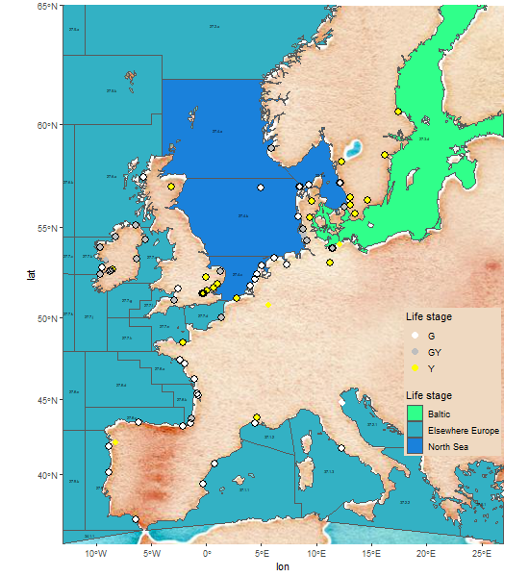
Map of recruitment sampling stations, left (white = Glass eel (G); grey = Glass + Yellow eel (GY), right Yellow eel (Y)).

Details on data selection and processing
Out of the 103 series that were compiled in the Data Call81 meet the required conditions to be used in the analysis to calculate the recruitment indexes ( see tables @ref(tab:xstatseriesGEE) - glass eel (G) stage for the Elsewhere Europe area, @ref(tab:xstatseriesGNS) - glass eel (G) North Sea, @ref(tab:xstatseriesGY) - glass and yellow combined (GY) and @ref(tab:xstatseriesY) - yellow eel stage for the full description of the series compiled in the data call)
- First, if there are two or more series from the same location, i.e. they are not independent, only one series is kept. For instance, the longer of two series has been kept for the Severn (Severn EA, a total of all the glass eel fisheries for England and Wales) while the second series (Severn HMRC) has been dropped from the list, as it was considered a duplicate being based on the same fishery. The series left out following this rule are : BroGY(GB), EmsBGY(DE), FarpGY(DE), FlaGY(GB), HHKGY(DE), MeusY(BE), SeHMG(GB) [TODO SELECT AMONG THOSE THE DUPLICATES, BroGY(GB), EmsBGY(DE), FarpGY(DE), FlaGY(GB), SeHMG(GB)]
- The second rule is to exclude a series from the analysis when it is less than ten years long. The series are, however, still updated in the database until they are long enough to be included. If there are missing years, or years excluded for data quality reasons, the data series will be included when the total number of “good” years of data meets the 10 year criterion. Within any series, individual annual data point or points can be excluded from the analysis where a one-off problem is identified which negates the value as an index for that year, such as a major reduction in effort (e.g. Covid or other effort related restriction). The series left out because they don’t meet the 10 years criteria are : CorGY(IE), EmsHG(DE), HoSGY(DE), InagG(IE), LangGY(DE), MiScG(PT), MiSpY(ES), PogoG(IT), PovoG(IT), ShiFG(GB), TibnG(IT), VeAmG(BE), VeAmY(BE), WaSEY(DE), WaSG(DE)
- Finally, it was decided to discard recruitment series that were obviously biased by restocking (e.g. Farpener Bach in Germany). The series left out for that reason are BroGY(GB), EmsBGY(DE), FarpGY(DE), FlaGY(GB), HHKGY(DE), MeusY(BE), SeHMG(GB) [ TODO among those select HHKGY(DE), MeusY(BE)]

[remove this section after check there should be no ser_qal_id 4] There should be nothing here :

See Annex X, table XX for the reason for which the series have been excluded for the recruitment analysis.

Number of series available

Some stats related to the graph on the number of series
Glass eel and glass eel + young yellow eel time-series available maximum :
49 in 2015 38 in 2023.
The maximum number of older yellow eel :
time-series has increased to 21 in 2021 but dropped to 10 (Figure @ref(fig:figure2)).

The WGEEL has collated information on recruitment from r selection_summary[["nb_series_init"]] time-series (Table 2.1. fig. 2.2). Among those series, 81 have been selected for further analysis. For the calculation of the glass eel recruitment index, 60 series have been retained (39 glass eel series and 21 glass and yellow eel mixed series), from which 34 came from NS and 26 from EE (see Annex X table 1). For the calculation of the yellow eel recruitment index, 21 yellow eel series have been retained, most of the retained yellow eel series (18) coming from the North Sea region (see Annex X table 2).
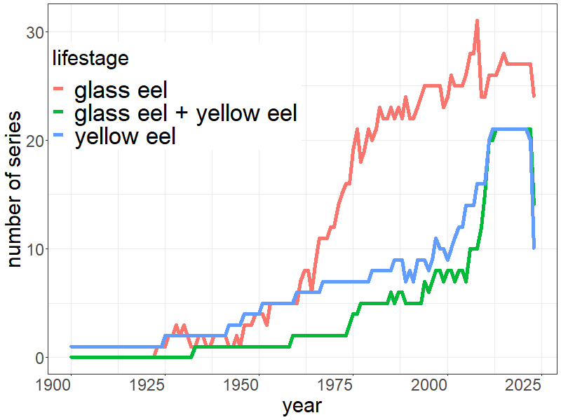
Trends in number of glass eel (black circle), glass+young yellow eel (grey triangle) and older yellow eel (black triangle) time-series giving a report in any specific year.
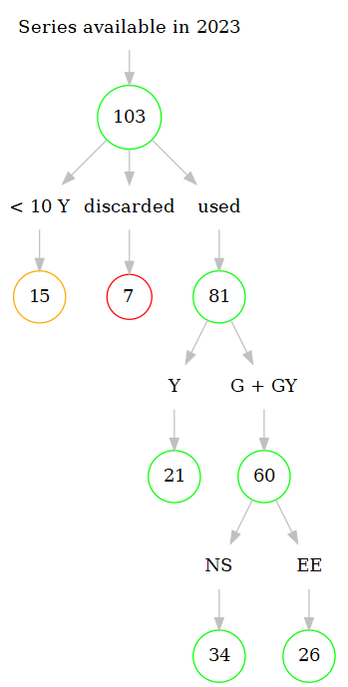
Series selection and analysis. Series less than 10 years are not used in the analysis. Y yellow eel series, G + GY glass and young yellow eel series. NS North Sea, EE Elsewhere Europe

Check on series updates for analyses[remove this paragraph]
48 time-series updated to 2023 0 for glass eel 0 for glass + yellow eel and 0 for yellow eel 20 time-series (0} for glass eel, r format(selection_summary[["nCYm1GY"]], scientific=TRUE) for glass + yellow eel and r format(selection_summary[["nCYm1Y"]], scientific = TRUE) for yellow eel) were updated to 2022 only (Table @ref(tab:xseriesCYm1))).
13 time-series have been stopped or not updated beyond 2016 (12 for glass eel, 0 for glass eel + yellow eel and 1 for yellow eel (Table @ref(tab:xserieslost))) but are still included in the analysis. Some have stopped reporting either because of a lack of recruits in the case of the fishery-based surveys (Ems in Germany, stopped in 2001; Vidaa in Denmark, stopped in 1990), a lack of financial support (the Tiber in Italy, 2006) or the introduction of quota from from 2008 to 2011 that has disrupted the five fishery-based French time-series . The two English series (FlaE and BeeG) are still operating but data have not been updated since 2016.

Raw data
Calculation of the geometric mean of all time-series is given in (Figures @ref(fig:figure3) and @ref(fig:figure4)).
knitr::include_graphics(paste0(imgwd,'figure3.png'))
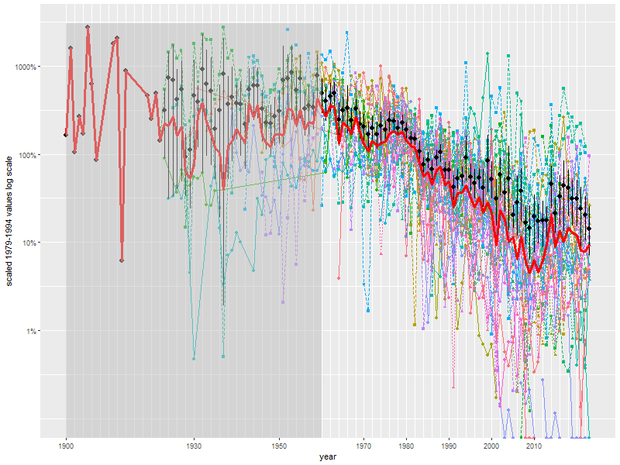
Time-series of glass eel and yellow eel recruitment in European rivers with time-series having data for the 1979-1994 period ( 45 sites). Each time-series has been scaled to its 1979-1994 average. Note the logarithmic scale on the y-axis. The mean values and their bootstrap confidence interval (95%) are represented as black dots and bars. Geometric means are presented in red.
knitr::include_graphics(paste0(imgwd,'figure4.png'))
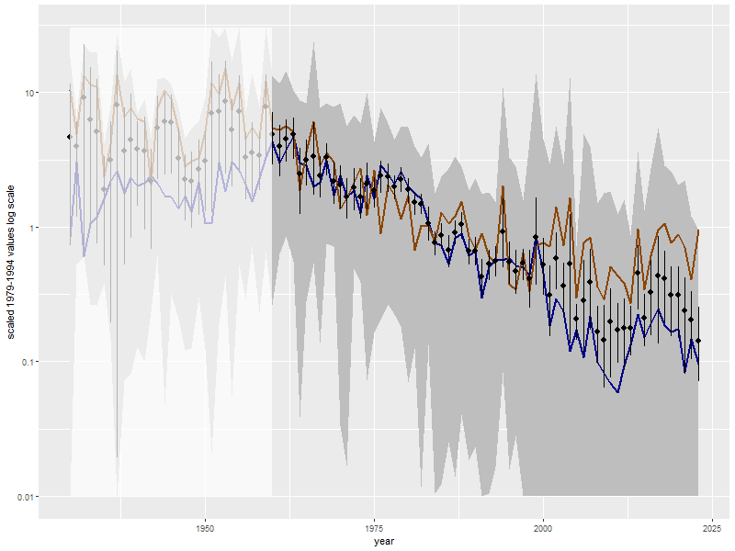
Time-series of glass eel and yellow eel recruitment in Europe with 45 time-series out of the 103 available to the working group. Each time-series has been scaled to its 1979-1994 average. The mean values of combined yellow and glass eel time-series and their bootstrap confidence interval (95%) are represented as black dots and bars. The brown line represents the mean value for yellow eel, the blue line represents the mean value for glass eel time-series. The range of these time-series is indicated by a grey shade. Note that individual time-series from Figure @ref(fig:figure3) were removed to make the mean value more clear. Note also the logarithmic scale on the y-axis.

GLM based trend
The WGEEL recruitment index used in the ICES Annual Stock Advice is fitted using a GLM (Generalised Linear Model) with gamma distribution and a log link: , where is individual glass eel time-series, including both pure G series and those identified as a mixture of glass and yel-low eel (G+Y), is the site monitored for recruitment, area is either the continental North Sea or Elsewhere Europe, and year is the year coded as a categorical value. For yellow eel time-series, only one estimate is provided: .
The trend is hindcast using the predictions from 1960 onwards for 60 glass eel time-series and from 1950 onwards for 21 yellow eel time-series. Some zero values have been excluded from the GLM analysis: 22 for the glass eel model and 41 for the yellow eel model. This treatment is parcimoniuous and tests shows it has no effect on the trend (ICES, 2017).
The reconstructed values are then aggregated using geometric means of the two reference area (Elsewhere Europe EE, and North Sea NS). The predictions are given in reference to the geometric mean of the 1960-1979 period. Note that the shift from arithmetic to geometric means was done this year because post-hoc model checking confirmed that log-normal (or Gamma Distribution) and geometric means are the prefered choice.
As some of the values were not complete the 2018, the level of European eel recruitment compared to the 1960-1979 average has changed when compared to last year report. The value has decreased from 9.6% in last year report to 11.3% for the Elsewhere Europe area. It remains unchanged for the North Sea at 0.7%. For 2019, data are only provisional and give estimates at 0.4% for the North Sea and 8.8% for the Elsewhere Europe area, but some of the series are not yet complete (Figure @ref(fig:figure5) @ref(fig:figure5withlogscale) (log.scale), Tables @ref(tab:tableglmglasseel)).
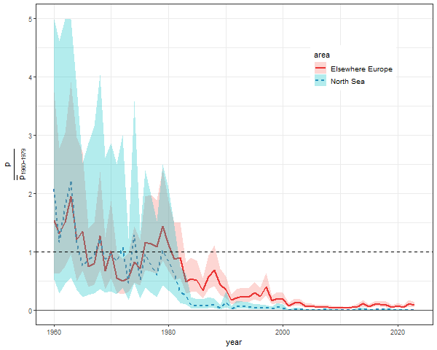
WGEEL recruitment index: estimated (GLM) glass eel recruitment for the continental North Sea and Elsewhere Europe series with 95% confidence intervals updated to 2023 . The GLM () was fitted on 60 time-series comprising either pure glass eel or a mixture of glass eels and yellow eels. The predictions have been scaled to the 1960-1979 average . Number of series Elsewhere Europe = North Sea
For yellow eel series, the autumn ascent has not been recorded yet and most of the series have reported data till the middle of the summer. The 2022 yellow eel index is at 8.9% of the 1960-1979 baseline.
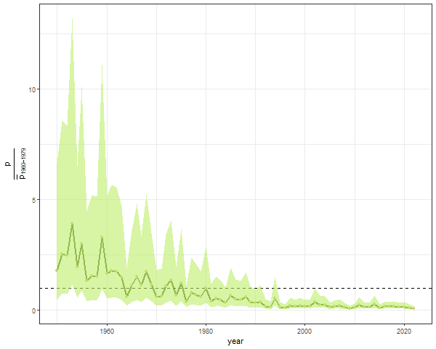
Geometric mean of estimated (GLM) yellow eel recruitment for Europe updated to 2023 . The GLM (yellow eel ~ year+site) was fitted to 21 yellow eel time-series and scaled to the 1960-1979 average .

Is there a positive trend in recruitment ?
After high levels in the late 1970s, the recruitment declined and has been very low for all years after 2000. From ICES (2014) onward a change in the recruitment has been detected. One of the test used to show that change in 2014 was based on SGIPEE(2011) working group. We have used a test only slighly different from the test used in ICES 2011. The difference is that the model is now based on individual series as source data, not only the prediction. The model differs from that used by wgeel also as year is here treated as a continuous value, whereas it is treated as a factor in the glm for recruitment, and the years are restricted to decreasing part of the recruitment (after 1980). where glass eel is the number of glass eel in the glass eel series, either for the Elsewhere Europe or the North Sea time series, is a continuous value corresponding to year after 1980, is also a continuous value, is a random error with mean 0 and standard deviation sigma, and , and are the estimated parameters. The parameters are higly significant both in the Elsewhere Europe area (p=0 and for the North Sea p=0 North Sea. This result confirms that there has been a change in the recruitment slope.

To test whether there is an increase in recruitment since 2011 the slope of , i.e. the slope of the recent increase in recruitment is positive, the NULL hypothesis is tested.
To summarize, after high levels in the late 1970s, the recruitment declined and has been very low for all years after 2000. There has been a change in the trend in 2011, the recruitment has stopped to decrease, and has been increasing in the period 2011-2019 with a rate significantly different from zero. However, this increase needs to be taken very carefully. Firstly , not all series have been reported for 2019 and the results might change when missing data is incorporated to the analysis. Secondly, even if the results would not change, recruitment remains very low 0.4% for the North Sea and 8.8% for the Elsewhere Europe area. Recruitment has been continually decreasing from 1980 to 2011 (31 years), thus, the positive trend should be maintained during more years in order to consider that the stock is safe. In that sense and finally, during the 2011-2019 period, the maximum values were reached in 2014; but recruitment has been decreasing since then.

Annex

Additional figures
We provide the same figures as in the main text but Figure @ref(fig:figure3withoutlogscale) without log scale for Figure @ref(fig:figure3). For the prediction, figures with log scales are provided (Figures @ref(fig:figure5withlogscale) and @ref(fig:figure6withlogscale)).
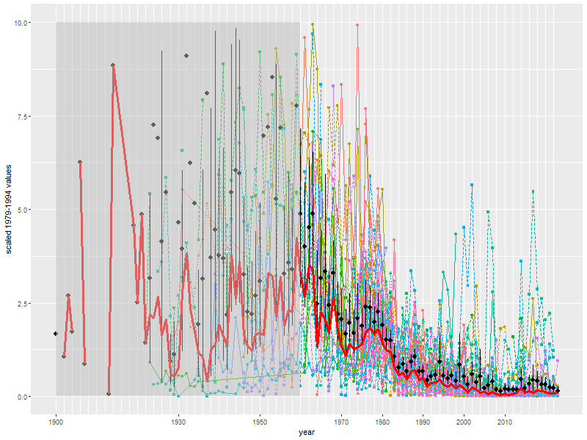
Same as figure @ref(fig:figure3) but without log scale
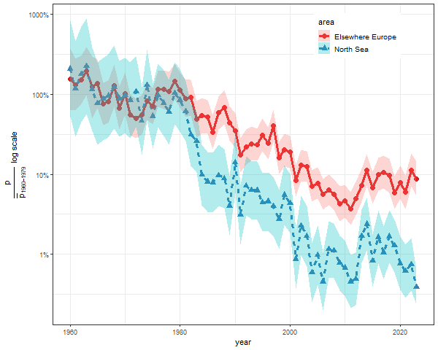
Same as figure @ref(fig:figure5) but with a log scale.
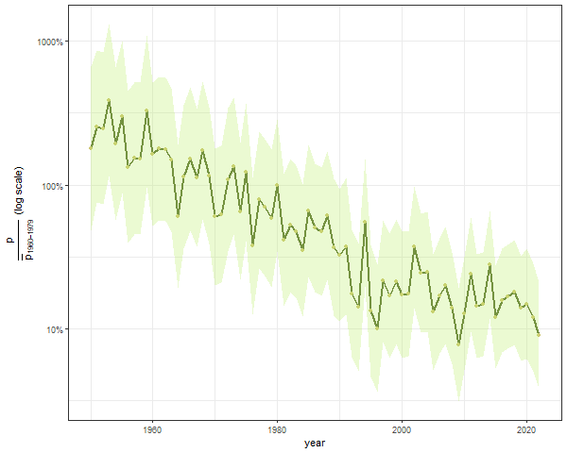
Same graph as figure @ref(fig:figure6) but with a log scale.

Additional Tables for annex recruitment

Exploitation Rates
By dividing glass eel declared landing by the time series of abundance, we an derive a relative indicator of glass eel mortality exploitation rate that can inform on trends in glass eel fishing mortality. The analysis is restricted to Elsewhere Europe since no commercial fisheries took place in the North Sea area in the last years. Moreover, we restricted the analysis to the post 2000 period since recent ICES data calls have focused on those decades. While some landings data are still missing, the diagram suggests that the exploitation rate for glass has decreased after the implementation of the Eel Regulation in 2009 (Year 2009 was removed since French, which accounts for a significant part of the landings, have not reported data for this year) and reached its lowest level from 2014 to 2017. The exploitation rate has remained at this level since then despite an increase from 2017 to 2019. The upcoming landing workshop aiming at reconstructing time series of landings could enable us to go further back in time and to improve. This exercise is currently only feasible for glass eel recruitment: while landings data are available for other stages, we are still missing abundance indices of yellow eel standing stock of for silver eel abundance.

This figure is given as it consistent with the trend provided by WGEEL from 2002 to 2006. The scaling is performed on the 1979-1994 average of each time-series, and rlength(selection_summary[[“sc_1979_1994_unused_series”]])` time-series without data during that period are excluded from the analysis. The time-series left out are : BeeG, BeeGY, BeeY, BresGY, BroG, BrokGY, BroY, DoElY, FlaG, FlaY, FreY, GirnY, GreyGY, GuadG, HellGY, InagGY, KlitG, LiffGY, MaigG, MertY, MillY, MolY, NmiGY, NorsG, OatGY, OriaG, RhoY, RodY, ShiMG, SleG, SousGY, StraGY, VacG, VerlGY, WiFG, WisWGY

