Untitled
2025-01-24

First title

Second Title
This is ICES report (ICES, 2007). A reference to the graph (Figure 1.1).
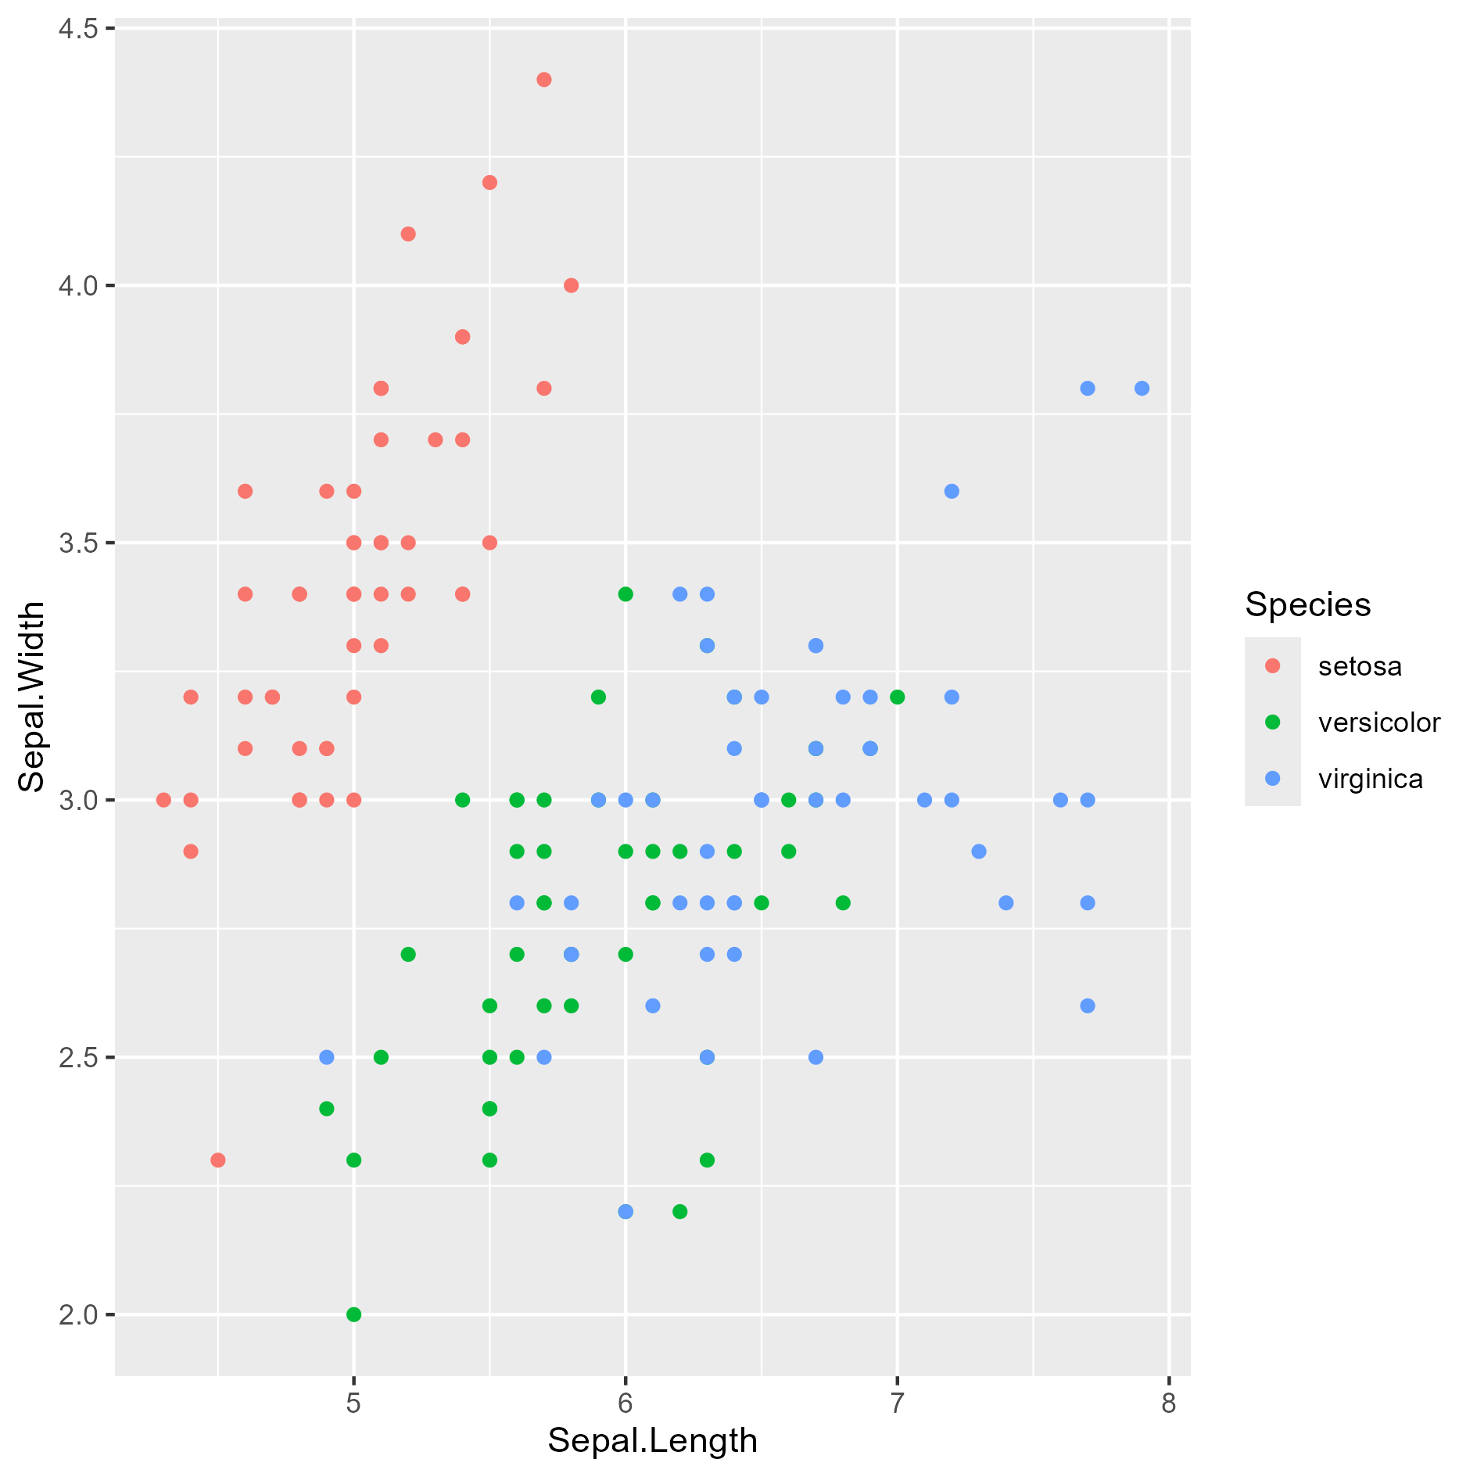
Figure 1.1: mon graph
and this is my table (Table 1.1).
Table 1.1: mon tableau
Sepal.Length | Sepal.Width | Petal.Length | Petal.Width | Species
5.1 | 3.5 | 1.4 | 0.2 | setosa
4.9 | 3.0 | 1.4 | 0.2 | setosa
4.7 | 3.2 | 1.3 | 0.2 | setosa
4.6 | 3.1 | 1.5 | 0.2 | setosa
5.0 | 3.6 | 1.4 | 0.2 | setosa

I can include ref to equation (equation 1.1).
$$E=m⋅c^{2} (1.1)$$

Title2
Nothing
Table 1.2: mon tableau 2
Sepal.Length | Sepal.Width | Petal.Length | Petal.Width | Species
5.1 | 3.5 | 1.4 | 0.2 | setosa
4.9 | 3.0 | 1.4 | 0.2 | setosa
4.7 | 3.2 | 1.3 | 0.2 | setosa
4.6 | 3.1 | 1.5 | 0.2 | setosa
5.0 | 3.6 | 1.4 | 0.2 | setosa
5.4 | 3.9 | 1.7 | 0.4 | setosa

- Title of annex 1
- References
ICES. 2007. Report of the 2007 session of the Joint EIFAC/ICES Working Group on Eels. Bordeaux.

