Blue Whiting Spawning Habitat Forecast

ICES WGS2D Forecast sheet 01-v03.0

Issued 01-03-2018. Valid through to 01-06-2018.

Prepared by Mark R. Payne, DTU Aqua, Copenhagen, Denmark.

This forecast sheet superceeds the previous version 001-v02.1, issued 17-01-2018. For details, see the Change Log at the bottom of this document.

This is the final update for the 2018 spawning season. The first forecast for the 2019 spawning season is planned on or before 1 October 2018.

## Forecast

The spawning distribution for March 2018 is expected to be highly compressed against the continental shelf edge, reflecting the current unusual oceanographic conditions, with minimal spawning on or to the west of Rockall Plateau (Figure 1). In historical terms, the core spawning area and the westward extent of spawning are forecast to be amongst the lowest since 1950 (Figure 2).

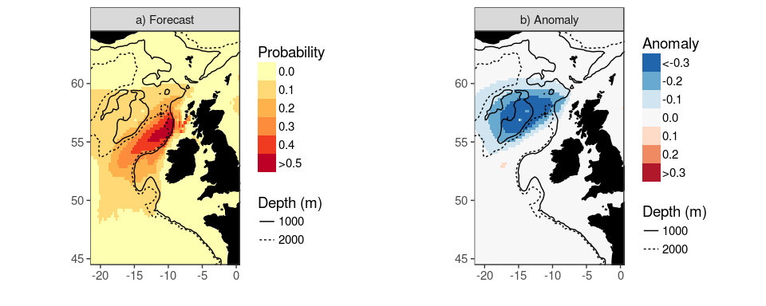

**Figure 1. Forecast spawning distribution for blue whiting in March 2018.** Distribution is represented here as the probability of observing blue whiting larvae in a single haul performed by the Continuous Plankton Recorder and is plotted as a) the value and b) the anomaly relative to the climatological probability (1960-2010). Probabilities > 0.4 can be considered as the core spawning habitat. The 1000m and 2000m isobaths are added for reference.

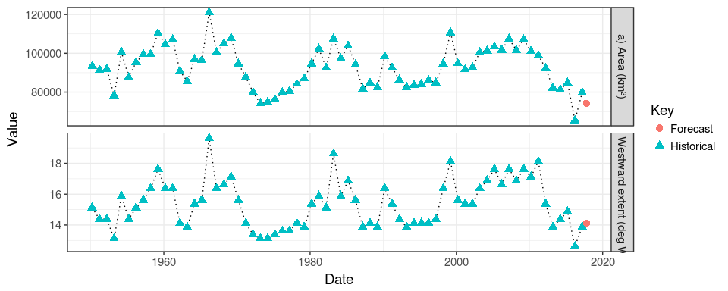

**Figure 2. Time series of core spawning area characteristics.** a) Area (km²) of core spawning area of blue whiting in the month of peak spawning (March). b) Westward extent (degrees of Longitude W) of core spawning area. Historical (blue triangles) and forecast (orange dot) values are shown.

## Background

The spawning distribution of blue whiting has varied in the past and has expanded, contracted and shifted locations (Figures 2, 3). The dominant feature of these changes is a westward expansion away from the shelf-break region west of the north-west European continental shelf onto the Rockall plateau and Hatton bank region (Figure 3).

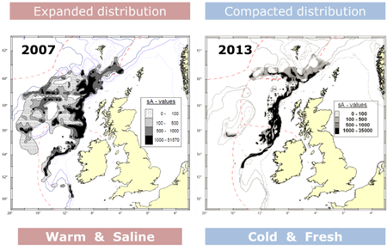

**Figure 3. Spatial distributions of blue whiting from the International Blue Whiting Spawning Stock Survey** Two years characterized by different oceanographic conditions (2007 and 2013) are shown. Note the large difference in range occupied towards the west in 2007 compared to 2013.

The spawning distribution of blue whiting has been linked to oceanographic conditions in this region (Hatun et al 2009), and in particular to the salinity in the region. Spawning typically occurs within a narrow salinity window (Figure 4) (Miesner and Payne 2018). Salinity in this region is strongly driven in turn by the dynamics of the North Atlantic sub-polar Gyre (Hatun et al. 2005). The slow dynamics of oceanographic properties can be used to provide reliable estimates of future distributions of water masses and thereby spawning habitat for blue whiting.

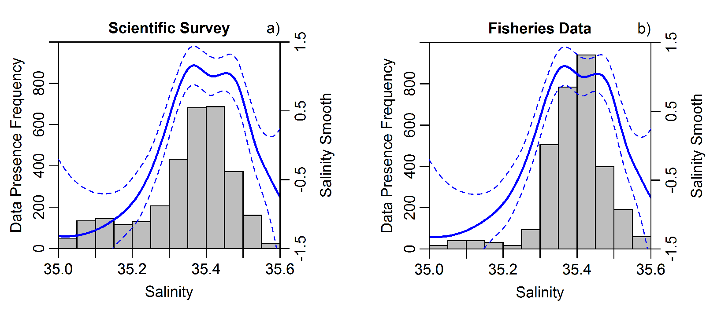

**Figure 4. Relationship between spawning and salinity from independent data sources** Presence frequency of spawning blue whiting (number of pixels with presences) a) observed in scientific surveys and b) caught in fisheries is compared to the salinity (250-600 m) at which these observations were made (bars). The blue line indicates the modelled smooth function of blue whiting larval-presence obtained from the Species Distribution Model (SDM) based on larval blue whiting catches by the CPR survey, with dashed lines indicating the standard error. Panel a) shows observations from late March/ early April, and Panel b) data shows data from March.

## Basis for Forecast

|  |  |
| --- | --- |
| Component | Description |
| Biological model | Species distribution model (GAM) using salinity, latitude, day-of-year, solar elevation, and depth. Model is parameterised against observations of Blue Whiting larvae from the continuous plankton recorder (CPR) between 1951 and 2005. |
| Environmental data set(s) | 1. EN v4.2.1: an optimal interpolation of oceanographic profiles onto a 1x1 degree, monthly grid from 1900-present (Good et al 2013)  2. PSY4 v3.1: a model-based reanalysis with assimilation of profile and satellite data, on a 1/12 x 1/12 degree grid, used here as a monthly product, from 2007-present. Copernicus CMEMS product id: GLOBAL_ANALYSIS_FORECAST_PHY_001_024_MONTHLY |
| Environmental variables | Salinity averaged over 250-600m depth on a pixel-by-pixel basis |
| Environmental forecast method | Persistence from the most recent data product (January 2018) |
| Forecast lead time | Two months (From January 2018 to March 2018) |

This forecast is based on a species distribution model developed by Miesner and Payne (2018). The model uses observations of blue whiting larvae captured in the Continuous Plankton Recorder (CPR) as a response variable and links their presence to environmental covariates as explanatory variables, including salinity at spawning depth (300-600m), latitude, day of year, solar elevation angle and bathymetry. Salinity at spawning depth was shown to be the most important environmental factor that varied inter-annually, and drives the westward expansion of spawning habitat. The model has been verified by cross-validation with the CPR observations. Furthermore, the sensitivity of the larval response to salinity obtained from CPR data shows good agreement with independent distribution data sets obtained from both commercial fishers and scientific surveys (Figure 4).

Forecasts of the physical environment (and specifically salinity at spawning depth) are derived by assuming that the most recently observed state of the environment will persist until at least the next spawning period and possibly beyond.

## Quality Considerations

This forecast is a prediction of the potential spawning habitat of the species, and should not be interpreted as a direct forecast of distribution. While there is a relationship between the two, it is important to remember that the actual distribution of spawning may not utilise all of the potential spawning habitat (e.g. due to migration dynamics, density-dependent processes or other biotic factors). On the other hand, it is unlikely that spawning can occur in the absence of suitable habitat. The ability of this forecast to represent distribution is therefore asymmetrical.

Forecasts of the physical environment in this region are based on persistence i.e. the assumption that, for example, next year will be the same as this year. While the dynamics in this region are typically slow, they have occasionally moved rapidly, which could cause discrepancies between forecasted and observed spawning habitat. However, such events are considered relatively rare and analysis of the forecast skill has shown that this is a valid assumption.

## Forecast Skill Assessment

Forecast skill was assessed using historical data independent of those used in model development, for different time lags. The skill based on persistence is significant for forecast lead-times up to 2-3 years (Figure 5).

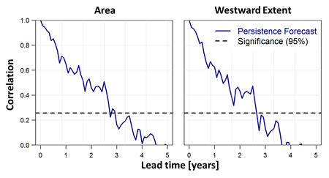

**Figure 5. Forecast skill assessment** Forecast skill is shown for a) the area (km²) and b) westward extent of potential spawning area for blue whiting in the waters west of the northwest European continental shelf. The plots show correlation based on persistence of ocean dynamics for various lead times into the future. The dashed line indicates the minimum significant correlation (P > 0.05).

## For More Information

For more information, contact Mark R. Payne, DTU-Aqua. The latest version of this and other forecasts can be found on the website <http://ww.fishforecasts.aqua.dtu.dk> and on the Rpubs website <http://rpubs.com/markpayne/WGS2D_01_blue_whiting_spawning> Code used to generate this forecast is available from the WGS2D GitHub repository, <https://github.com/ices-eg/wg_WGS2D> in the directory "01_Blue_whiting_spawing_distribution".

## Acknowledgements

The research leading to these results has received funding from the European Union 7th Framework Programme (FP7 2007–2013) under grant agreement number 308299 (NACLIM) and the Horizon 2020 research and innovation programme under grant agreement number 727852 (Blue-Action). We thank Åge Høines and the members of the WGIPS group responsible for planning the IBWSS survey for input and providing the proposed survey track.

## References

Good, S. A., M. J. Martin and N. A. Rayner. (2013). EN4: quality controlled ocean temperature and salinity profiles and monthly objective analyses with uncertainty estimates, Journal of Geophysical Research: Oceans, 118, 6704-6716, <doi:10.1002/2013JC009067>

Hátún, H., Sandø, A. B., Drange, H., Hansen, B., & Valdimarsson, H. (2005). Influence of the Atlantic subpolar gyre on the thermohaline circulation. Science, 309(5742), 1841–4. <https://doi.org/10.1126/science.1114777>

Hátún H, Payne MR, Jacobsen JA (2009) The North Atlantic subpolar gyre regulates the spawning distribution of blue whiting (Micromesistius poutassou). Canadian Journal of Fisheries and Aquatic Sciences 66: 759–770

Miesner, A.K., and Payne, M.R. (2018) Oceanographic variability shapes the spawning distribution of blue whiting (*Micromesistius poutassou*). Fisheries Oceanography. In press.

## Change Log

* 20180301.v03.0 Updated EN4 data set to 4.2.1. Added forecast expressed as an anomaly. Added "forecast basis" summary table. Added supplementary information comparing with survey track and current oceanographic state. Add PSY4 reanalysis product into mix.
* 20180117.v02.1 Minor update to include salinity contours in Figure 2.
* 20180115.v02 Updated to October 2017 oceanography. Visual improvements.
* 20170614.v01 Initial draft version

## Supplementary Information

### S1. Oceanographic Conditions

To provide a more detailed insight into the current oceanographic conditions driving the distribution, the current state of salinity at the spawning depth is shown below. In particular, the well-reported salinity anomalies in the North Atlantic sub-polar gyre (upper-left side of panel b) are having a clear effect on the spawning region of blue whiting and compressing the spawning habitat.

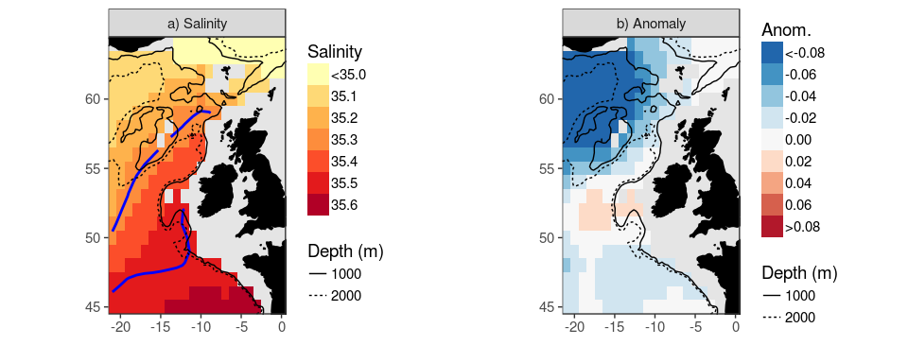

**Figure S1.1 Observed salinity distribution and associated anomaly in the spawning region.** Salinity is based on the EN4 observational dataset for January 2018 at spawning depth (250-600m) and is plotted as a) the absolute value and b) the deviation from the annual climatology (1960-2010). The isohalines defining the suitable salinity window (35.3 - 35.5) at spawning depth for Blue Whiting are marked with a blue contour line in panel a). The 500m and 2000m isobaths are added for reference.

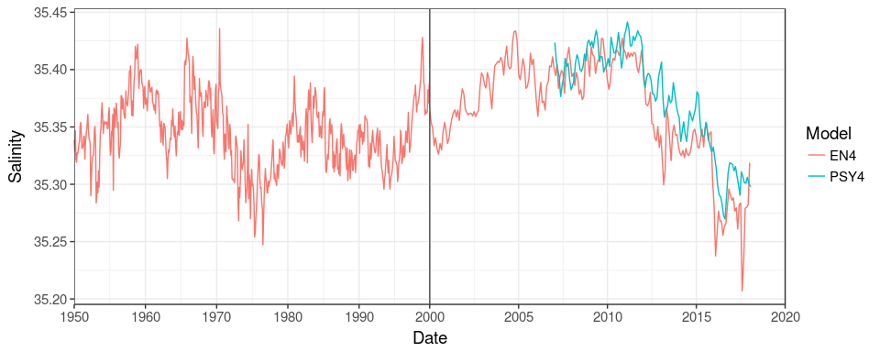

**Figure S1.2. Time series of salinity in the spawning area.** Monthly salinity at spawning depth (250-600m) from the EN4 and PSY4 datasets are plotted as a function of time - note the change in timescale at 2000, to give greater resolution of the most recent years.

### S2. Comparison with proposed survey track

To allow a more direct comparison between the proposed survey track and the modelled distribution of blue whiting, we have overlaid the survey track on top of Figure 1 below.

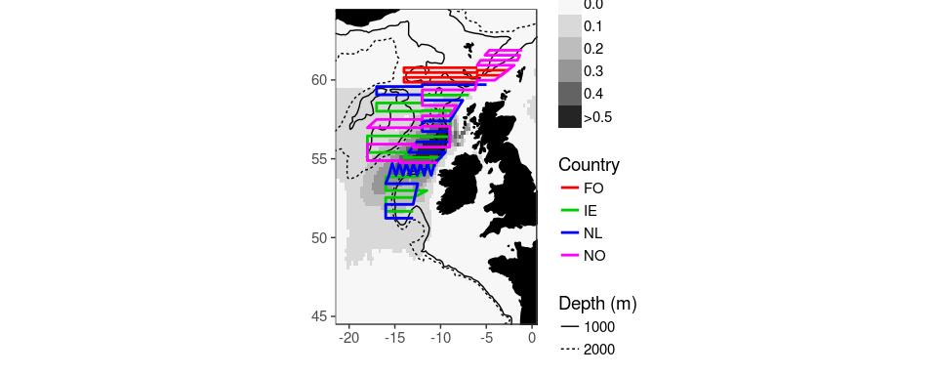

**Figure S2.1. Comparison of survey track and forecast distribution** Forecast spawning distribution (see Figure 1 above) represented here as the probability of observing blue whiting larvae in a single haul performed by the Continuous Plankton Recorder is plotted as the grey background distribution. The proposed survey tracks, broken down by country, are overlayed as coloured lines. The 1000m and 2000m isobaths are added for reference.

*This work by WGS2D is licensed under a Creative Commons Attribution-NonCommercial-ShareAlike 3.0 Unported License. For details, see* [*http://creativecommons.org/licenses/by-nc-sa/3.0/deed.en_US*](http://creativecommons.org/licenses/by-nc-sa/3.0/deed.en_US) *Basically, this means that you are free to "share" and "remix" for non-commerical purposes as you see fit, so long as you "attribute" me for my contribution. Derivatives can be distributed under the same or similar license.*

*This work comes with ABSOLUTELY NO WARRANTY or support.*

