Overview
The inaugural meeting of the Global Acoustic Interoperable Network (GAIN) was held in Brest, France on the 8th April 2024 with 27 participants (18 in person, 9 online, 12 out of session, see Appendix B). The overarching aim of the meeting was to engage the international community to develop a framework to enable sharing and dissemination of processed water column backscatter data at a global scale.

The vision of the GAIN community is to achieve a global observational system for processed active acoustic water column data that can be sustained over multi-decadal periods. This will match the timeframes over which long term trends in biological oceanic processes might be observed. Key to this will be to follow FAIR principles, to have rigorous adherence to metadata, documentation of processing methods (e.g. Haris et al. 2021) and to house the data products in a suitable format. Importantly, to facilitate uptake and impact, the product must be in a form that is readily understandable to researchers from other disciplines. This will allow easy comparison with other ocean observation and incorporation into models.

GAIN extends an open invitation to welcome the WGFAST and broader scientific community to participate. This can include:
- Join the community to contribute to discussions (Github link) and participate in workshops
- Inform of publicly available data holdings
- Make a product! Seek information about data processing methods to create interoperable outputs.
- Assist with linking to and/or guiding other disciples in the utilization and uptake of GAIN products
- Contribute in funding search and project submissions to maintain this working group.

Background
Studies of large scale biological ocean processes using active acoustic measurements of water column backscatter are a fast emerging area of research (Irigoien et al. 2014; Proud et al. 2017; Ariza et al. 2022). The expansion of large-scale studies was further indicated by multiple presentations at both the ICES Symposium in Portland, Maine USA in April 2023 and at the ICES WGFAST meeting in Brest in April 2024 (e.g. Receveur et al. unpub; Alberne et al. unpub). Common to most of these studies was the use of curated, processed, and publicly available acoustic data. The availability of such databases has been possible thanks to multiple national efforts during the last 10 years, such as the IMOS program (Haris et al. 2021), the SONA and MESOPP projects, which united data contributions from CSIRO (Australia), the British Antarctic Survey (UK), and the Sorbonne University (France) in a common data format following the ICES metadata convention (ICES WGFAST Topic Group, TG-AcMeta, 2020). This database continued growing afterwards, driven by geographical requirements of data users, with recent contributions from IRD (France) and Imarpe (Peru). As result, more than a million kilometers of data are publicly available in a common data format (Fig. 1)

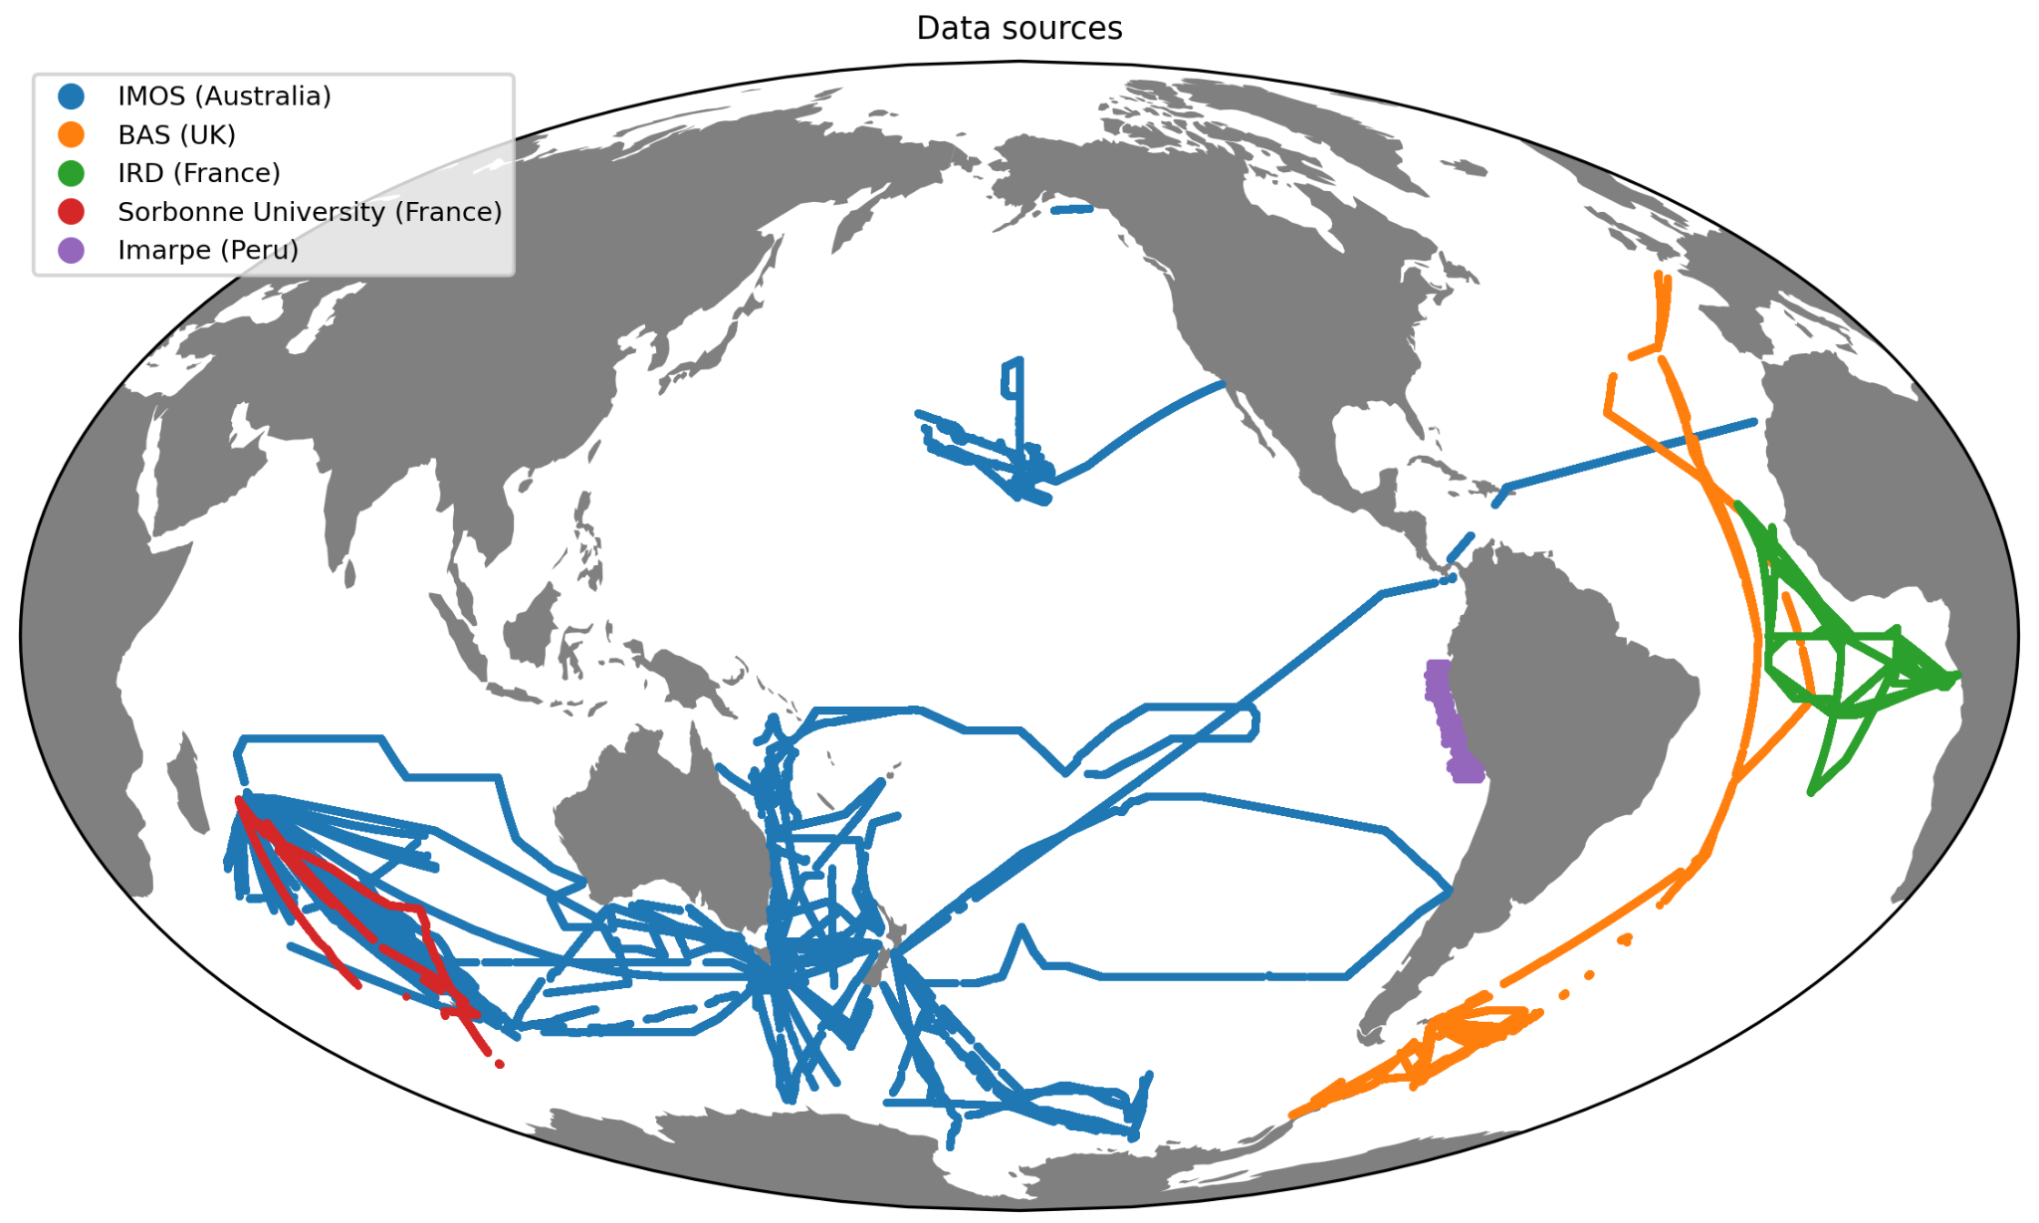
Figure 1. Acoustic data publicly available by 2022. The database is in a common NetCDF data format, and is intended for final users: gridded, denoised, corrected water-column backscatter, documented following ICES Metadata conventions.

While these efforts towards a common database are valuable, we are still far away from meeting FAIR data principles. Findability, for instance, is not yet achieved. Acoustic data is disseminated through multiple national data portals, some data links are broken, and part of the data that was available by 2022 do not exist anymore. Interoperability, on the other hand, is only partially reached, and the user still needs to handle some exceptions when reading different data sources. These issues are likely due to the multiple governance and project frameworks during the growing process of the database. Indeed, we lack an international community that provides guidance and assures resources to maintain a database with common minimum standards. In this context we add an ‘S’ for Sustained to create FAIR-S, which is to say the success of GAIN will be defined by the ability to maintain consistent delivery of well-defined, scientifically relevant data products over multi-decadal time frames. Another issue of concern is that in the absence of publicly-available quality-controlled products, large-scale acoustics studies are increasingly using datasets in raw format and not even available on-line, decreasing the reproducibility of scientific results. It is also obvious looking at Figure 1 that as an international community we can achieve a much larger geographical and temporal coverage which will help to answer important scientific questions at global scale.

Objectives
Based on the aforementioned issues to achieve a global acoustic database which meets FAIR data principles we agreed the following objectives:
- Create an international panel of experts to provide guidance in acquisition and processing protocols towards the generation of an harmonized database. As an example there could be protocols to operate by default to use agreed echosounder settings when on transit and only change if there are survey specific needs. We also may provide tutorials to generate an agreed final product following community standards.
- Locate and centralize existing acoustic data in a common data portal in order to work out the size and diversity of data and propose adapted solutions to converge in a common data format.
- Provide an international framework which ensures funding and support to participants across the globe and over multi-decadal periods, to collect, process, and deliver acoustic data products.
- Provide the first reference global acoustic database, updated on an annual basis.

Next steps
To accomplish with the objectives we propose the following immediate actions:
- GAIN will operate inter-sessionally using online cloud-based solutions (Github link).
- Search for potential funding opportunities, propose project submissions to partners.
- Hold an in-person side meeting at the WGFAST in Reykjavik, Iceland.
- Create an application to check for compliant NetCDF + ICES metadata files.
- Draft guidelines for acquisition and processing for discussion with the GAIN partners.
- Search for new data holdings (Institutional, fishing vessels, ASV, moorings).
- Design of acknowledgement strategy to ensure crediting and recognition to data holders.

Summary of Inaugural meeting
The meeting was open with a presentation of Tim Ryan (CSIRO). Tim showcased the multiple presentations held in the ICES Symposium in Portland (2023) using extensive spatial and temporal acoustic datasets. These datasets now enable researchers to explore questions of global abundance, trends, and linkages to changing oceans. However, challenges in interoperability, encompassing processing methods, acquisition, metadata, and dissemination, persist. Tim highlighted the importance of addressing these challenges and encouraged the implication of the WGFAST community, creating a working group: GAIN.

The following presentations were given:

- E.J. Molenaar (Utrecht University) - The law of the Sea: Active acoustic data gathering and the law of the sea. To acquire and disseminate data at a global scale requires understanding of the jurisdictional rules as described in the (United Nations Convention on the Law of the Sea) UNCLOS agreement. The law of the sea, as described by UNCLOS, applies to a framework of maritime zones, each of which have different legal implications. These are broadly divided into ‘coastal states’ (internal waters, EEZ) and ‘areas beyond national jurisdiction’ (e.g. high seas). The responsibility for adhering to the UNCLOS rules is of course a matter for nation states and institutes. Nevertheless endeavors such as GAIN should maintain awareness of UNCLOS when bringing together raw or processed data products for publication.

- Carrie Wall Bell (NOAA) - NCEI Water Column Sonar Data Archive: Carrie provided an overview of the NCEI water column sonar data archive. At the time of writing this archive holds 283TB of raw sonar data. Approximately 50% is single beam data from Simrad echosounders. The visibility and accessibility of these data holdings are a leading demonstration of FAIR principles with the data archive operating at a national (USA) level. A question and challenge for GAIN is how to develop FAIR processes for raw acoustic data at a global scale - even the F (Findable) in FAIR is not developed for raw acoustic data at a global scale.

- Wu-Jung Lee (University of Washinton) - Data processing levels: Common science data processing steps - how to adapt them from satellite (cited 1995 & 2014) to acoustic data. There are analogies that address needs for spatio-temporal, calibration, gridded requirements. Need to establish a ‘user expectation’ of the type of processing that has been applied to the data. Support data provenance. There is not currently a community-wide agreement. Wu-Jung provided a link to proposed draft definitions that could be applied to acoustic data (Figure 2).

- Alejandro Ariza (Ifremer) - Global distribution and format of publicly available sources: Data global coverage and discussion on what is the product?. Alejandro showed a global map with NetCDF data following ICES metadata conventions. He stressed the importance of having a final product that is understandable by non-acousticians. He later introduced a graphic illustrating the processing journey from raw to processed NetCDF data.

Overall, the meeting centered on legal, technical, and practical aspects of sharing acoustic data globally, with an emphasis on standardization, collaboration, and transparency.
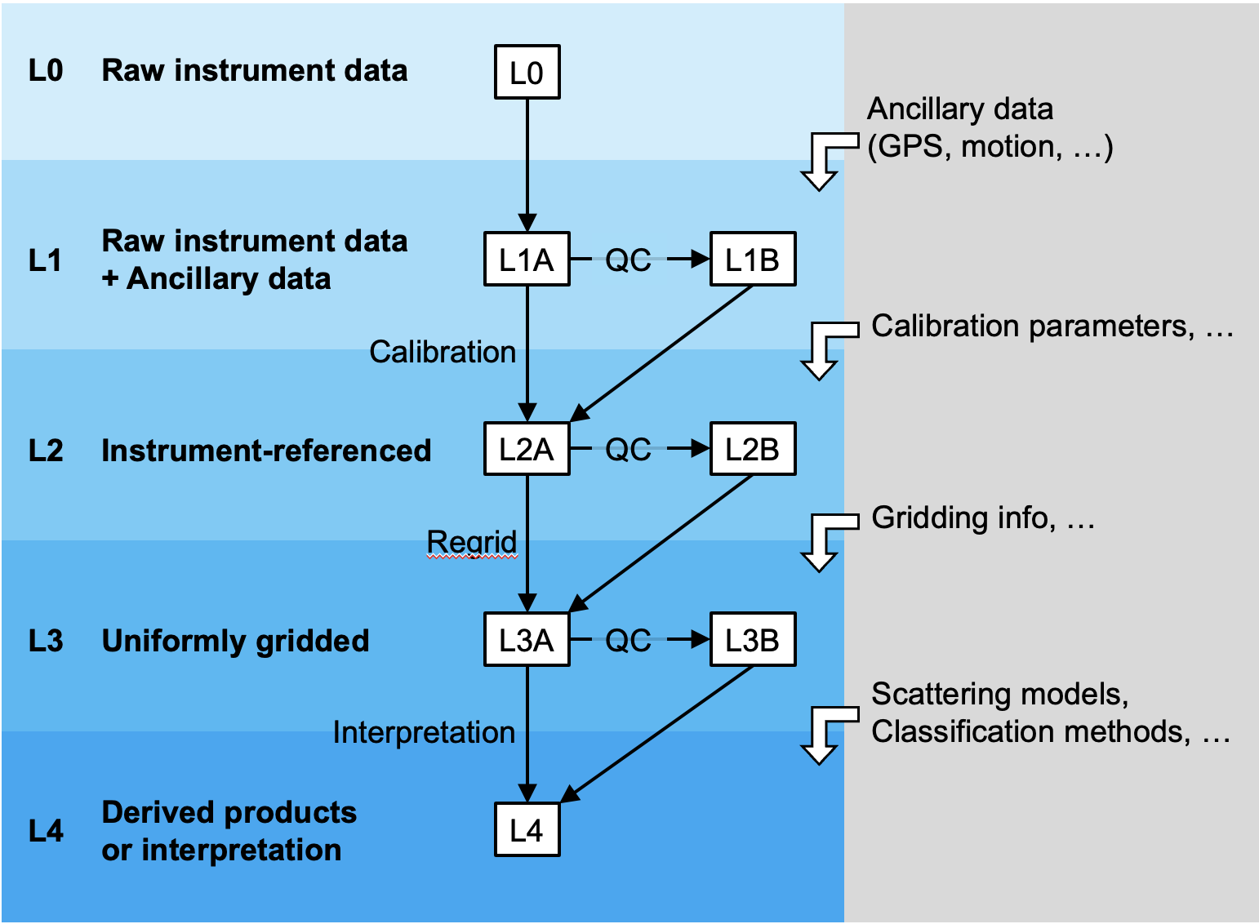
Figure 2. Diagram from Wu-Jung Lee’s document showing possible processing levels for acoustic data.

The F in FAIR
Findability was a common theme of the meetings. The challenge of achieving Findability let alone Accessibility on a global scale is of course immense. In particular for Raw data given data volumes, millions of files and varying quality of metadata. Even knowing about the existence of data sets is not trivial. As an exercise, the in-person participants were asked to take a marker pen and scribble out their areas of data holdings (Figure 3). It was notable that during the subsequent WGFAST meeting (9th to 12th April) other large data sets were mentioned in various presentations that fell outside of those shown on our map.

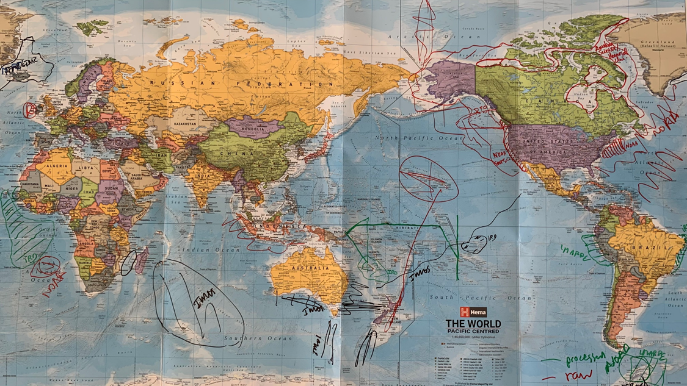
Figure 3. Drawings of participant’s data on a physical map brought to the meeting in Brest. Lines indicate potential data contributions to a common global data product. Green and red colors stand for processed and raw data. Note: Contributions from on-line and out-of-session participants are not included.

The NOAA/NCEI repository demonstrates how exceedingly large repositories can be made Findable and Accessible and serves as a precedent on how this might be done on a global scale. What is not clear is exactly how this might be done. Who would host and manage such a repository, would nation states be willing to contribute and what restrictions and obligations would be sought? In this the early stages of GAIN we look to establish knowledge of raw data holdings at national/institutional level. Beyond this a truly global repository will require further discussion to understand how this might be done and who would fund and host. Pragmatically in the short to medium term at least, it may be better to encourage visibility and accessibility of national/institutional repositories to operate with a nodular framework instead of a unified global model.

The Findability and Accessibility of Processed data is more tractable if the products are created as to be Interoperable. Processed data volumes are typically a tiny fraction of the Raw having been selected according to a criteria (e.g. on-transect) with processed outputs usually having a much coarser resolution. Importantly, if following Interoperable principles the output data will contain all necessary metadata to be fully self describing. In Ariza et al. (2022), the authors compiled processed data from five repositories (IMOS, British Antarctic Survey, University of Sorbonne, IRD, and Imarpe) that conformed to IMOS NetCDF format. Importantly this format follows the AcMeta convention (ICES, 2016). A success was that by conforming to the same fully describing format, Interoperability was achieved which underpinned the analysis. The challenge was that a large amount of work was needed to identify data holdings and bring them together. Further, to bring future Processed data into this collection would once more be a manual and tedious exercise. A solution would be to have a method of unifying Processed by having either a central repository or a website that provides automated linking to the ‘nodes’. Creation and maintenance of such a system will require fundings and persons with the right expertise.

Interoperability and Inter-comparability
Methods of achieving Interoperability were discussed, including the suitability of Sonar-netCDF. This format was initially developed for raw omni-directly sonar data and is now being extended to raw single and multi-beam echosounder data. Ultimately it may be developed to become the natural format to store Processed single beam data products. Conversations between GAIN and Sonar-netCDF developers can explore this possibility. In the meantime the ICES netCDF format is proving to provide effective Interoperability, as demonstrated by Ariza et al. (2022) when collating multiple data sets processed independently but adhering correctly to the requirements of the data format.

Of course Interoperability does not ensure Inter-comparability. For the data collated by Ariza (2022) IMOS data holdings variant processed using Echoview and a standardized template. The Peruvian data were also processed using Echoview but with the workflow developed independently. Finally the French Piratas data were processed using MatEcho (Perrot et al., 2018) broadly following the filtering algorithms described by Ryan et al. (2015). The specific detail of the processing workflow would need to be assessed to be sure of comparability. Even then, for IMOS Bio-acoustic data processing at least there is a degree of user subjectivity in terms of manual QC editing and setting parameters for noise filters. Hence the same workflow applied to the same data may have differences due to user decisions. The consequence of differences between or even within processing methods will depend on the question being asked. For large scale processes any of the mentioned methods should be effective in describing bio-regions - for example the contrast between oligotrophic and highly productive temperate regions should be readily apparent. Conversely if looking at time-series questions relatively small changes are biologically significant but need to be underpinned by accurate and repeatable measurements.

GAIN recognises that at this point in time Processed data products will be produced by both commercial (e.g. Echoview) and open source software (MatEcho, ESP3 and prospectively in 2025 onwards). Although a single agreed workflow using one software package would aid Inter-comparability, pragmatically this is unlikely given the various motivations that influence choices in software selection. Hence a single prescriptive solution in favor of one software package over another is not being recommended. What is important is that the software package and details of the workflow are well documented and visible. Once such example is Haris et al. (2021).

Funding
GAIN has noted previous endeavors to bring data holdings together (e.g. Southern Ocean Network of Acoustics, MESOOP). The common experience is that such projects are funded for a relatively short in the scheme of oceanic observations. Whereas the FAIR-S concept needs support over time periods that reflect that of oceanic processes (i.e. multi-decadal). GAIN will explore funding options. If short term this would allow identifying frameworks for long term success and developing proof of concept deliverables. Longer term funding will ultimately be needed to operate beyond short term projects and/or within national/institutional entities. We welcome suggestions from both GAIN members and those outside this community on funding possibilities.

Bibliography
Ariza, A., Lengaigne, M., Menkes, C., Lebourges-Dhaussy, A., Receveur, A., Gorgues, T., Habasque, J., Gutiérrez, M., Maury, O., Bertrand, A., 2022. Global decline of pelagic fauna in a warmer ocean. Nat. Clim. Change 12, 928–934. https://doi.org/10.1038/s41558-022-01479-2
Haris, K., Kloser, R.J., Ryan, T.E., Downie, R.A., Keith, G., Nau, A.W., 2021. Sounding out Life in the Deep Using Acoustic Data from Ships of Opportunity. Sci. Data 8, 23. https://doi.org/10.1038/s41597-020-00785-8
ICES, 2016. A Metadata Convention for Processed Acoustic Data from Active Acoustic Systems. https://doi.org/10.17895/ICES.PUB.7434
Irigoien, X., Klevjer, T.A., Røstad, A., Martinez, U., Boyra, G., Acuña, J.L., Bode, A., Echevarria, F., Gonzalez-Gordillo, J.I., Hernandez-Leon, S., Agusti, S., Aksnes, D.L., Duarte, C.M., Kaartvedt, S., 2014. Large Mesopelagic Fishes Biomass and Trophic Efficiency in the Open Ocean. Nat. Commun. 5, 3271. https://doi.org/10.1038/ncomms4271
Perrot, Y., Brehmer, P., Habasque, J., Roudaut, G., Behagle, N., Sarré, A., Lebourges-Dhaussy, A., 2018. Matecho: An Open-Source Tool for Processing Fisheries Acoustics Data. Acoust. Aust. 46, 241–248. https://doi.org/10.1007/s40857-018-0135-x
Proud, R., Cox, M.J., Brierley, A.S., 2017. Biogeography of the Global Ocean’s Mesopelagic Zone. Curr. Biol. 27, 113–119. https://doi.org/10.1016/j.cub.2016.11.003
Ryan, T.E., Downie, R.A., Kloser, R.J., Keith, G., 2015. Reducing Bias Due to Noise and Attenuation in Open-Ocean Echo Integration Data. ICES J. Mar. Sci. 72, 2482–2493. https://doi.org/10.1093/icesjms/fsv121

Appendix A. Summary of questionnaire responses
A questionnaire was sent to the GAIN participants prior to the Brest meeting to collate both common and diverse ideas to help guide and focus the direction of this, the first formal meeting of the GAIN community. ChatGPT was initially used to summarize the quite large collation of responses, with a human review and edit to ensure the AI text had achieved the right emphasis and not included false or misleading information.

Question 1. Summarize in one or two sentences your motivation for participating in this group. The participants express a shared motivation to harness the potential of global acoustic data for scientific research. They emphasize the need for FAIR (Findable, Accessible, Interoperable, Reusable) principles in handling large datasets and stress the importance of addressing challenges such as metadata, data access rights, and jurisdictional considerations, particularly within Exclusive Economic Zones (EEZs).

Question 2. In your opinion, what are the major challenges around the utilization of global acoustic data? Major challenges identified include data comparability, processing protocols, data format variations, and issues related to data accessibility and quality.

Question 3. In your opinion, what are the major opportunities around the utilization of global acoustic data? Opportunities lie in creating a global network of acoustic data, enabling regional comparative studies, and producing global indices for various applications.

Question 4. What do you think is the ideal long-term output that should arise from this workshop? The ideal long-term output from the workshop is envisioned as a centralized, standardized database with open access, unified processing methods, and metadata.

Question 5. If pragmatic, what is a realistic output that we could offer to the community in the mid-term? Realistic mid-term outputs include a website centralizing different data sources and a roadmap towards a global network of acoustic data.
Question 6. Which immediate actions should we take in the next WGFAST to advance in these short- and long-term objectives? Immediate actions proposed for the next workshop (WGFAST) include setting up an enduring structure, conducting surveys, defining minimum standards, and developing open-source software. The participants also highlight the importance of engaging the community and securing long-term funding.

Question 7. If you are aware of similar endeavors please alert the group. The participants mention existing efforts like the Southern Ocean Network of Acoustics and the Ocean Sound Essential Ocean Variable Implementation Plan. They propose collaboration with other organizations, such as PICES, CAMMLR, and GOOS/SCOR/POGO.

Question 8. Do you have relevant publications related to the topic? Relevant publications and resources on the topic are shared

Question 9. Other thoughts? The participants express readiness to contribute to the development of a global database for acoustic data. They stress the need to address jurisdictional issues in EEZs and consider the global context of data acquisition. Overall, the group aims to establish a framework for a global network of acoustic data, addressing challenges while leveraging opportunities for scientific advancements.

Appendix B. Attendees

Online:
Angelee Annasawmy pannasawmy@yahoo.com (IRD), Brandyn Lucca (PostDoc at UW), Erik Molenaar (Lawyer from Netherlands), Marian Peña marian.pena@ieo.csic.es (Spanish Institute of Oceanography), Valentina Staneva vms16@uw.edu (UW), Wu-Jung Lee leewj@uw.edu (UW), Zacharias Kapelonis (Hellenic Center for Marine Research), Federico Iniarte, Hassan Moustahfid hassan.moustahfid@noaa.gov (NOAA), Ramiro Castillo, Teresa Silva teresa.silva@hafogvatn.is

In room:
Tim Ryan Tim.Ryan@csiro.au (CSIRO), Alejandro Ariza alejandro.ariza@ifremer.fr (IFREMER), Sigurdur Jonsson sigurdur.thor.jonsson@hafogvatn.is (Iceland), Mike Jech michael.jech@noaa.gov (NOAA), Anne Lebourges anne.lebourges.dhaussy@ird.fr (IRD), Jeremie Habasque jeremie.habasque@ird.fr (IRD), Mariano Gutierrez mgutierrez@ihma.org.pe (Humboldt Institute), Martin Santivañez-Yuffra msantivanez@copeinca.com.pe (Copeinca), Maxime Geoffroy maxime.geoffroy@mi.mun.ca (Memorial University), Briony Hutton briony.hutton@echoview.com (Echoview), Geoff Matt (Echoview), Carrie Wall carrie.wall@noaa.gov (CU / NOAA NCEI), Stephane Gauthier (DFO), Josiah Renfree josiah.renfree@noaa.gov (NOAA), Kevin Stierhoff kevin.stierhoff@noaa.gov (NOAA), Robert Levine (NOAA), Sven Gastauer sven.gastauer@thuenen.de (German Institute/SCRIPPS), Aurore Receveur aurore.receveur@fondationbiodiversite.fr (FRB-CESAB, France).

